

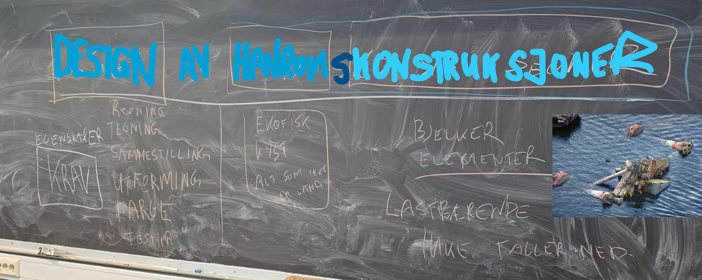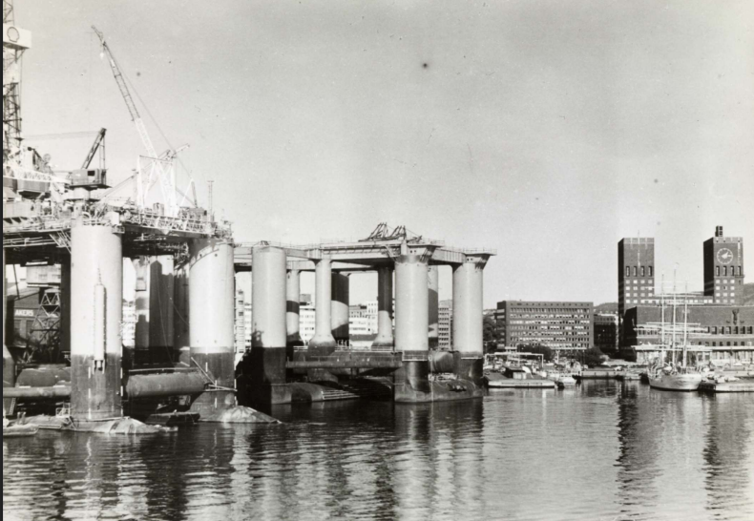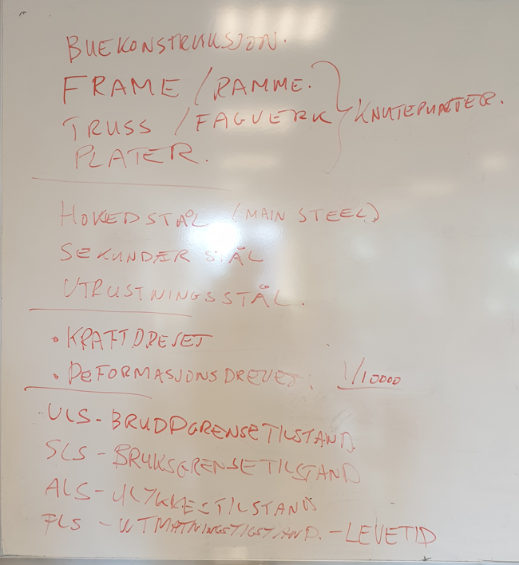

Design of Ocean Space Structures
Jomar Tørset, NTNU
2025

Preface
This book is authored by Jomar Tørset, a senior lecturer at NTNU, drawing from extensive experience in the structural analysis and design of offshore oil and gas structures. Jomar graduated in Structural Engineering from NTH in 1991 and obtained a Master of Technology and Management from NTH, NHH, and the National University of Singapore in 2004.
With over three decades of experience in engineering, Jomar has worked with notable organizations such as Aker Solutions, the Norwegian Public Roads Administration, Aibel, and GE, and has been involved in fabrication processes at Aker Verdal, Vigor Kristiansund, and Aibel Thailand.
This book serves as a comprehensive guide for designing load-bearing offshore structures in accordance with NORSOK requirements. The author believes that these standards should also be applied to onshore structures, aiming to inspire engineers in both offshore and onshore design
practices.
The goal of this book is to provide practical knowledge essential for becoming a structural engineer, specifically tailored for bachelor students. Unlike master's students, who at NTNU take the course “TVM4116 Hydro meccanics,” this book focuses on the foundational concepts and skills that bachelor students need to succeed in their studies and future careers. The content will emphasize practical applications and relevant topics that are directly applicable to the field of structural engineering, ensuring that students are well-prepared for real-world challenges. What has been included is the essential knowledge needed to perform calculations on marine structures. This content focuses on the key principles and practices that are crucial for understanding and analyzing structures in marine environments.
The Bachelor's Degree emphasizes practical skills and teamwork for real-world problem-solving. The Master's Degree focuses on advanced theory with some practical application, encouraging collaboration. The PhD centers on theoretical research, requiring interdisciplinary cooperation for innovation. Each level has unique strengths, and cooperation is key to solving complex engineering challenges. This book provides a solid foundation for making practical choices across all levels, including technical vocational schools.
Jomar Tørset
NTNU
2025

Index

Preface 2
Index 4
1. Summary 6
2. Introduction to design of Ocean Space Structures 11
3. Examples of collaps of load bearing structures 16
4. Integrity of Load bearing Structures 20
5. Contigency, allowance and COG margins 24
6. Weight and COG estimates 26
7. Calculation of Moment of inertia 27
8. Still water condition 29
9. Stability (part of still water condition) 31
9. Calculation of hydrostatic pressure 33
11. Morison Equation 37
6. Morison Equation and 42
7. Wind 45
10. Waves and current 92
11. Marine fouling 114
12. Sagging and hogging 116
13. Stability 120
14. Dynamics 148
17. Ice 153
18. Snow 154
19. Earthquake 155
20. Loads combinations 156
21. Global design 186
23. Foundation and foundation design (Marine Geotechnical design) 195
21. Global buckling 195
22. Local design 196
22. Local buckling 229
22. Interaction local and global buckling 230
23. Material selection and design according to NORSOK 231
24. Fatigue and life cycle evaluations 241
25. Vortex induced vibrations (VIV) in wind and wave current 263
26. Vibrations and noise 267
27. Condition monitoring 268
28. Problem sets and examples 269
27. References 273

Summary
Structure Design Definition
In this book, structure design is defined as the design of load-bearing structures in ocean space. The content is primarily based on lectures from the courses TBYG3018 Design of Ocean Space Structures and BYGT2312, which share the same focus. This book describes the knowledge and principles applicable to the design of ocean space constructions.
Introduction video in Norwegian video about TBYG3018 tell something about for TBYG3018 from around 2020 provides an overview of the course, focusing on the design principles and challenges associated with load-bearing structures in ocean environments. The video likely emphasizes the course's practical applications and relevance to the ocean space industry, as well as its alignment with NORSOK standards.
Key Focus Areas:
- Analysis, drawings, and documentation for fabrication, assembly, erection, maintenance, and inspection of load-bearing structures.
- Emphasis on structural steel as the primary construction material.
Knowledge Objectives:
- Familiarity with design codes, including NORSOK, DnV, and Eurocode.
- Understanding of global and local structural concepts for floating, fixed, and subsea structures.
- Basic knowledge of environmental forces such as waves, currents, and wind.
Skills Development:
- Proficiency in material selection and hand calculations.
- Competence in using 3D CAD and analysis software.
- Ability to find practical solutions and document steel structures effectively.
Standards Covered:
- NORSOK STANDARD N-001: Structural Design
- NORSOK STANDARD N-004: Design of Steel Structures
- Eurocode 3: NS-EN 1993-1-1 (General rules and rules for buildings)
- Eurocode 3: NS-EN 1993-1-3, NS-EN 1993-1-5, NS-EN 1993-1-8 (Design of Steel Structures and Joints)
- NORSOK M-001, M-101, M-120 (Material selections)
- DnV: DNV-RP-C205 (Environmental Conditions and Environmental Loads)
This course equips students with the essential knowledge and skills needed for the design and analysis of offshore structures, ensuring compliance with industry standards and best practices.
Recommended Book as Background Information: Havromsteknologi - et hav av muligheter
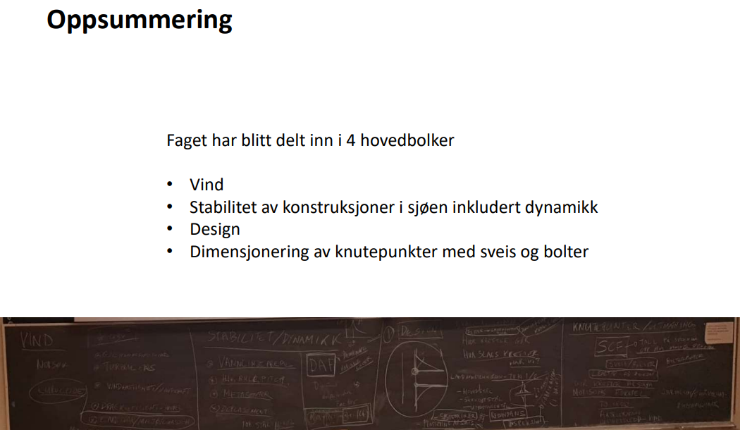
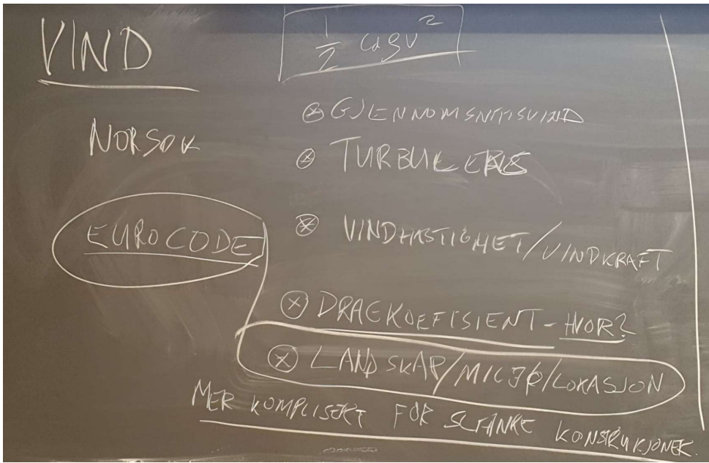
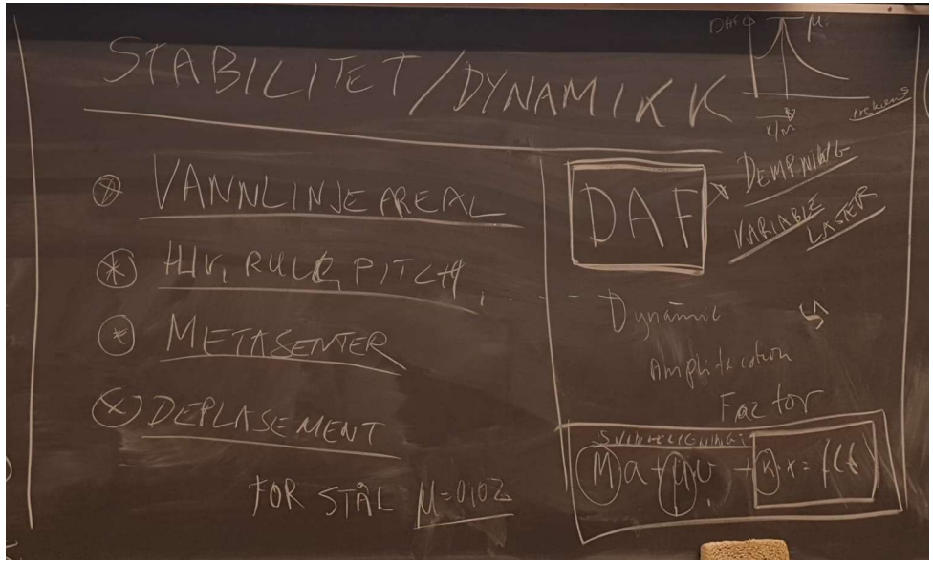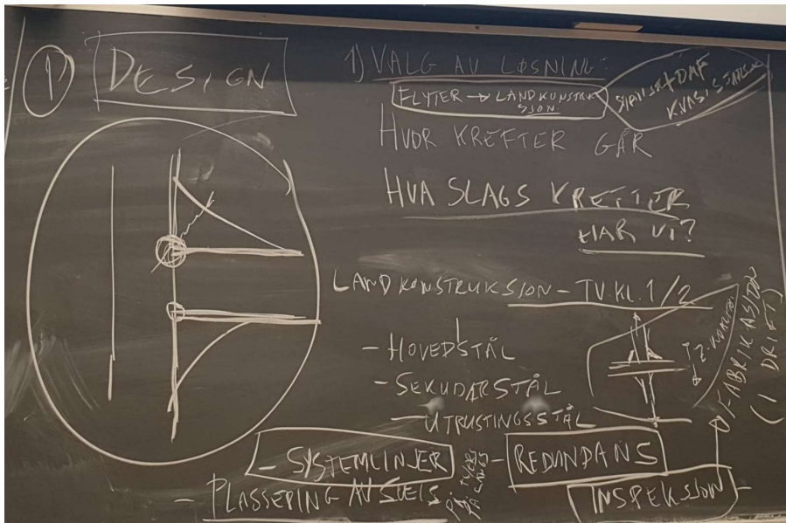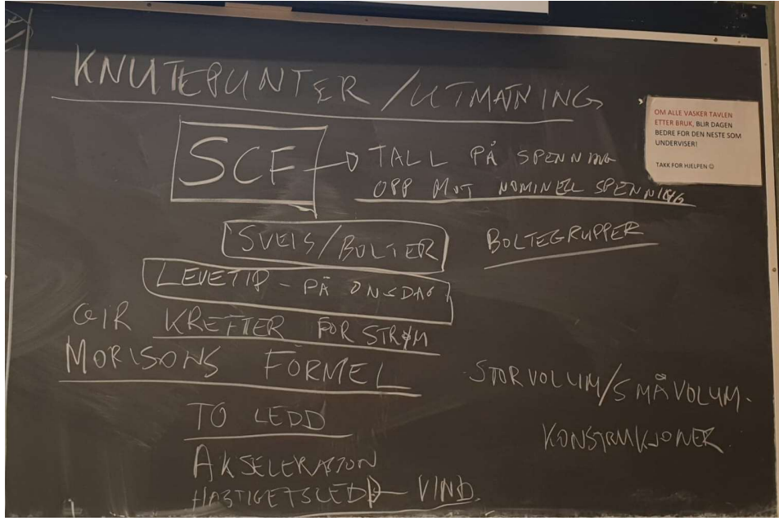

Summary:
Summary Part 1
- Loads and load combinations related to design, especially main steel.
Summary Part 2
Oppsummering:
- Design
- Material selection, criticality, and design solutions
- Fatigue
Summary of Node Design and Fatigue

2. Introduction to design of Ocean Space Structures
Definition of Structure Design
In this course, structure design is defined as the design of load-bearing structures specifically for the Norwegian ocean space.
Engineering Focus:
- The engineering process involves selecting appropriate load-bearing structural shapes, dimensions, and material quality.
- The primary aim is to teach students how to evaluate the behavior of structures under specific operational conditions in marine environments, particularly along the Norwegian coast.
Key Areas of Emphasis:
- A strong focus on environmental loads, including wave, wind, and current forces.
- Understanding the fundamental principles of structural design.
Materials Used:
- While the course primarily emphasizes steel as the construction material, aluminum is also frequently utilized.
- The use of aluminum helps reduce weight and can lower maintenance costs to some extent.
This comprehensive approach prepares students to design effective and efficient structures that can withstand the unique challenges of the marine environment.
Barenzwatch is indeed a valuable resource for understanding the harsh environmental conditions along the Norwegian coast. It provides real-time data on wave conditions, currents, and other relevant marine factors.
For current wave conditions in Trondheimsfjorden, you can visit the Barenzwatch website and navigate to the specific section for wave conditions. Here’s a general link to get you started: Barenzwatch.
Please check the site for the most accurate and up-to-date information on wave conditions in Trondheimsfjorden. Link to current wave conditions in Trondheimsfjorden.

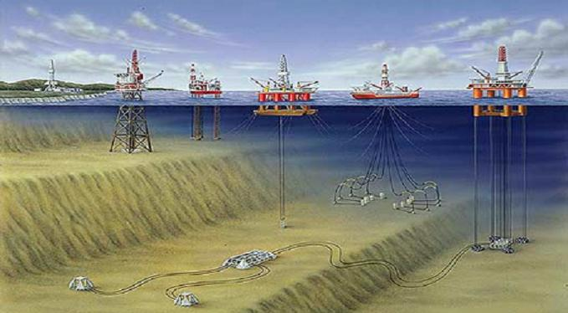
This figure gives an overview of different types of ocean structures in oil & gas.
Key information about different types of ocean space structures.
TLP concept: https://no.wikipedia.org/wiki/Strekkstagplattform
Subsea: https://en.wikipedia.org/wiki/Subsea_(technology)
Jacket: Jacket – Wikipedia
Ship: FPSO – Wikipedia
North sea (floater): Åsgardfeltet – Wikipedia
North sea (GBS-structure): Trollfeltet – Wikipedia
Pironeering sprit (World biggest lifting vessel) (Youtube )
Offshore fishing farm: Ocean farm 1 (kart): OFFSHORE FISH FARMING - SalMar ASA
Offshore fishing farm: Havfarm 1, Jostein Albert: (kart)
Floating bridge: Bergsøysundbrua
Floating bridge: Nordhordalandsbrua
Living on the sea: Houses on the sea

Bailey Bridge
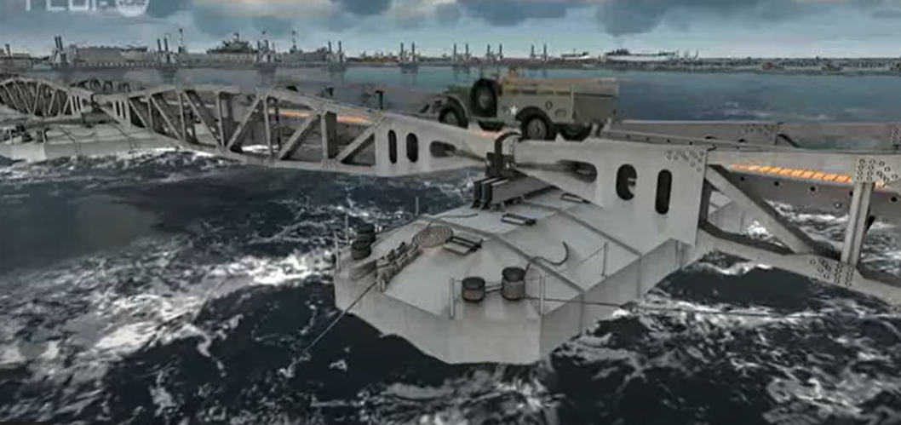
Floating bridges built during World War II, particularly by the Allies, were an innovative solution for ensuring transportation and logistics under challenging conditions. These temporary bridges were often constructed from lightweight materials such as steel and wood, designed for quick assembly and disassembly.
A notable example is the "Bailey Bridge," developed by the British. This type of bridge could be rapidly erected by soldiers without specialized equipment, which was crucial for maintaining supply lines in combat zones.
Floating bridges were especially useful in areas with water, such as rivers and lakes, where traditional bridges would have been too time-consuming or costly to construct. They significantly improved mobility for troops and supplies and played an important role in the war effort.
Reconstitution en images de synthèse du port d'Arromanches en 1944 - YouTube
Unique Solutions/Challenges Related structures in Water for Fosen Bridge: Fosenbrua.pdf
Molohåndboka (The Molo Handbook) is a comprehensive guide published by the Norwegian Coastal Administration, focusing on the design, construction, and maintenance of coastal structures, particularly breakwaters (molos) and harbors. It serves as a valuable resource for engineers, architects, and planners involved in coastal and marine projects.

Example Loads on H3 Rig: Eksempel H3-rigg
Here’s a translation and brief explanation of the terms related to design loads and considerations for floating structures:
Load Scenarios
- Design Load Scenarios: These are specific conditions and load cases that must be considered during the design process to ensure the structure can withstand various operational and environmental loads.
Displacement of Floating Structures
- Displacement of Floating Structures: This refers to the weight of water displaced by a floating structure, which is crucial for determining buoyancy and stability.
Still Water Condition (Design Basis)
- Still Water Condition (Design Basis): This is the baseline condition used for design calculations, assuming calm water without waves or currents, which helps in assessing the structural response under static loads.
Wind Load on Derrick
- Wind Load on Derrick: This refers to the forces exerted by wind on the derrick structure of the rig, which must be calculated to ensure stability and safety during operations.
Shape Factor (C_s)
- Shape Factor (C_s): This is a coefficient used to account for the shape of the structure when calculating wind loads. It influences how wind interacts with the structure's surface.
Height Dependency Factor (C_h)
- Height Dependency Factor (C_h): This factor accounts for the variation of wind speed with height above the water surface. It is used to adjust wind load calculations based on the height of the structure.
These concepts are essential for the design and analysis of floating structures, ensuring they can safely operate in marine environments while accounting for various loads and conditions.

Link to historical stories about Ocean Space Structures
-An Aker H3 rig at the Norwegian Petroleum Museum | Facebook
-Aker H3 platforms under construction at Aker Mek. Verksted.
- Oslo Museum / DigitaltMuseum
-The story of Change – and Finding Solutions atAker Solutions
- Oil and Us – Oil and Us – and Those on the Other Side of the North Sea – NRK TV

3. Examples of collaps of load bearing structures

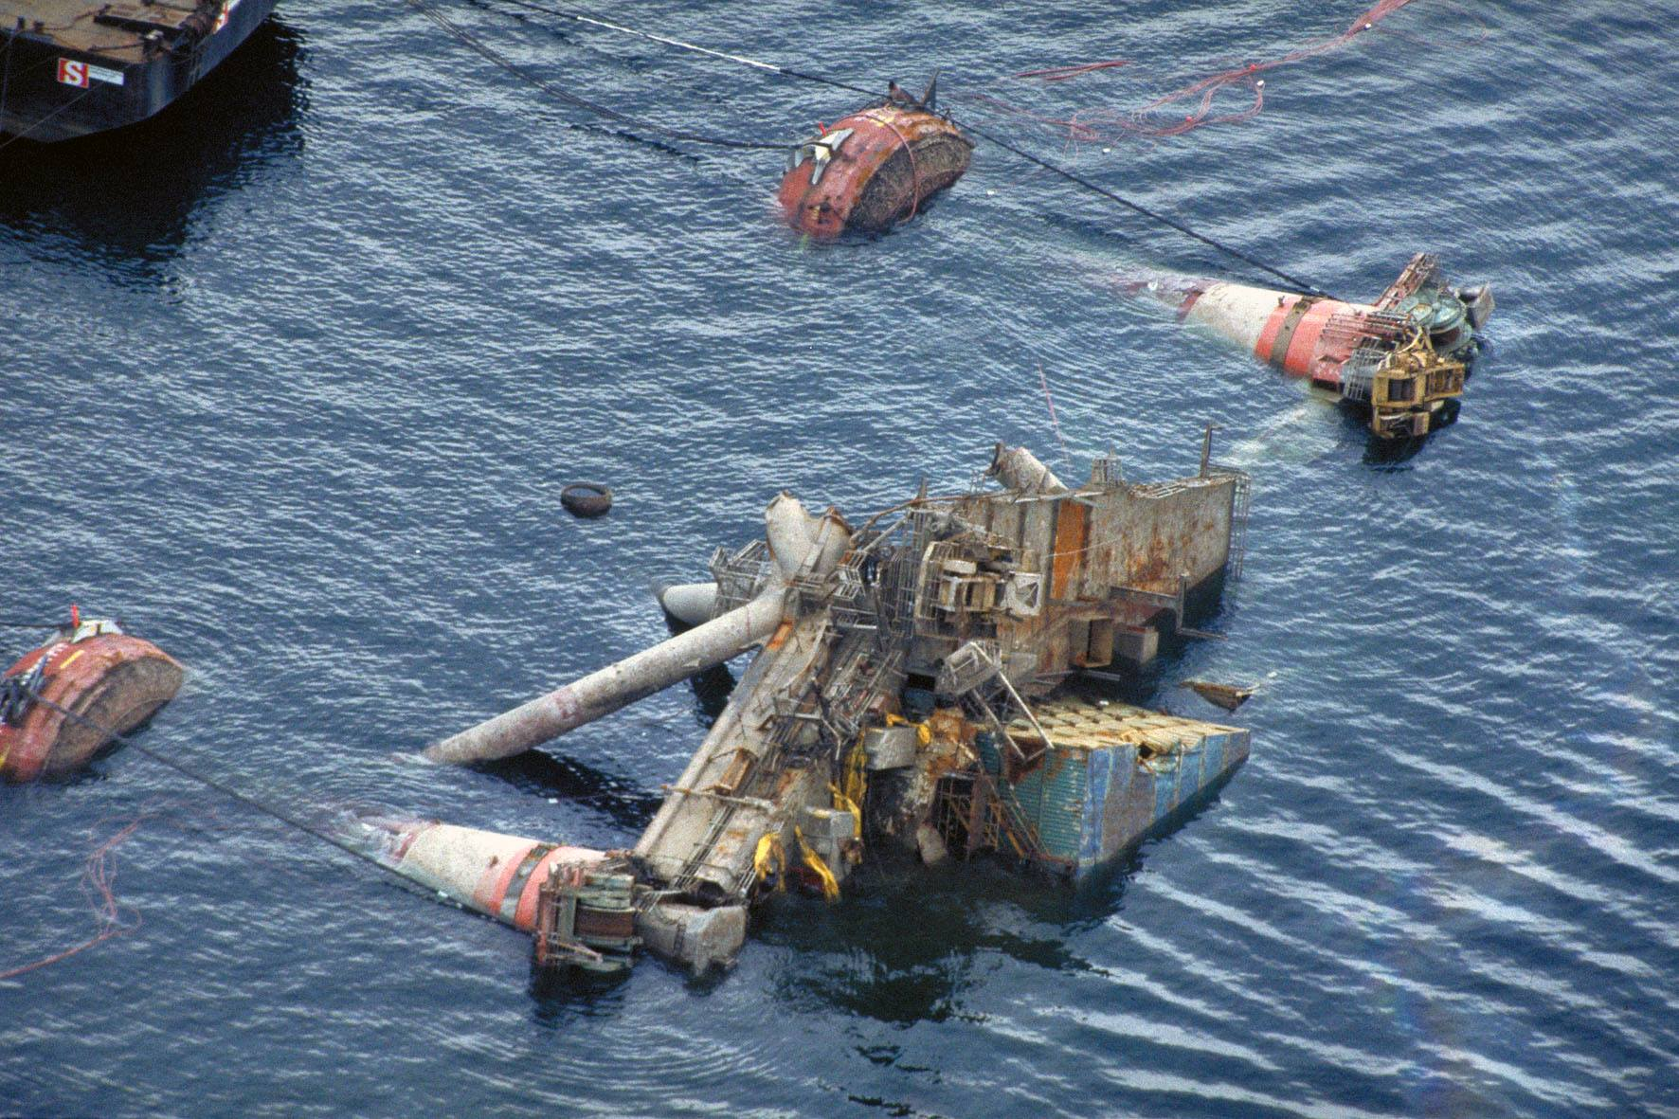
The Aleksander Kielland-accident marked a significant turning point in the development of safety philosophy within the oil and gas industry. In response to this tragedy, a comprehensive set of regulations known as NORSOK was developed to enhance safety standards. This book is centered around these regulations, which are specifically designed for offshore structures. However, the underlying safety philosophy is considered good practice and is applicable to land-based structures as well. This approach emphasizes the importance of safety in all engineering practices, ensuring that both offshore and onshore projects adhere to high safety standards.
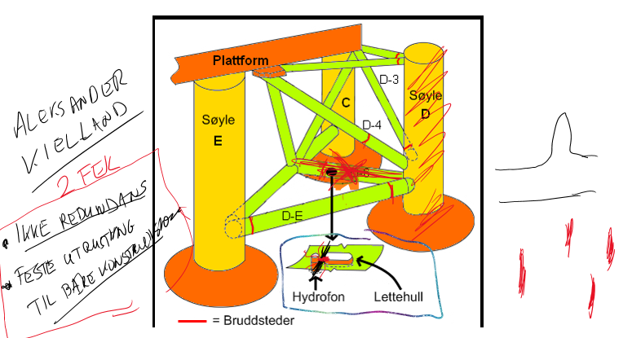
In recent years, several accidents involving onshore structures have raised questions about the need to clarify and possibly enhance the requirements for these structures, similar to those outlined in NORSOK. Notable incidents include the collapse of the Tretten Bridge in 2022 and the crane at Melhustorget that was blown down in 2023. These events highlight potential gaps in safety regulations and standards for onshore construction, prompting discussions about the importance of adopting rigorous safety measures and practices akin to those used in offshore structures to prevent future accidents and ensure public safety.

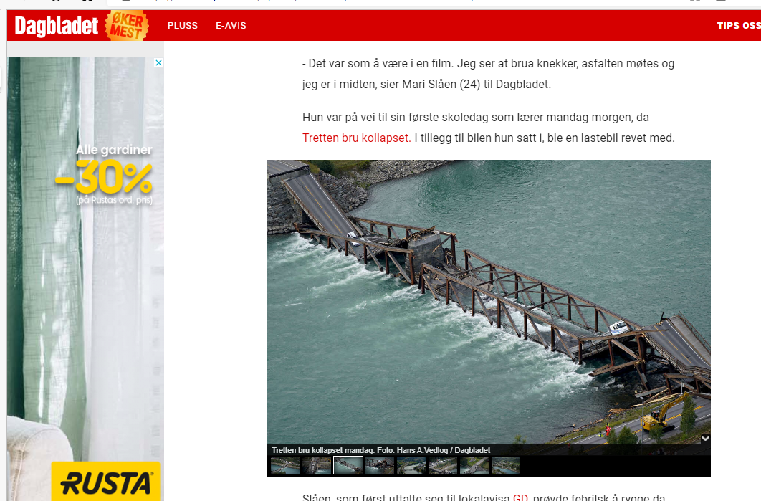
Dagsrevyen – Monday – Bridge Collapsed at Tretten – NRK TV
The Bridge Collapsed Under Her: - Dramatic (dagbladet.no)
The link to an article from NRK (Norwegian Broadcasting Corporation) discusses the collapse of Tretten Bridge. The article highlights findings from the Accident Investigation Board, which indicated that the bridge was weakened prior to its collapse. It also criticizes the Norwegian Public Roads Administration for its handling of the situation and oversight regarding the bridge's condition.
https://www.nrk.no/innlandet/havarikommisjonen_-tretten-bru-var-svekket.-statens-vegvesen-far-sterk-kritikk-1.16515705.
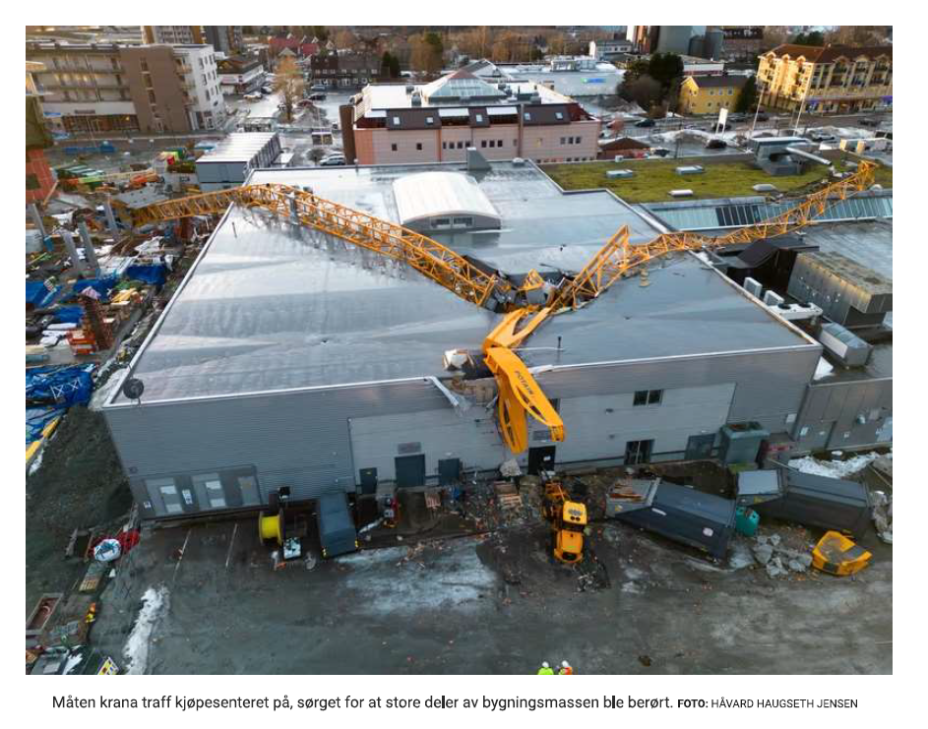
The incident as described on NRK's website
The aim of this book is to demonstrate how to prevent structural collapses. It focuses on best practices, design principles, and safety measures that can be implemented to ensure the integrity and stability of structures, thereby minimizing the risk of failure.

4. Integrity of Load bearing Structures
The core principles for structural design are outlined in Section 7.1 of NORSOK N-001. This section provides essential guidelines and considerations that engineers should follow to ensure the safety, reliability, and performance of structures. It emphasizes the importance of understanding loads, material properties, and environmental factors, as well as the need for a systematic approach to design that prioritizes safety and compliance with relevant standards.
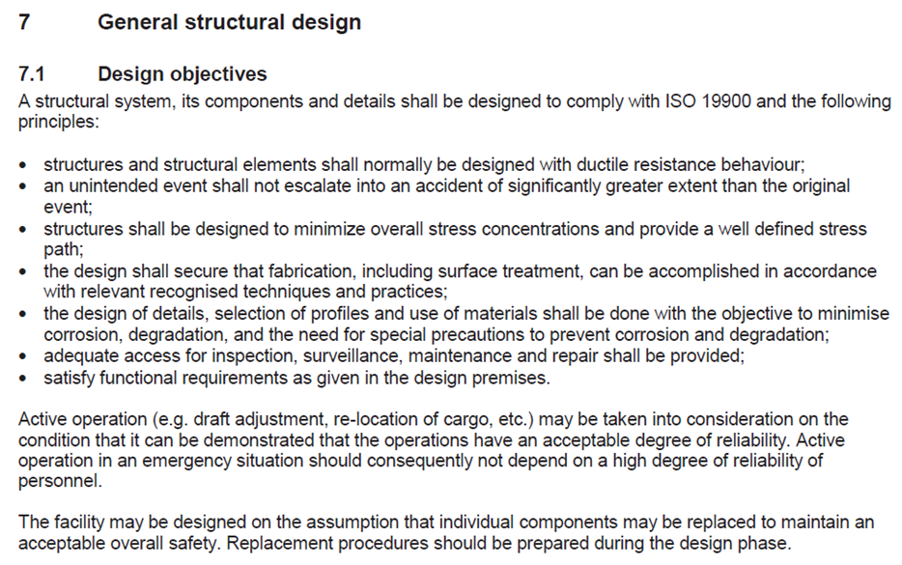
Background information:
Microsoft Word - NORSOK -Design Fabrikasjon-MOM-2015 (konstruksjon.com)
Designers' Guide to EN 1990 Eurocode: Basis of Structural Design | Designers' Guide to Eurocodes (icevirtuallibrary.com)
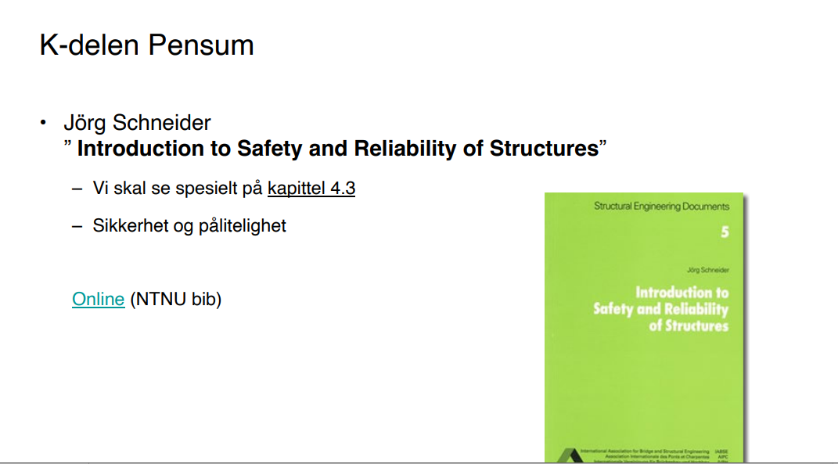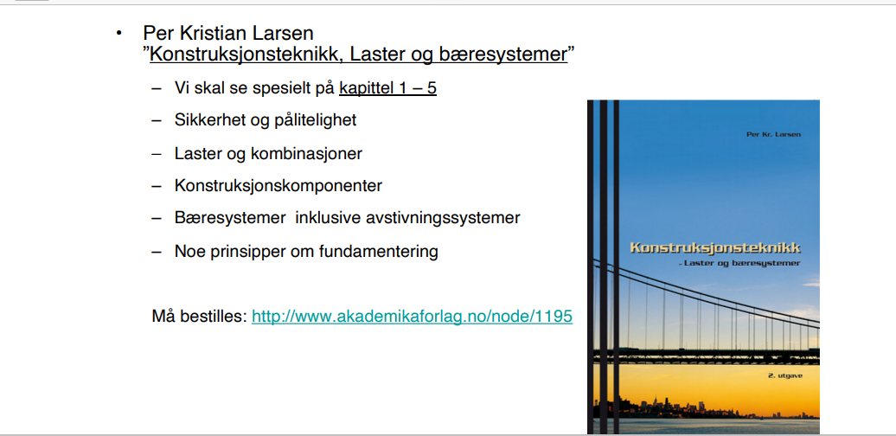

The corresponding text in EUROCODE may not be as clear, but I interpret it to suggest that the intention is similar: that the design does not comply with the established regulations. This implies that both NORSOK and EUROCODE emphasize the importance of adhering to specific standards and guidelines in structural design to ensure safety and reliability.
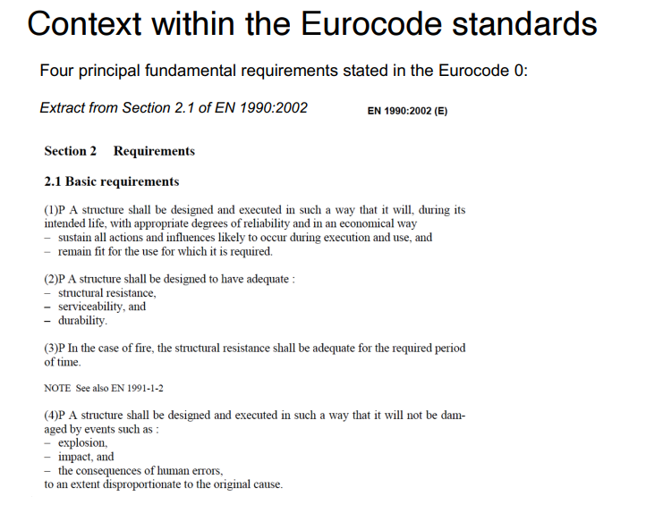
The most important points regarding structural design are:
- Ductile Behavior: The structure should exhibit ductile behavior, allowing it to deform without sudden failure, thereby enhancing its ability to withstand unexpected loads.
- Damage Control: In the event of an incident, the design should prevent damage from escalating, ensuring that any failure is contained and does not lead to catastrophic consequences.
- Minimize Stress Concentration Factors: Stress concentration factors should be minimized to reduce the likelihood of localized failures, which can compromise the overall integrity of the structure.
- Force Absorption Philosophy: There should be a clear philosophy regarding how the structure is designed to absorb and dissipate forces, ensuring that it can effectively manage loads during normal operation and in the event of extreme conditions.
These principles are essential for creating safe and resilient structures.

5. Contigency, allowance and COG margins
Engineering is not an exact science; it involves making informed judgments about sensible engineering solutions. We must carefully consider how the structure will behave and how we plan for it to function. Our goal is always to err on the side of safety.
When it comes to loads, we use load factors, but we can never know the exact loads or the center of gravity (COG) for self-weight. To account for uncertainties, we add extra loads in our analysis to cover contingencies and allowances. For the COG, we operate within an envelope to ensure we remain within safe limits. These factors tend to be larger in the early stages of projects, such as studies and Front-End Engineering Design (FEED), and will be reduced as we approach implementation and construction. This reduction is dependent on the level of experience we have with various aspects of the project.
To calculate the behavior of a structure in water, it is essential to know the mass (or to make an estimate of the mass and its distribution). This is crucial for determining buoyancy, stability, and dynamic behavior. Therefore, weight estimation is an important topic in the design process.
Allowance
- Definition: An allowance in this context refers to a specific amount of weight or cost that is included in the budget to account for known variations in the weight of materials or fabrication processes.
- Purpose: It is used to cover anticipated changes or additional requirements related to weight and fabrication costs that may not be fully defined at the time of budgeting.
- Example: If a project estimates the weight of steel components but recognizes that the final design may require additional material, an allowance might be set for an extra 10% of the estimated weight. Similarly, if there are uncertainties about the fabrication methods that could affect costs, an allowance might be included to cover those potential increases.
Contingency
- Definition: Contingency, in this context, refers to a reserve of funds or weight set aside to address unforeseen issues related to weight and fabrication costs that may arise during the project.
- Purpose: It provides a financial buffer to manage unexpected changes or risks that were not anticipated in the original budget, specifically related to weight and fabrication.
- Example: A project might include a contingency fund of 5% of the total fabrication cost to cover unexpected expenses, such as price increases in materials or additional labor costs due to unforeseen complexities in the fabrication process.
Summary
- Allowance is for specific known variations in weight and fabrication costs, while contingency is a reserve for unforeseen changes or risks related to these factors. Both are essential for effective budgeting and project management in engineering and construction.
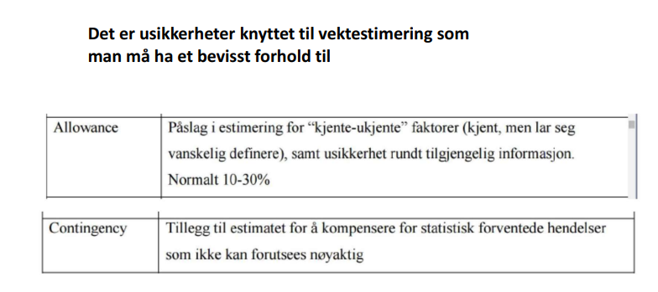

6. Weight and COG estimates

Weight Estimation (a specialized field):
Weight estimation is a critical aspect of engineering, particularly in the design and analysis of structures. It involves determining the mass of various components and understanding how that mass is distributed, which is essential for assessing the center of gravity (CoG) and ensuring the stability and performance of the structure.
Center of Gravity (CoG):
The center of gravity is the point at which the total weight of a body is considered to act. Accurate knowledge of the CoG is vital for evaluating the buoyancy, stability, and dynamic behavior of structures, especially those operating in marine environments.
Equinor's Technical Requirements (TRs):
For your information, Equinor has different Technical Requirements (TRs) for new builds compared to modifications. This distinction ensures that the specific safety, performance, and regulatory standards are met for both new constructions and modifications to existing structures. Understanding these requirements is crucial for compliance and successful project execution.
Link to Equinors TR’er for newbuilts structures opp mot modifications.

7. Calculation of Moment of inertia
When estimating the mass and inertias of structures, there are generally two approaches: point mass and rod mass. Here’s a brief overview of each method:
1. Point Mass
- Definition: The point mass approach simplifies the analysis by treating the mass of an object as concentrated at a single point. This method is often used for discrete masses or when the distribution of mass is not critical to the analysis.
- Application: This method is useful for calculating the center of gravity (CoG) and inertial properties of structures where the mass can be approximated as being concentrated at specific points, such as in the case of weights, machinery, or other discrete components.
- Inertia Calculation: The moment of inertia for a point mass about an axis can be calculated using the formula: [ I = m \cdot r^2 ] where ( I ) is the moment of inertia, ( m ) is the mass, and ( r ) is the distance from the axis of rotation to the point mass.
2. Rod Mass
- Definition: The rod mass approach considers the mass distributed along a length of a rod or beam. This method is more accurate for continuous structures where the mass distribution is significant.
- Application: This method is used for calculating the inertial properties of beams, rods, or any elongated structures where the mass is distributed along their length. It is particularly useful in structural analysis and dynamics.
- Inertia Calculation: The moment of inertia for a uniform rod about its center can be calculated using the formula: [ I = \frac{1}{12} m \cdot L^2 ] where ( I ) is the moment of inertia, ( m ) is the mass of the rod, and ( L ) is the length of the rod. If the axis of rotation is at one end, the formula becomes: [ I = \frac{1}{3} m \cdot L^2 ]
Summary
- Point Mass is suitable for discrete masses and simplifies calculations by concentrating mass at a single point.
- Rod Mass is appropriate for continuous mass distributions along a length, providing a more accurate representation of inertial properties for elongated structures.
Choosing the appropriate method depends on the specific application and the level of accuracy required in the analysis.
Mass inertia description
Moment of Inertia for point mass and rod - YouTube
MomentOfInertiaHibeler.pdf

8. Still water condition
Design of Floaters
The design of floaters begins with an analysis of the still water condition. This condition consists of dead weight and ballast. The structure must be capable of floating and robust enough to withstand environmental loads such as wind, waves, ice, and ice spray.
Environmental loads like wind and waves occur at varying intensities and with different periods/frequencies. The design must ensure that the natural frequencies of the structure do not coincide with the most significant and severe loads, as this could lead to structural failure.
Both extreme loads and fatigue are critical considerations. It is often the medium-sized waves, with periods of approximately 5 to 10 seconds, that generate the most fatigue damage.
Displacement of Floating Structures
Displacement in floating structures refers to the volume of water displaced by the structure when it is floating. This is crucial for determining buoyancy, stability, and overall performance in marine environments. Proper calculations of displacement ensure that the structure remains stable and functional under various loading conditions.
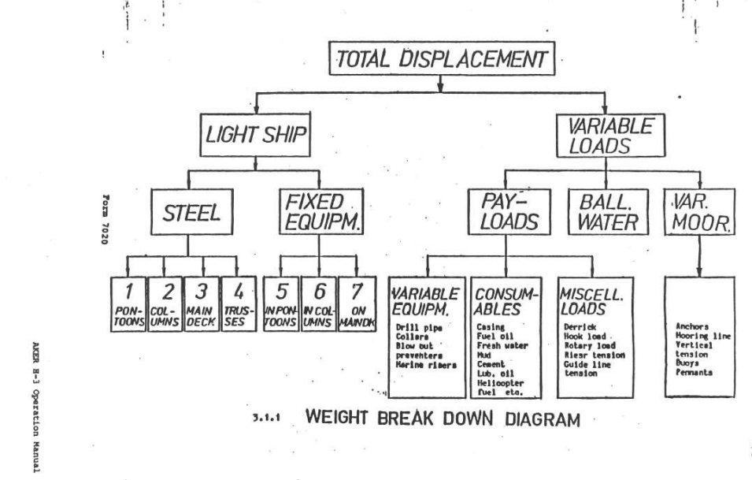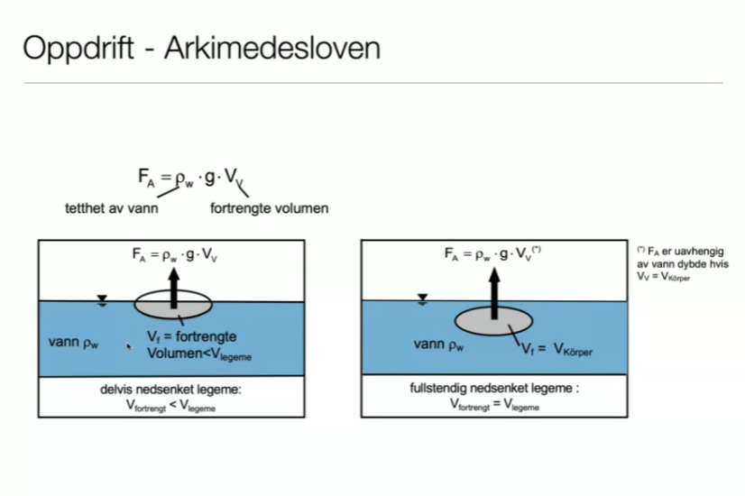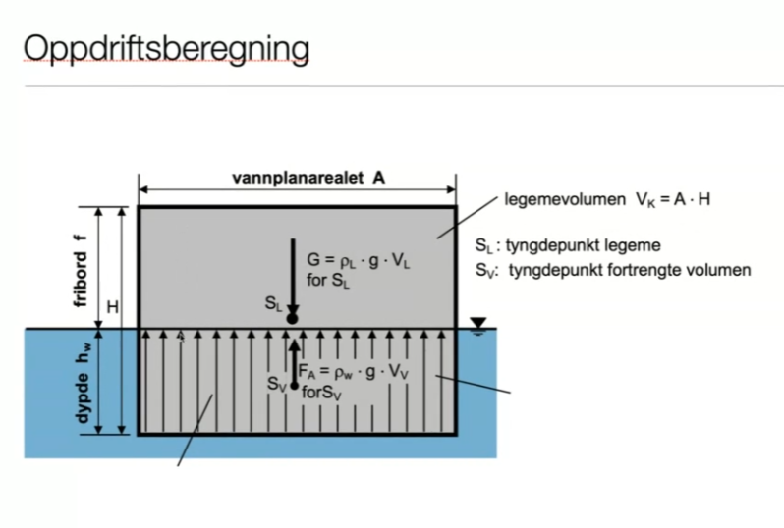

9. Stability (part of still water condition)
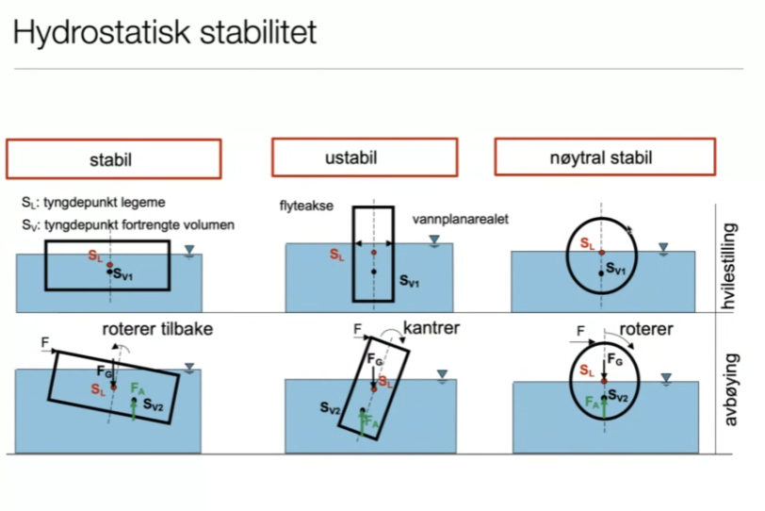
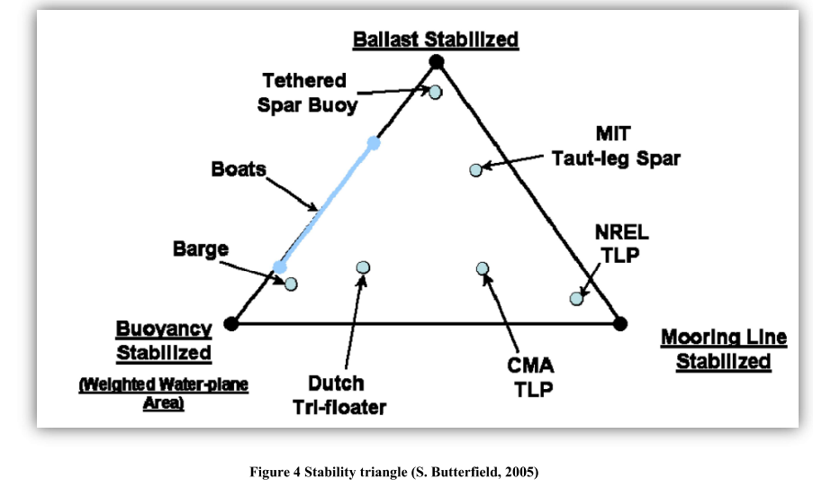
Stability Triangle Representation
- The stability triangle visually represents how these three stabilization methods interact and contribute to the overall stability of a floating structure. Each method can be seen as a vertex of the triangle, and the effectiveness of the structure's stability can be assessed based on the relative contributions of each method.
Conclusion
Understanding the stability triangle and the roles of ballast, buoyancy, and mooring line stabilization is essential for designing safe and effective floating structures in marine environments. Each method has its strengths and weaknesses, and the optimal design often involves a combination of these stabilization techniques to achieve the desired performance and safety.
Stability Triangle Overview
- Ballast Stabilized
  - Definition: This method involves adding weight (ballast) to the structure to lower its center of gravity, enhancing stability against external forces such as waves and wind.
  - Characteristics:
    - Increases the overall weight of the structure.
    - Lowers the center of gravity, which helps resist tipping or rolling.
  - Applications: Commonly used in ships, floating platforms, and offshore structures where stability is critical.
- Buoyancy Stabilized
  - Definition: This method utilizes buoyant elements to provide stability. The upward buoyant force counteracts the weight of the structure, helping to maintain an upright position.
  - Characteristics:
    - Relies on the design of the structure to maximize buoyancy.
    - Can be effective in maintaining stability in rough sea conditions.
  - Applications: Used in floating structures like spar buoys, tension-leg platforms, and semi-submersibles.
- Mooring Line Stabilized
  - Definition: This method involves anchoring the floating structure to the seabed using mooring lines. The tension in these lines provides stability and prevents excessive movement.
  - Characteristics:
    - Allows for dynamic positioning and can accommodate movement due to environmental forces.
    - Provides flexibility in stabilizing floating structures.
  - Applications: Commonly used in floating production storage and offloading (FPSO) units and other offshore installations.

9. Calculation of hydrostatic pressure
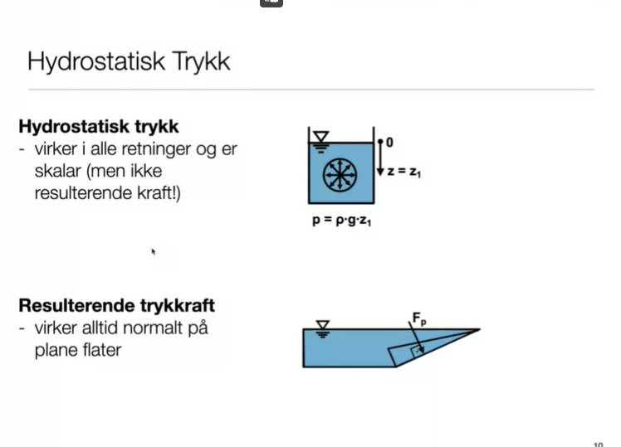

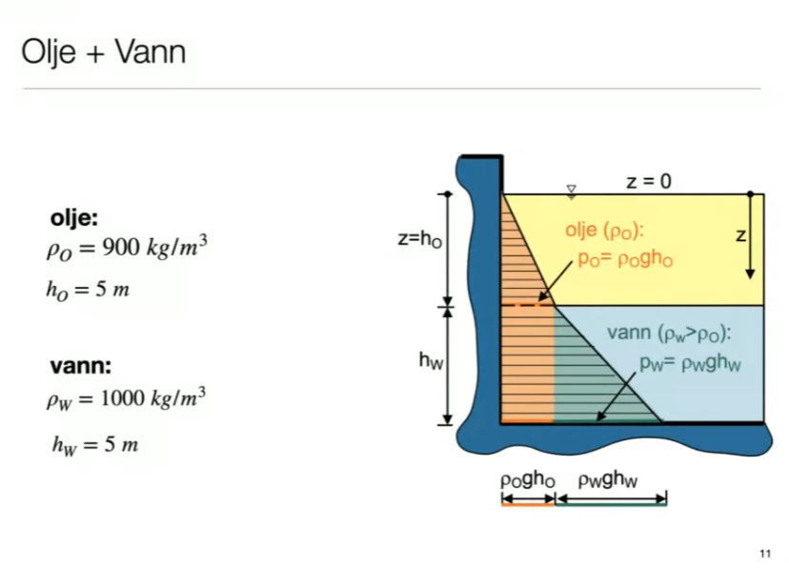

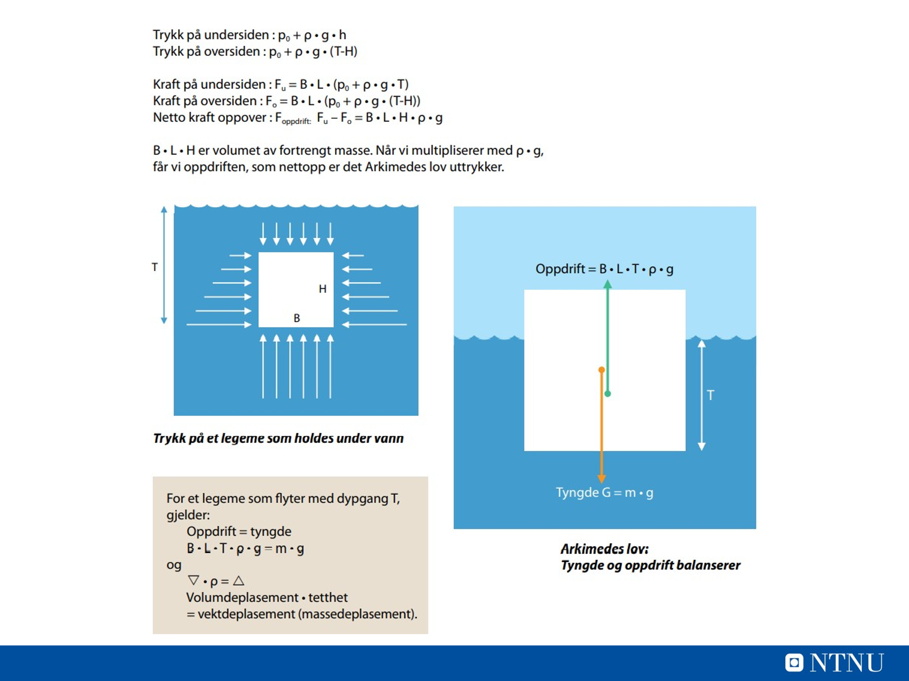
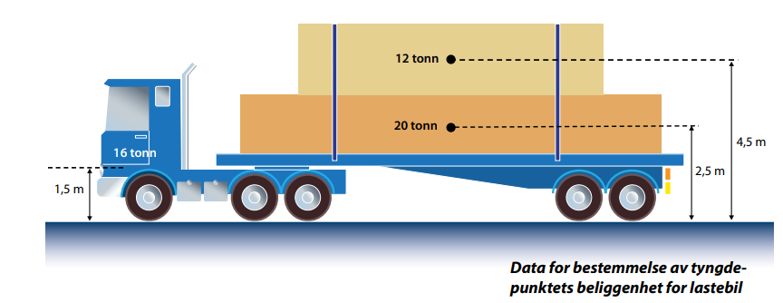
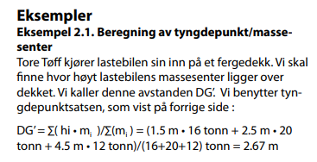
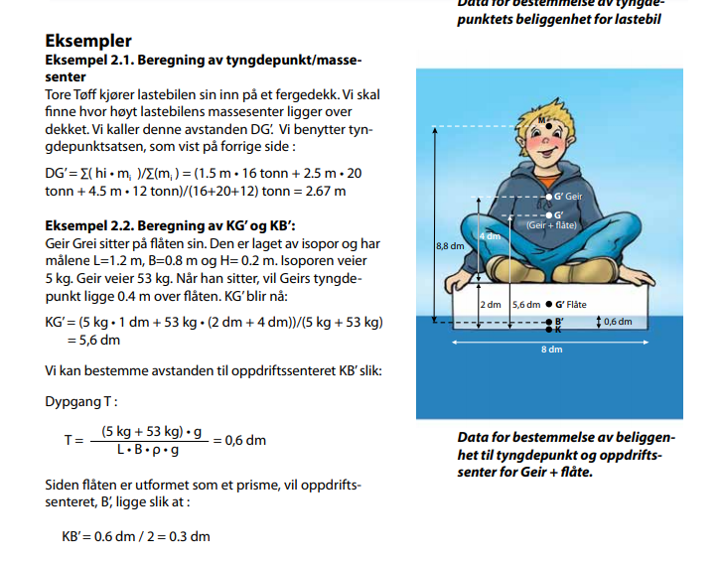

"Geir floats" from Marine Technology "A Sea of Opportunities." Page 89 in the PDF file: Bok.pdf (ntnu.no).
- SAP2000 calculation «Geir flyter»
- Mathcad beregning Geir flyter

11. Morison Equation
Morison's Equation
When is it used? Morison's equation is used to calculate the forces acting on structures submerged in fluid flows, such as offshore platforms, pipelines, and other marine structures. It accounts for both drag and inertia forces due to the fluid motion.
Potential Theory
When is it used? Potential theory is applied in fluid dynamics to analyze the flow of inviscid (non-viscous) fluids. It is particularly useful for calculating wave forces on large structures, where the effects of viscosity can be neglected. This theory helps in understanding the potential flow around objects and is often used in the design of marine structures.
Keulegan-Carpenter Number
The Keulegan-Carpenter number (Kc) is a dimensionless parameter that characterizes the relative importance of inertial forces to restoring forces in oscillatory flow. It is particularly relevant for distinguishing between large-volume and small-volume structures in fluid dynamics.
Drag vs. Inertia Forces and Phase Differences
- Drag Forces: These are the forces exerted by the fluid on the structure due to the fluid's velocity. In wind, the drag force is significant because the mass of the wind is small, and the direct force from wind pressure dominates.
- Inertia Forces: These forces arise from the acceleration of the fluid and the structure. In water, the effect of waves depends on the size of the structure relative to the wave size. For large structures, the inertia forces become more significant compared to drag forces.
Coefficients for Cd and Cm in Morison's Equation
- Cd (Drag Coefficient): This coefficient represents the drag force acting on a structure due to fluid flow.
- Cm (Inertia Coefficient): This coefficient accounts for the inertia forces acting on the structure due to fluid acceleration.
Summary
To find forces from fluid flows, whether air or water, we use Morison's equation. The first term corresponds to the drag component, which is significant in wind due to its low mass. The direct force from wind pressure dominates, although there is also an inertia contribution that is often negligible because the wind's mass is small and out of phase.
In water, the impact of waves depends on the size of the structure relative to the wave size. If the structure is large compared to the waves, it can "dampen" the waves, and we focus only on the energy (using potential theory). This scenario is referred to as "large-volume structures," where inertia forces become more relevant, allowing us to neglect the drag component since it becomes insignificant.
Inertia (Treghet) – Wikipedia
Froude–Krylov force - Wikipedia
Drag equation - Wikipedia
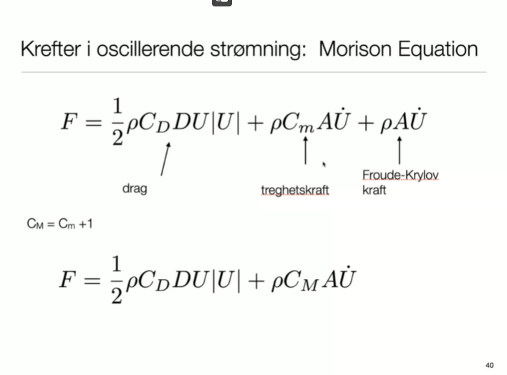
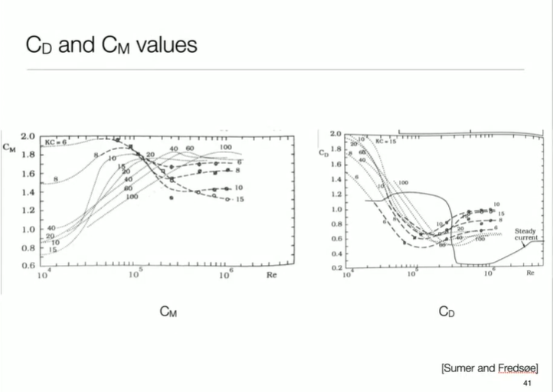
BYGT2312-Forelesning-20221123-DragKoefisienter.pdf
Regneeksempel med bestemmelse av dragkoefisenter

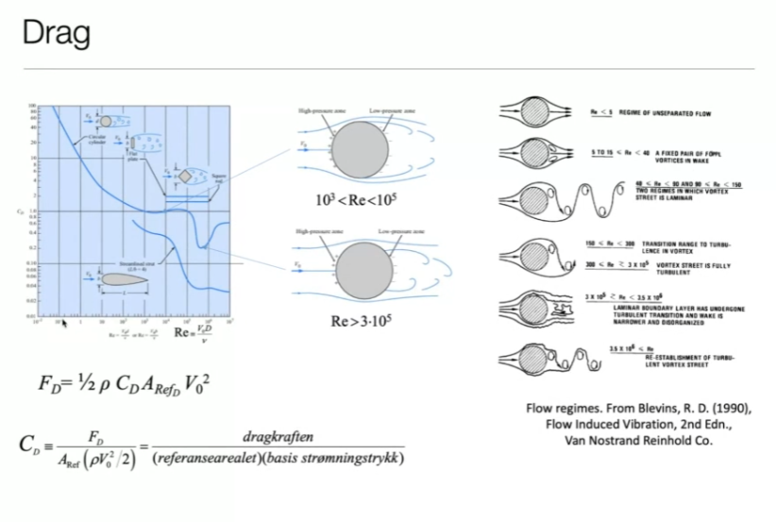
BYGT2312-Forelesning-20221123-DragKoefisienter.pdf
Reinhold's Number is a dimensionless parameter that provides insight into the intensity of fluid flow, particularly in the context of wave dynamics. It helps characterize the flow regime and can indicate whether the flow is laminar or turbulent. This number is useful in understanding how structures interact with fluid flows, especially in marine environments.
Use of Morison's Equation with Wave Airy Formulas
Morison's Equation is often used in conjunction with Airy wave theory to calculate the forces acting on structures due to wave action. The Airy wave theory provides formulas for particle velocities and accelerations in waves, which are essential for determining the dynamic response of structures in oscillatory flow.
- Particle Velocities: The Airy wave theory describes the motion of water particles in waves, providing expressions for the particle velocities at different depths. These velocities are crucial for calculating the inertia forces in Morison's equation.
- Application: When using Morison's equation, the drag and inertia forces can be calculated based on the particle velocities derived from the Airy wave theory. The equation typically takes the form: [ F = \frac{1}{2} C_d \rho A V^2 + C_m \rho V \frac{dV}{dt} ] where:
  - ( F ) = total force on the structure
  - ( C_d ) = drag coefficient
  - ( C_m ) = inertia coefficient
  - ( \rho ) = fluid density
  - ( A ) = projected area of the structure
  - ( V ) = particle velocity from wave theory
  - ( \frac{dV}{dt} ) = acceleration of the particle
By combining Morison's equation with the particle velocities from the Airy wave theory, engineers can accurately assess the forces acting on marine structures due to wave action, ensuring that designs are robust and capable of withstanding the dynamic marine environment.
Morison Equation - wave loads on structures INERTIA force - YouTube
Wave pressure - how to calculate wave height and wavelength - YouTube
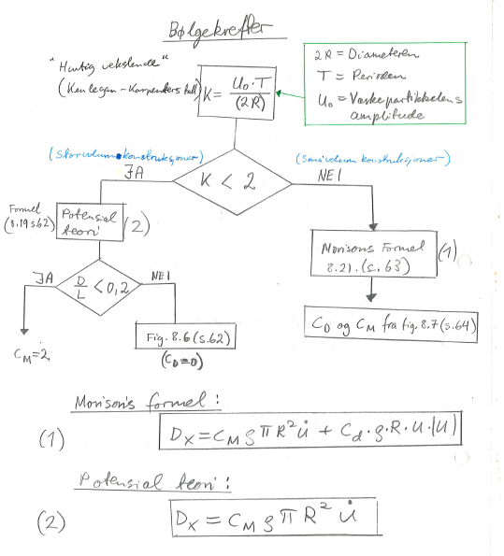
For sylinder

https://en.wikipedia.org/wiki/Keulegan%E2%80%93Carpenter_number
https://no.wikipedia.org/wiki/Froude-krylov-kraft
Morison Equation - wave loads on structures INERTIA force - YouTube

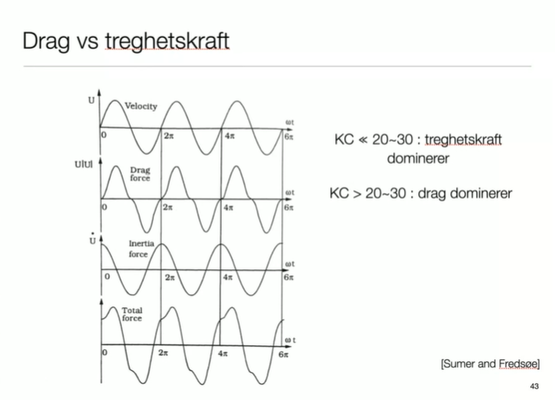

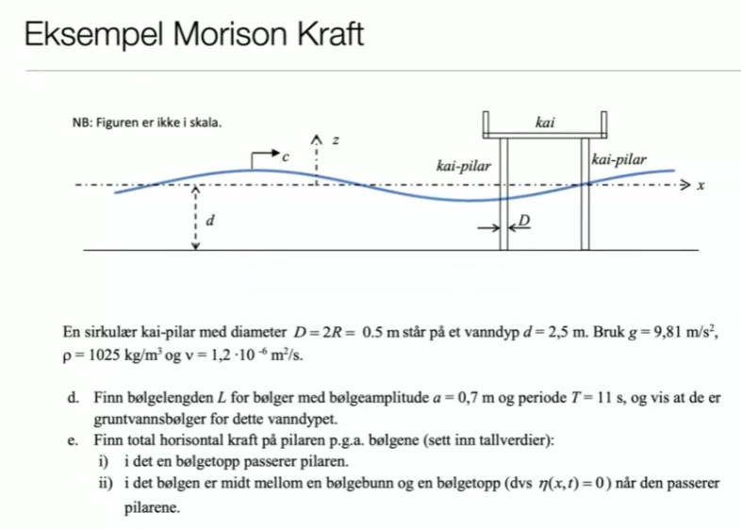
How to calculate forces on small structures. Morison’s equation - YouTube
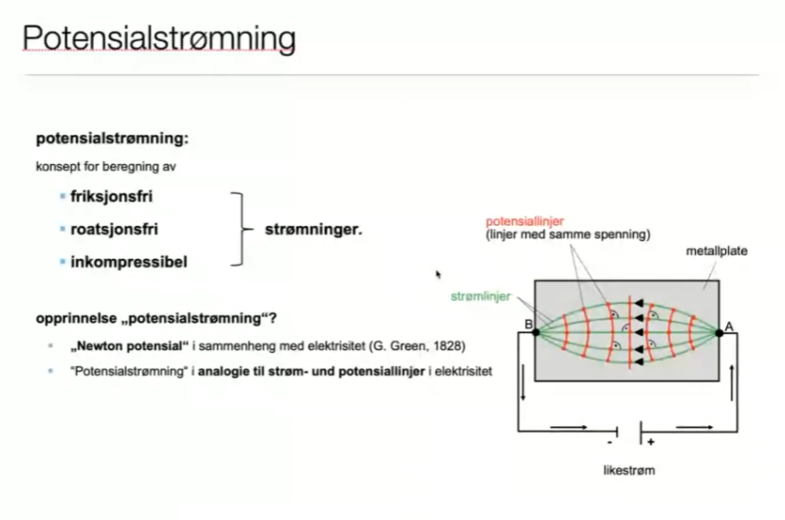

7. Wind
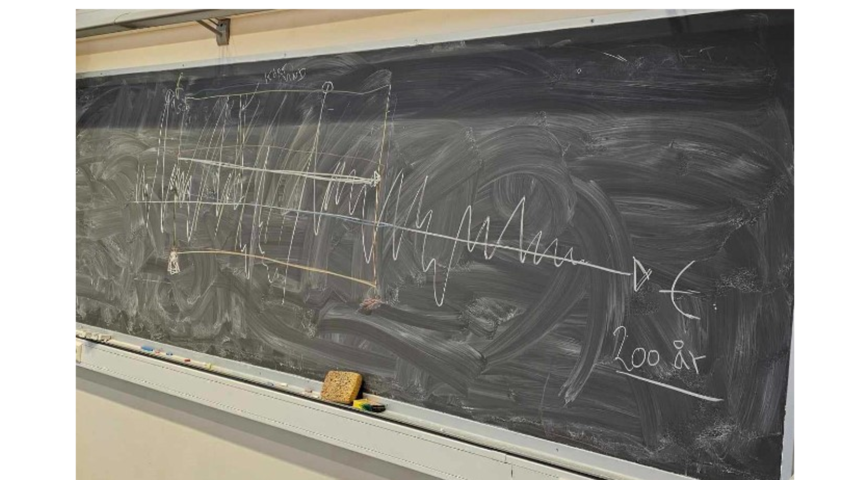
Flow visualization around simple building shapes in wind tunnel - YouTube
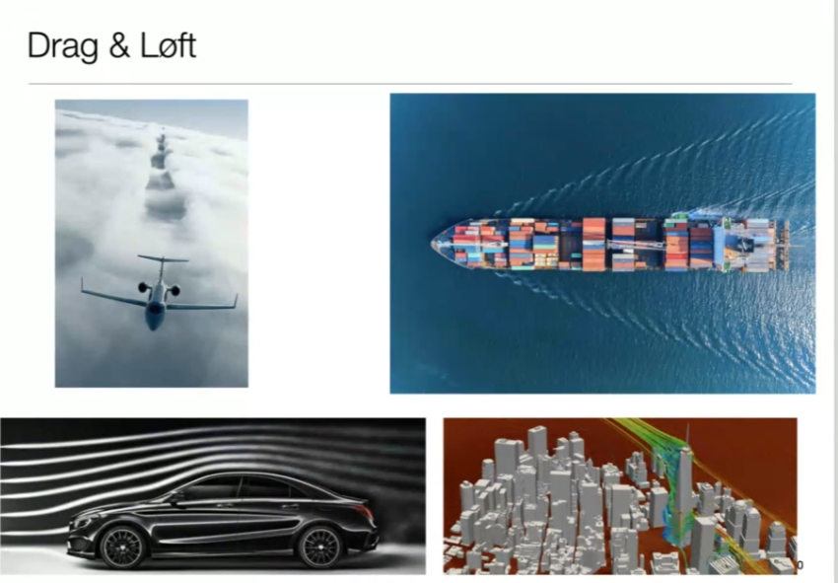
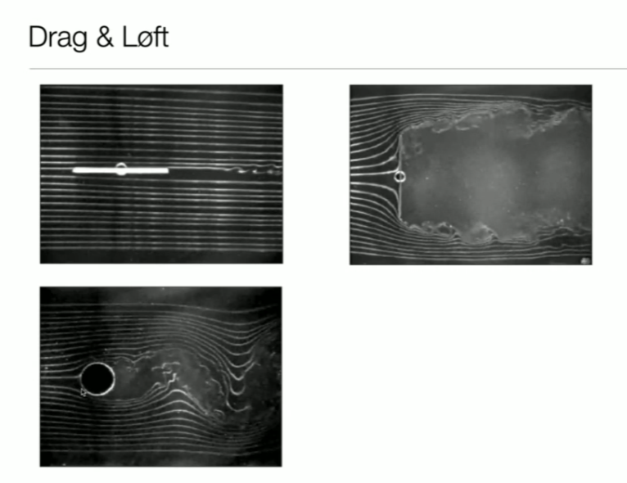
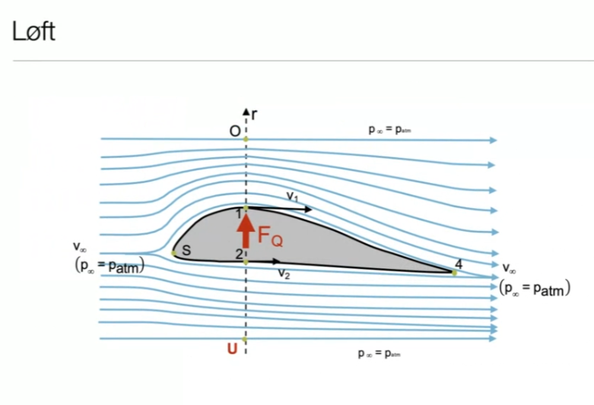
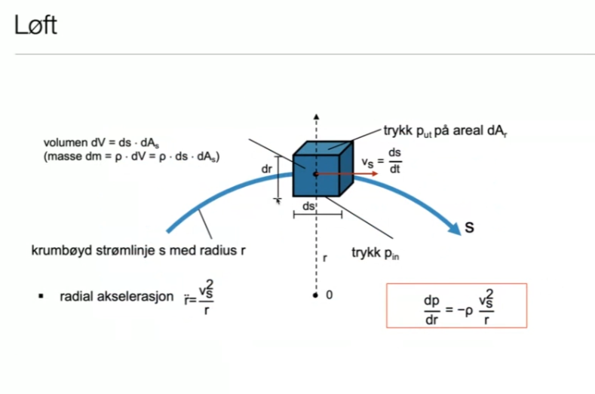
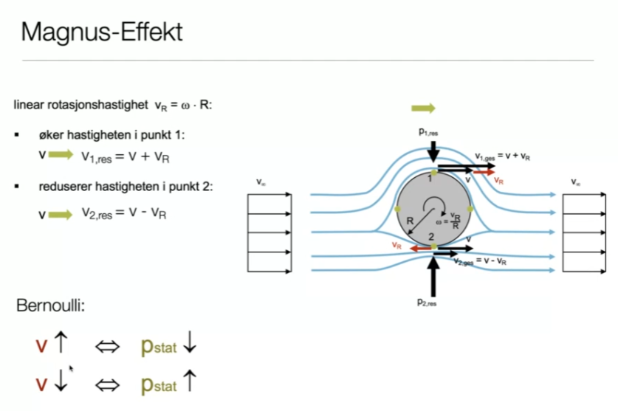

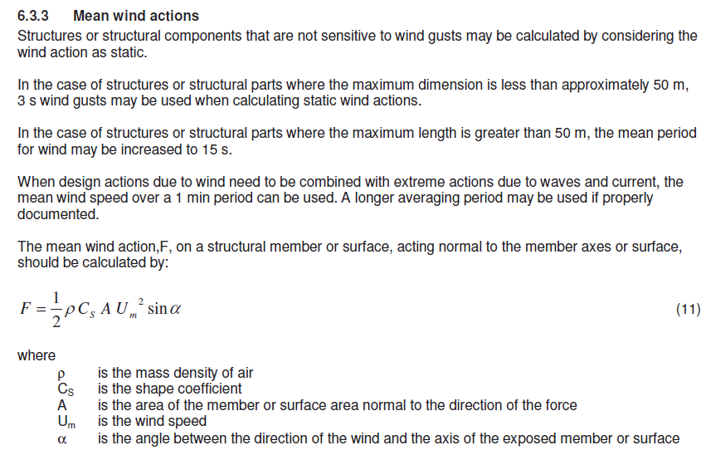

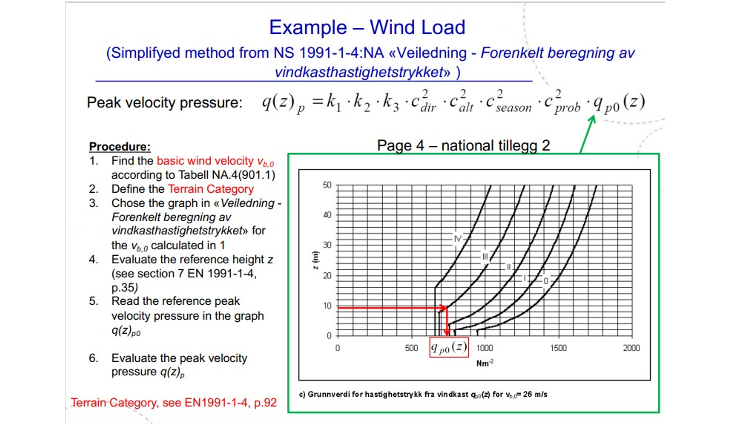

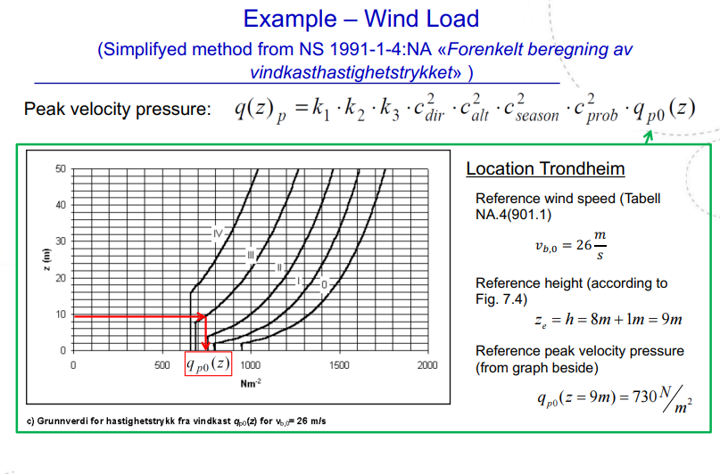
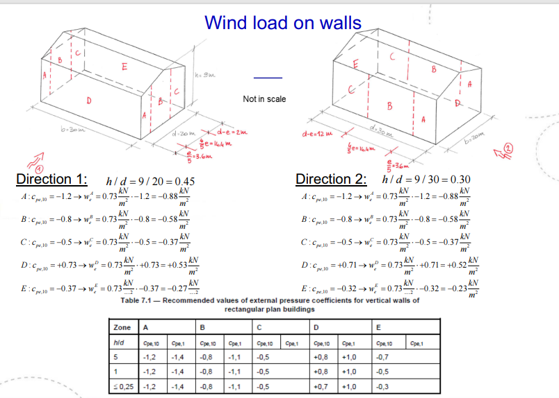
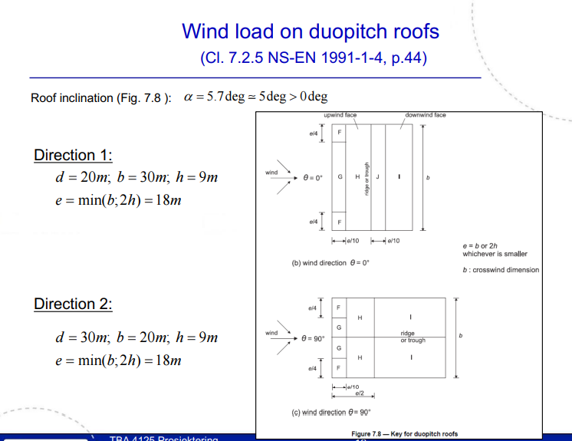

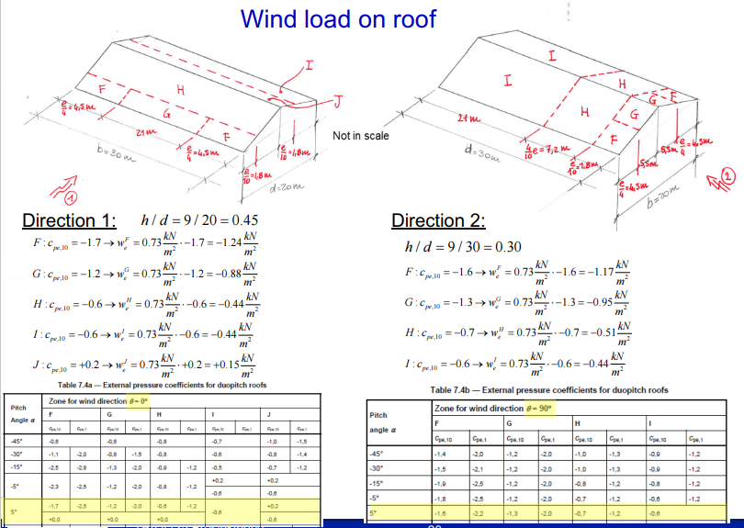
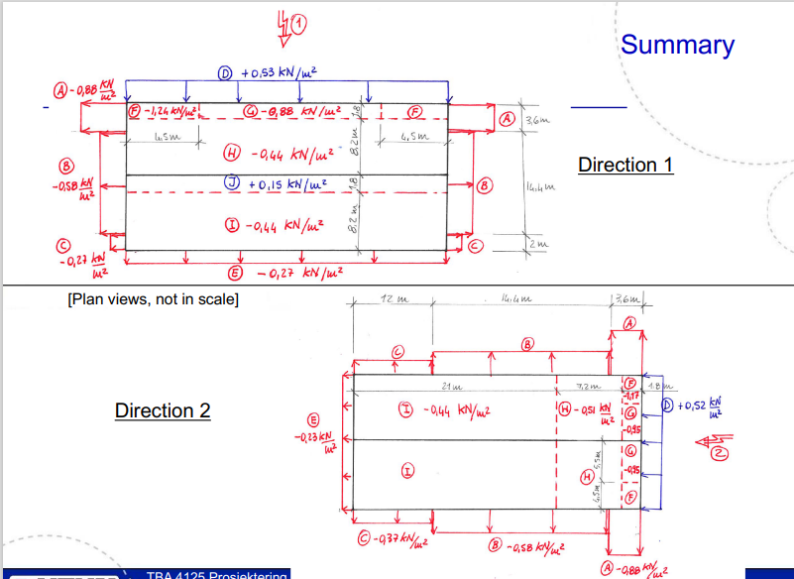

Introduction
Global Winds
Introduction wind
Vindbelastning på hus
Vindavstivning
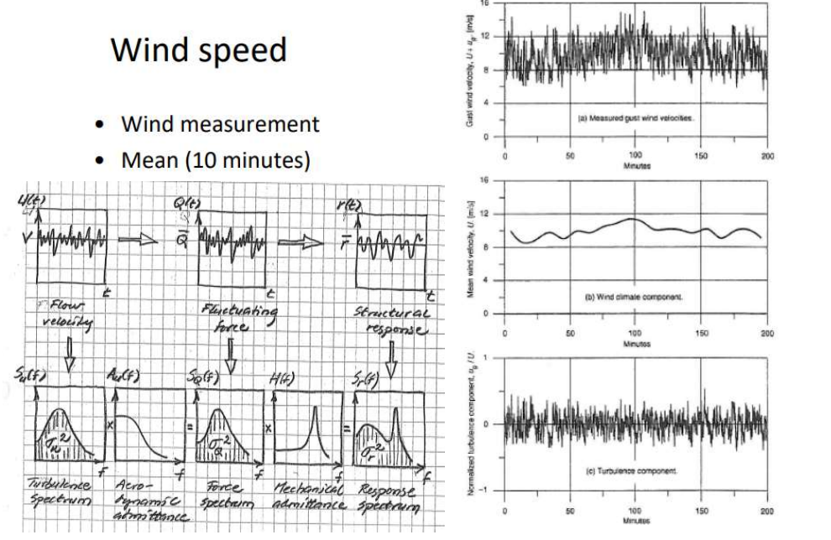

Wind consists of a "static part", e.g. an average of 10 minutes, and a "dynamic part" called turbulence. For more dynamic structures, it may be necessary to use a spectrum to find the correct wind load. The turbulence is the measured wind minus this "average wind". This subject does not deal with spectrum analysis, but it is expected that one knows that in order to get the correct dynamic contribution for dynamic structures, one must take into account a "turbulence spectrum" that describes the dynamic part of the wind. If this turbulence spectrum changes character before it becomes a force when the wind hits the structure, then it is called "aerodynamic admittance". This gives a force spectrum that, multiplied by any resonance effects called "mechanical admittance" in the figure, gives a response spectrum. A response spectrum is a spectrum of stresses/deformations (repons). This subject does not go into this here more than that the problem is mentioned in connection with this review. This is reviewed with the aim of understanding that when the simplifying methods can no longer be used, the technique is to use spectrum to find the capacity of the structure. It is also an idea with this review that one should be able to start noticing how wind affects different structures and be able to better put into words what is happening.
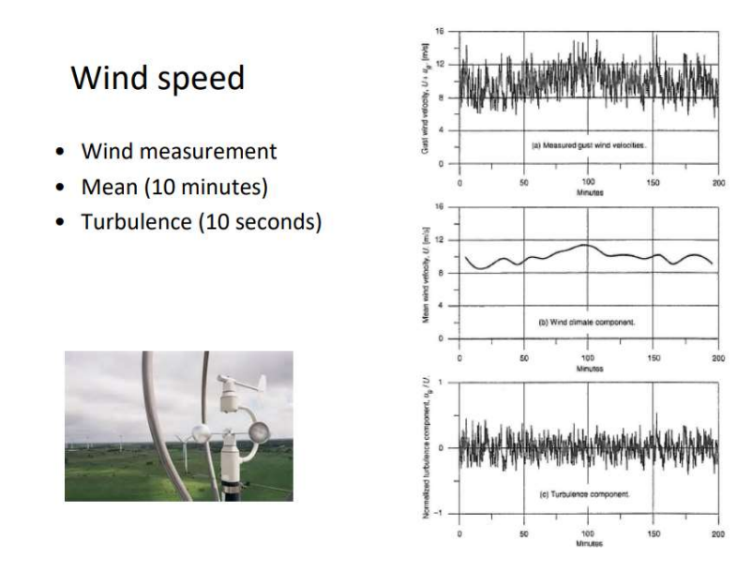
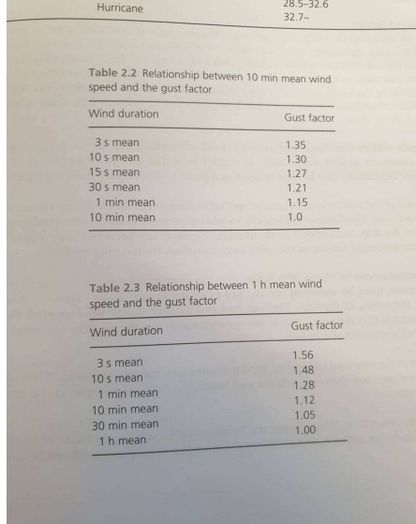
The formulas in Eurocode where the basis is a 10-minutes wind, NORSOK wind can be adapted to the structure or the part of the structure that we want to look at. We may look at a small or an overall big part. How long the wind exposes the structure determine what gust in seconds we will use in our design of the structure.
This means that you know more about what kind of wind you have if you use NORSOK formulas, but it also becomes a little more demanding as you have to make an assessment of what kind of wind load you have to use to dimension the structure. It is not just about taking the numbers from a table like in Eurocode where you distinguish between 1 m² and 10 m². For large offshore structures,
For small but more dynamically sensitive structures, 3 seconds are used. NORSOK says 15 seconds for smaller structures. 1 minute wind can be used for the overall structure (main steel).
TBA4265 Arctic and Marine Civil Engineering – wind calculations
Example with wind and snow on house
Wind calculations in SAP2000 on Youtube
Example with wind in SAP2000
Wind calculation in Mathcad according to NORSOK
Wind pressure loads 10 min mean-old NORSOK N-003.xmcd
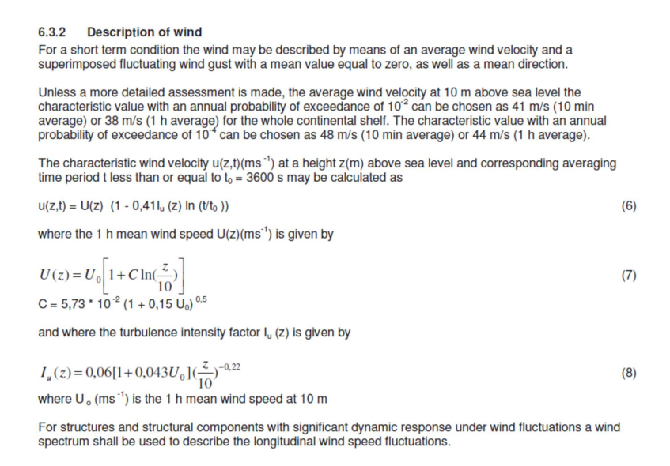
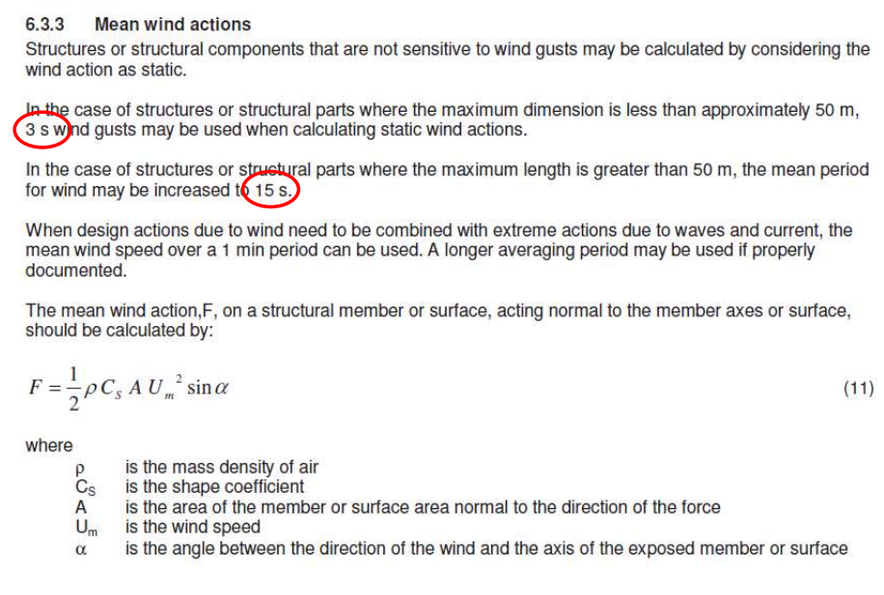
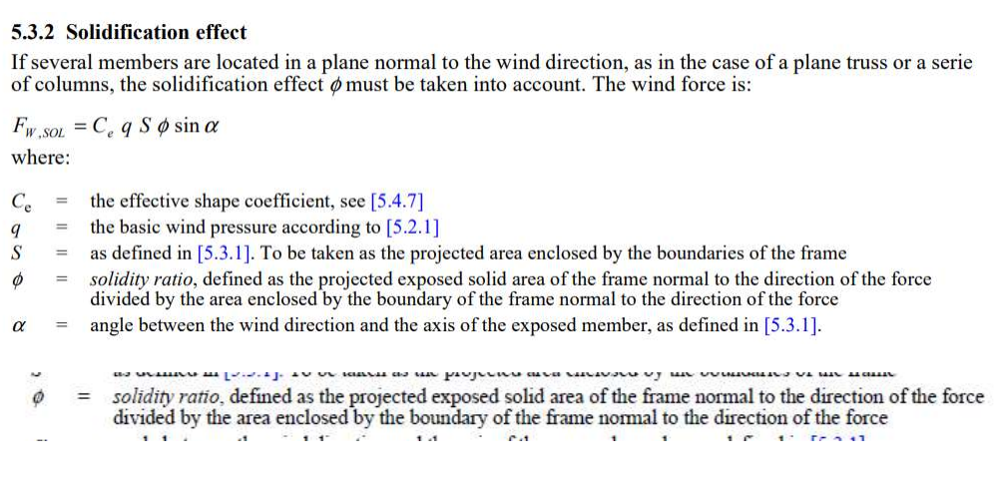
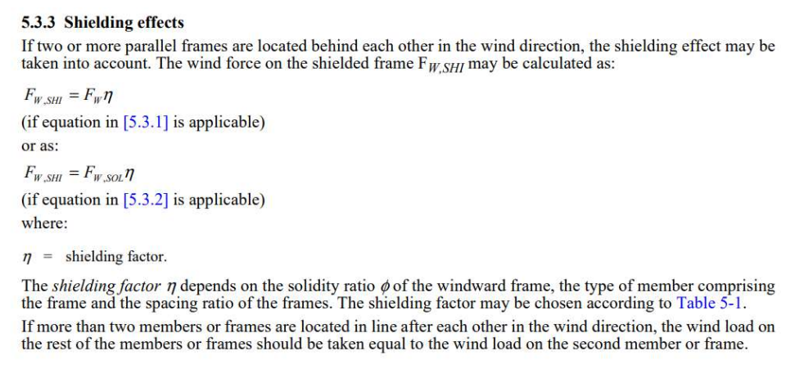
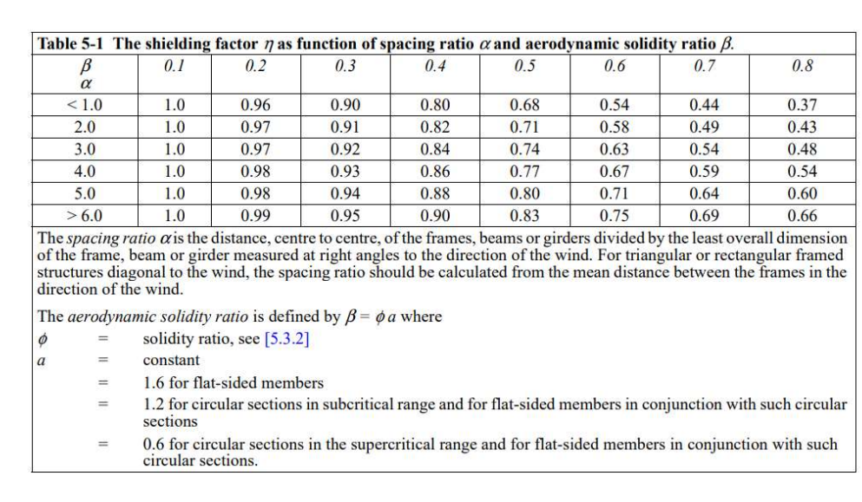

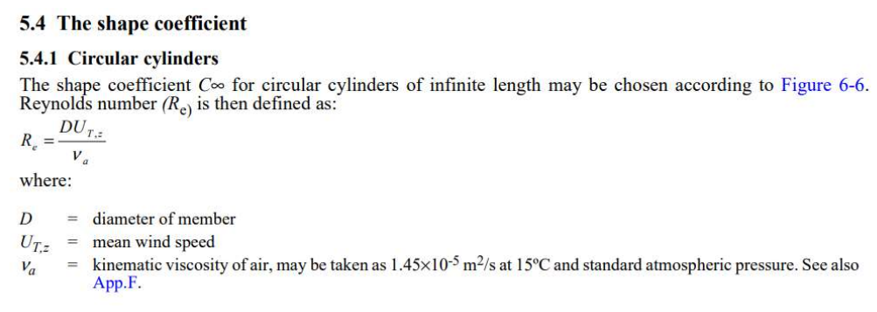
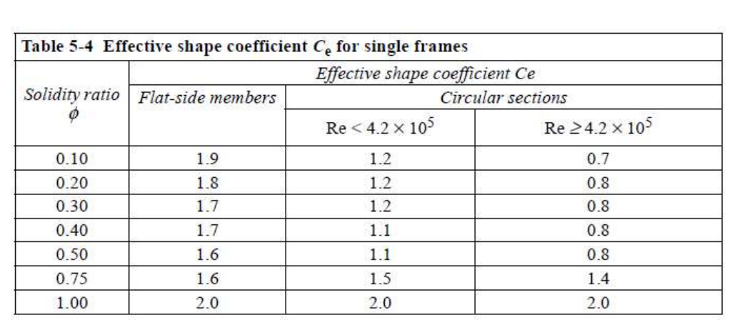
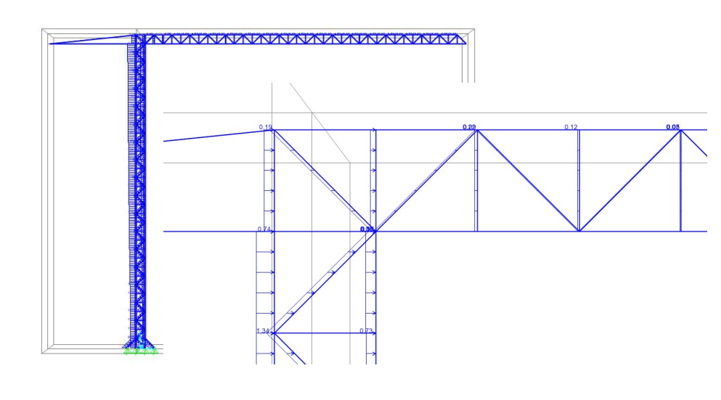
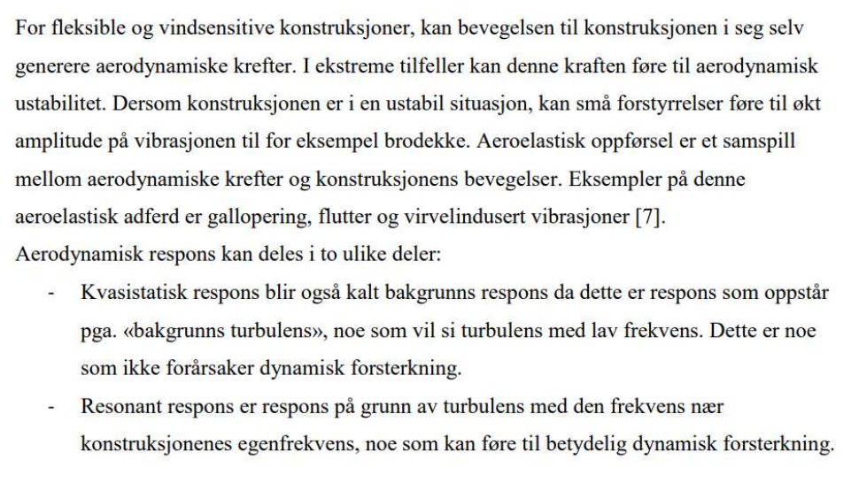

Wind calculation in Mathcad according to Eurocode
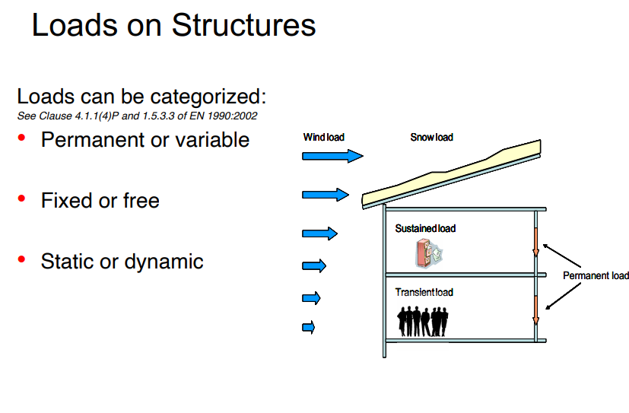
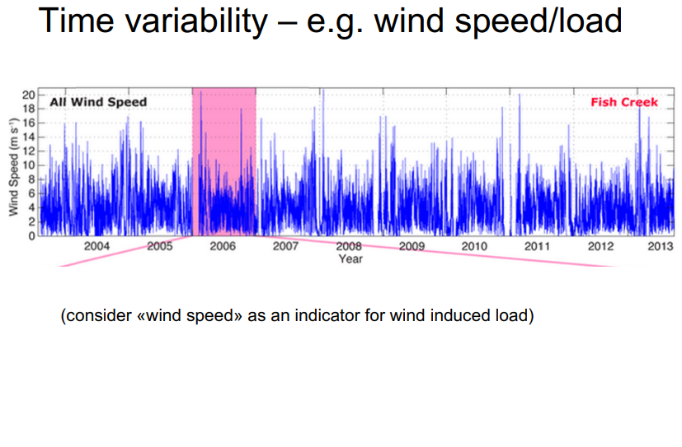
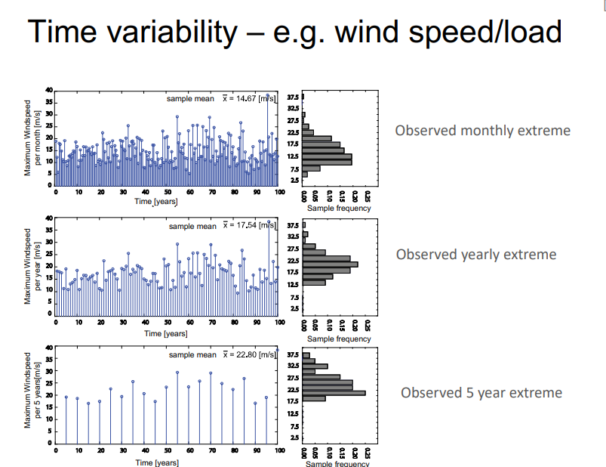
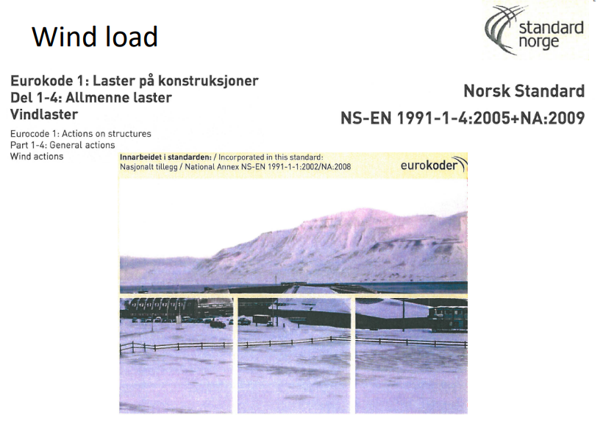
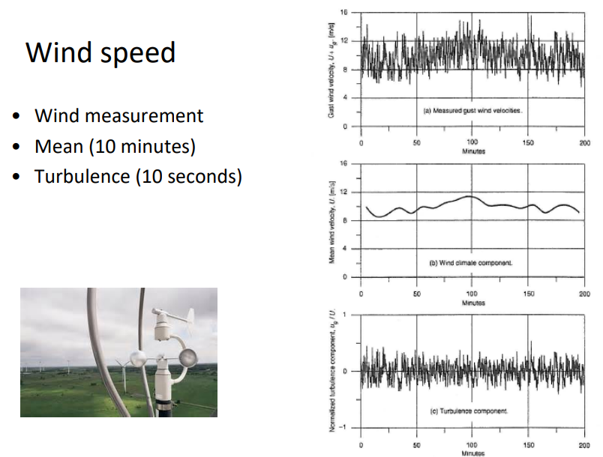
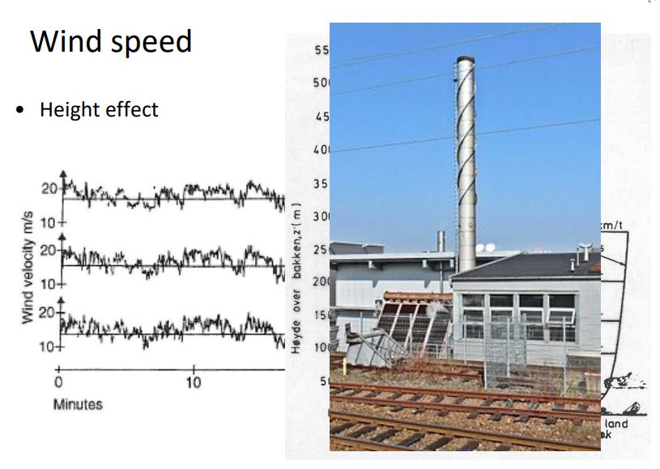
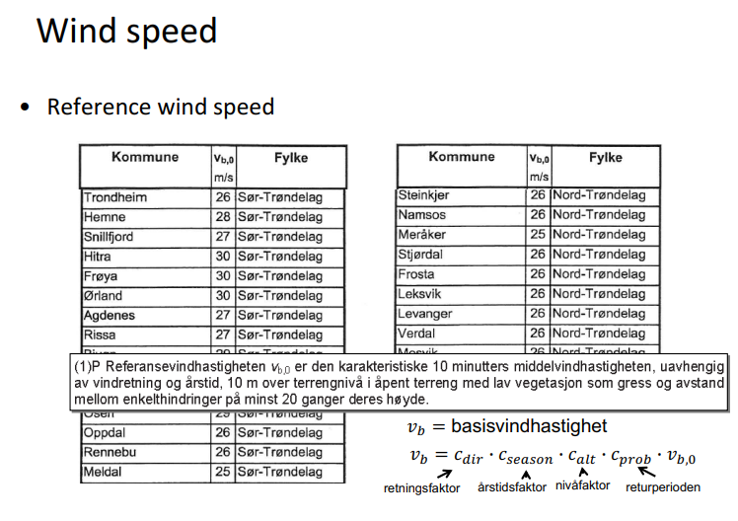
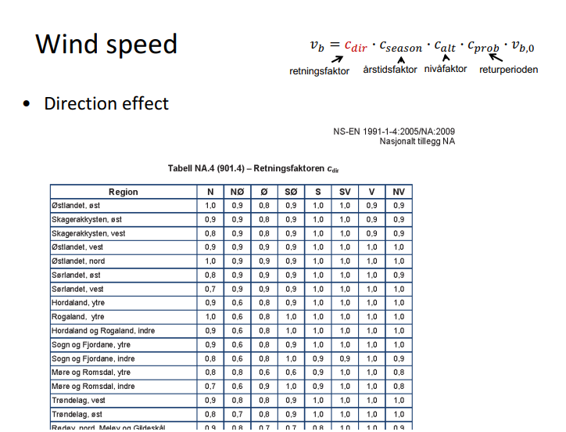
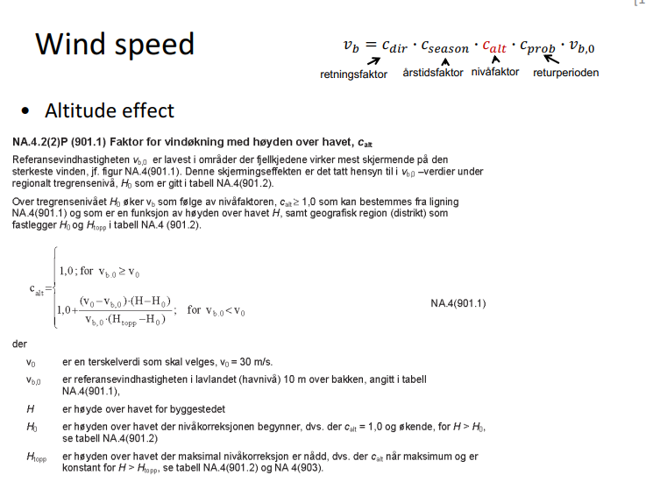

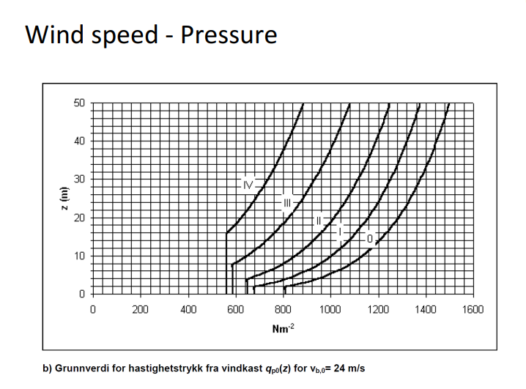

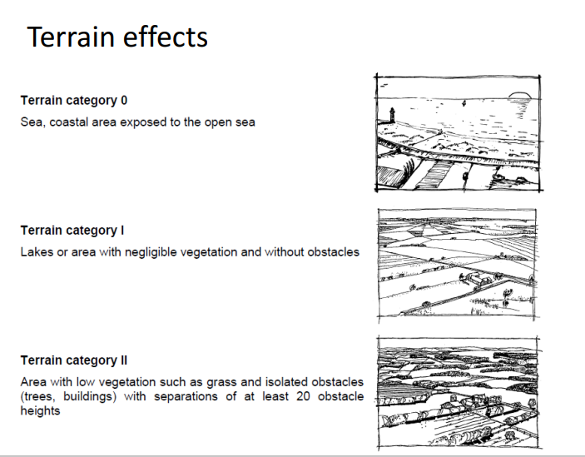
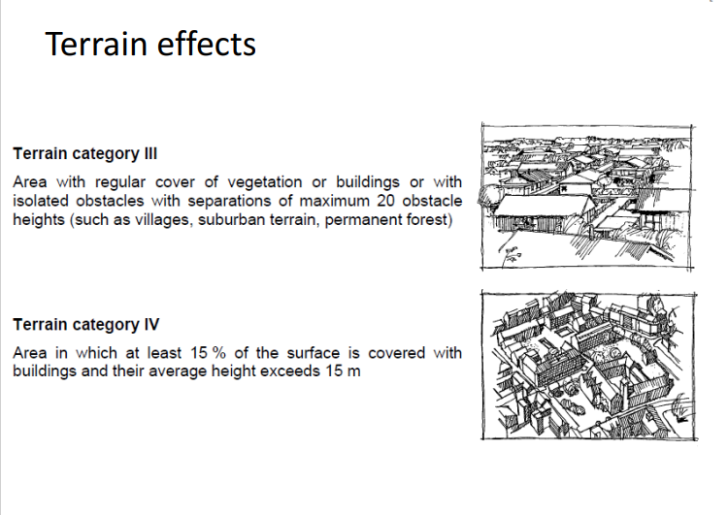

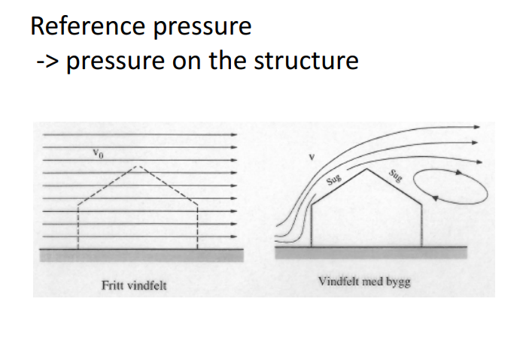
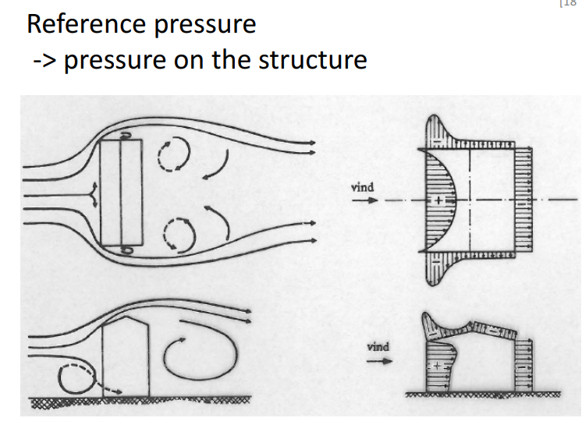
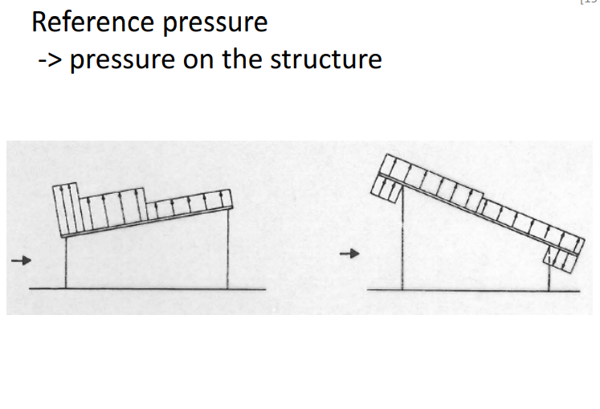
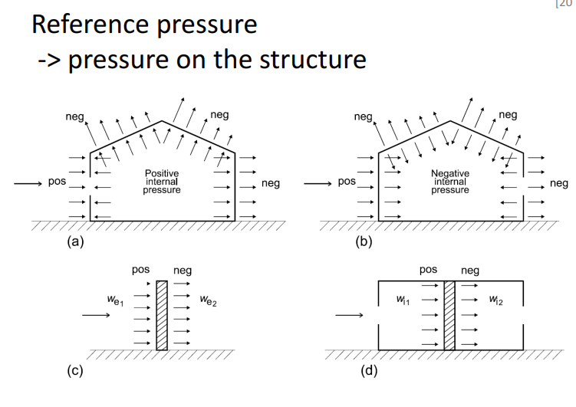
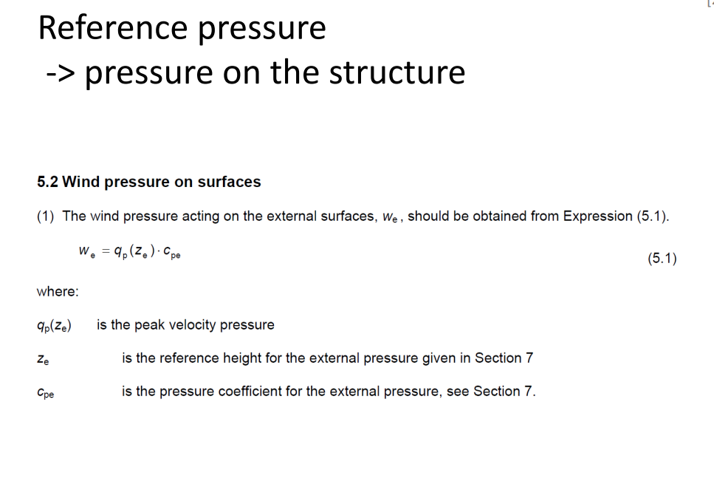
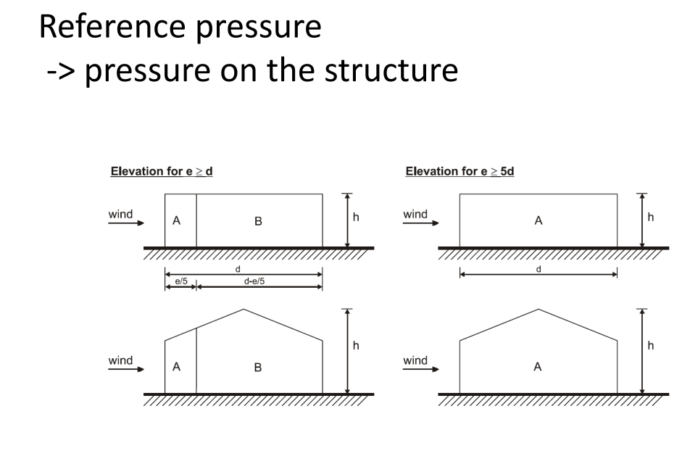
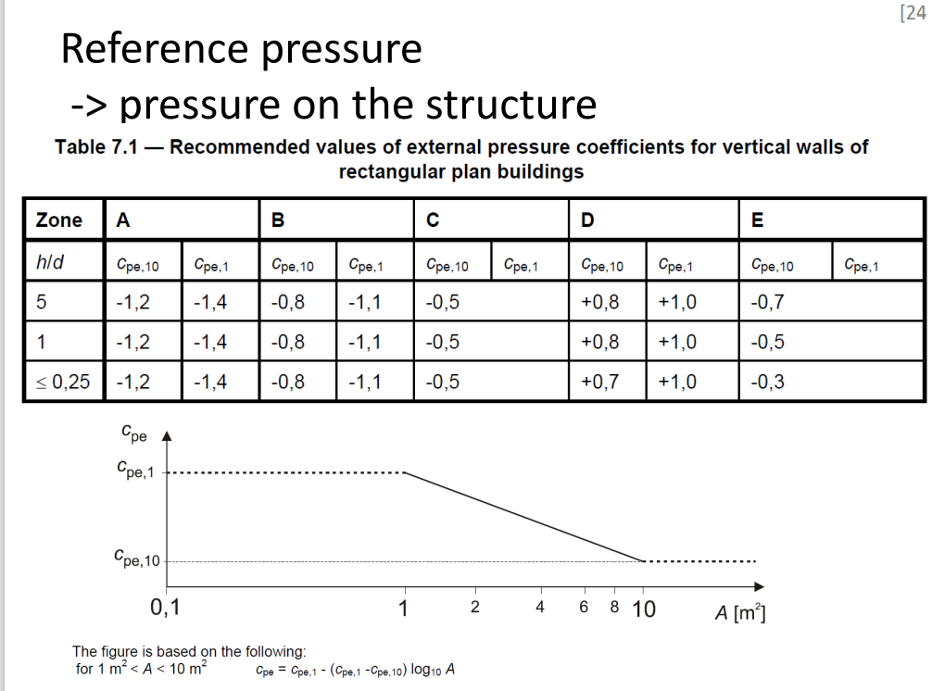
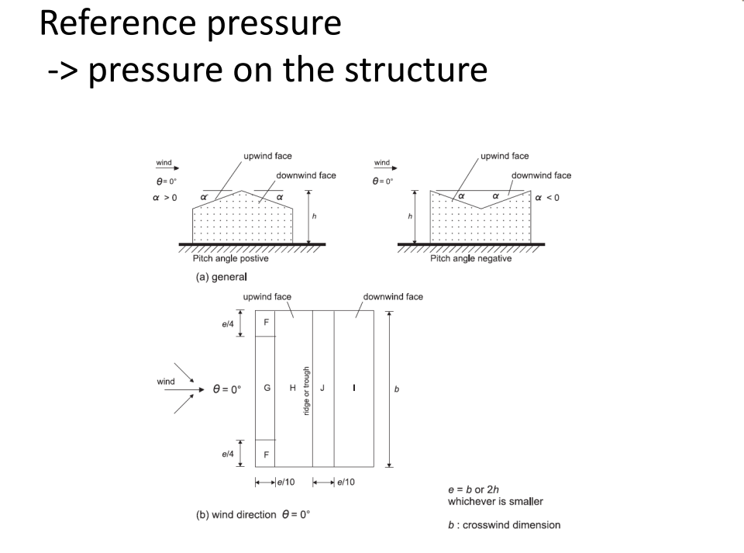
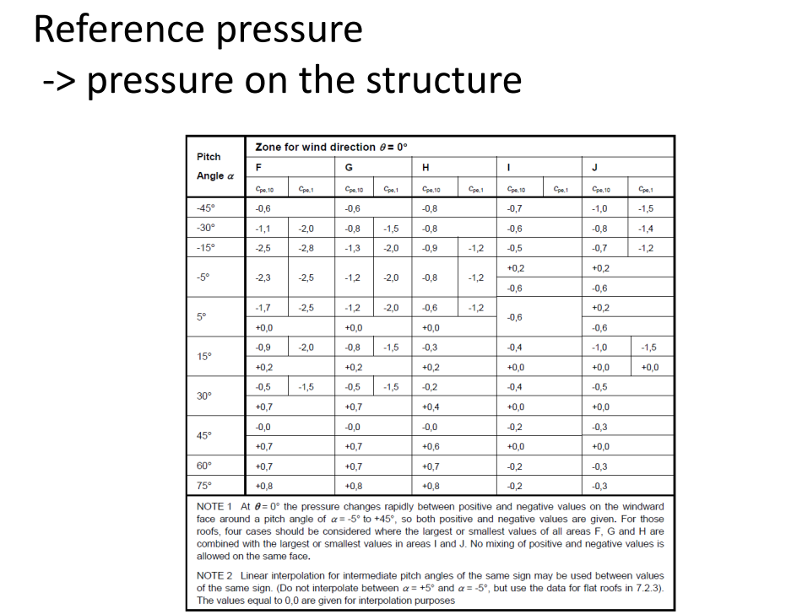
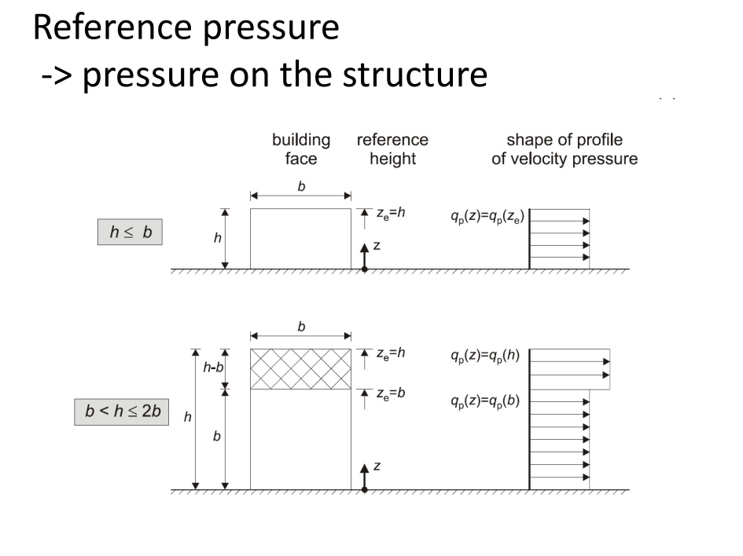
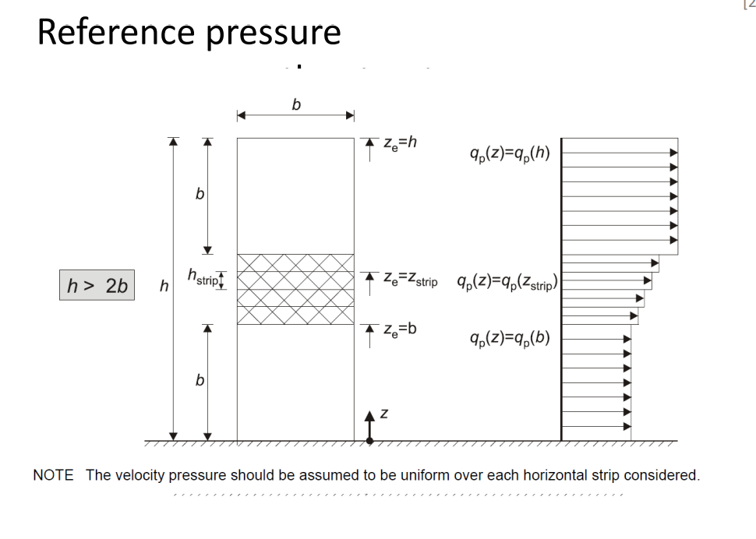
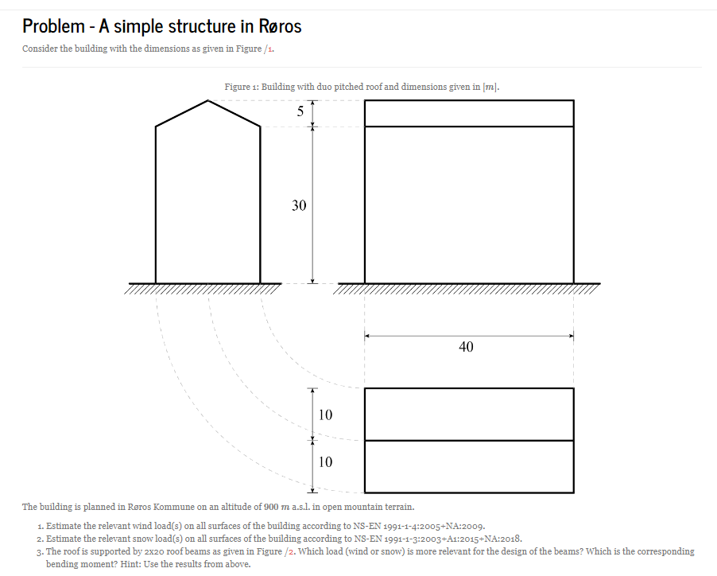
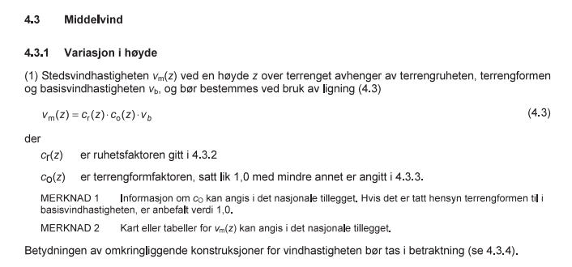
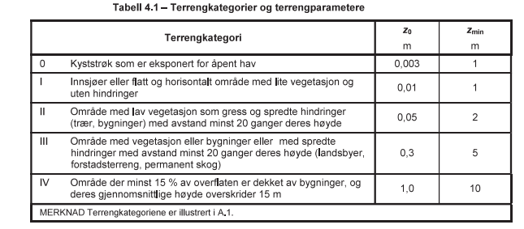
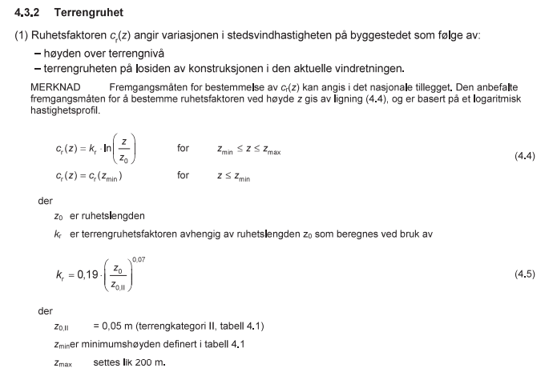
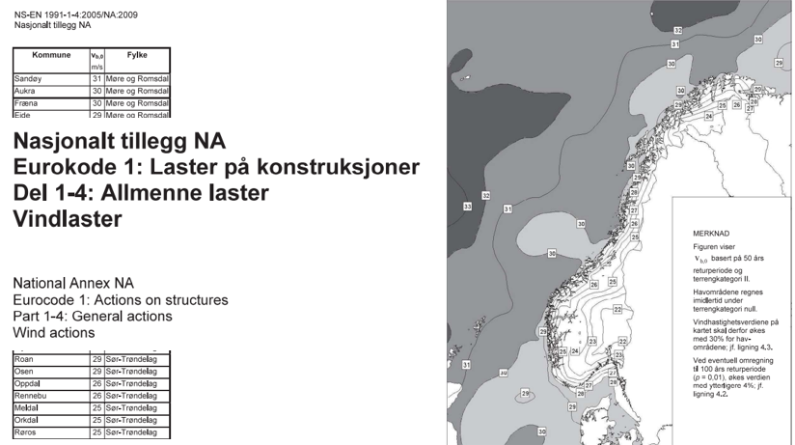
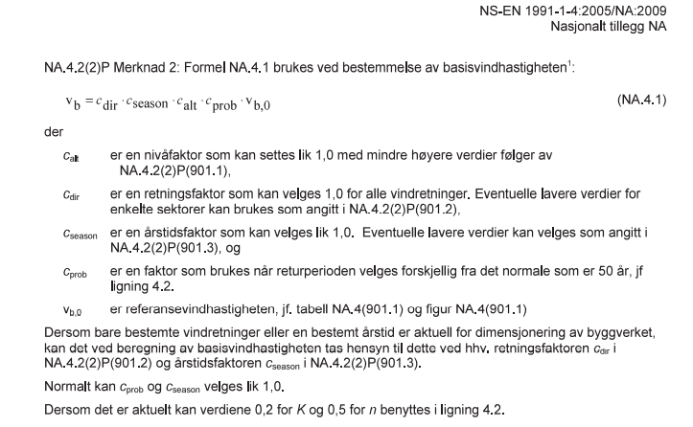
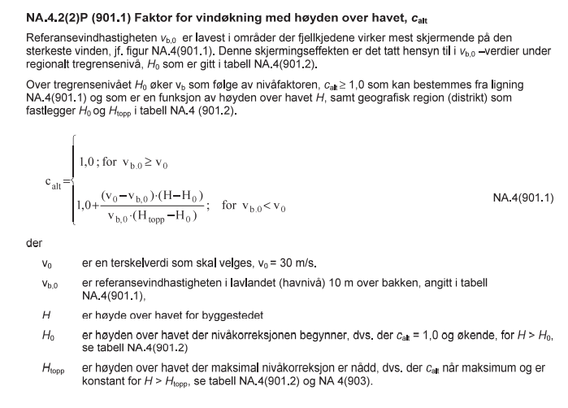
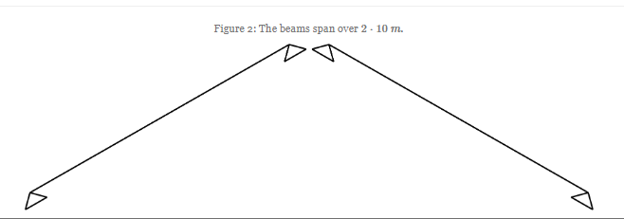
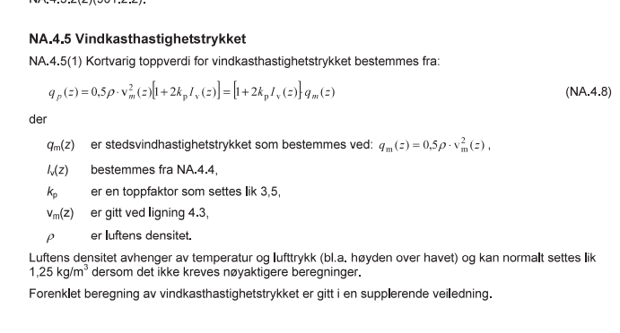
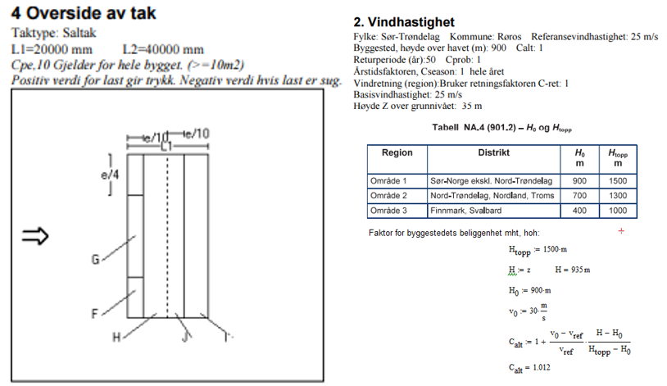

Mathcad-ark med beregninger av vindhastigheter ihht. NORSOK.
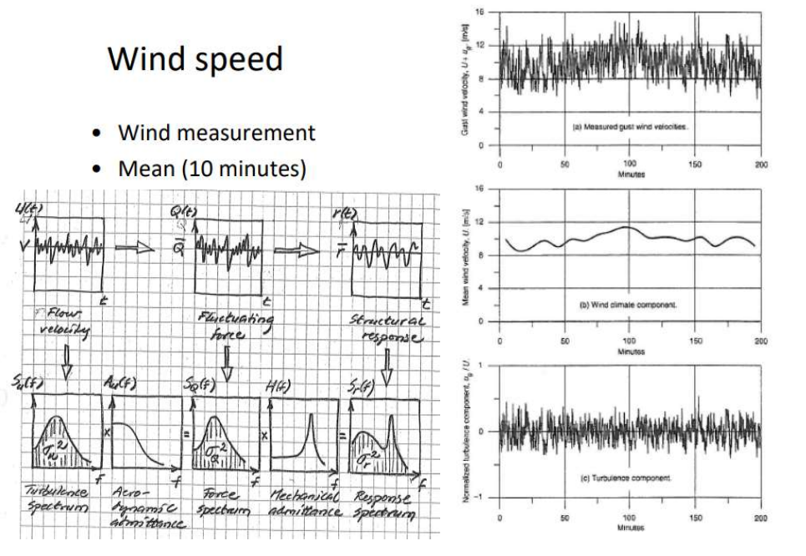
Vindberegning ihht. Eurocode: Vindberegning20220827.xmcd
Oppgave 1 øving 1, vind gitt i SAP2000: TretekniskSenterOving-ver2.sdb
Forskjell på grunt vann, endelig vanndyp og dypt vann.
Formler (wave-airy) for strømning avhengig av bølgelengder og vanndyp er gitt. Dette er de mest brukte formlene for dette selv om vi vet at bølgene ikke alltid er er en sinusbølge så er det en god tilnærming som er godt nok i de fleste tilfelle for design.
Beskrivelse av bølgebevegelser:
https://www.ck12.org/book/ck-12-fourth-grade-science/section/2.11/
Bølgebeskrivelse mer i detalj:
https://www.youtube.com/watch?v=hplb9HXM6KA

5. Interaction between landscape and wind
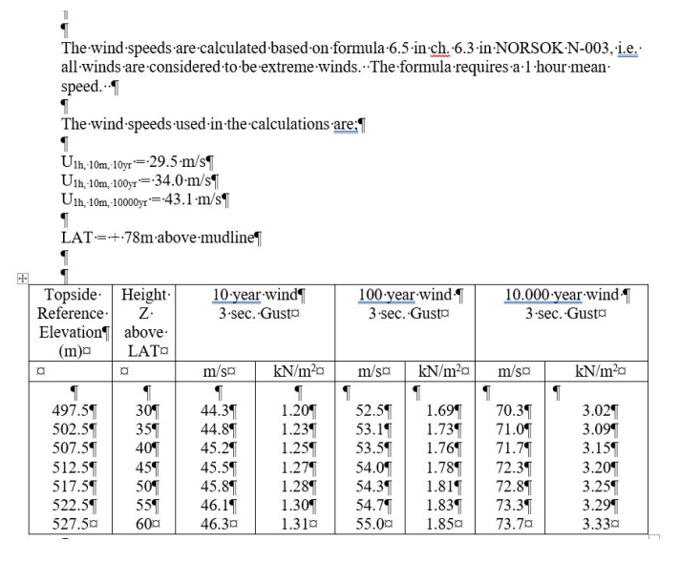
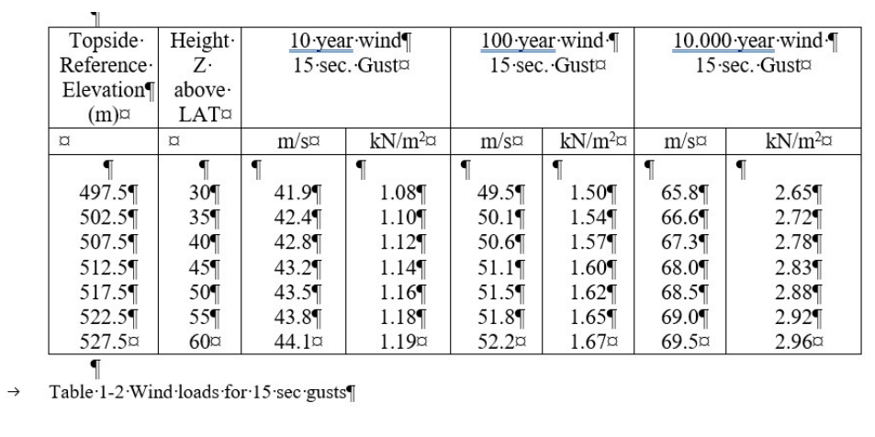
Vind oppsummert

10. Waves and current

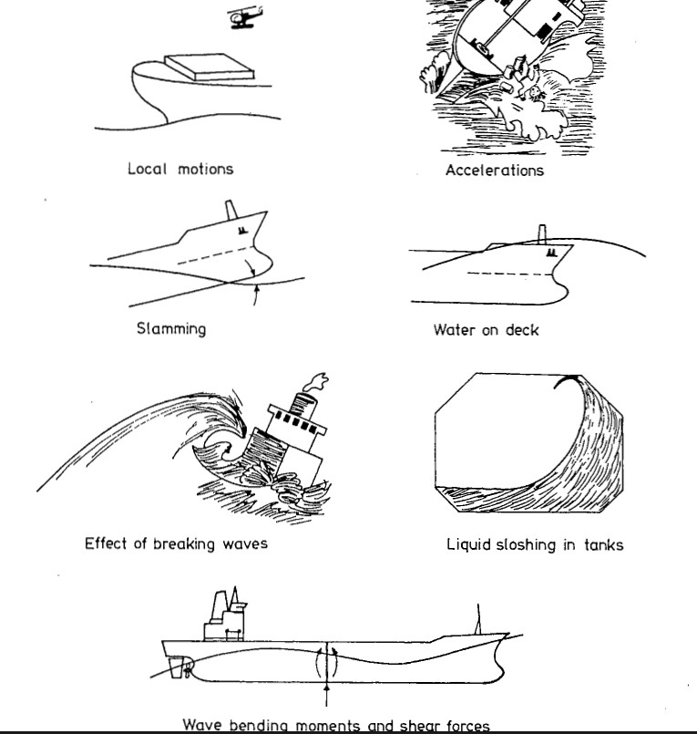
Verdens høyeste bølger er i havet utenfor Norge (forskning.no)
Bruk av Morisons formel sammen med "wave airy" formlene for partikkelhastigheter for bølger.
Morison Equation - wave loads on structures INERTIA force - YouTube
Wave pressure - how to calculate wave height and wavelength - YouTube
Video "How to calculate forces on structures"
waves.pdf
Formler (wave-airy) for strømning avhengig av bølgelengder og vanndyp er gitt. Dette er de mest brukte formlene for dette selv om vi vet at bølgene ikke alltid er er en sinusbølge så er det en god tilnærming som er godt nok i de fleste tilfelle for design.
Beskrivelse av bølgebevegelser:
https://www.ck12.org/book/ck-12-fourth-grade-science/section/2.11/
Bølgebeskrivelse mer i detalj: https://www.youtube.com/watch?v=hplb9HXM6KA
Beauforts skala er en gammel praktisk måte å beskrive vindinduserte bølger på og som fortsatt brukes for de som ferdes på sjøen. Dette er en erfaringsbasert måte å beskrive bølger på. Kanskje er det av dette man fant opp begrepet H_{s} som er den vanlige tekniske måte å beskrive bølgehøyder på en lokasjon ved et gitt tidspunkt/tidsperiode. H_{s} er gjennomsnittet av 1/3 av de største bølgene. Link for beskrivelse av Beaufort.
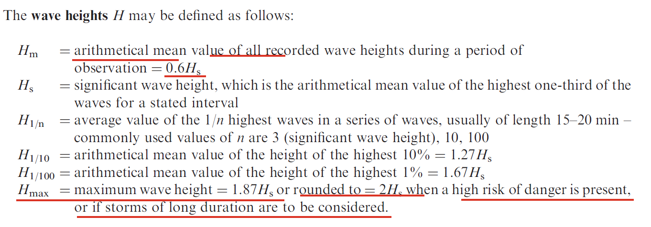
Definisjon av bølgehøyde i Wikipedia
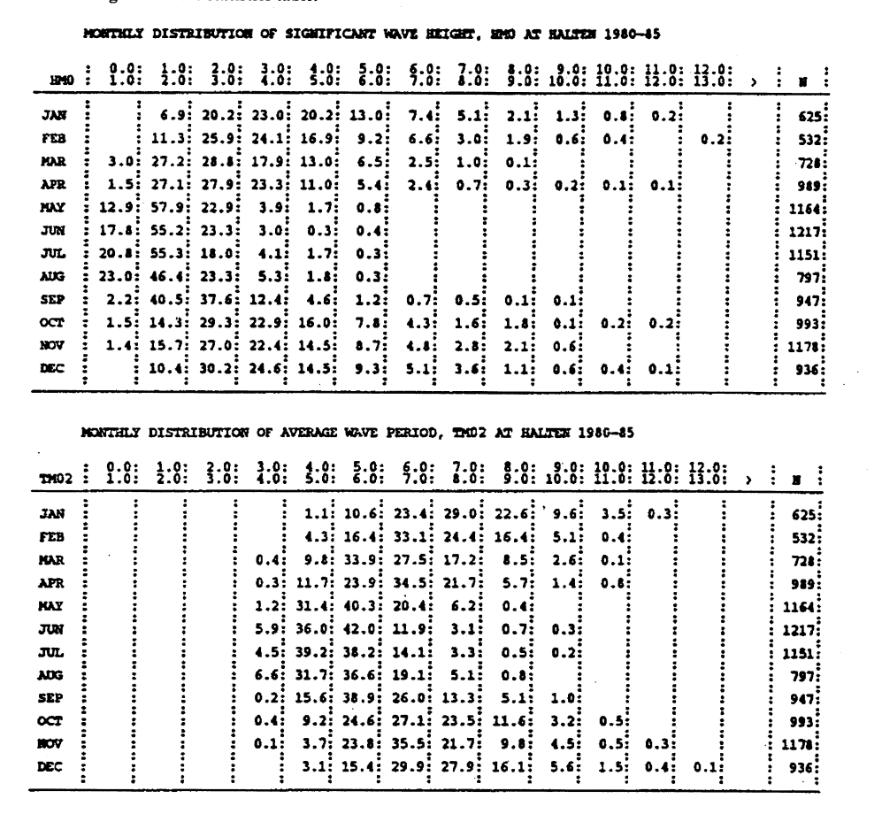
Formler (wave-airy) for strømning avhengig av bølgelengder og vanndyp er gitt. Dette er de mest brukte formlene for dette selv om vi vet at bølgene ikke alltid er en sinusbølge så er det en god tilnærming som er godt nok i de fleste tilfelle for design.
Forskjell på grunt vann, endelig vanndyp, dypt vann.
Empirisk sammenheng
Wavelength: the distance between two identical points on successive waves, for example crest to crest, or trough to trough. Wave steepness: the ratio of wave height to length (H/L). If this ratio exceeds 1/7 (i.e. height exceeds 1/7 of the wavelength) the wave gets too steep, and will break.
Wave airy har denne begrensningen men brukes konservativt for å finne bølgelaster

Wave airy regneark
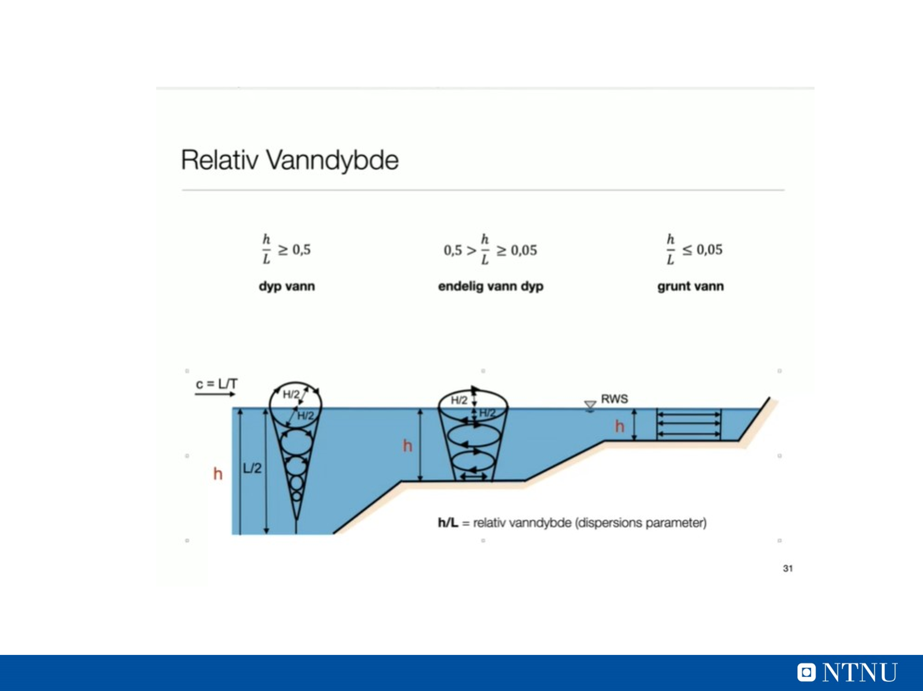
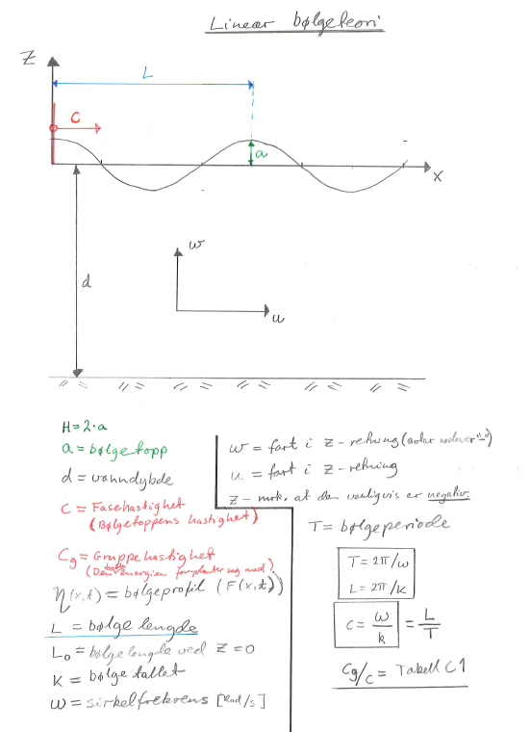

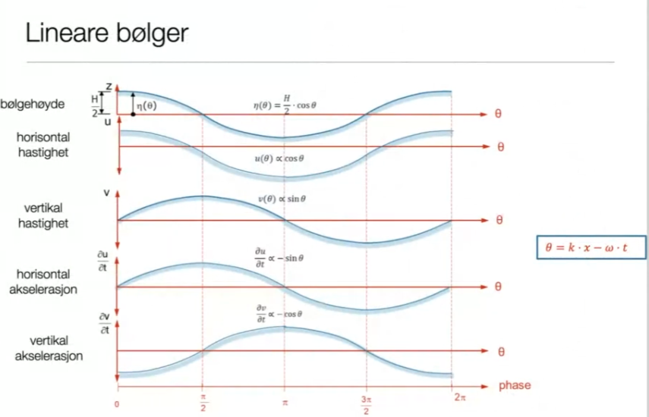
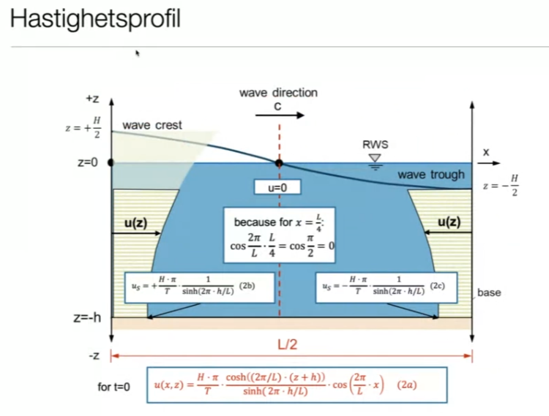
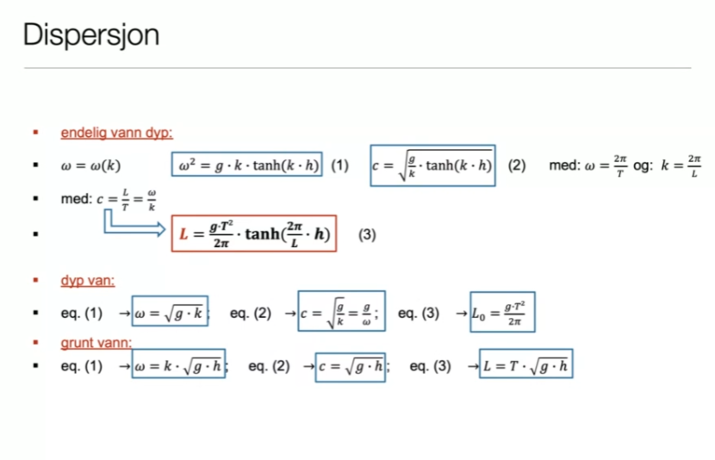
Dispersjon – bølger med forskjellige lengder beveger seg i forskjellig hastighet
Calculations wave and movements
Gjennomgang av ulike fenomener knyttet til bølger og vann.
Det er ikke meningen at man skulle kunne regne på dette her i dette faget men det forventes at studenten vet sånn nogen lunde hva dette er og når disse fenomenene opptrer.
Dette for å kunne unngå problemer med dette her ved design av havromskonstruksjoner.
For praktisk bruk så er det spesielt slamming vi kunne brukt mer tid på.
Wind-Generated Waves: Directional and Terrain Dependence
1. Wind-Generated Waves:
- Wind-generated waves are created by the friction between the wind and the surface of the water. The characteristics of these waves, such as height and direction, depend on several factors, including wind speed, duration, and fetch (the distance over which the wind blows).
2. Directional Dependence:
- The direction of the wind plays a crucial role in wave formation. Waves will generally travel in the same direction as the wind. Understanding the wind direction is essential for predicting how waves will behave in a given area.
3. Terrain Dependence:
- The local terrain, including underwater topography and coastal features, significantly influences wave behavior. For example, waves may be refracted, diffracted, or reflected by features such as islands, reefs, or shallow areas. This can lead to variations in wave height and direction as they approach the shore.
4. SWAN Model:
- The SWAN (Simulating Waves Nearshore) model is a numerical tool used to simulate wave generation and propagation. It takes into account wind direction, wave direction, and local terrain effects.
- While SWAN is effective for modeling waves, it was developed in the Netherlands and may not be fully adapted to specific conditions found in Norway, such as fjords and complex coastal topographies.
5. Application in Norway:
- To improve the accuracy of wave predictions in Norwegian waters, it may be necessary to adjust the SWAN model based on local data and conditions. This could involve incorporating local wind patterns and topographical features.
- Combining SWAN with other models or local observations can enhance the reliability of wave forecasts in specific regions.

Wave Effects Near Shore
1. Wave Refraction:
- As waves approach shallow water, they slow down and change direction due to the decreasing water depth. This bending of waves is known as refraction. It can lead to concentrated wave energy in certain areas, affecting coastal structures and sediment transport.
2. Wave Breaking:
- When waves enter shallow water, they become steeper and eventually break. This process can create significant turbulence and energy dissipation, impacting coastal erosion and sediment dynamics. The type of breaking (spilling, plunging, or surging) depends on the wave height and slope of the seabed.
3. Wave Reflection:
- Some waves may reflect off structures such as seawalls, jetties, or cliffs. This reflection can lead to increased wave energy in certain areas, potentially causing erosion or structural damage. Understanding reflection is crucial for designing coastal defenses.
4. Wave Setup and Surge:
- Wave setup refers to the increase in water level near the shore due to the energy of breaking waves. This can lead to higher water levels during storms, contributing to coastal flooding. Wave surge is the additional water level rise caused by wind and atmospheric pressure changes, which can exacerbate flooding.
5. Longshore Currents:
- Waves approaching the shore at an angle can generate longshore currents, which move parallel to the coastline. These currents can transport sediment along the beach, affecting erosion and deposition patterns. Understanding longshore currents is essential for coastal management and engineering.
6. Interaction with Structures:
- Waves interacting with coastal structures can create complex flow patterns and forces. Engineers must consider these effects when designing breakwaters, piers, and other marine infrastructure to ensure stability and functionality.
7. Coastal Erosion:
- The combined effects of wave action, currents, and sediment transport can lead to coastal erosion. Understanding these processes is vital for developing effective coastal protection strategies and sustainable management practices.
Conclusion
Understanding wave effects near shore is crucial for marine engineering and coastal management. By considering factors such as wave refraction, breaking, reflection, and interactions with structures, engineers can design more resilient coastal infrastructure and mitigate the impacts of wave action on shorelines.
Wave-Coast Interactions | manoa.hawaii.edu/ExploringOurFluidEarth
Wave Effects Near Shore
1. Wave Refraction:
- As waves approach shallow water, they slow down and change direction due to the decreasing water depth. This bending of waves is known as refraction. It can lead to concentrated wave energy in certain areas, affecting coastal structures and sediment transport.
2. Wave Breaking:
- When waves enter shallow water, they become steeper and eventually break. This process can create significant turbulence and energy dissipation, impacting coastal erosion and sediment dynamics. The type of breaking (spilling, plunging, or surging) depends on the wave height and slope of the seabed.
3. Wave Reflection:
- Some waves may reflect off structures such as seawalls, jetties, or cliffs. This reflection can lead to increased wave energy in certain areas, potentially causing erosion or structural damage. Understanding reflection is crucial for designing coastal defenses.
4. Wave Setup and Surge:
- Wave setup refers to the increase in water level near the shore due to the energy of breaking waves. This can lead to higher water levels during storms, contributing to coastal flooding. Wave surge is the additional water level rise caused by wind and atmospheric pressure changes, which can exacerbate flooding.
5. Longshore Currents:
- Waves approaching the shore at an angle can generate longshore currents, which move parallel to the coastline. These currents can transport sediment along the beach, affecting erosion and deposition patterns. Understanding longshore currents is essential for coastal management and engineering.
6. Interaction with Structures:
- Waves interacting with coastal structures can create complex flow patterns and forces. Engineers must consider these effects when designing breakwaters, piers, and other marine infrastructure to ensure stability and functionality.
7. Coastal Erosion:
- The combined effects of wave action, currents, and sediment transport can lead to coastal erosion. Understanding these processes is vital for developing effective coastal protection strategies and sustainable management practices.
Conclusion
Understanding wave effects near shore is crucial for marine engineering and coastal management. By considering factors such as wave refraction, breaking, reflection, and interactions with structures, engineers can design more resilient coastal infrastructure and mitigate the impacts of wave action on shorelines.
If you need more specific details or examples, feel free to ask!
Bølger langs kysten
Certainly! Here’s an overview of coastal waves, focusing on their behavior and effects along the shoreline:
Waves Along the Coast
1. Wave Formation:
- Waves are generated by wind blowing over the surface of the water. The characteristics of these waves, such as height, period, and direction, depend on wind speed, duration, and fetch (the distance over which the wind blows).
2. Wave Propagation:
- As waves travel from deep water to shallow water, they undergo changes due to the interaction with the seabed. This process includes refraction, which alters their direction, and changes in speed and height.
3. Wave Refraction:
- When waves approach the coast at an angle, they slow down in shallower water, causing them to bend or refract. This can lead to concentrated wave energy in certain areas, affecting coastal erosion and sediment transport.
4. Wave Breaking:
- As waves enter shallower water, they become steeper and eventually break. There are different types of wave breaking:
  - Spilling Breakers: Gradually release energy as they break, common on gentle slopes.
  - Plunging Breakers: Steep waves that break suddenly, often seen on steeper beaches.
  - Surging Breakers: Waves that do not break but surge up the beach, typically on very steep slopes.
5. Longshore Currents:
- Waves that hit the shore at an angle create longshore currents, which move parallel to the coastline. These currents are responsible for transporting sand and sediment along the beach, influencing coastal morphology.
6. Coastal Erosion and Accretion:
- The interaction of waves with the shoreline can lead to erosion (removal of sediment) or accretion (deposition of sediment). Factors such as wave energy, sediment supply, and human activities (like construction) play a significant role in these processes.
7. Impact on Coastal Structures:
- Waves can exert significant forces on coastal structures such as seawalls, piers, and breakwaters. Engineers must consider wave height, period, and direction when designing these structures to ensure they can withstand wave action.
8. Tsunamis and Storm Surges:
- In addition to regular wind-generated waves, coastal areas can be affected by tsunamis and storm surges, which can cause rapid and extreme changes in water levels, leading to flooding and damage.
Conclusion
Understanding the behavior of waves along the coast is essential for coastal management, engineering, and environmental protection. By studying wave dynamics, engineers and scientists can develop strategies to mitigate erosion, protect infrastructure, and maintain healthy coastal ecosystems.
https://www.youtube.com/watch?v=3yNoy4H2Z-o
Wave Shoaling
Definition: Wave shoaling refers to the process by which waves increase in height and decrease in wavelength as they move from deeper water into shallower water. This phenomenon occurs due to the interaction of waves with the seabed.
Key Concepts:
- Wave Speed and Depth:
  - In deep water, waves travel faster and have longer wavelengths. As waves approach shallower areas, their speed decreases, and their wavelengths shorten.
- Energy Conservation:
  - The energy of the wave remains relatively constant as it shoals. As the wave enters shallower water and slows down, the energy is concentrated in a smaller volume, resulting in an increase in wave height.
- Wave Height Increase:
  - The increase in wave height can be significant, especially in areas with steeply sloping seabeds. This can lead to breaking waves as they approach the shore.
- Breaking Waves:
  - As waves shoal and their height increases, they eventually reach a point where they can no longer maintain their shape and begin to break. The type of breaking (spilling, plunging, or surging) depends on the steepness of the wave and the slope of the seabed.
- Refraction and Direction:
  - Wave shoaling is often accompanied by wave refraction, where waves bend as they approach the shore. This can lead to changes in wave direction and can concentrate wave energy in certain areas, affecting coastal erosion and sediment transport.
- Practical Implications:
  - Understanding wave shoaling is crucial for coastal engineering, navigation, and marine activities. It helps in predicting wave behavior near the shore, which is important for designing coastal structures, managing beaches, and ensuring safety for vessels.
Conclusion
Wave shoaling is a fundamental process that affects wave dynamics as they transition from deep to shallow water. By understanding this phenomenon, engineers and scientists can better predict wave behavior and its impacts on coastal environments and infrastructure.
Wave shoaling - Wikipedia
Wave refraction: https://www.youtube.com/watch?v=G1FIBuybN78
Wave breaking: https://youtu.be/aXuQC1qRuEM
Wave + current interaction: https://youtu.be/2tQz1_39eF0
Green Water ("Grønn Sjø")
Definition: "Green water" refers to the phenomenon where waves break over the deck of a floating offshore structure, such as a ship or platform, resulting in free water accumulating on the deck. This can pose significant risks to the integrity and safety of the structure.
Key Concepts:
- Causes of Green Water:
  - Green water typically occurs during extreme wave events, where large waves break over the vessel or platform. Factors contributing to this include wave height, wave period, and the vessel's motion.
- Airgap Problems:
  - The airgap is the vertical distance between the waterline and the lowest point of the structure (e.g., the hull or deck). Extreme waves can reduce this airgap, increasing the risk of water entering the structure or causing damage.
- Slamming:
  - Slamming occurs when a wave impacts the hull of a vessel or platform, creating a sudden and intense force. This can lead to structural damage, especially if the vessel is not designed to withstand such impacts.
- Impact on Safety and Operations:
  - Green water on the deck can create hazardous conditions for personnel and equipment. It can lead to loss of stability, increased weight on the structure, and potential damage to machinery and cargo.
- Characterization of Extreme Waves:
  - Identifying and characterizing extreme waves is complex due to the varying physics involved in different wave phenomena. Factors such as wave height, steepness, frequency, and direction must be considered.
  - Advanced modeling and simulation techniques are often used to predict extreme wave conditions and their potential impacts on offshore structures.
- Mitigation Strategies:
  - To mitigate the risks associated with green water and extreme waves, designers may incorporate features such as:
    - Higher freeboard (the height of the deck above the waterline).
    - Improved hull designs to minimize slamming.
    - Effective drainage systems to manage water accumulation on the deck.
Conclusion
Green water is a critical concern for the safety and integrity of floating offshore structures, particularly during extreme wave events. Understanding the dynamics of green water, airgap issues, and slamming is essential for effective design and operational strategies in marine environments.
✅ Wave Run-up
Definisjon:
Wave run-up refers to the maximum vertical extent of wave uprush on a structure above the still water level. It is the distance water travels upward on a surface (e.g., a monopile, a quay wall, or a breakwater) due to wave action.
Bruksområder:
- Offshore wind foundations (e.g., monopiles, jackets)
- Coastal and port structures (e.g., quays, breakwaters)
- Platform legs or sea walls
Faktorer som påvirker wave run-up:
- Bølgehøyde og bølgelengde
- Konstruksjonens geometri (skrå, vertikal, kurvet osv.)
- Vannstand og tidevann
- Overflatens ruhet og belegg

Hvis du ønsker en tilsvarende norsk formulering, brukes ofte:
- "bølgeopprulling" (vanlig i kystteknikk)
- "bølgepåløp"
- Eller ganske enkelt: "hvor høyt vannet klatrer opp konstruksjonen under bølgepåvirkning"

https://www.sciencedirect.com/science/article/pii/S0378383906001128
✅ Ringing – teknisk definisjon
Ringing er en type høyfrekvent, lav-amplitudebelastning som skyldes ikke-lineære bølgevirkninger, ofte knyttet til brå hendelser som bølgetopper, slam eller brudd i bølgeformen (wave slamming).
Den oppstår typisk ved:
- Kortperiodiske (steile) bølger
- Slanke, aksialsymmetriske strukturer (som monopæler)
- Dypvann og lange bølger (der klassisk Morison-last blir lite presis)
- Kombinasjon av bølgepåvirkning og strukturens egenfrekvens

📌 Kjennetegn ved ringing:
Parameter | Beskrivelse
Type last | Ikke-lineær, impulsiv
Varighet | Kortvarige utbrudd
Frekvens | Høyere enn bølgefrekvensen – typisk nær egenfrekvens
Effekt | Induserer svingninger i konstruksjonen (dynamisk respons)
Forskjell fra "springing" | Ringing er impulsiv og plutselig – springing er kontinuerlig resonans

🔍 Forsknings- og ingeniørmessig betydning:
- Ringing er utfordrende å forutsi med lineære bølgemodeller (krever ofte CFD eller empiriske modeller).
- Kan føre til utmattingsskader over tid eller uventede dynamiske responser.
- Er spesielt relevant for design av offshore vindfundamenter (som monopæler) og plattformer i utsatte områder.

📚 Standarder og verktøy:
- DNV-RP-C205 ("Environmental Conditions and Environmental Loads") omtaler ringing.
- Beregnes ikke pålitelig med Morison-ligningen alene – CFD eller fysiske modellforsøk anbefales for detaljert analyse.
https://draugen.industriminne.no/en/2018/05/14/the-ringing-phenomenon/
✅ Springing – teknisk definisjon
Springing er en lav-amplitude, høyfrekvent resonansrespons i slanke offshorestrukturer (f.eks. monopæler, søyleplattformer og skipsskrog), indusert av bølger med frekvens nær konstruksjonens egenfrekvens i vertikal (aksial) eller horisontal retning.

📌 Kjennetegn ved springing:
Parameter | Beskrivelse
Type last | Periodisk og harmonisk (resonans)
Opphav | Lav til moderat sjø – vanligvis ikke brå bølger
Frekvens | I eller nær konstruksjonens egenfrekvens
Varighet | Langvarig, vedvarende påvirkning
Effekt | Akkumulert utmatting over tid (kan være kritisk)
Forskjell fra "ringing" | Springing er en kontinuerlig resonans, mens ringing er en kortvarig, impulsiv respons forårsaket av brå last (slamming)

🔍 Eksempel på springing:
- En FPSO eller TLP (tension-leg platform) kan oppleve aksiale svingninger i strekkstagene, fordi bølgene treffer med en frekvens nær konstruksjonens naturlige egenfrekvens.
- Offshore vindmonopæler kan oppleve springing i moderat sjø, noe som over tid kan føre til utmattingsskader – særlig i overgangsområdet mellom fundament og tårn.

📚 Viktige momenter for ingeniører og forskere:
- Springing krever at bølgefrekvensen matcher eller nærmer seg egenfrekvensen i strukturens fleksible moduser (f.eks. 1. eller 2. bøyningsmodus).
- Er vanskelig å fange opp i klassiske lineære analyser, og krever hydroelastisk modellering (kombinasjon av hydrodynamikk og strukturens elastiske respons).
- Kan være avgjørende for utmattingsdesign.

📖 Standarder og metoder:
- DNV-RP-C203 og DNV-RP-C205 omtaler springing i sammenheng med utmattingsberegninger.
- Numerisk modellering må inkludere både bølgelast og strukturens modale egenskaper.
- Noen ganger brukes CFD eller spesialiserte analyseverktøy (som OrcaFlex, HydroD, SIMO-RIFLEX).
http://www.kvitrud.no/1994-Ringing.pdf
Slamming
Definition: Slamming refers to the sudden impact of waves against the hull of a vessel or floating structure, resulting in a sharp and intense force. This phenomenon occurs when a vessel moves through waves, particularly in rough sea conditions, and can lead to structural damage and safety concerns.
Key Concepts:
- Causes of Slamming:
  - Slamming typically occurs when a vessel is navigating through steep waves or when it is airborne (e.g., when the bow rises and then falls back into the water). The sudden re-entry into the water creates a high-pressure impact.
- Factors Influencing Slamming:
  - Wave Height and Steepness: Higher and steeper waves increase the likelihood of slamming.
  - Vessel Speed: Faster speeds can exacerbate the impact as the vessel may not have enough time to adjust to wave conditions.
  - Hull Design: The shape and design of the hull can influence how well a vessel handles slamming. Vessels with sharper bows may experience more slamming compared to those with more rounded designs.
- Effects of Slamming:
  - Structural Damage: Repeated slamming can lead to fatigue and damage to the hull, deck, and internal structures.
  - Safety Risks: Slamming can create hazardous conditions for crew and equipment, potentially leading to injuries or loss of cargo.
  - Operational Disruption: The impact can affect the vessel's stability and maneuverability, complicating navigation and operations.
- Mitigation Strategies:
  - Hull Design Improvements: Designing hulls to minimize slamming effects, such as using bulbous bows or other shapes that reduce the impact.
  - Speed Management: Reducing speed in rough seas can help minimize slamming occurrences.
  - Shock Absorbing Systems: Implementing systems that can absorb or dampen the impact forces can help protect the structure.
- Modeling and Prediction:
  - Engineers use computational fluid dynamics (CFD) and other modeling techniques to predict slamming events and assess their potential impacts on vessel design and performance.
Conclusion
Slamming is a significant concern in marine engineering, particularly for vessels operating in rough seas. Understanding the causes and effects of slamming, along with effective design and operational strategies, is essential for ensuring the safety and integrity of floating structures.
Teori wave slamming (for spesielt interesserte)
Eksempel beregning Slamming (fra Aibel)
Impact of Batterometry on Landscape
Definition: Batterometry refers to the study of the impact of wave action, particularly in relation to coastal and marine environments. It involves understanding how waves interact with the shoreline and the effects of these interactions on the landscape, including erosion, sediment transport, and coastal morphology.
Key Concepts:
- Wave Action and Erosion:
  - Waves exert significant forces on coastal landscapes, leading to erosion of shorelines. The intensity of wave action can vary based on factors such as wave height, frequency, and direction.
  - Erosion can reshape coastlines, leading to the loss of land and altering habitats.
- Sediment Transport:
  - Waves play a crucial role in the movement of sediments along the coast. This process, known as longshore drift, can lead to the formation of features such as beaches, sandbars, and coastal dunes.
  - The balance between erosion and sediment deposition is vital for maintaining coastal stability.
- Coastal Morphology:
  - The interaction of waves with the landscape contributes to the development of various coastal features, including cliffs, beaches, estuaries, and deltas.
  - Changes in wave patterns due to human activities (e.g., construction of jetties or breakwaters) can significantly alter coastal morphology.
- Impact of Extreme Weather Events:
  - Storms and extreme wave events can lead to significant changes in coastal landscapes, including increased erosion and flooding. Understanding batterometry helps predict these impacts and inform coastal management strategies.
- Human Influence:
  - Coastal development, such as the construction of ports, marinas, and coastal defenses, can affect natural wave patterns and sediment transport. This can lead to unintended consequences, such as increased erosion in adjacent areas.
  - Sustainable coastal management practices are essential to mitigate negative impacts on landscapes.
- Monitoring and Assessment:
  - Tools such as remote sensing, wave modeling, and field surveys are used to assess the impact of wave action on coastal landscapes. This data is crucial for effective coastal planning and management.
Conclusion
Understanding the impact of batterometry on landscapes is essential for effective coastal management and environmental protection. By studying wave action and its effects on erosion, sediment transport, and coastal morphology, scientists and engineers can develop strategies to preserve and enhance coastal environments.

Oppsummering krefter fra vann

11. Marine fouling
NORSOK S-002: This standard addresses the design and construction of offshore structures, including considerations for marine growth and fouling.
"Marin begroing" translates to "marine fouling" in English. It refers to the accumulation of various organisms, such as algae, barnacles, and mollusks, on submerged surfaces, such as ships, buoys, and marine equipment. This phenomenon can lead to increased drag, corrosion, and maintenance challenges in marine environments. If you have more specific questions about marine fouling, feel free to ask!
Marine fouling: Begoing på jacket konstruksjoner (kvitrud.no)

12. Sagging and hogging
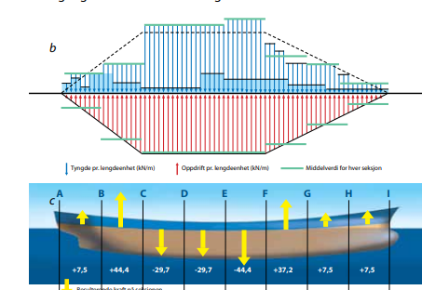
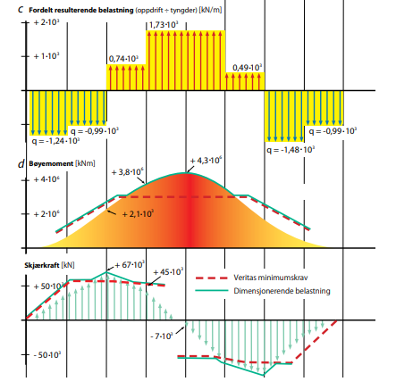

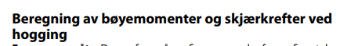
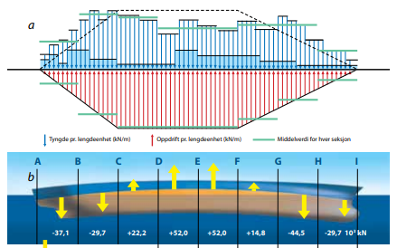
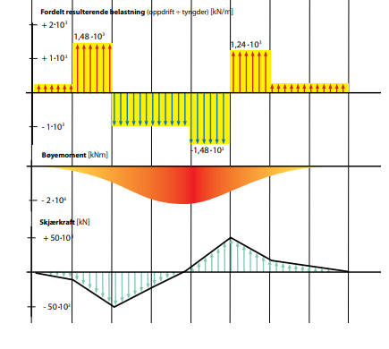

13. Stability

Design av flytere starter med å se på stillevannskondisjonen (Se forelesning Wind for Aker H3). Stillevannskondisjonen består av dødvekt og ballast. Konstruksjonen må kunne flyte og være robust mot vind, bølger og andre miljølaster som is, issprøyt osv. Miljølaster som vind og bølger kommer i ulike intensiteter med ulike perioder/frekvenser. Konstruksjonen må designes slik at man unngår at egensvingninger treffer de største og verste lastene slik at konstruksjonen havarerer. Det gjelder ekstremlaster med også utmatning som kan være vel så kritisk. Det er typisk at det er de mellomstore bølgene som generer mest utmatningsskade med en periode på kanskje 5 til 10 sekunder.
"Kilde sluk beregningsmetode"
Vi jobber nå med å forsøke å gjøre noen anslag rundt oppførsel av konstruksjoner av vann og "added mass". Enkle betraktninger og erfaringstall må gjøres i alle faser i et prosjekt. Øvelsene vi gjør her nå bidrar til at man skal kunne gjøre slike betraktninger.
For å være helt sikker på at man har riktige laster må man bruke en "kilde-sluk"-beregning. Deretter settes lastene på manuelt evt. at man her et eget konverteringsprogram som sørger for at lastene blir satt på riktig i modellen. Fjærer da benyttes slik som i den første "Geir flyter" modellen. "Kilde-sluk" er ikke pensum i dette faget. Kilde-sluk samt panelmodellen er de mest vanlige beregningsteknikkene som gjøres på hydrodynamiske analys. Se KildeSluk.pdf
(In english this is called the source-sink method:
DNV-RP-F20: Global Performance Analysis of Deepwater Floating Structures (hvl.no) )
Fra faglærer sin side så er det også en ambisjon om at studentene skal få en følelse av hva dette her er og hva slags størrelser det er snakk om (deplasement koblet til bredde, lengde, egensvingeperioder) igjennom å gjøre noen enkle betrakninger rundt temaet. Hva er de kritiske parametrene for å bygge noe som skal ligge på sjøen?
Bevegelser i vann
BYGT2312-Lecture2023.09.22-BevegelserIVann.pdf
- Svingeligning:
(m+m.a)a + uv + kx = f(t,x,y,z)
Inneholder massekraft, motstandkraft og
forskyvningskraft.
- Beregninger av vanntrykk
- Beregning av tyngdepunkt
- 3 prinsipper: Balaststabilisert, buoyanc
stabilisert, mooring stabilisert.
- Egenperioder med og uten "added mass".
Added mass:
Medsvingende vekt fra vann i bølger og luft i vind må tas med for å finne riktig oppførsel av konstruksjonen. For vind så er betyr added mass mindre siden luft veier mye mindre.
Typiske rulleperioder for ulike flytekonsepter:
BYGT2312-Lecture2023.09.22-TypiskeRulleperioder.pdf

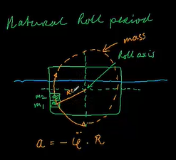
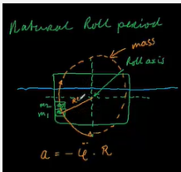
Hvordan gjette på riktig massetreghetsmoment:
SDY_Natural Roll Period of a vessel - YouTube
Eksempel på beregninger av bevegelser på en barge med transport av en flammebom mer nøyaktig ihht. DnV-standard:
BYGT2312-Lecture2023.09.22.DnV-barge-movements.pdf
Dynamisk forsterkningsfaktor er gitt på side 34. Svingning av konstruksjoner (nb.no)
Også beskrevet på side 181 i Havromsteknologiboka. Her er det også en figur som viser effekten av "dempning" på figuren her. Eksempelet med 2% dempning blir slik:
DAF-HavromsteknologiEksempel.pdf
Side 89 og side 93. Ser på grunnleggende flyte/stabilitetsprinsipper.
For å forstå hva disse egenfrekvensene er då kan man se beskrivelsene under her. Ifm. er jeg kun ute etter bruken her ifm. design men denne videoen var såpass enkelt og godt forklart så da tar jeg det med her.
Egenfrekvenser finnes ut fra ma + kx = 0
(svingeligning). Dette kan være matriser med mange frihetsgrader men for få frihetsgrader kan man enkelt regne ut både svingeform og svingeperioder. Denne videoen viser hvordan denne beregningen gjøres:
Dette er eksempel på en egenverdiberegning. For mange frihetsgrader blir dette mer komplisert da det blir for mange ligninger og for mange ukjente. I dataprogrammer som SAP2000 finnes ulike algoritmer for å finne egenverdier målet er det samme. Dvs. å finne i hvilken form konstruksjonen svinger (evt. knekker) og hvilken energi skal til for at konstruksjonen skal svinge (eller knekke).
Egenfrekvenser for rotasjon finnes ut fra rotasjonsstivhetfra det nedykkede vannet sammen med massetreghetsmomentsmomentet. I SAP2000 er massene knyttet til knutepunkter. M er om massetreghetsmomenter er beskrevet i denne videoen:
Moment of Inertia for point mass and rod - YouTube
Moment of inertia, masstreghetsmoment (fra Hibeler):
MomentOfInertiaHibeler.pdf

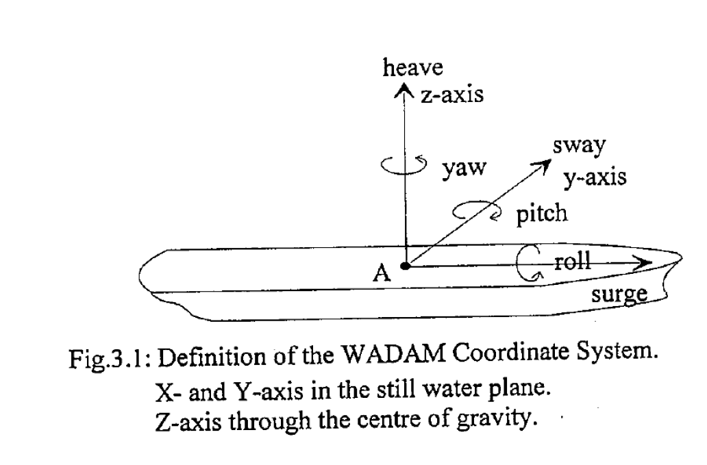
Kjenne begrepene: Surge, sway, hiv, roll, pitch, yaw
Med tilleggsbegreper "heel" og "trim"
Ship motions - Wikipedia
Eksempel på beregninger av bevegelser på en barge med transport av en flammebom mer nøyaktig ihht. DnV-standard: Beregning ihht. DnV regelverk.
"Kilde sluk beregningsmetode"
Vi jobber nå med å forsøke å gjøre noen anslag rundt oppførsel av konstruksjoner av vann og "added mass". Enkle betraktninger og erfaringstall må gjøres i alle faser i et prosjekt. Øvelsene vi gjør her nå bidrar til at man skal kunne gjøre slike betraktninger.
For å være helt sikker på at man har riktige laster må man bruke en "kilde-sluk"-beregning. Deretter settes lastene på manuelt evt. at man her et eget konverteringsprogram som sørger for at lastene blir satt på riktig i modellen. Fjærer da benyttes slik som i den første "Geir flyter" modellen. "Kilde-sluk" er ikke pensum i dette faget. Kilde-sluk samt panelmodellen er de mest vanlige beregningsteknikkene som gjøres på hydrodynamiske analyser. Beskrive kilde-sluk
(In english this is called the source-sink method:
DNV-RP-F205: Global Performance Analysis of Deepwater Floating Structures (hvl.no) )
Fra faglærer sin side så er det også en ambisjon om at studentene skal få en følelse av hva dette her er og hva slags størrelser det er snakk om (deplasement koblet til bredde, lengde, egensvingeperioder) igjennom å gjøre noen enkle betrakninger rundt temaet. Hva er de kritiske parametrene for å bygge noe som skal ligge på sjøen?
Bevegelser i vann
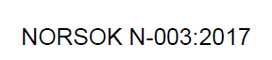
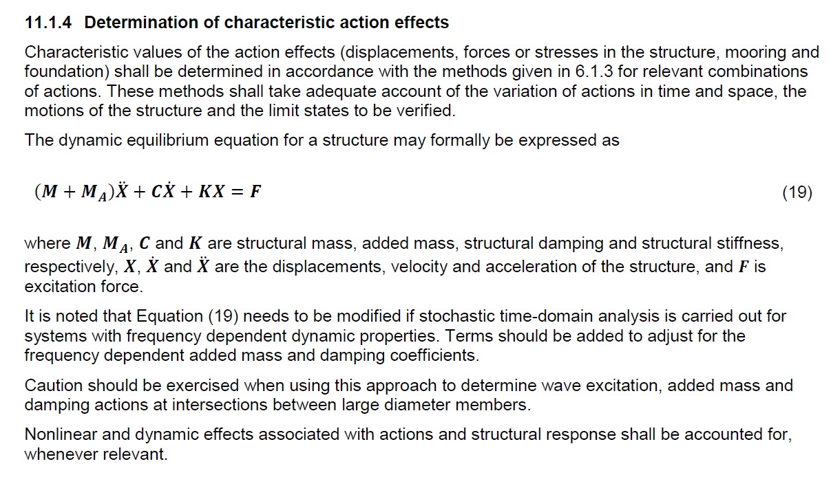

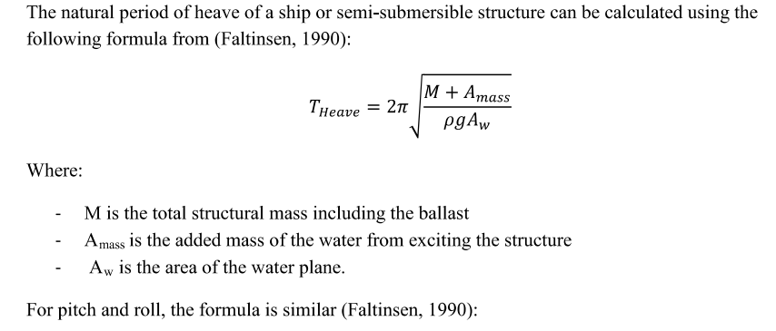
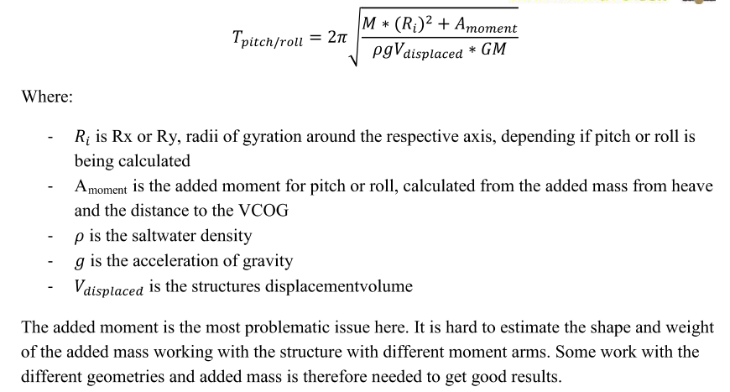
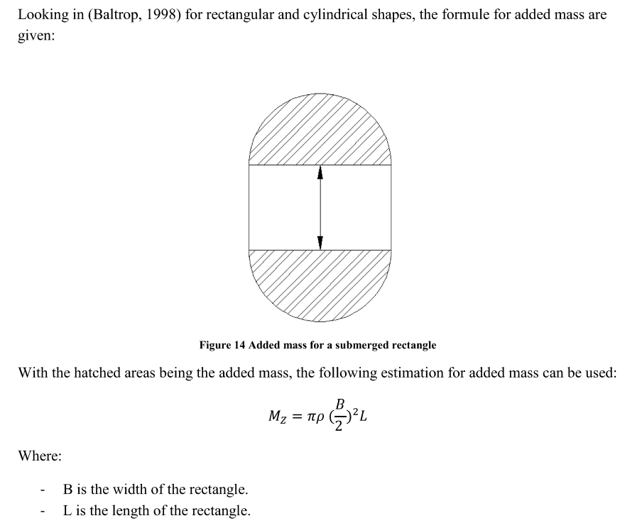
- Svingeligning:
(m+m.a)a + uv + kx = f(t,x,y,z) 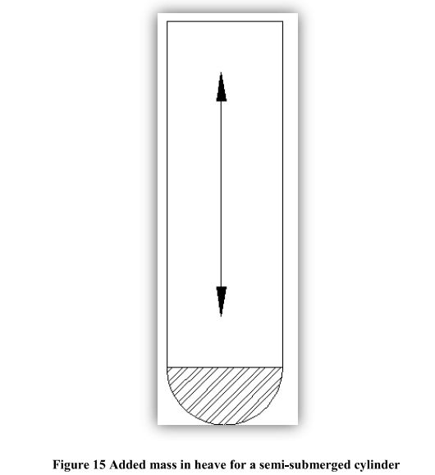
Inneholder massekraft, motstandkraft og
forskyvningskraft.
- Beregninger av vanntrykk
- Beregning av tyngdepunkt
- 3 prinsipper: Balaststabilisert, buoyanc
stabilisert, mooring stabilisert.
- Egenperioder med og uten "added mass".
Dynamisk forsterkningsfaktor er gitt på side 34. Svingning av konstruksjoner (nb.no)
Også beskrevet på side 181 i Havromsteknologiboka. Her er det også en figur som viser effekten av "dempning" på figuren her. Eksempelet med 2% dempning blir slik:
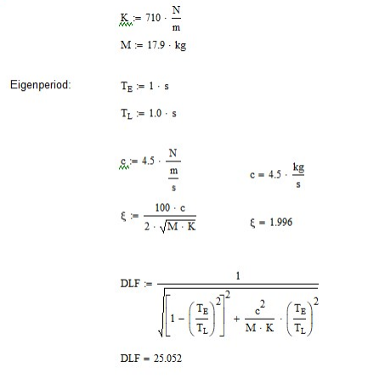
Bok.pdf (ntnu.no)
Side 89 og side 93. Ser på grunnleggende flyte/stabilitetsprinsipper.
For å forstå hva disse egenfrekvensene er då kan man se beskrivelsene under her. Ifm. er jeg kun ute etter bruken her ifm. design men denne videoen var såpass enkelt og godt forklart så da tar jeg det med her.
Egenfrekvenser finnes ut fra ma + kx = 0
(svingeligning). Dette kan være matriser med mange frihetsgrader men for få frihetsgrader kan man enkelt regne ut både svingeform og svingeperioder. Denne videoen viser hvordan denne beregningen gjøres: https://youtu.be/cD41LXKSyVU
Dette er eksempel på en egenverdiberegning. For mange frihetsgrader blir dette mer komplisert da det blir for mange ligninger og for mange ukjente. I dataprogrammer som SAP2000 finnes ulike algoritmer for å finne egenverdier målet er det samme. Dvs. å finne i hvilken form konstruksjonen svinger (evt. knekker) og hvilken energi skal til for at konstruksjonen skal svinge (eller knekke).
Egenfrekvenser for rotasjon finnes ut fra rotasjonsstivhetfra det nedykkede vannet sammen med massetreghetsmomentsmomentet. I SAP2000 er massene knyttet til knutepunkter. M er om massetreghetsmomenter er beskrevet i denne videoen:
Moment of Inertia for point mass and rod - YouTube
Added mass:
Medsvingende vekt fra vann i bølger og luft i vind må tas med for å finne riktig oppførsel av konstruksjonen. For vind så er betyr added mass mindre siden luft veier mye mindre.
Typiske rulleperioder for ulike flytekonsepter:
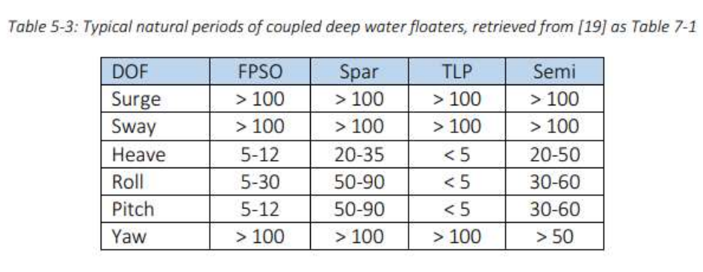
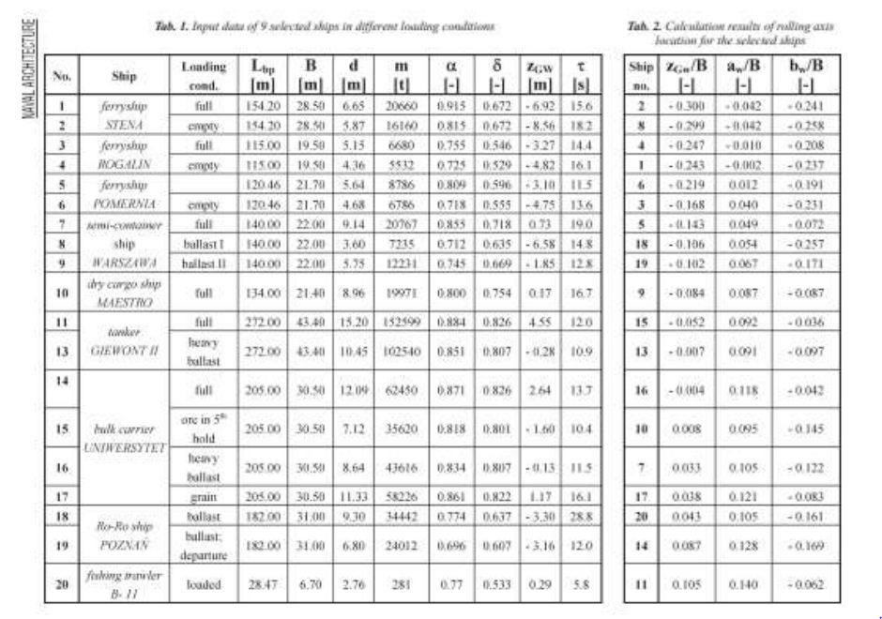

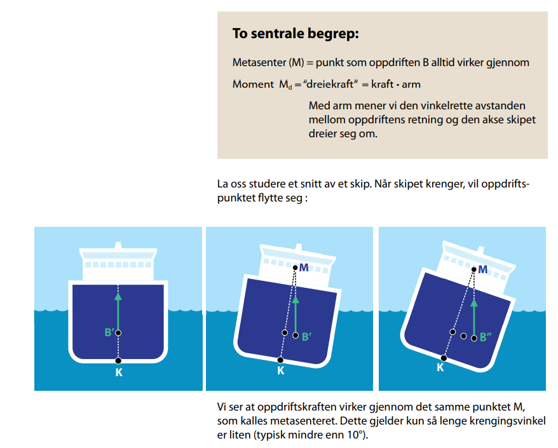
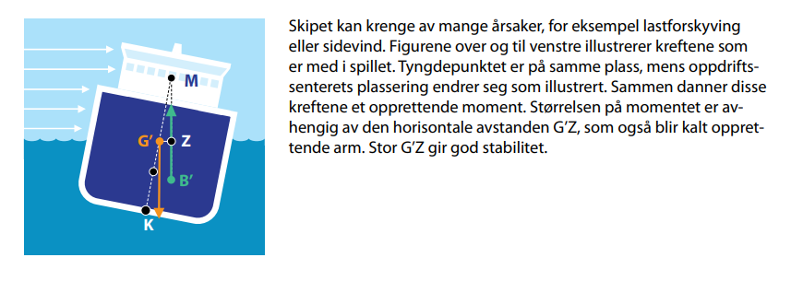
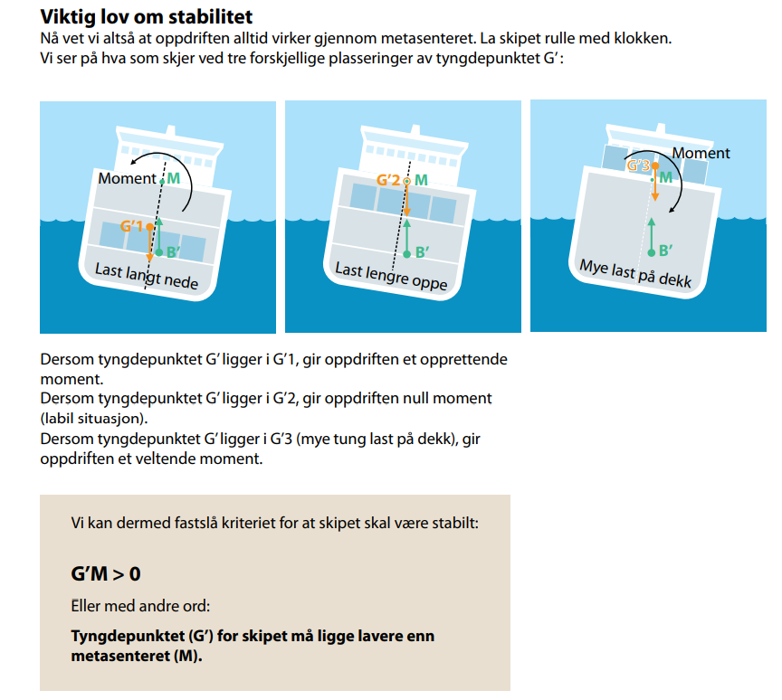

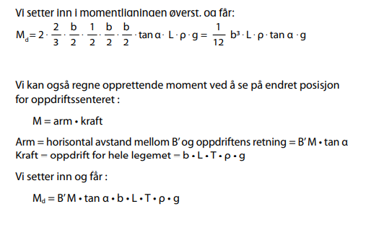
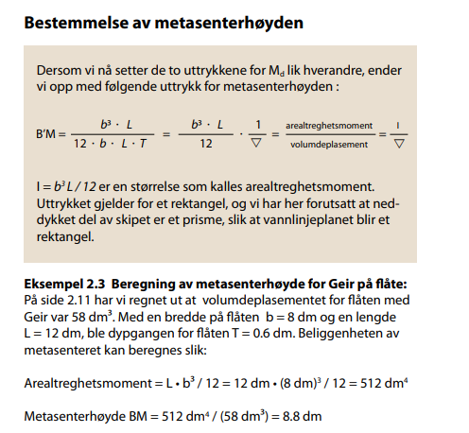
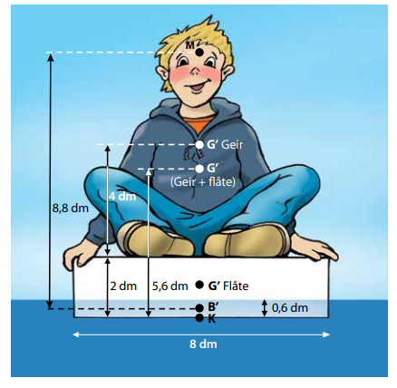
Løsningsforslag fra eksamen 2021 på spørsmål om stabilitet

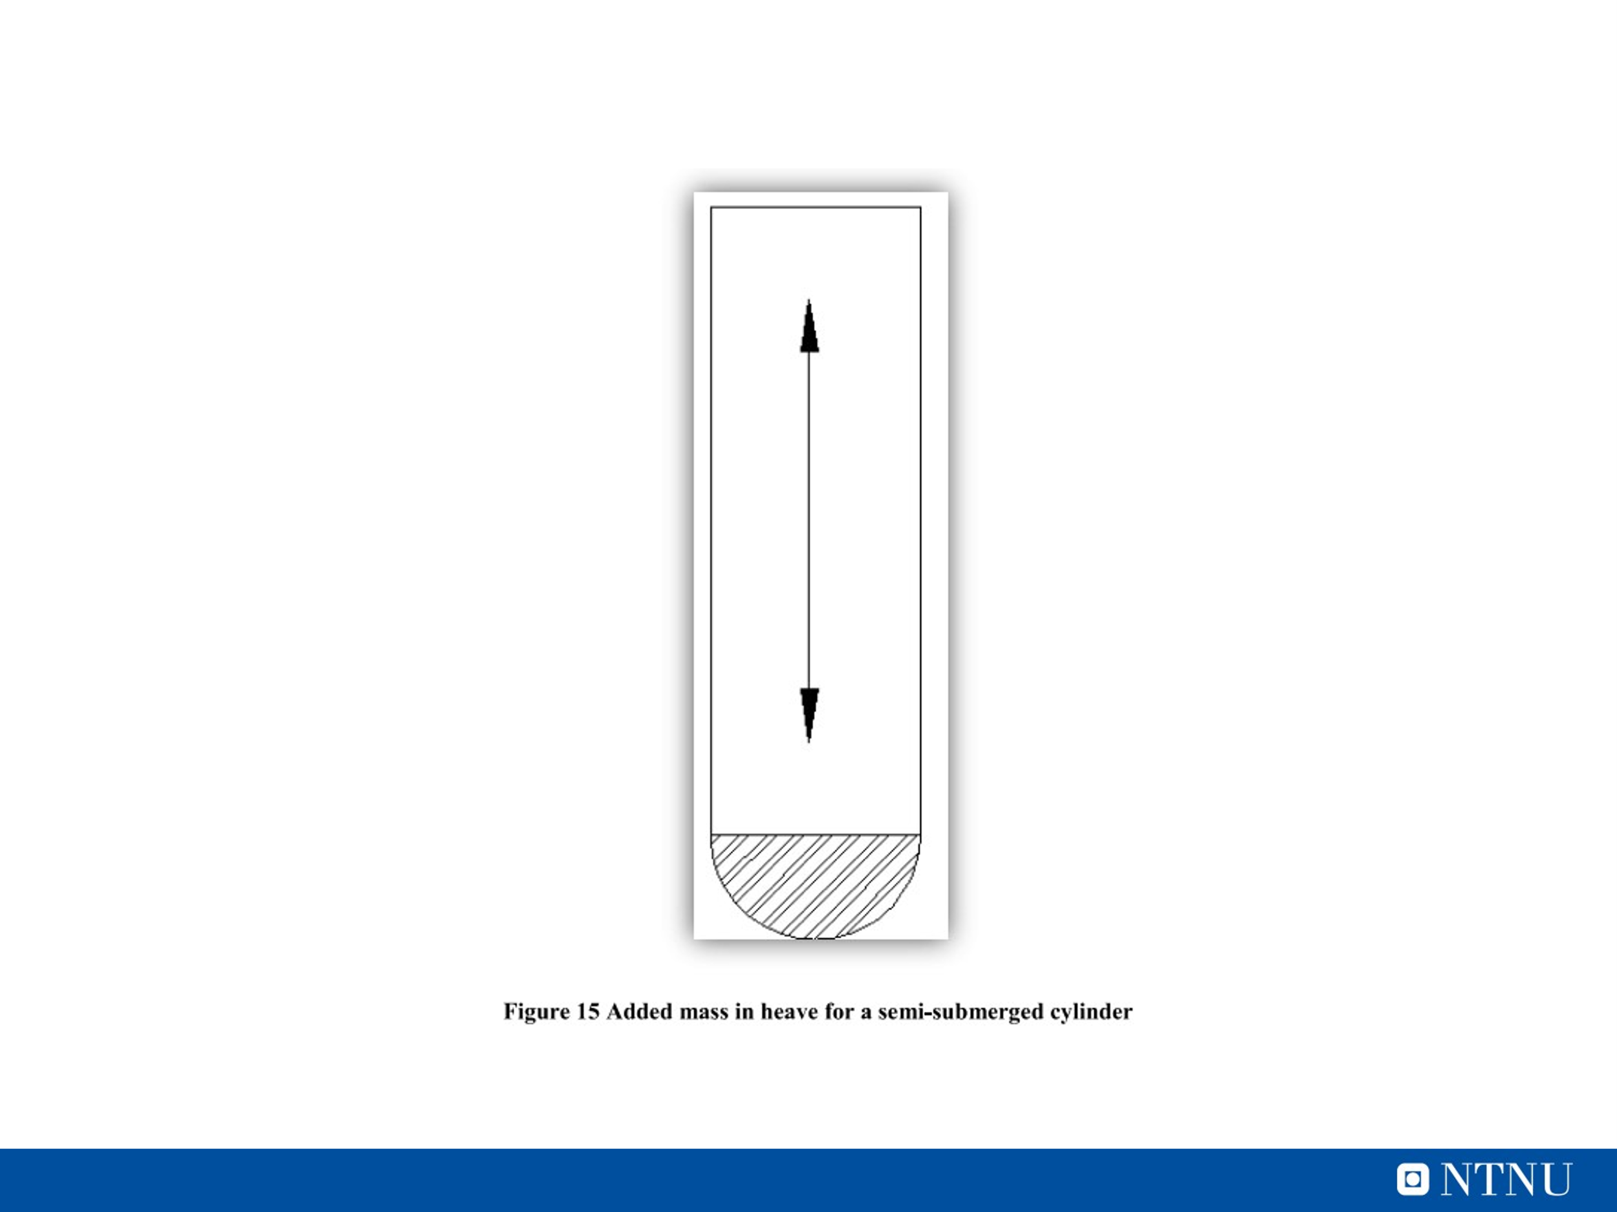

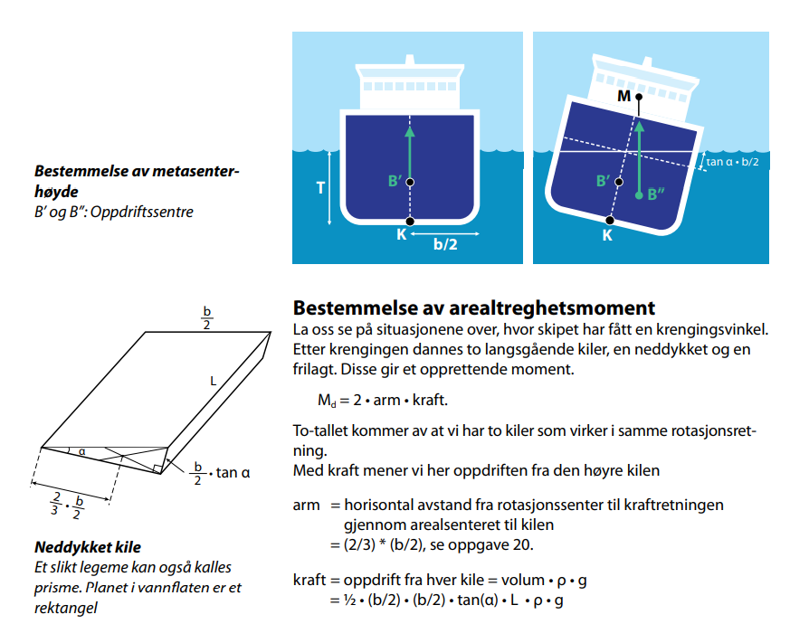

14. Dynamics
Forskjellen på: - Kvasistatisk, dynamisk, kvasidynamisk
Design handler om å tilpasse konstruksjonen til bruken og omgivelsene. På sjøen så har vi bølger med ulike perioder og størrelser. For periodiske laster gjelder det å unngå periodene til de største lastene. Både i industrien (verksted/maskiner/strømningshastigheter) og ute i naturen (vind) og spesielt havet (vind og bølger) er det viktig at vi designer konstruksjonen slik at disse periodiske lastene ikke ødelegger konstruksjonen. I eksempelet for Halten ser man typiske størrelser for havrommet utenfor Norge. Hvordan man regner på dette her avhenger av om man er i det kvasistatiske, dynamiske eller kvasidynamiske området. Konstruksjoner der de største lastene har en mer sakte frekvens enn egenperioden kalles kvasistatisk (f.eks. jacket). Hvis lastene har en raskere frekvens enn egenperioden er man i det kvasidynamiske området (f.eks. flytere).
Det som skal forstås av svingninger i dette faget er:
1. Stivheten av vannet styres av vannlinjearealet
2. Dynamikken styres av en sammenheng mellom masse og stivhet.
3. Klare å finne egenfrekvensen for et 1 frihetsgradssystem omega = rot(masse/stivhet)
3. En konstruksjon må designes slik at at ytre laster som er lik egenfrekvensen til konstruksjonen er små og påvirker konstruksjonens levetid og kapasitet lite.
4. Miljølaster som vind og bølger (+ jordskjelv) består av et spekter av frekvenser. Det er ikke til å unngå at noen laster (bølger eller vindkast) er lik egenperioden til en konstruksjon. Periodiske laster som er lik eller nær egenfrekveksen bør være små slik at den ikke blir kritisk for konstruksjonen. For konstruksjoner der periodiske laster er dominerende vi utmatning ("fatigue") ofte være dimensjonerene. Mer om dette her kommer senere i faget.
5. Det forventes at begrepet "vortex shedding" er kjent men det forventes ikke at man skal kunne regne på dette her.
A Brief Explanation on Vortex Shedding (Meca Enterprises Inc.) - YouTube
6. Tiltak mot vortex shedding kan være enkelt:
A Brief Explanation of Helical Strakes (Meca Enterprises Inc.) - YouTube
Det er å merke seg at løsning som "Helical Strakes" øker vindarealet og virker utgunstig på den måten.
Youtube: All about Damping
Eksempel med “Geir flyter” i SAP2000.
Forskjellen på:- Kvasistatisk, dynamisk, kvasidynamisk
Design handler om å tilpasse konstruksjonen til bruken og omgivelsene. På sjøen så har vi bølger med ulike perioder og størrelser. For periodiske laster gjelder det å unngå periodene til de største lastene. Både i industrien (verksted/maskiner/strømningshastigheter) og ute i naturen (vind) og spesielt havet (vind og bølger) er det viktig at vi designer konstruksjonen slik at disse periodiske lastene ikke ødelegger konstruksjonen. I eksempelet for Halten ser man typiske størrelser for havrommet utenfor Norge. Hvordan man regner på dette her avhenger av om man er i det kvasistatiske, dynamiske eller kvasidynamiske området. Konstruksjoner der de største lastene har en mer sakte frekvens enn egenperioden kalles kvasistatisk (f.eks. jacket). Hvis lastene har en raskere frekvens enn egenperioden er man i det kvasidynamiske området (f.eks. flytere).
Det som skal forstås av svingninger i dette faget er:
1. Stivheten av vannet styres av vannlinjearealet
2. Dynamikken styres av en sammenheng mellom masse og stivhet.
3. Klare å finne egenfrekvensen for et 1 frihetsgradssystem omega = rot(masse/stivhet)
3. En konstruksjon må designes slik at at ytre laster som er lik egenfrekvensen til konstruksjonen er små og påvirker konstruksjonens levetid og kapasitet lite.
4. Miljølaster som vind og bølger (+ jordskjelv) består av et spekter av frekvenser. Det er ikke til å unngå at noen laster (bølger eller vindkast) er lik egenperioden til en konstruksjon. Periodiske laster som er lik eller nær egenfrekveksen bør være små slik at den ikke blir kritisk for konstruksjonen. For konstruksjoner der periodiske laster er dominerende vi utmatning ("fatigue") ofte være dimensjonerene. Mer om dette her kommer senere i faget.
5. Det forventes at begrepet "vortex shedding" er kjent men det forventes ikke at man skal kunne regne på dette her.
Paper på rulleperioder
http://yadda.icm.edu.pl/baztech/element/bwmeta1.element.baztech-article-BWM2-0041-0006
Youtube: All about Damping
"Geir flyter" og egenperioder i vann:
A Brief Explanation on Vortex Shedding (Meca Enterprises Inc.) - YouTube
6. Tiltak mot vortex shedding kan være enkelt:
A Brief Explanation of Helical Strakes (Meca Enterprises Inc.) - YouTube
Det er å merke seg at løsning som "Helical Strakes" øker vindarealet og virker utgunstig på den måten.
Hvordan gjette på riktig massetreghetsmoment:
SDY_Natural Roll Period of a vessel - YouTube
Paper - rulleperioder:
http://yadda.icm.edu.pl/baztech/element/bwmeta1.element.baztech-article-BWM2-0041-0006
Dynamisk forsterkningsfaktor er gitt på side 34. Svingning av konstruksjoner (nb.no)
Bok.pdf (ntnu.no)
Side 89 og side 93. Ser på grunnleggende flyte/stabilitetsprinsipper.
For å forstå hva disse egenfrekvensene er då kan man se beskrivelsene under her. Ifm. er jeg kun ute etter bruken her ifm. design men denne videoen var såpass enkelt og godt forklart så da tar jeg det med her.
Egenfrekvenser finnes ut fra ma + kx = 0
(svingeligning). Dette kan være matriser med mange frihetsgrader men for få frihetsgrader kan man enkelt regne ut både svingeform og svingeperioder. Denne videoen viser hvordan denne beregningen gjøres:
Dette er eksempel på en egenverdiberegning. For mange frihetsgrader blir dette mer komplisert da det blir for mange ligninger og for mange ukjente. I dataprogrammer som SAP2000 finnes ulike algoritmer for å finne egenverdier målet er det samme. Dvs. å finne i hvilken form konstruksjonen svinger (evt. knekker) og hvilken energi skal til for at konstruksjonen skal svinge (eller knekke).
Egenfrekvenser for rotasjon finnes ut fra rotasjonsstivhetfra det nedykkede vannet sammen med massetreghetsmomentsmomentet. I SAP2000 er massene knyttet til knutepunkter. M er om massetreghetsmomenter er beskrevet i denne videoen:
Moment of Inertia for point mass and rod - YouTube
Design av flytere starter med å se på stillevannskondisjonen (Se forelesning Wind for Aker H3). Stillevannskondisjonen består av dødvekt og ballast. Konstruksjonen må kunne flyte og være robust mot vind, bølger og andre miljølaster som is, issprøyt osv. Miljølaster som vind og bølger kommer i ulike intensiteter med ulike perioder/frekvenser. Konstruksjonen må designes slik at man unngår at egensvingninger treffer de største og verste lastene slik at konstruksjonen havarerer. Det gjelder ekstremlaster med også utmatning som kan være vel så kritisk. Det er typisk at det er de mellomstore bølgene som generer mest utmatningsskade med en periode på kanskje 5 til 10 sekunder.
"Kilde sluk beregningsmetode"
Vi jobber nå med å forsøke å gjøre noen anslag rundt oppførsel av konstruksjoner av vann og "added mass". Enkle betraktninger og erfaringstall må gjøres i alle faser i et prosjekt. Øvelsene vi gjør her nå bidrar til at man skal kunne gjøre slike betraktninger.
For å være helt sikker på at man har riktige laster må man bruke en "kilde-sluk"-beregning. Deretter settes lastene på manuelt evt. at man her et eget konverteringsprogram som sørger for at lastene blir satt på riktig i modellen. Fjærer da benyttes slik som i den første "Geir flyter" modellen. "Kilde-sluk" er ikke pensum i dette faget. Kilde-sluk samt panelmodellen er de mest vanlige beregningsteknikkene som gjøres på hydrodynamiske analyser.
(In english this is called the source-sink method:
DNV-RP-F205: Global Performance Analysis of Deepwater Floating Structures (hvl.no) )
Fra faglærer sin side så er det også en ambisjon om at studentene skal få en følelse av hva dette her er og hva slags størrelser det er snakk om (deplasement koblet til bredde, lengde, egensvingeperioder) igjennom å gjøre noen enkle betrakninger rundt temaet. Hva er de kritiske parametrene for å bygge noe som skal ligge på sjøen?
- Svingeligning:
(m+m.a)a + uv + kx = f(t,x,y,z)
Inneholder massekraft, motstandkraft og
forskyvningskraft.
- Beregninger av vanntrykk
- Beregning av tyngdepunkt
- 3 prinsipper: Balaststabilisert, buoyanc
stabilisert, mooring stabilisert.
- Egenperioder med og uten "added mass".
Added mass:
Medsvingende vekt fra vann i bølger og luft i vind må tas med for å finne riktig oppførsel av konstruksjonen. For vind så er betyr added mass mindre siden luft veier mye mindre.
Denne videoen viser de 3 første modene (de 3 første svingeperiodene fra egenverdiberegningen) for 2 SAP2000 modeller. For den siste versjonen av "Geir flyter" er fjærene som skal representere vannet flyttet til tyngdepunktet for Geir og isoporplate tilsammen. Dette er et forsøk på å finne en mer riktig representasjon av bevegelsen på for ROLL og PITCH.
Video roll og pitch i SAP2000
Ved analyser så bruker man vanligvis å representere vannet slik som i den første modellen. Det er for å gi konstruksjonen mest mulig riktig innspenningsforhold men for masseberegningen/svingeberegningen gir ikke det helt riktig svar. For rullebevelsene blir det mer komplisert. De fleste lærebøker har derfor ut fra hva faglærer har funnet så langt unnlatt å snakke om det. For flytende konstruksjoner så styres design stort sett av hiv og rullebevegelse sammen med "hogging" og "sagging".
Video "mass and modal analysis":
SAP2000 - 04 Mass and Modal Analysis: Watch & Learn - YouTube
Vi regner Mathcad på stabilitetet til Geir og hvor mye han må bevege seg før han evt. tipper rundt.
Hva skjer i SAP2000 hvis tyngdepunktet til Geir blir for høyt?
Vi fortsetter med Geir flyter og regner med "Added mass". Vi legger inn masser i SAP2000 og i Mathcad. I tillegg ser vi på kombinerings av laster for å få inn usikkerheter plassering av vekt og tyngdepunkt.
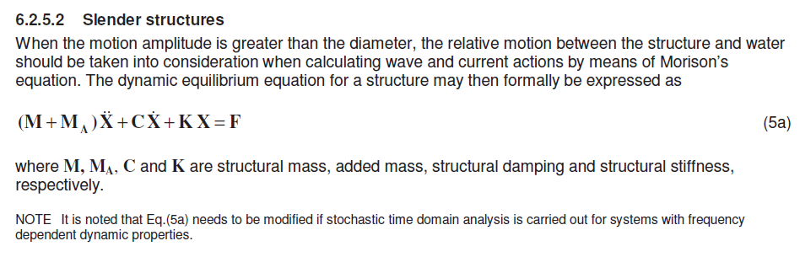

17. Ice
I et forsøk på å bli integrert i forskergruppa Marin byggrteknikk forsøkte jeg med et notat der alle med sine spesialiteter kunne bidra. Det var ikke noe suksess men med basis i det jeg fikk tak ble dette notatet laget i alle fall.
Jeg har erfaringer med isproblematikk på brues i elver. Det vil si Melhusbrua og Kviteseid bru. I tillegg var det ei bru som ble feid på sjøen av issmasser som kom ned fra fjellet i Finnmark på grensen mot Troms.
Notat islaster

18. Snow

TBA

19. Earthquake

TBA

20. Loads combinations
Definisjon: ULS, SLS, ALS, FLS
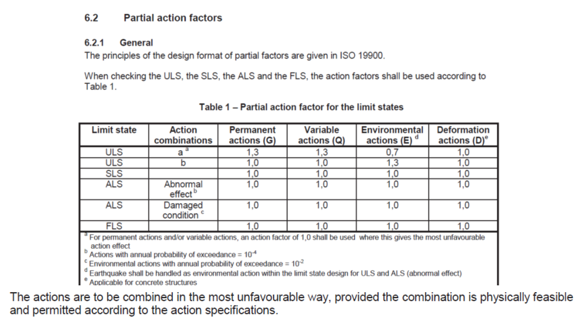

Laster, lastkombinasjoner
BYGT2312-Lecture2024.09.09-LoadCombinationsNORSOK.pdf
Definisjon: ULS, SLS, ALS, FLS
Kjenne begrepene: Surge, sway, hiv, roll, pitch, yaw
Med tilleggsbegreper "heel" og "trim"
Ship motions - Wikipedia
Lastkombinasjoner
Vi ser på et enkelt eksempel med lastkombinasjoner

Laster, lastkombinasjoner

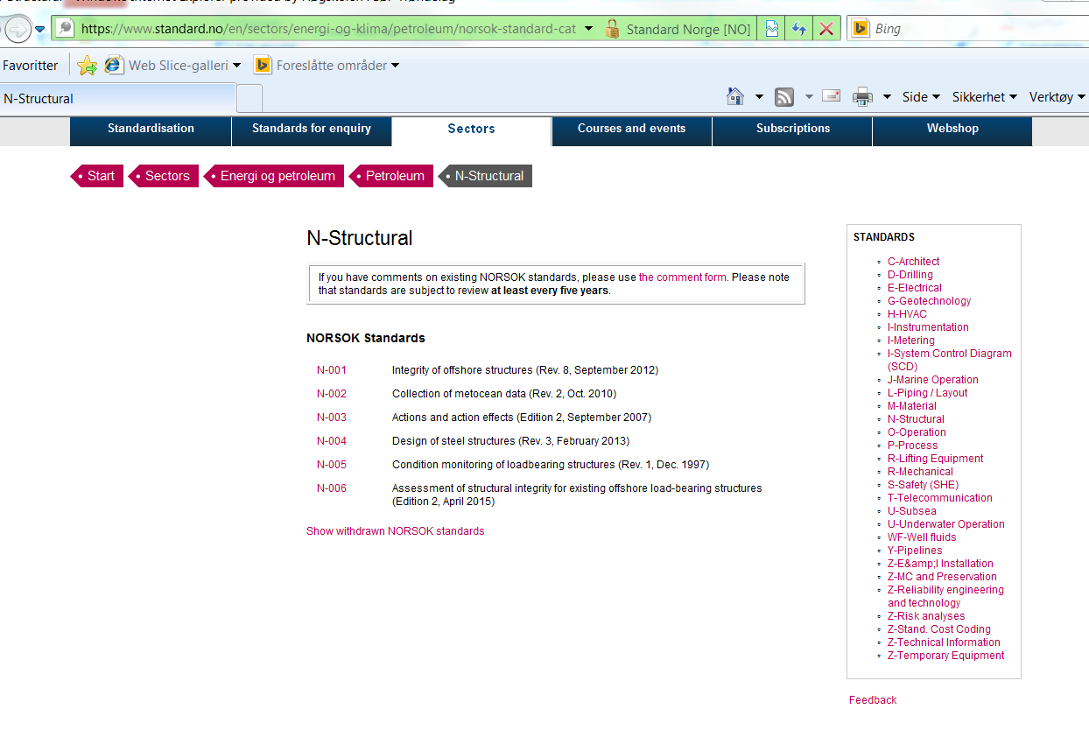
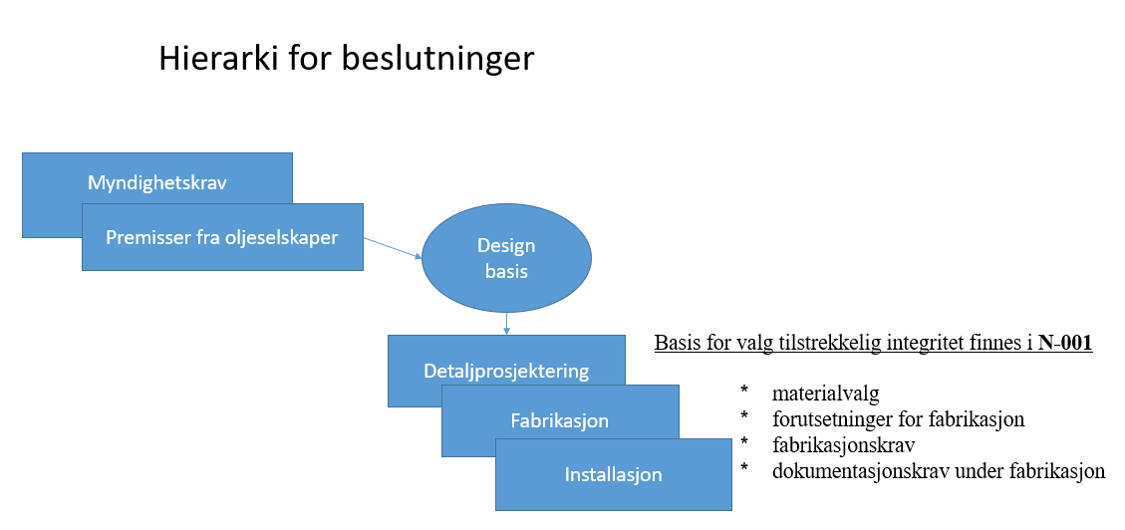
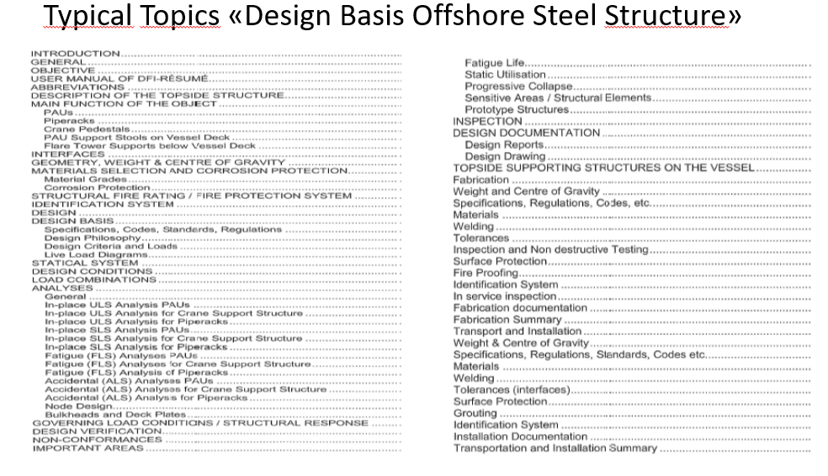
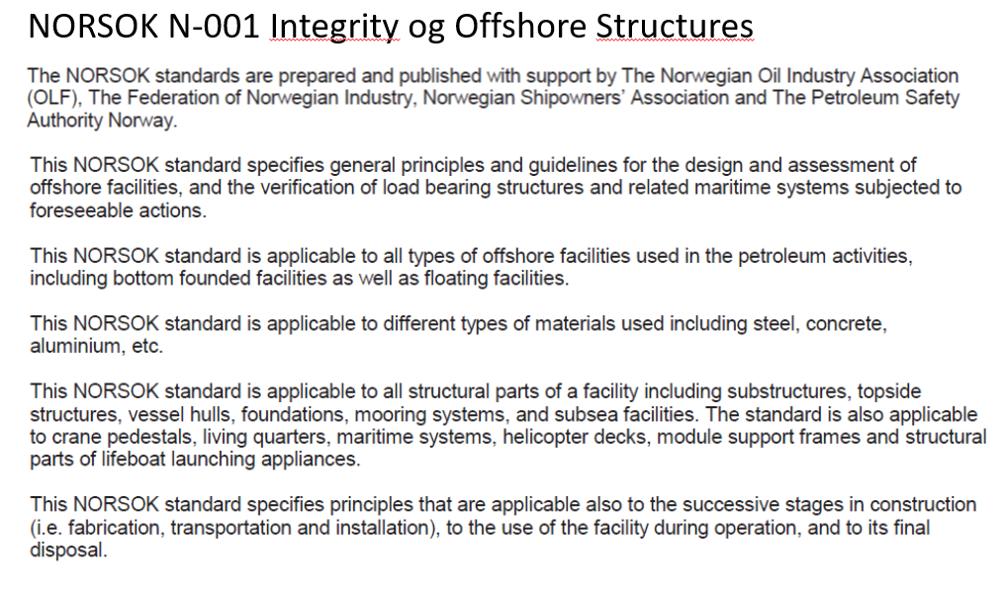
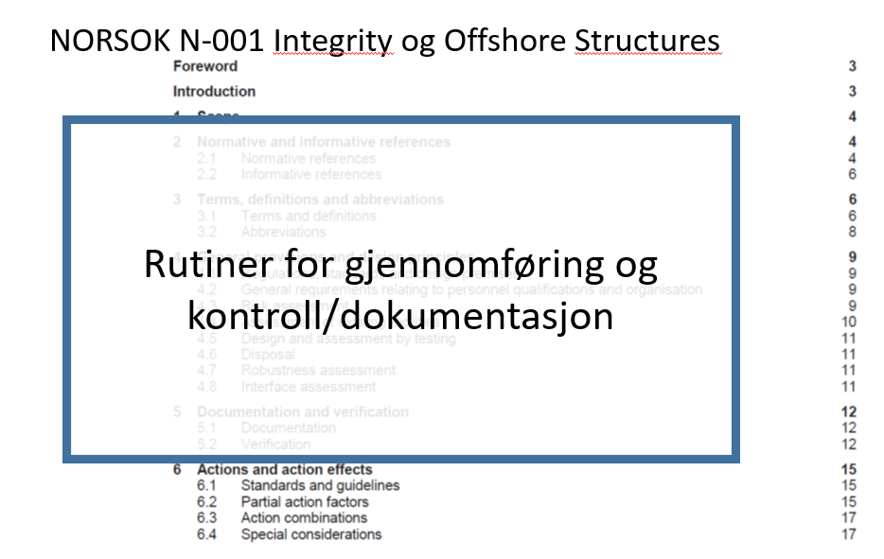
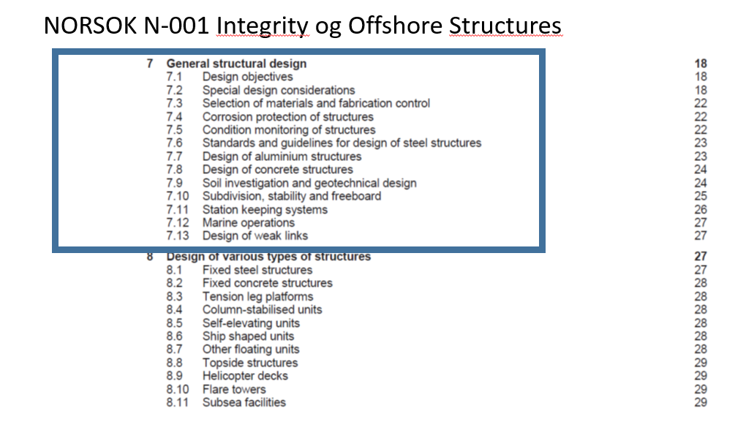
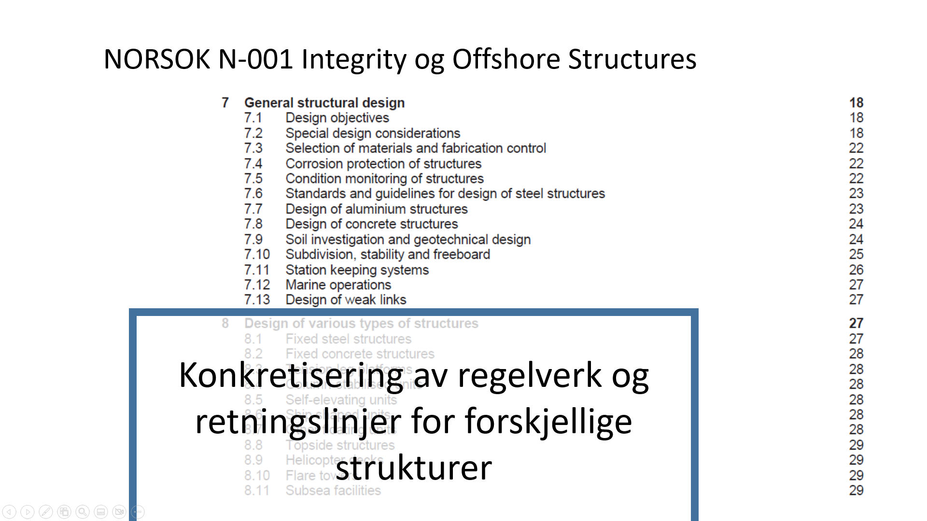

Definisjon: ULS, SLS, ALS, FLS
Forskjellen på:- Kvasistatisk, dynamisk, kvasidynamisk
Design handler om å tilpasse konstruksjonen til bruken og omgivelsene. På sjøen så har vi bølger med ulike perioder og størrelser. For periodiske laster gjelder det å unngå periodene til de største lastene. Både i industrien (verksted/maskiner/strømningshastigheter) og ute i naturen (vind) og spesielt havet (vind og bølger) er det viktig at vi designer konstruksjonen slik at disse periodiske lastene ikke ødelegger konstruksjonen. I eksempelet for Halten ser man typiske størrelser for havrommet utenfor Norge. Hvordan man regner på dette her avhenger av om man er i det kvasistatiske, dynamiske eller kvasidynamiske området. Konstruksjoner der de største lastene har en mer sakte frekvens enn egenperioden kalles kvasistatisk (f.eks. jacket). Hvis lastene har en raskere frekvens enn egenperioden er man i det kvasidynamiske området (f.eks. flytere).
Forskjell på grundt vann, endelig vanndyp, dypt vann.
Formler (wave-airy) for strømning avhengig av bølgelengder og vanndyp er gitt. Dette er de mest brukte formlene for dette selv om vi vet at bølgene ikke alltid er er en sinusbølge så er det en god tilnærming som er godt nok i de fleste tilfelle for design.
Beskrivelse av bølgebevegelser:
https://www.ck12.org/book/ck-12-fourth-grade-science/section/2.11/
Bølgebeskrivelse mer i detalj:
https://www.youtube.com/watch?v=hplb9HXM6KA

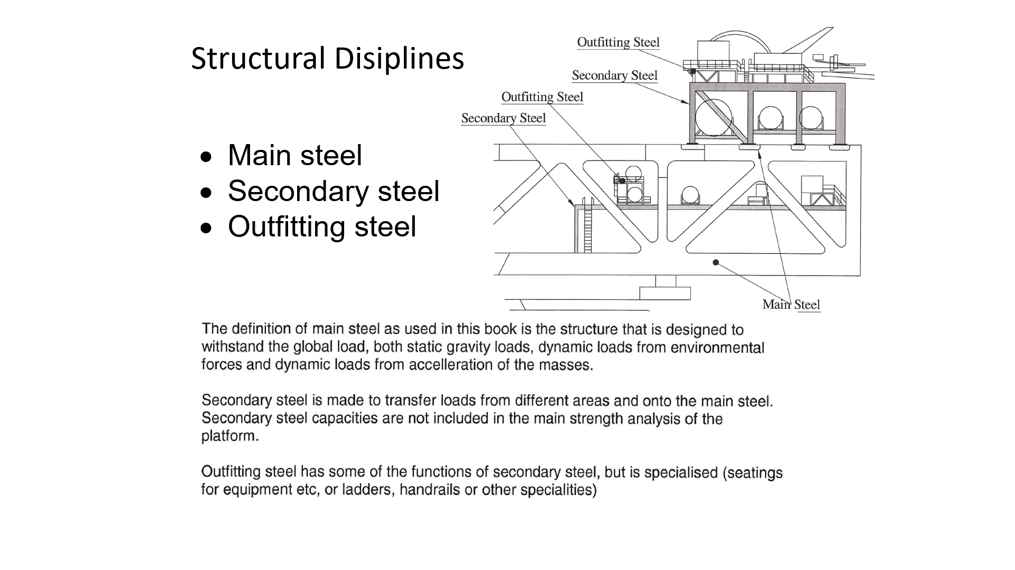
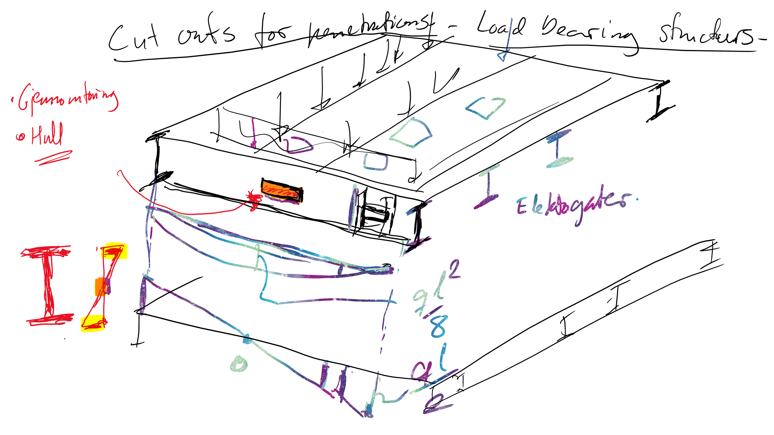
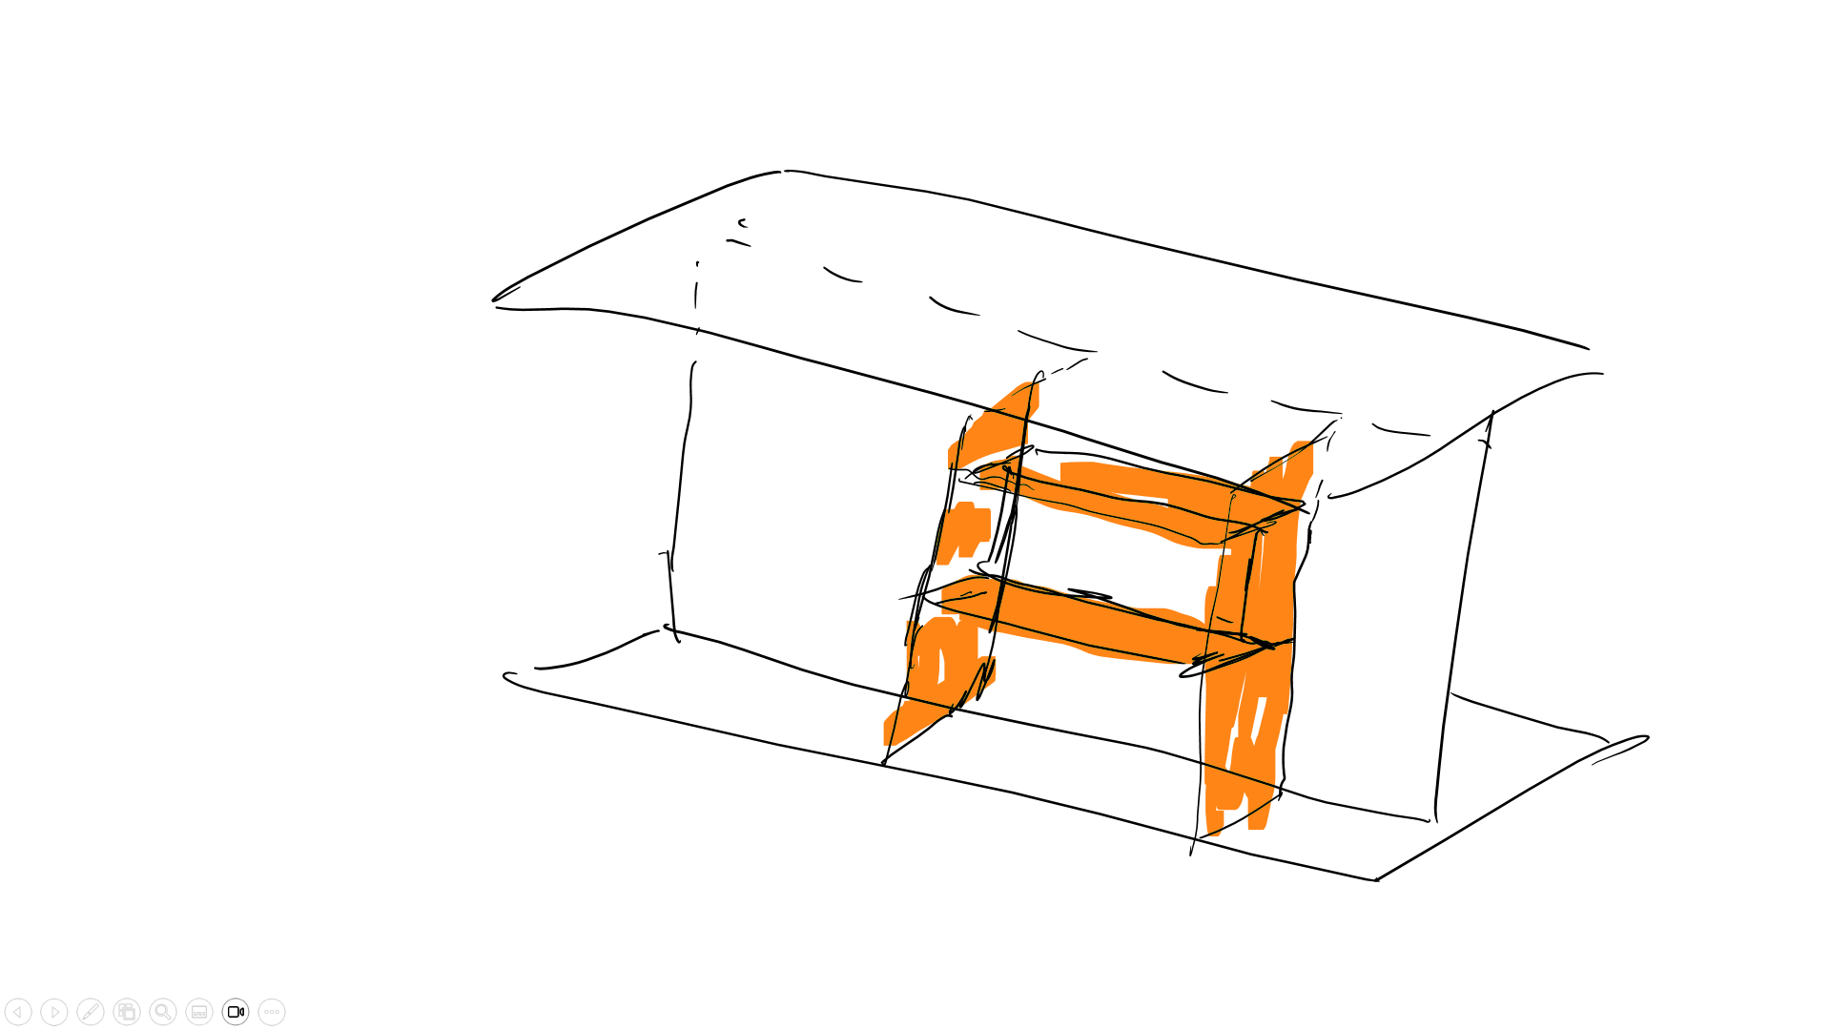
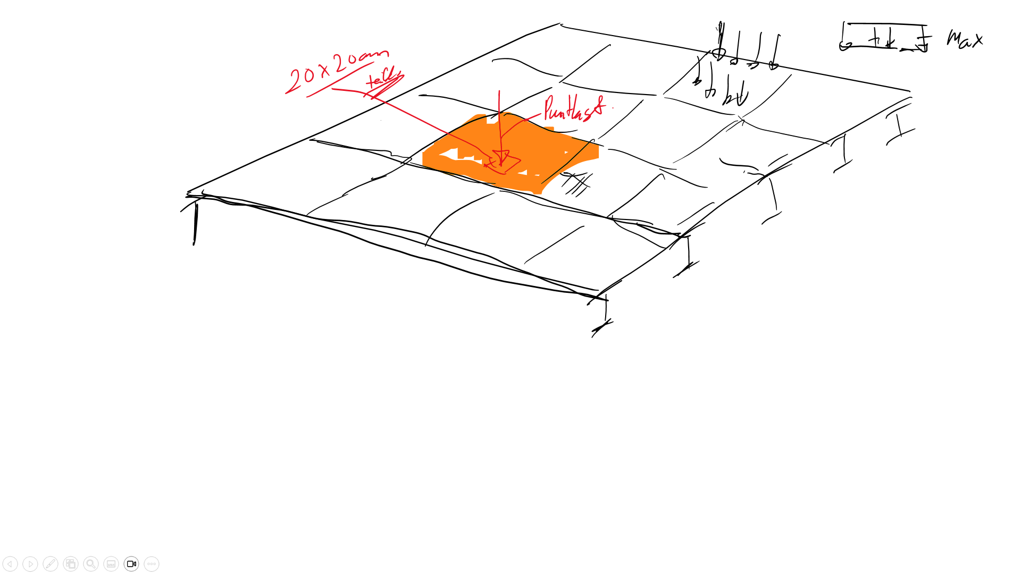
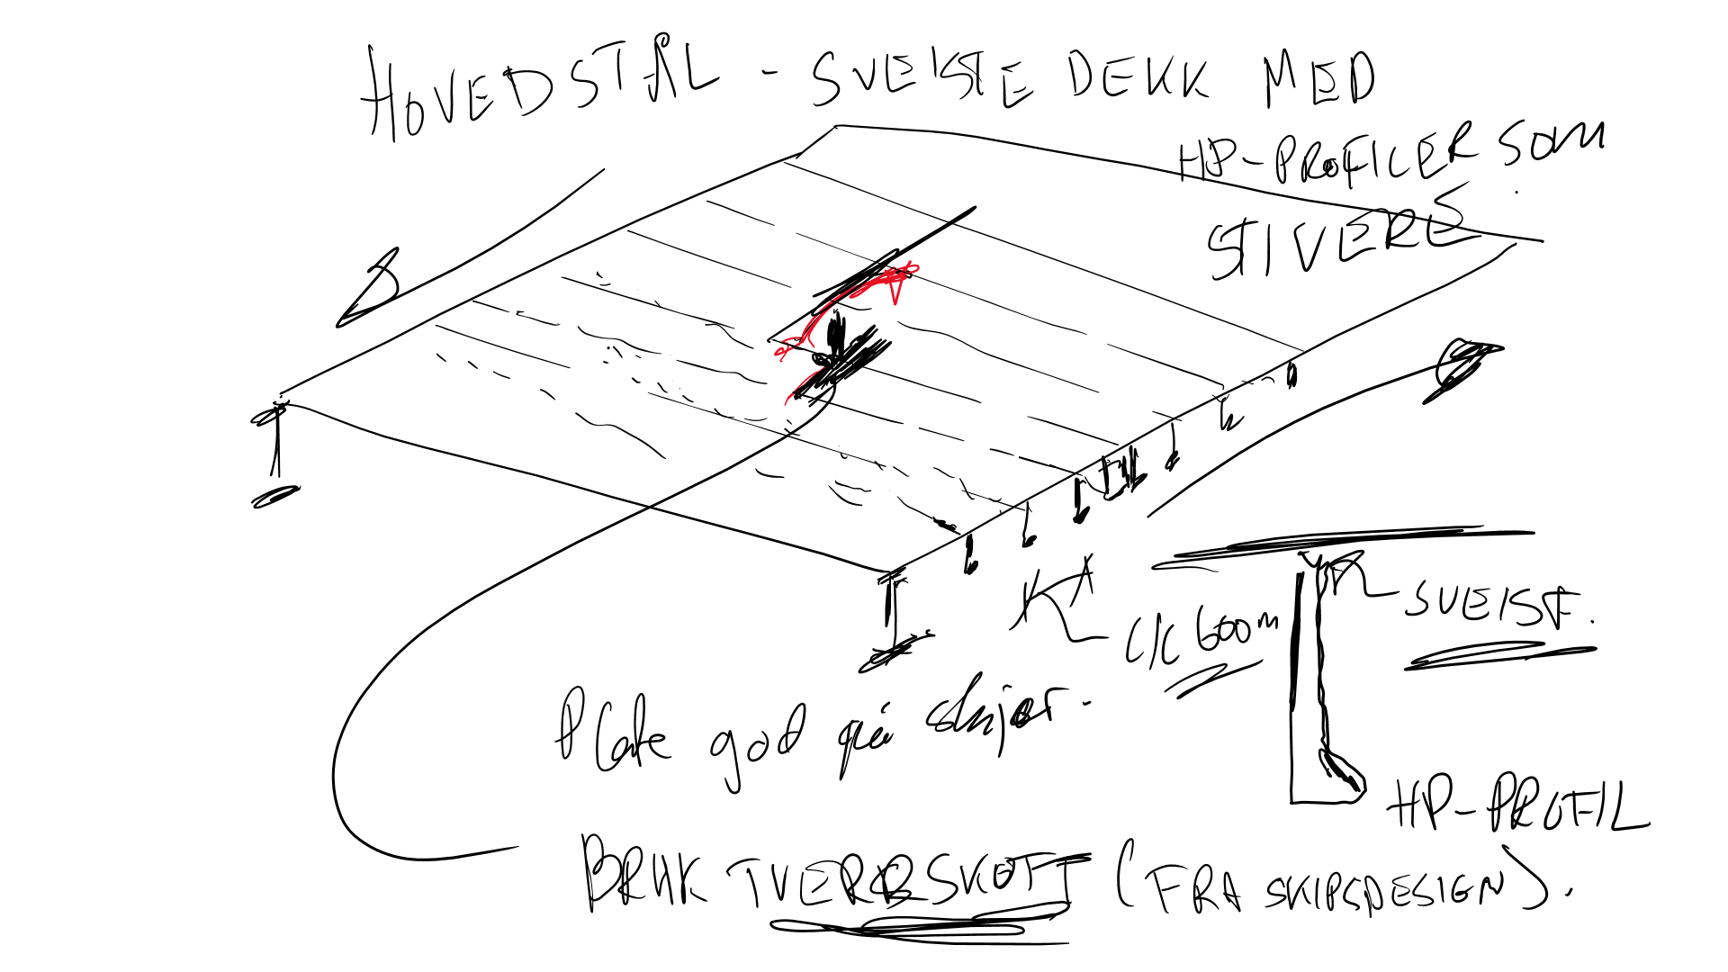
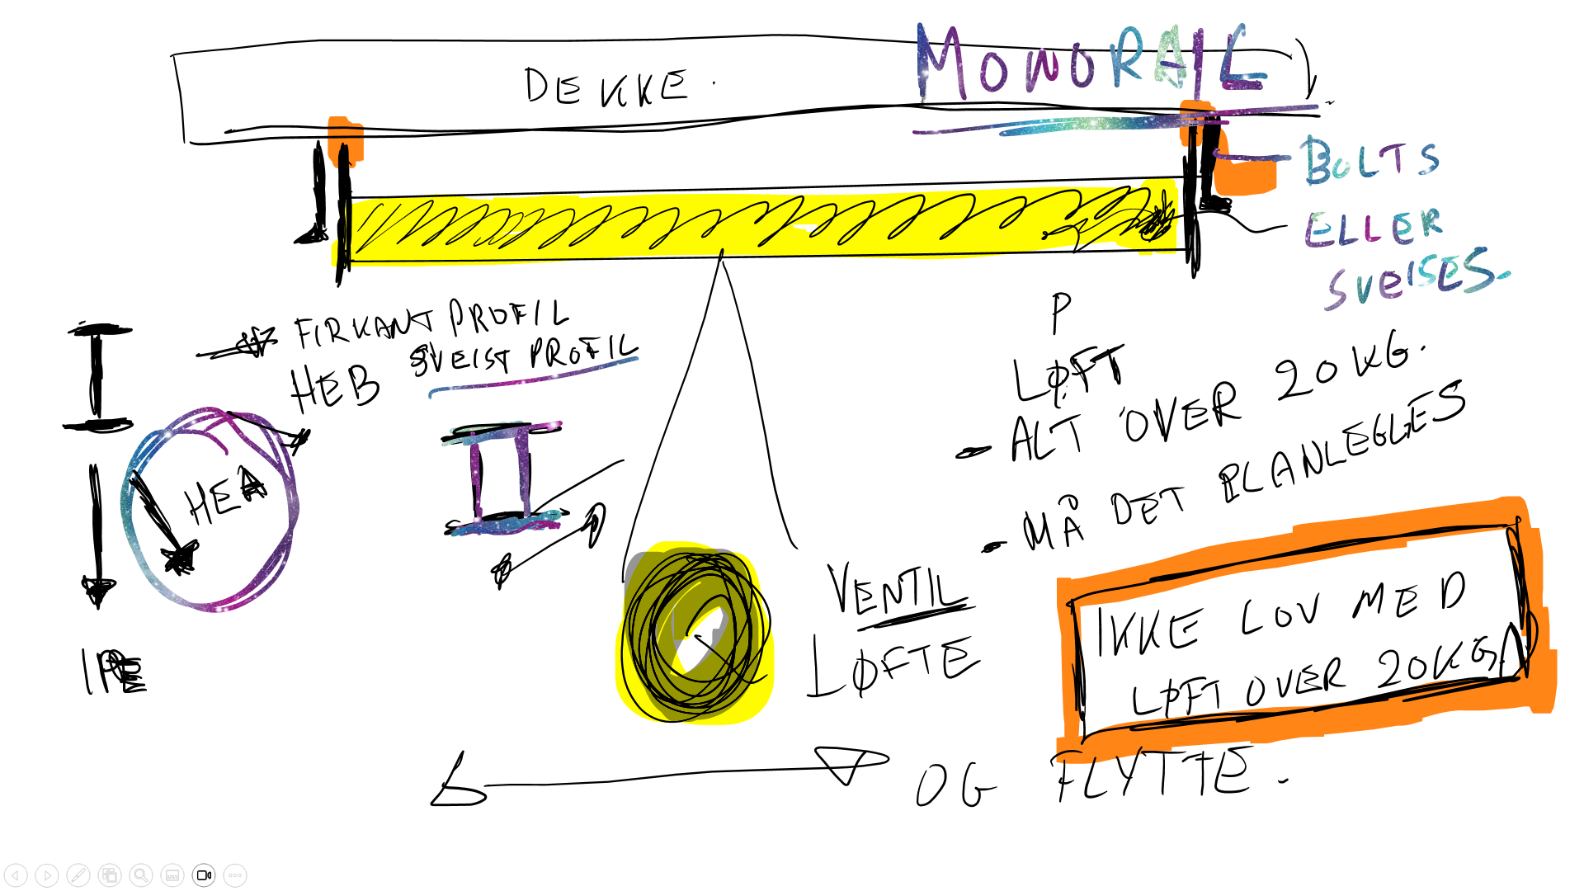
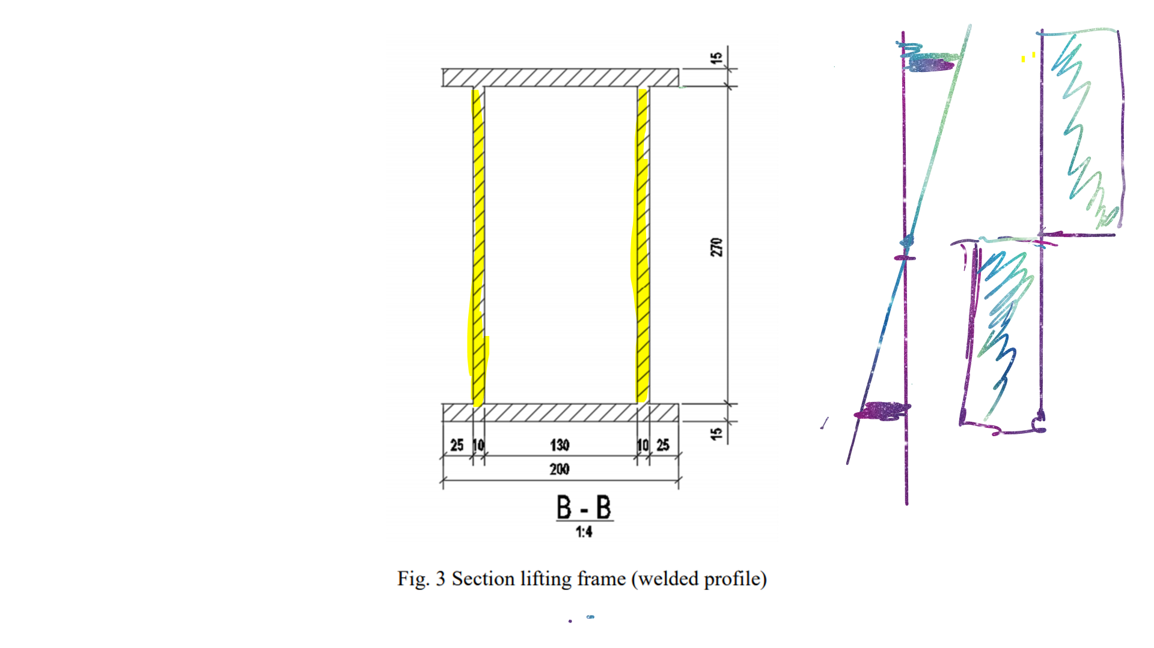
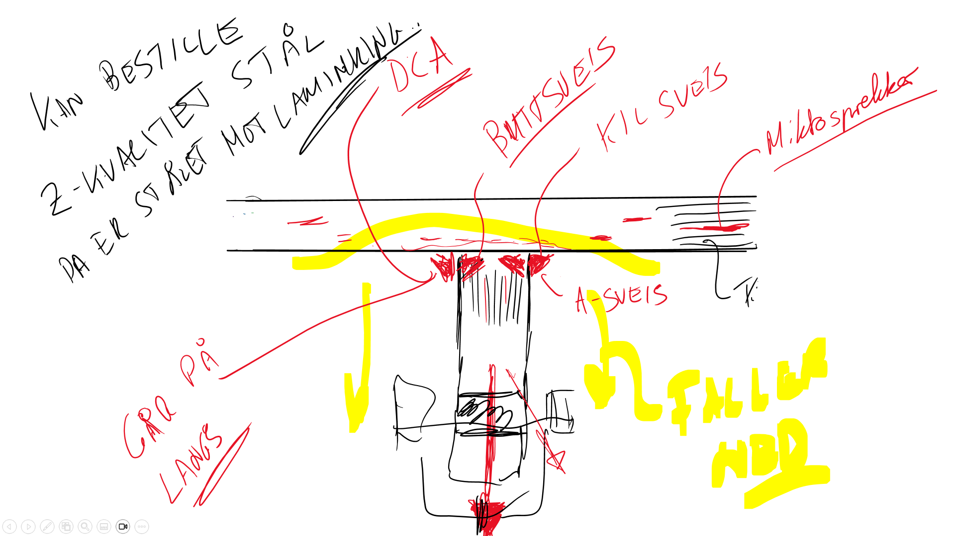
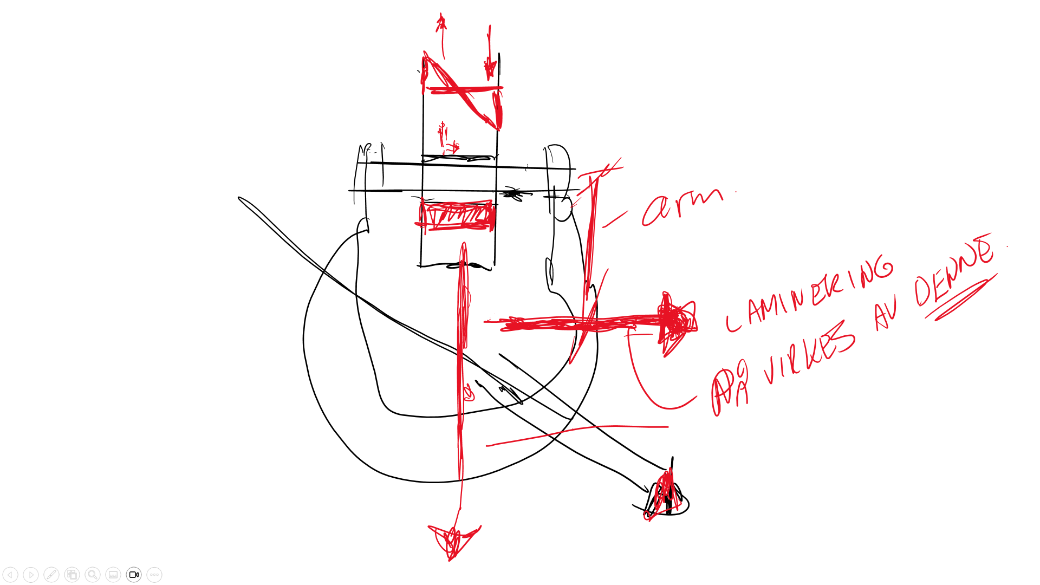
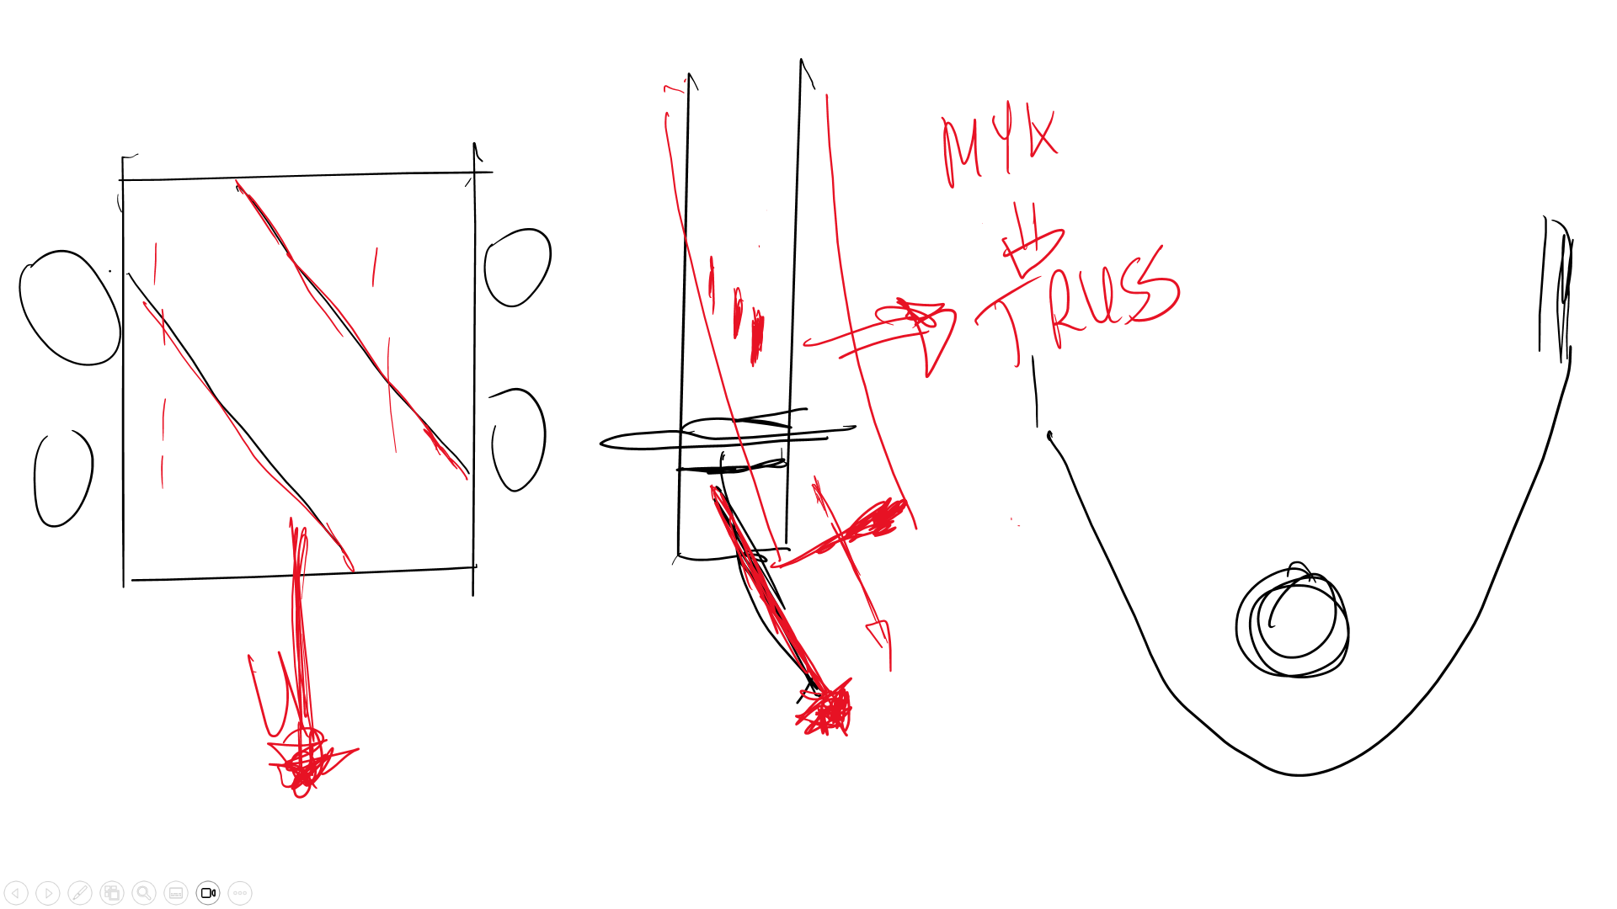
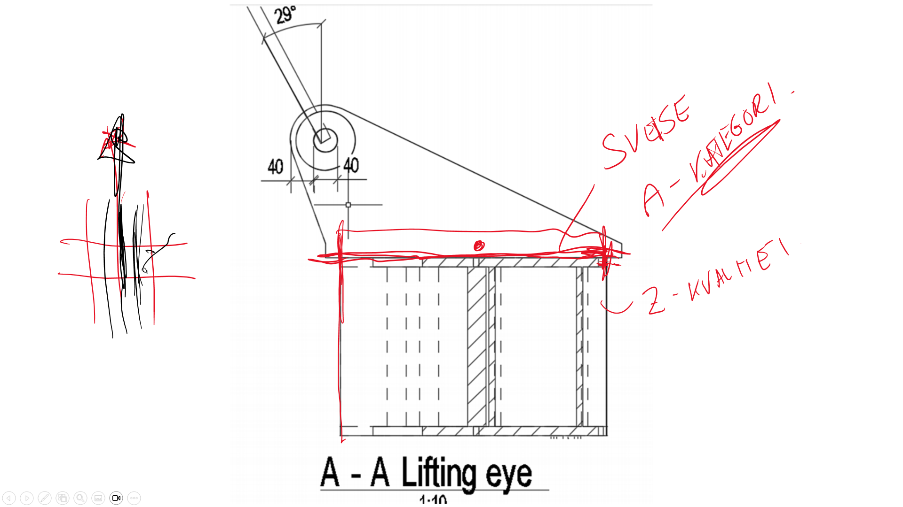
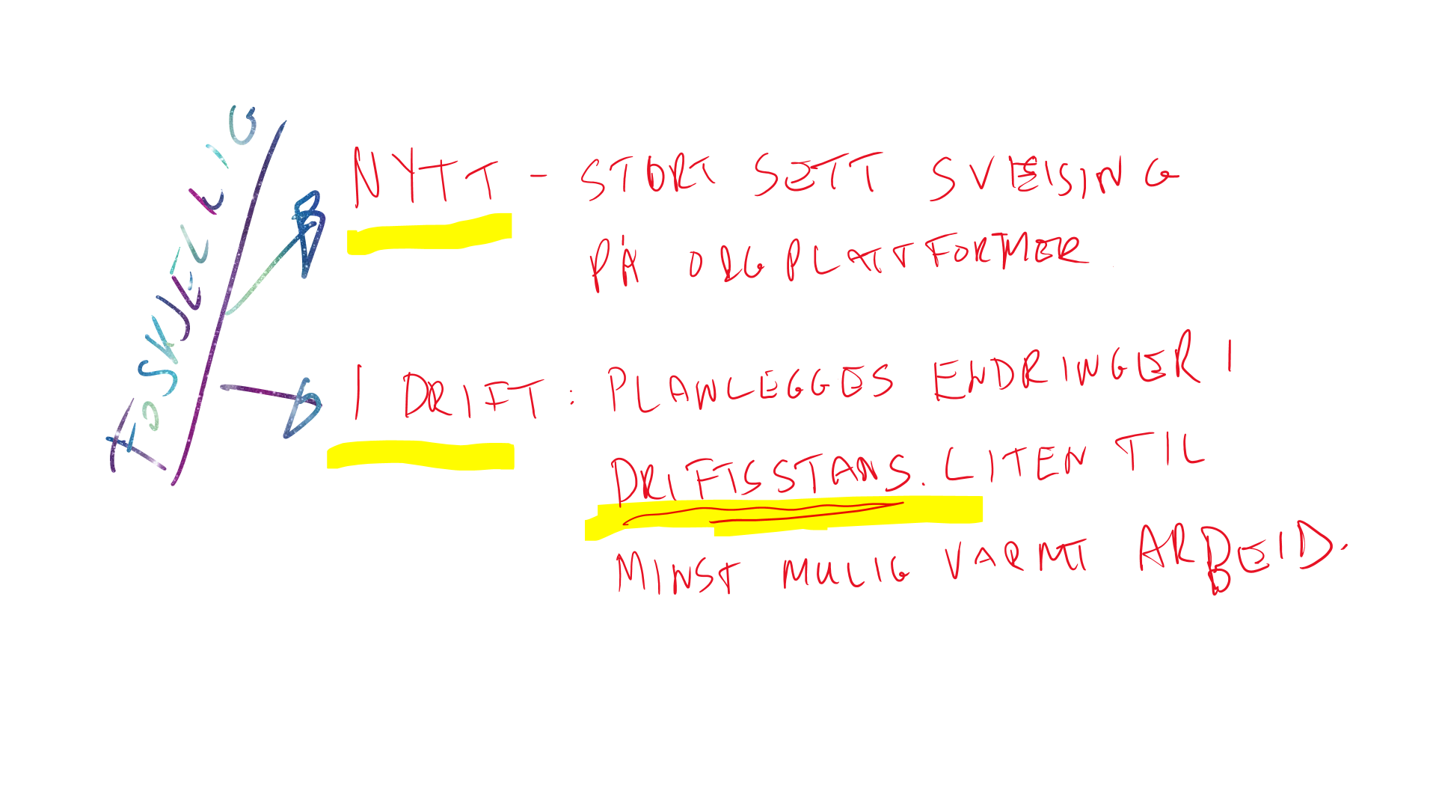
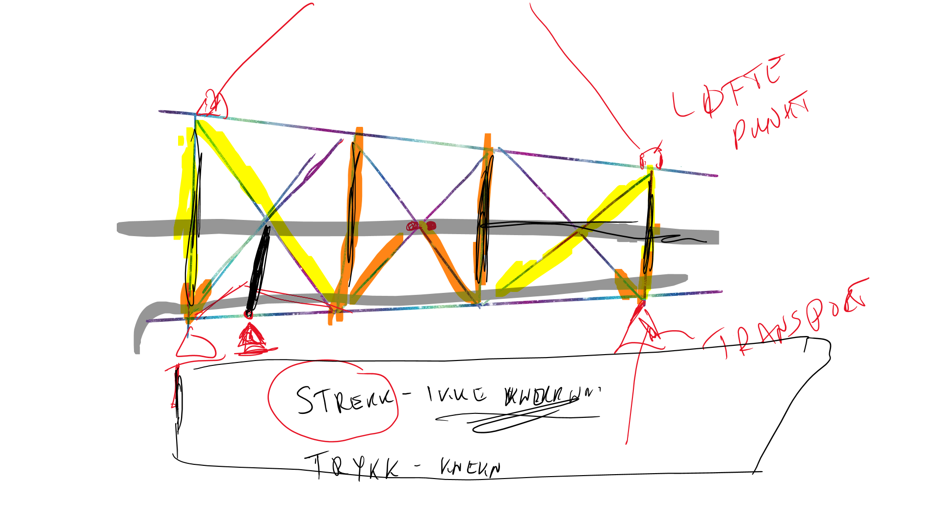
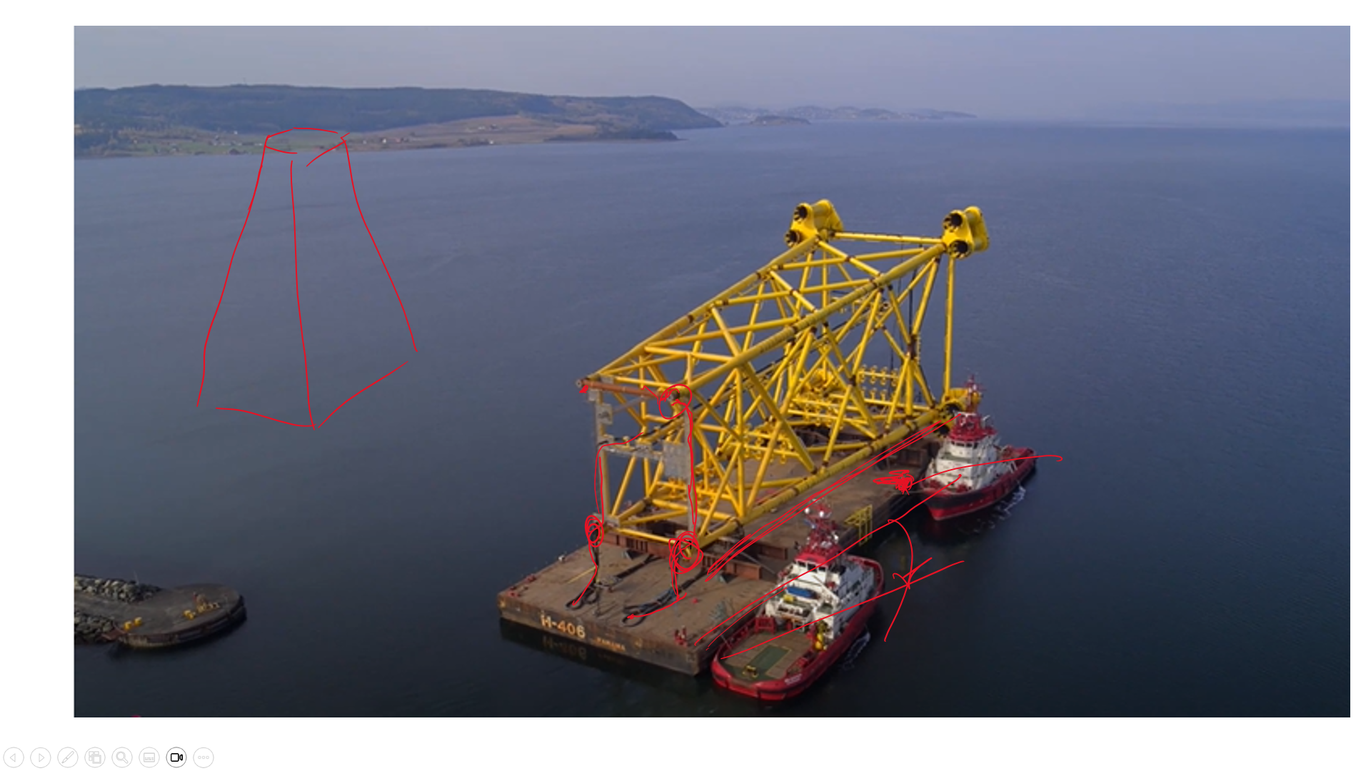
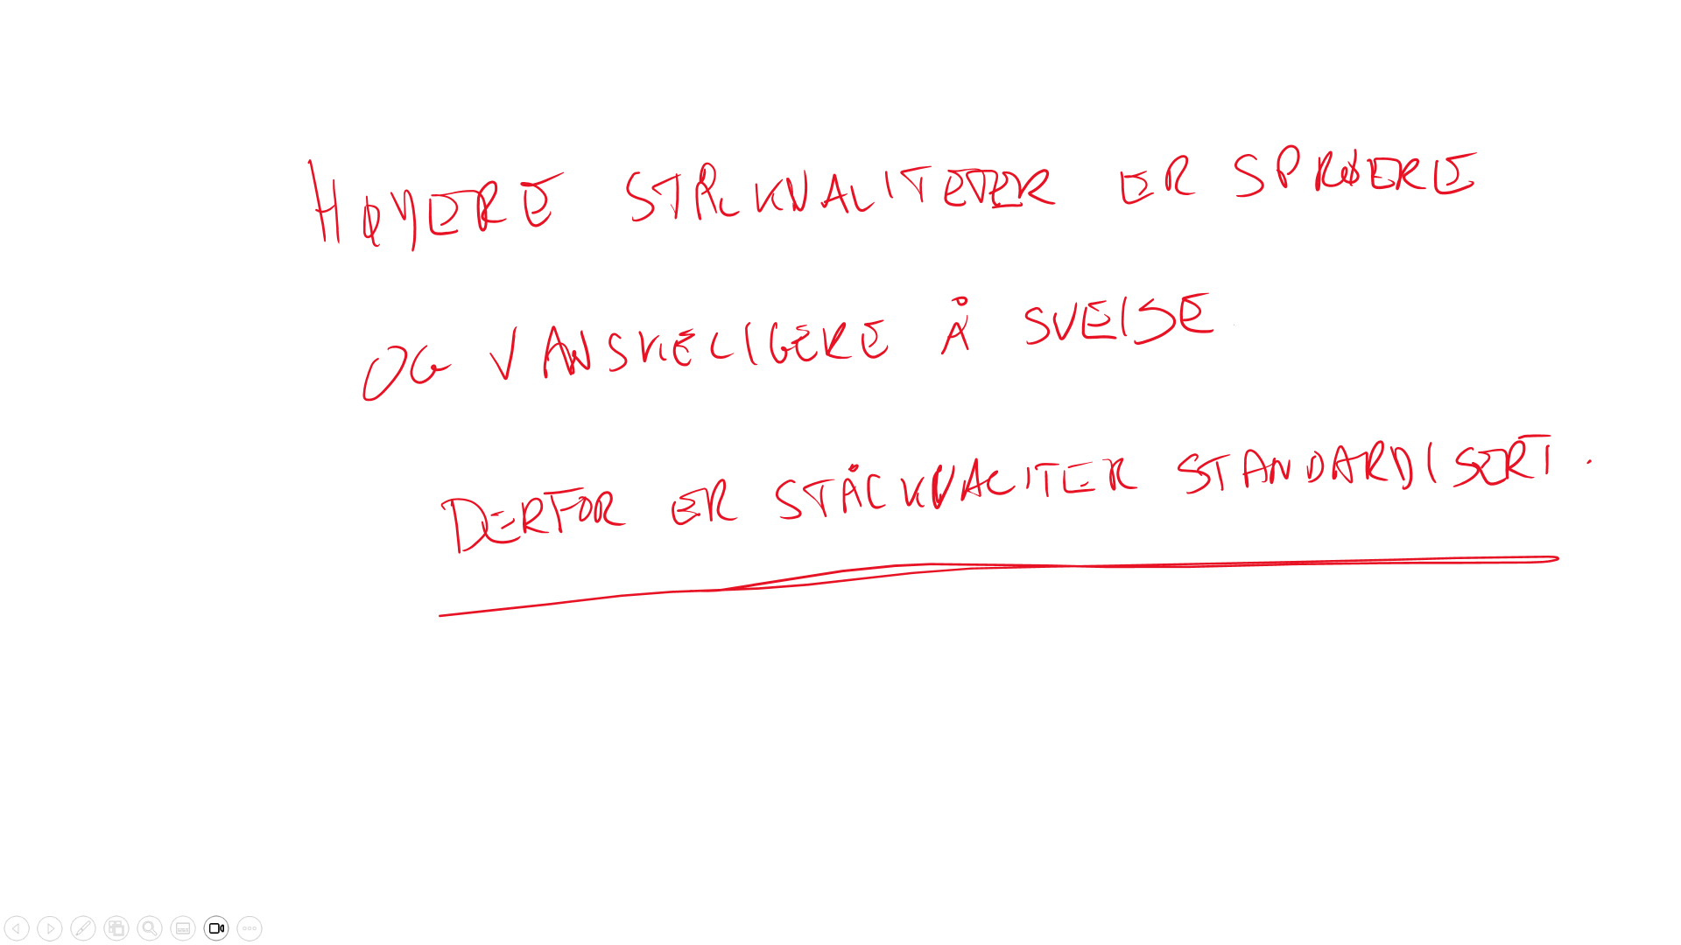
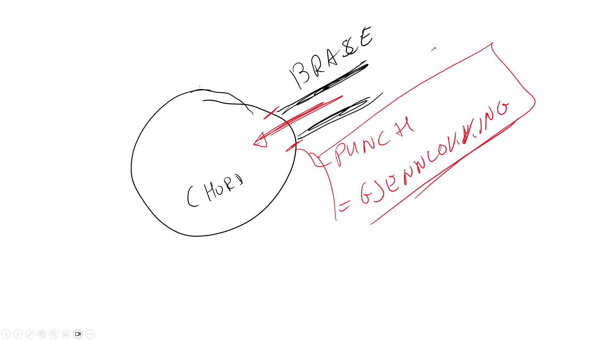
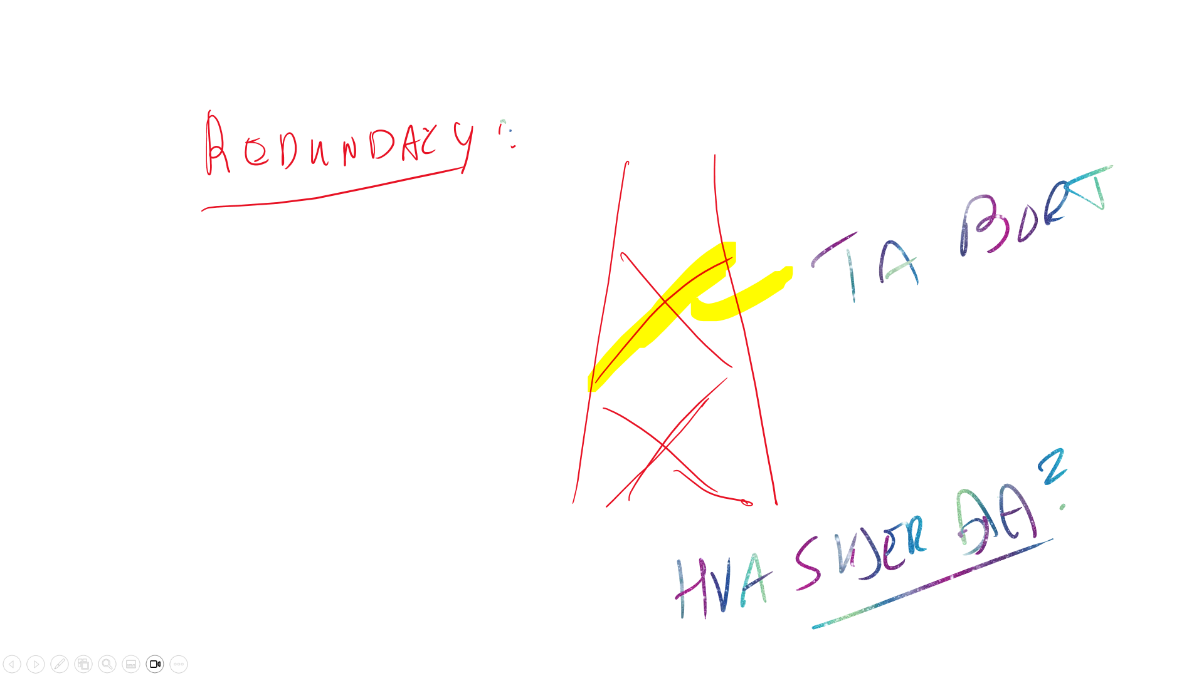
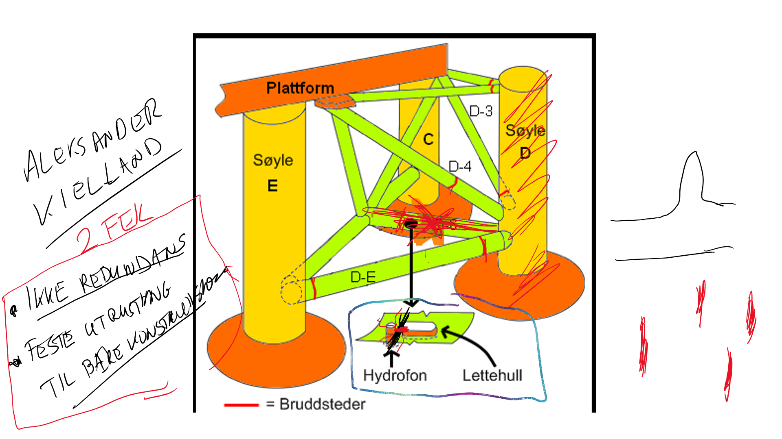
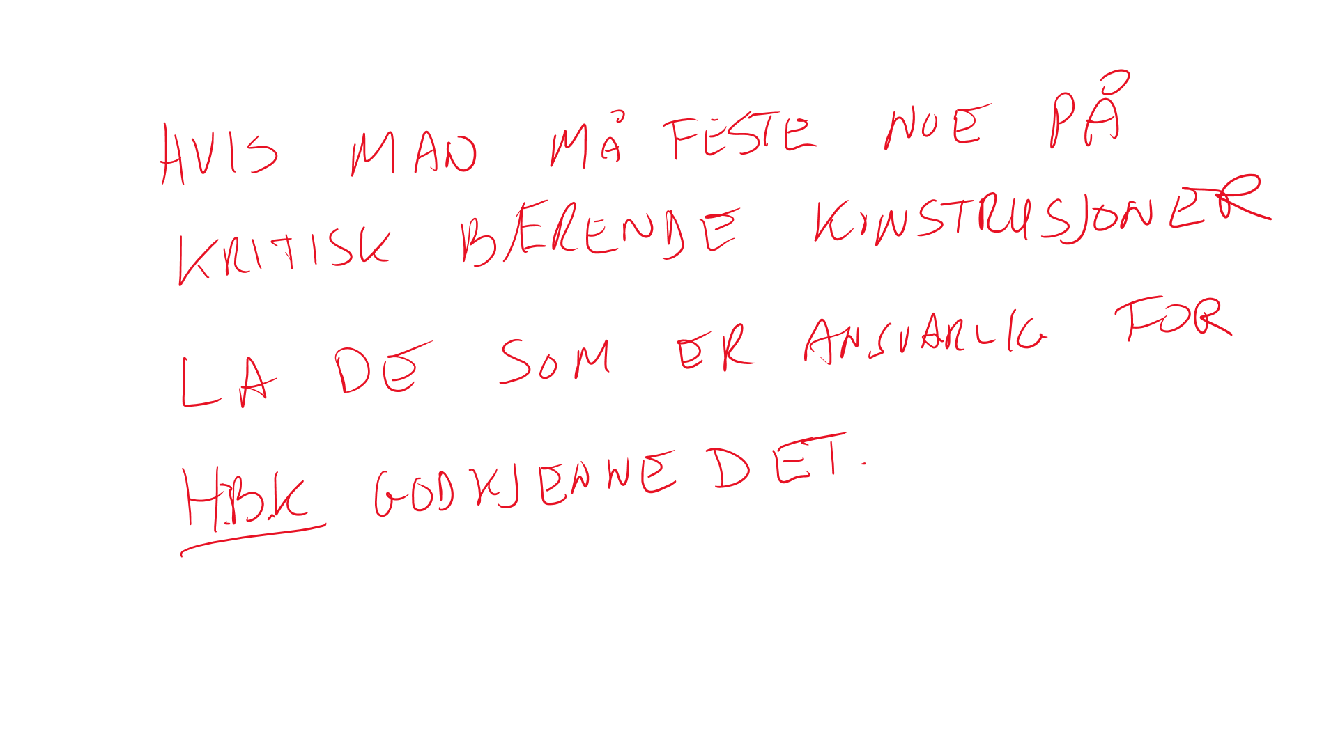

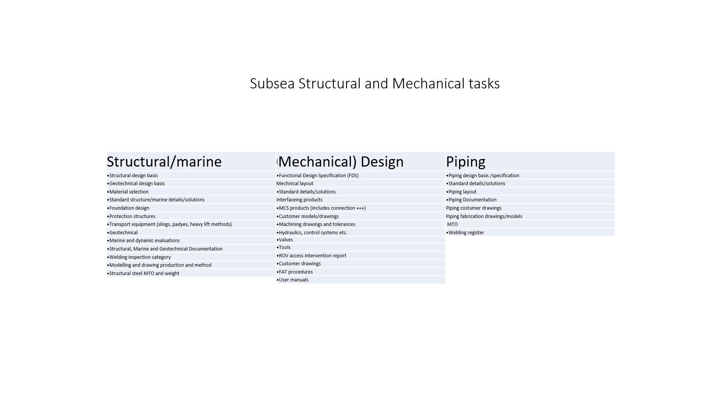
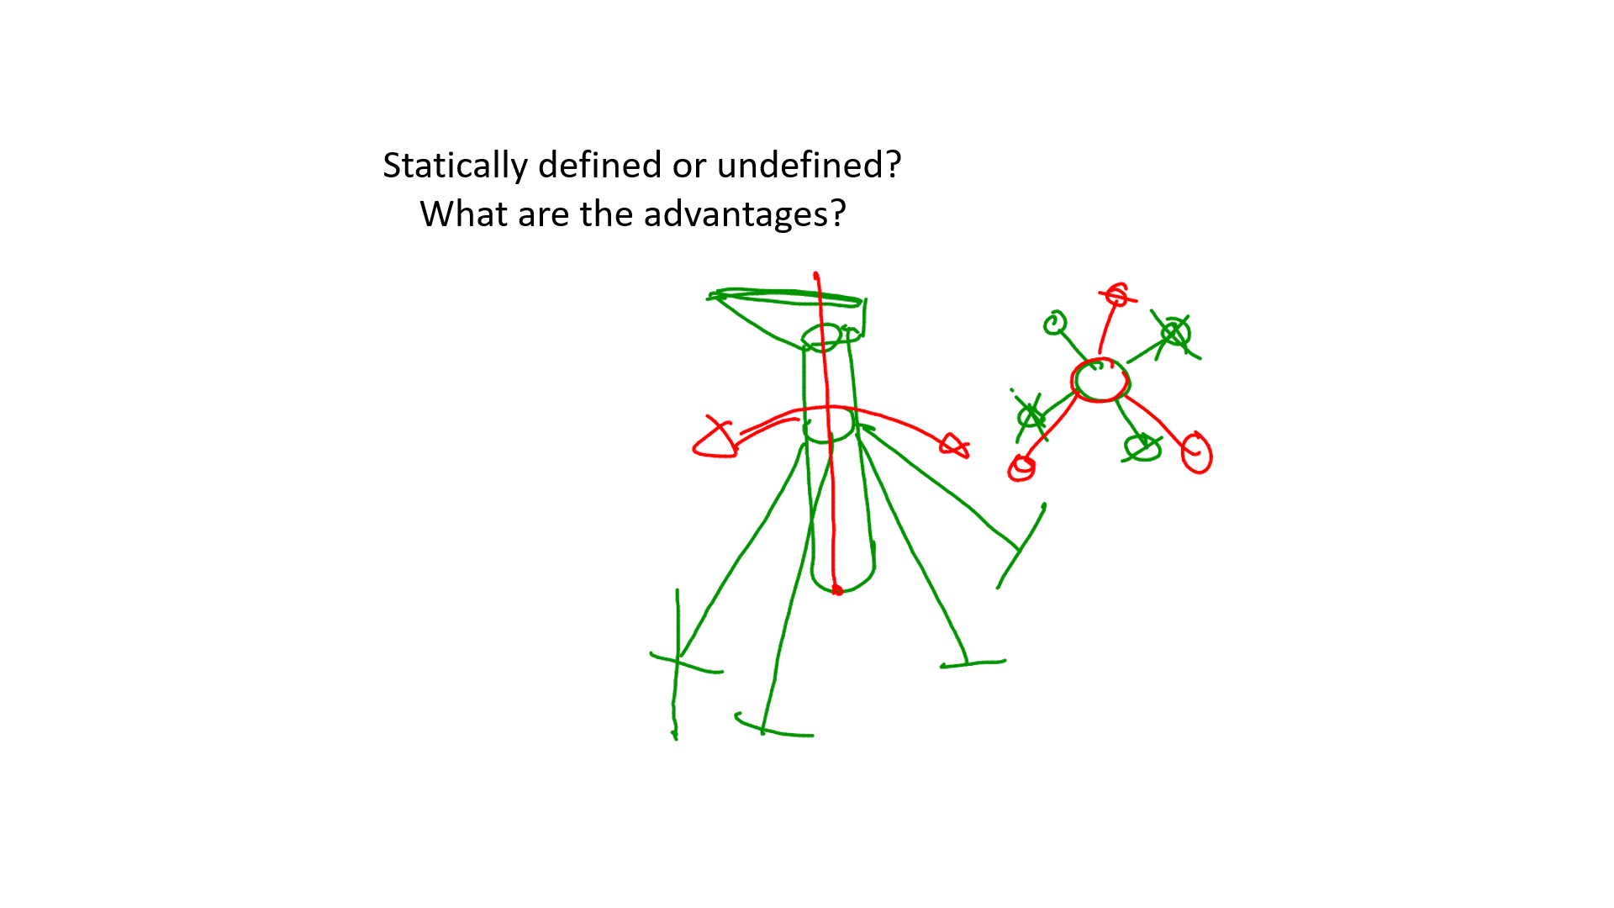
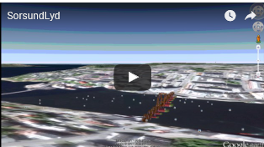

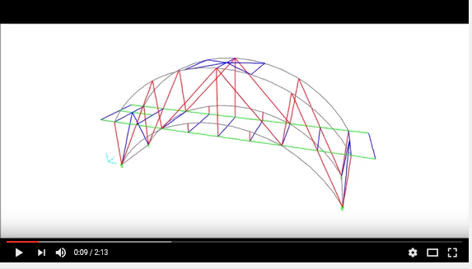

21. Global design
Innføring i Tekla. Tekla er en del av "pakken" "Idea Statica" (knutepunkter), "SAP2000" (beregningsverktøy) og "Tekla" (CAD-verktøy som er spesielt koblet til verksted og også roboter brukt i verksted) som tildels "snakker sammen". Det er mange "plugins som kan brukes her.
Se "Tekla warehouse" for muligheter.
Snarveier i Tekla: Tekla-snarveiene.docx
Tekla - introduction/modelling.
Prinsipper for design og hvordan man skal tenke når man designer konstruksjoner og ikke minst regner på konstruksjoner er gitt i denne presentasjonen.
BYGT2312-Lecture2023.10.13-DesignOfStructures.pdf
Forskjell på "fagverk", "ramme" og plater. Dvs. skjønne hvor man ofte tenker fagverk selv om, men reelt sett som regel har en rammekonstruksjon.
Betydningen av å lage en konstruksjon der man introduserer momenter når man ikke trenger det og hvordan det kan ødelegge hele ideen med konstruksjonen. Det kan medføre helt andre vekter og pris på en konstruksjon enn nødvendig.
Hvordan velge profiler og utforming knyttet til om konstruksjonen skal ta skjær, moment eller torsjon. Dvs. hvordan velge tverrsnitt og utforming slik at den passer til konstruksjonens funksjon.
Skjønne begrepene "kraftdrevet" kontra "defomasjonsdrevet" i design.
1. Kraftdrevet design av sekundundærkonstruksjoner Ja konstruksjonen står upåvirket at av hovedkonstruksjonen. Det betyr at hvis du forsterker konstruksjonen så vil spenningene til konstruksjonen bli mindre.
2. Defomasjonsdrevet design av sekundærkonstruksjon Ja hvis sekundærkonstruksjonen «bare følger med hovedkonstruksjonen» og sekundærkonstruksjonen bøyer seg like mye til tross for at du har forsterket den så er den deformasjonsdrevet. Det betyr at spenningene i sekundærkonstruksjonen kan bli høyere hvis du forsterker den siden den blir stivere. Løsningen hvis spenningene er for store da er å lage konstruksjonen mykere slik at hovedkonstruksjonens bevegelser ikke påvirker kreftene i sekundærkonstruksjonen like mye. Situasjonen kan til og med bli bedre hvis man går ned i dimensjon. En sekundærkonstruksjon skal ikke påvirke kraftgangen i hovedkonstruksjonen. Det er derfor viktig at den står selvstendig og at den tåler de bevegelser hovedkonstruksjonen har. Hvis man ikke klarer å unngå at sekundærkonstruksjonen påvirker kraftgangen i hovedkonstruksjonen må man vurdere om den skal bli en del av hovedkonstruksjonen.
Eksempler på utfordringer og løsninger fra virkelige prosjekter:
BYGT2312-Lecture2023.10.13-DesignOfSteelStructuresSolutionsFromRealProjects.pdf
Bruk av tverrskott kontra langsgående lukka profiler. Hva er mest effektivt?
Fotplateutforming mot dekk. Hvordan kan den overgangen lages koblet til grad av varierende laster som konstruksjonen utsettes for. Det vil si hvor utmatningspåkjent konstrusjonen er.
Eksempel på utmatningsvennlig overgang fra flens til vegg.
Eksempel på hvordan man kan sette sammen overganger mellom ulike dimensjoner for å unngå "sveis på sveis". Sveis endrer konsistensen på grunnmatrialet. Flere sveiser på samme sted er derfor uheldig. Det er god designpraksis å forsøke å unngå "sveis på sveis".
Eksempel på overgang mellom liten og stor I-bjelke (IPE, HEA, HEB evt. oppsveist f.eks.)
Eksempel på overgang mellom firkantprofil og flens for å gjøre overgangen mer utmatningsvennlig.
Eksempel på knutepunkt og overganger med bruk av firkantprofiler (RHS-profiler). Slike knutepunkter er mykere enn det vi normalt regner med i en globalanalyse i f.eks. SAP2000. Det medfører høyere momenter i knutepunktene enn det som er virkeligheten. Generelt sett så kan man også si at et slikt knutepunkt har mindre kapasitet enn hva det ville vært hvis man hadde brukt tilsvarende åpne profiler (dvs. IPE, HEA, HEB).
For platedekke (som også fungerer for å ta opp skjær, det vil si at dekket har en dobbeltfunksjon. Det tar laster lokalt og fungerer for å ta skjærkrefter globalt) ville det vært med naturlig å velge HP-profil framfor sveiste profiler. Dette da dette gir ganske mye mindre jobb i verksted.
Bulb Flats - Shipbuilding / Oil & Gas Profiles | Özkan Steel (ozkansteel.com)
Hvis man ikke trenger denne platen/dekket til å ta skjær kan man heller velge en gratingløsning.
GRP Grating | Marine and Rig Applications Photo Gallery (safetread.co.uk)
Hva er en stiver? (fra Google)
Stiffeners are secondary plates or sections which are attached to beam webs or flanges to stiffen them against out-of-plan deformations. Almost all main bridge beams will have stiffeners.
Hva er hensikten med en stiver?
The main purpose of Stiffener in a plate girder is to prevent the buckling of web. In which different type of stiffeners are used. Stiffeners: Stiffeners are used to make plate girder stiff or rigid. a) Intermediate transverse web stiffener — to improve the buckling strength of a slender web due to shear.
Hva er rollen til en stiver i et knutepunkt?
Stiffeners have one or both of the following functions. One is to control local buckling and the other is to connect bracing or transverse beams. It is a common practice to provide stiffeners to achieve the necessary moment of resistance in the connection.
Jeg vil kanskje legge til at man kan styre stivheten til knutepunktet slik at det får den funksjonen knutepunktet er tiltenkt. Skal det være fast innspent, leddet eller noe i mellom?
=======================================
Hva er systemlinjer i en konstruksjon?
Systemlinjer beskriver hvordan det statiske systemet fungerer. Det er ikke alltid lett å se hvordan en konstruksjon fungerer uten å ha litt trening men det kan også angis på en tegning (uten at jeg har sett at det har blitt gjort). Fant en referanse på dette her på denne linken:
http://files.noroff.no/lc/ted/courses/cad/05/m3-1/06.html
Systemlinjene er den informasjonen vi trenger for å kunne regne på konstruksjonen og lage en regnemodell av konstruksjonen.
Vi ser på Idea Statica og noen ideer rundt dette med designløsninger på knutepunkter og hvordan dette programmet er satt opp.
Studentene jobber med modeller i Tekla. Faglærer har leget en modell med ulike løsninger basert på problemstillinger presentert i foregåenede foreslesing. Tanken er å ta ugangspunkt i denne modellen.
Teklamodellen for disse eksemplene finnes her:
PipeSupport.db1
I NORSOK klassifiseres sveier etter kritkalitet. Sveisen kan være kritisk av ulike grunner og som vi kommer tilbake til koblet til. Hvordan konstruksjonen er utformet og hvor høyt sveisen er utnyttet har noe å si selvsagt.
Vi ser på sveiser i Tekla og sveissymboler.
Vi ser på det å modellere sveiser i Tekla:
- Create welds | Tekla User Assistance
- Change a weld to a polygon weld | Tekla User Assistance
Vi ser på designproblemene i øving 3.
Materialvalg og kritikalitetsløsninger
BYGT2312-Lecture2023.10.13-MaterialSelectionCriticaliyEvaluationsNORSOK.pdf
Begrepene "hovedstål", "sekundærstål" og "utrustningsstål" og hvorfor man deler inn en konstruksjon etter slike prinsipper.
Design av konstruksjoner designes slik at man minimerer muligheten for brudd og skade. Prosessen er derfor slik:
1. Vurdere konstruksjonens viktighet
2. Finn riktig materiale ut fra kritikatlitet og utforming
3. Utform konstruksjonsdetaljen best mulig ut fra kriteriene kritikalitet, utnyttelse og det å lage løsningen byggbar
4. Finn og angi inspeksjonsomfang på tegningen
Vedlegg til eksamen - NORSOK (å laste ned standarder anbefales):
NORSOK-summary.docx
Ulike løsninger. Dårlige løsninger for forbindelser ble gjennomgått knyttet til dette eksempelet koblet til materialvalg, redundans, stivhetsbetraktninger i knutepunkter opp mot beregninger. Her er det mange dårlige valg spesielt hvis konstruksjonen er utsatt for sykliske laster (utmatning). Dette er underlag for refleksjon for øving 3.
HusTaarn.db1
Hvis denne ikke lar seg åpne pga. gammel versjon av Tekla kan "IFC-fil" benyttes, men da mister man informasjon om sveis i modellen.
out.ifc
Kritikalitet med tanke på brudd:
Det ble diskutert at knutepunktene må ikke ryke først i en konstruksjon for da får man et plutselig og ukontrollert brudd. Når man regner så er det bedre å ha for stor stivhet i knutepunktene enn motsatt med tanke på at dimensjonerende moment i knutepunktet blir konservativt og ikke i søyla/bjelken. Et alternativ kan være 2 modeller. En for dim. av knutepunkter og en for søyler/bjelker/staver. Et RHS-knutepunkt kan derfor være brudd på dette prinsippet, men for verkstedet er dette en foretrukket løsning da det er både lettere å kutte og sveise. Denne løsningen blir derfor likevel ofte brukt.
Vi kommer i gang på Idea Statica - knutepunktsprogram
Vi ser på et slikt knutepunkt med RHS-profiler og regner på det.
Conn-59.ideaCon
Overgang med stiver - hvor lang trenger flensen å være?
Conn-23.ideaCon
Gjennomgang av ulike løsninger:
BYGT2312-Lecture2023.10.26-HusTaarnDiskusjon.pdf
Her det veldig mange dårlige løsninger som strider mot det som er angitt i NORSOK og god designpraksis. Det er å merke seg at løsningene er fabrikasjonsvennlige noe som kan være et dilemma mange ganger. Dette da fabrikasjonsvennlige løsninger også gir mer kostnadseffektive løsninger.
Klassifisering av knutepunkter ihht. NORSOK:
BYGT2312-Lecture2023.10.26-KlassifiseringAvKnutepunkter.pdf

Design solutions - discussion
- linked to problem set 3

Notat fra Måseide - underlag premisser design
NORSOK -Design Fabrikasjon-MOM-2015.pdf
Oppsummering sentrale stikkord for design:
Forelesning20221019-Designløsninger-forklaring-tavleskisser.pdf
Klassifisering av knutepunkter:
BYGT2312-Lecture2023.10.26-KlassifiseringAvKnutepunkter2.pdf
Se også i Eurocode for knutepunkter der flere detaljer er angitt.
Vanlige desigDesign av jacket med bilde av "Airgap", "Splash Zone" og "korrosjonssbeskyttelse i splashsone" samt "anodebeskyttelse".
JacketDesign20220906.pdf
Noen stikkord rundt val av tverrsnitt og z-kvalitet:
BYGT2312-Lecture2023.10.27-StikkordKonsekvensValgAvTverrsnitt.pdf
Utforming inkludert stivhetsbetrakninger internt i et knutepunkt:
BYGT2312-Lecture2023.11.02-UtformingAvKnutepunkter.pdf
Bolteberegninger:
BYGT2312-Lecture2023.11.02-Bolteberegninger.pdf
Sveiseberegninger - eksempler:
Sveiseforbindelser-statisk-forelesningnotater-15v.pdf
Hevarm problemstilling for bolteknutepunkter.
Forelesning20221031-SveisOgBolterHevarm.pdf
Supportering med stålplate:
JointBoltedSteel.ideaCon
Supportering mot betong:
JointBolted-ver2.ideaCon
Sveissymboler:
BYGT2312-Lecture2023.10.26-SveiseSymbol.pdf
Forelesning20221026-SveisOgSveisesymboler.pdf
Bransjen er veldig engelskdominert så det er viktig å kunne noen av de mest sentrale begrepene både på norsk og på engelsk.
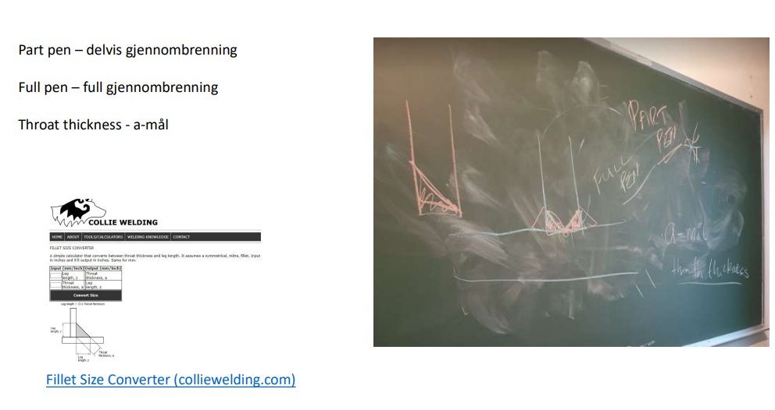
https://www.colliewelding.com/filletconverter.php

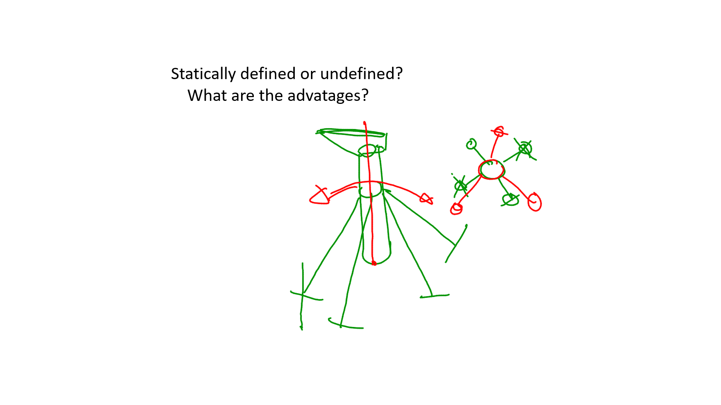
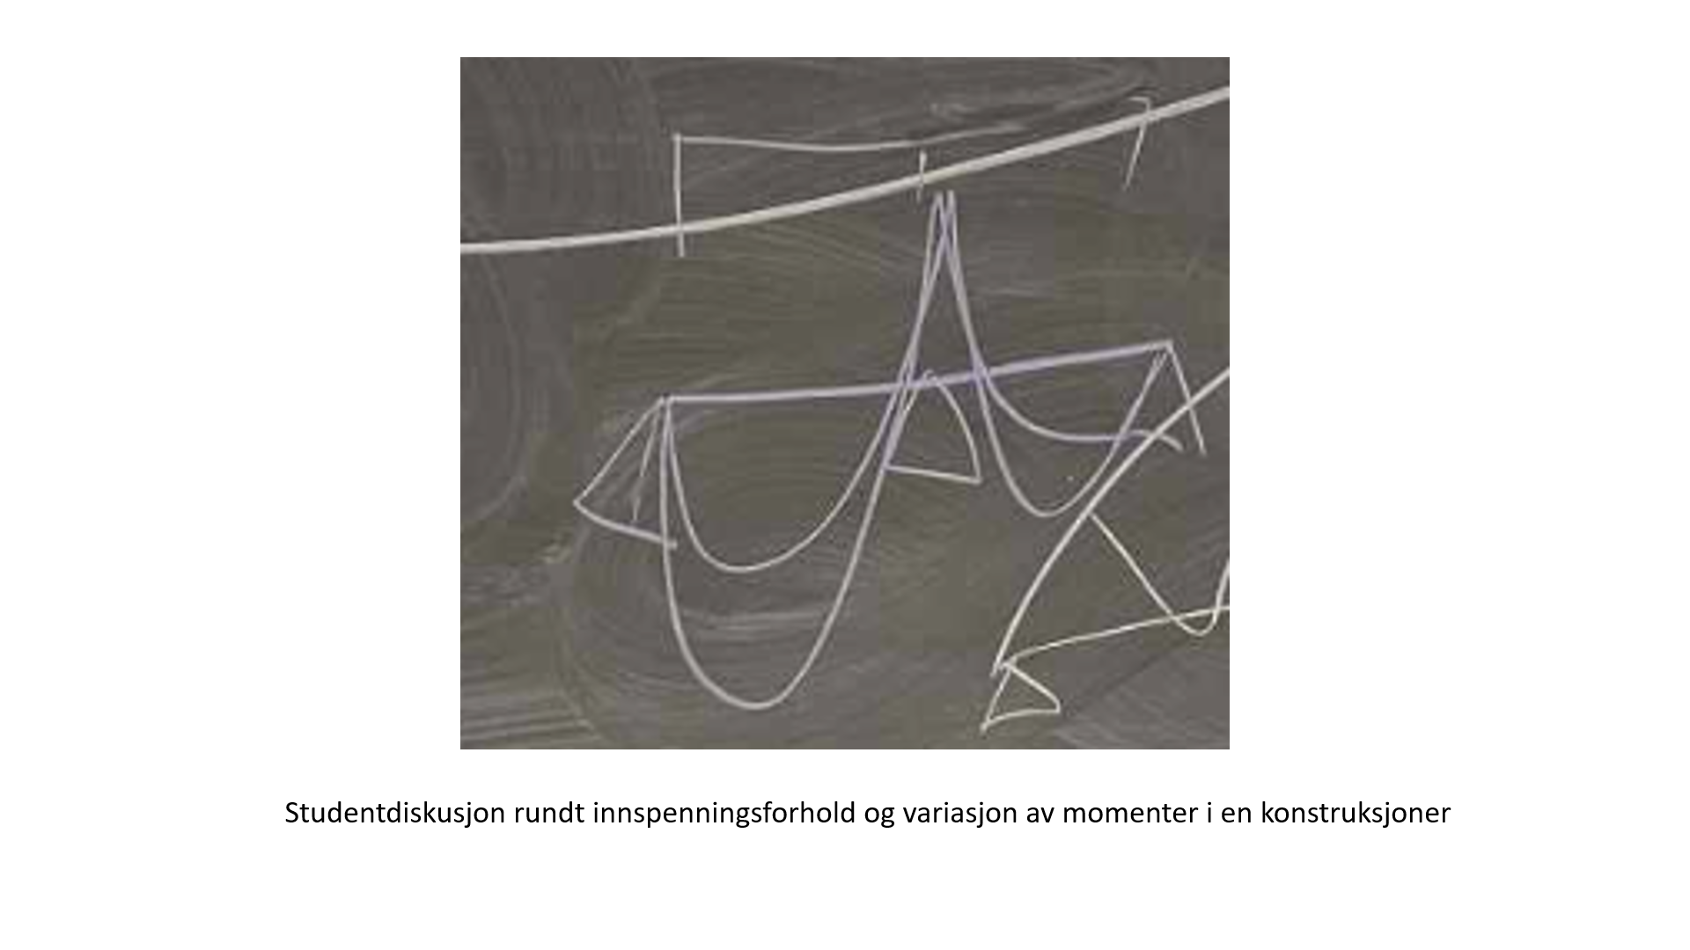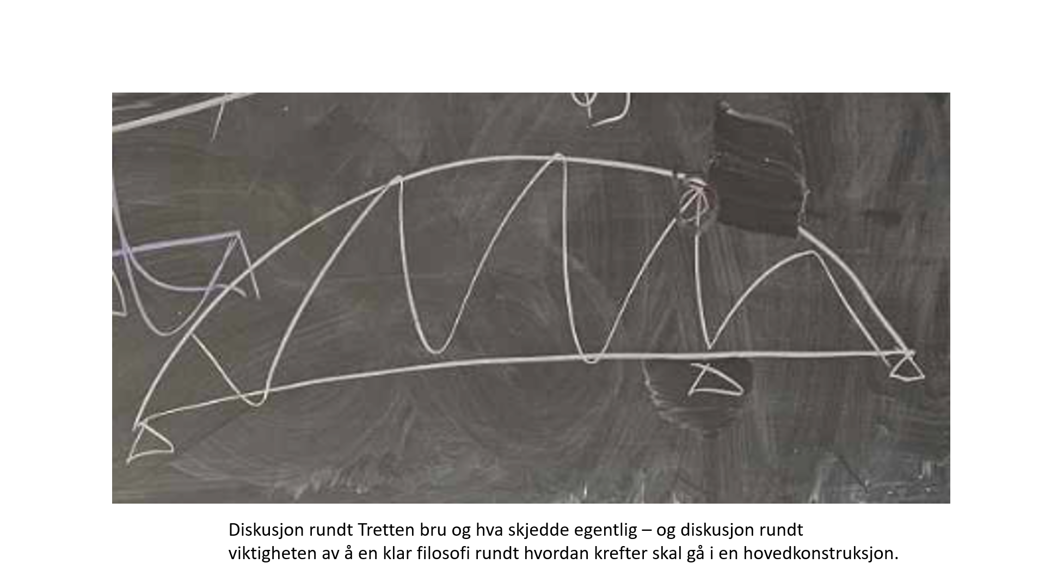

7. Buckling of beams and plates

23. Foundation and foundation design (Marine Geotechnical design)

Piles and pile cluster
Suction anchor
Mud mats

21. Global buckling

Global og lokal knekkning samt interaksjon
TBYG3011-20181029-Beregningseksempel.pdf
Vipping fra forenklet metode til mer detaljert beregning hentet fra aluminiumsstandarden Eurocode
TBYG3011-20181029-Vipping1.pdf

22. Local design

Innføring i Tekla. Tekla er en del av "pakken" "Idea Statica" (knutepunkter), "SAP2000" (beregningsverktøy) og "Tekla" (CAD-verktøy som er spesielt koblet til verksted og også roboter brukt i verksted) som tildels "snakker sammen". Det er mange "plugins som kan brukes her.
Se "Tekla warehouse" for muligheter. Link til oversikt over «kjappkomandoer».
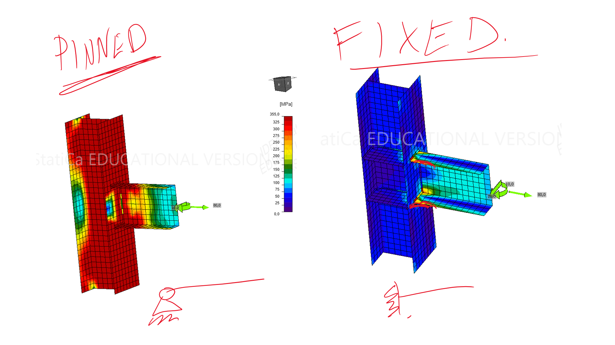
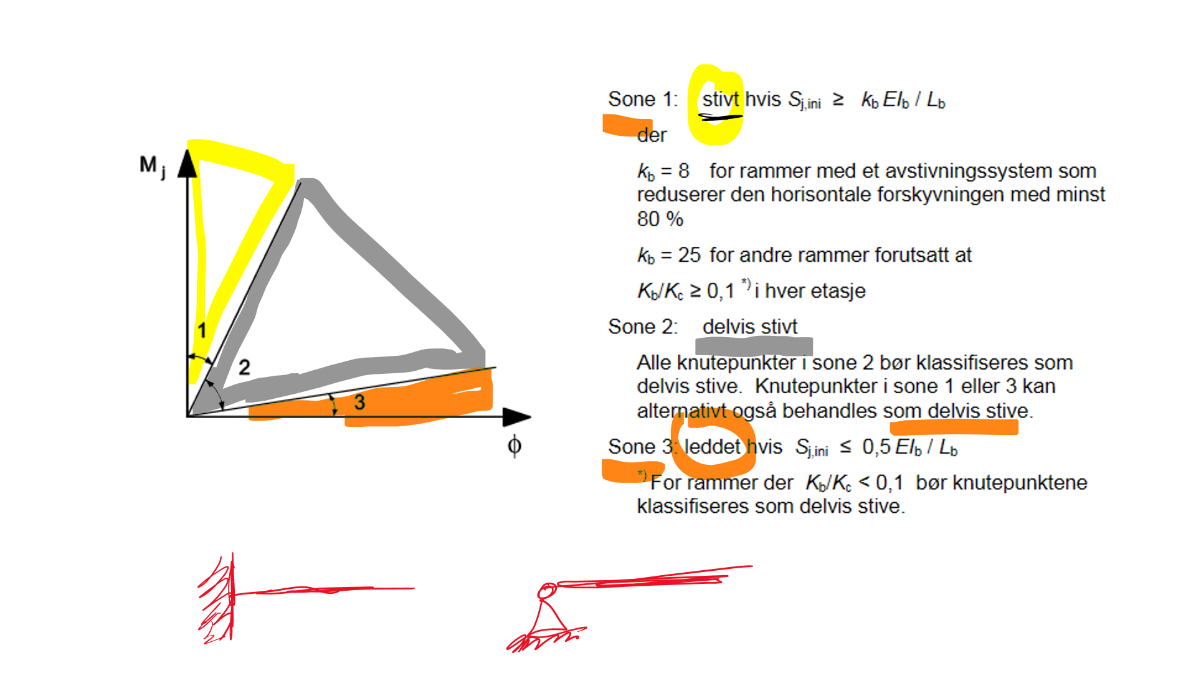

young's formula tubular joints

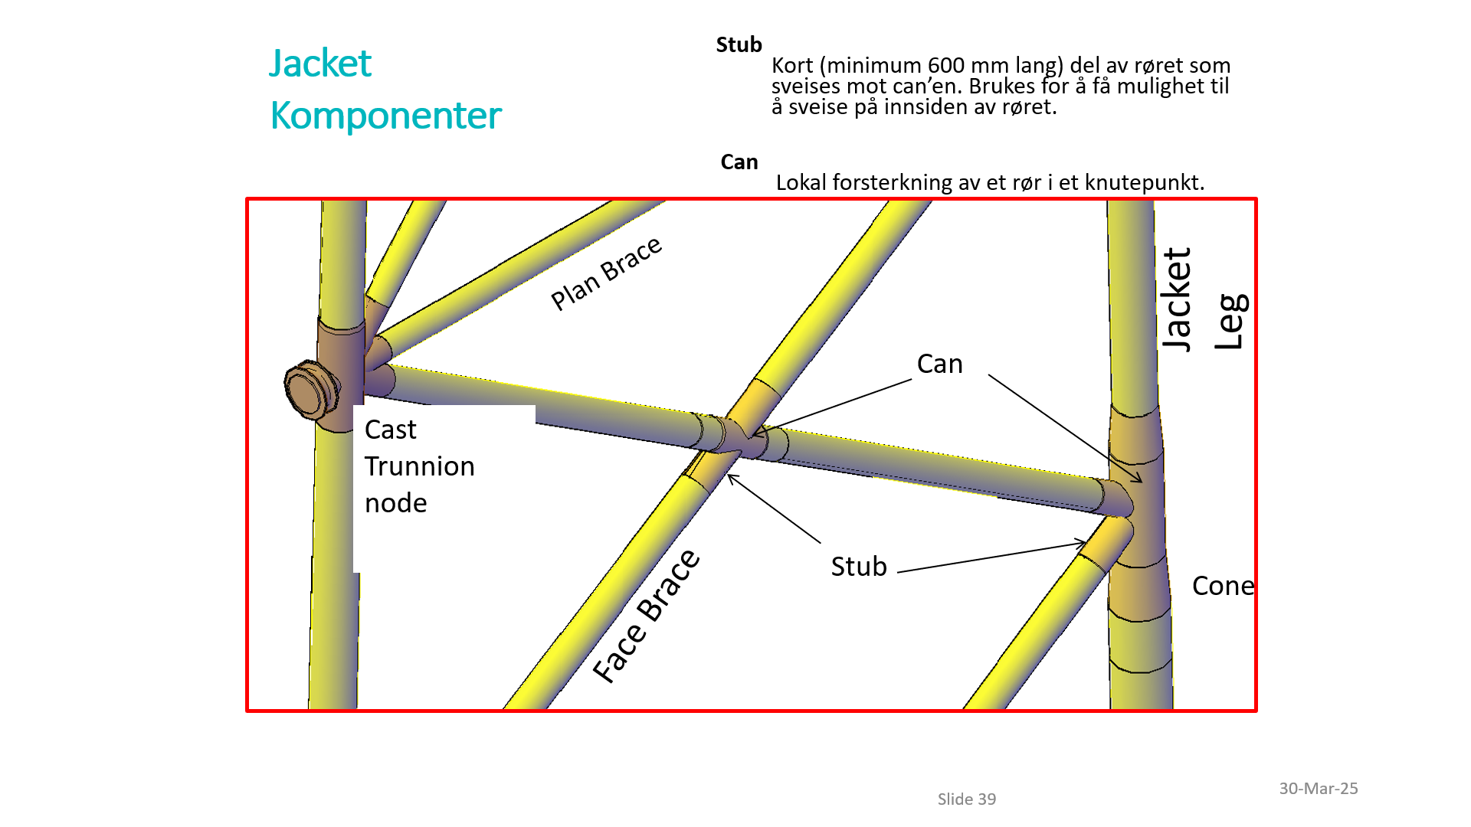
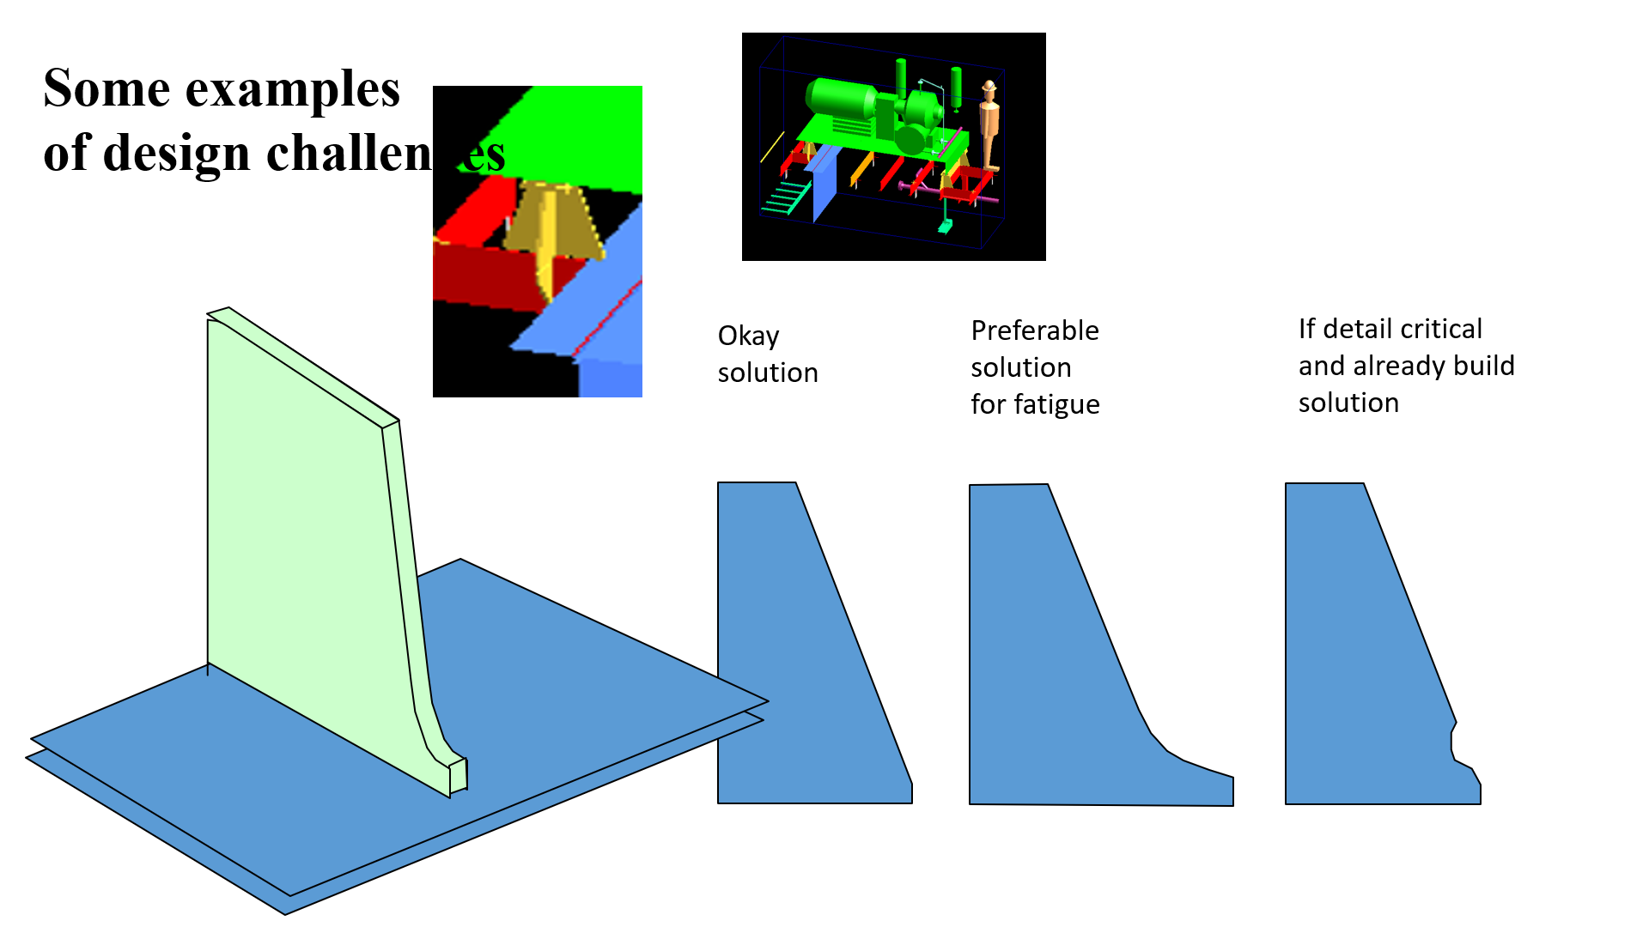
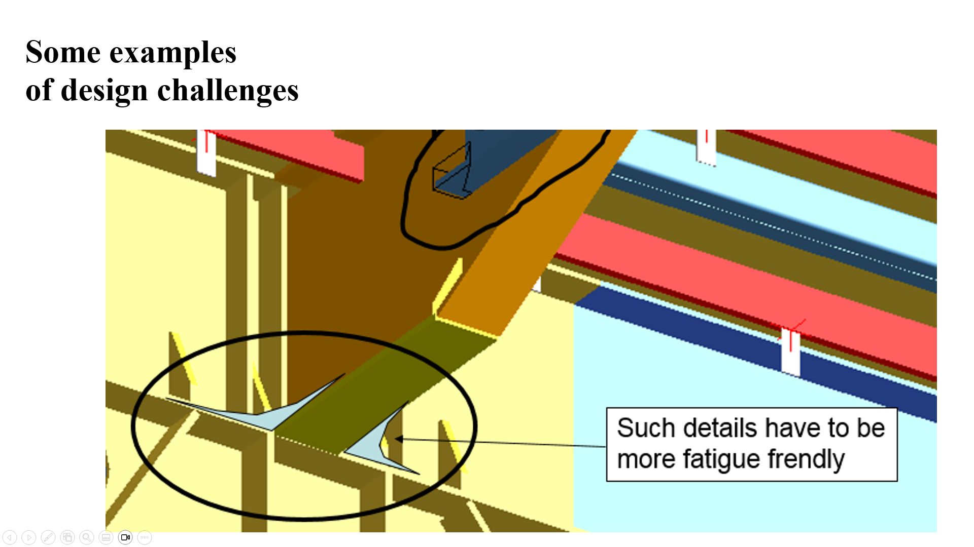
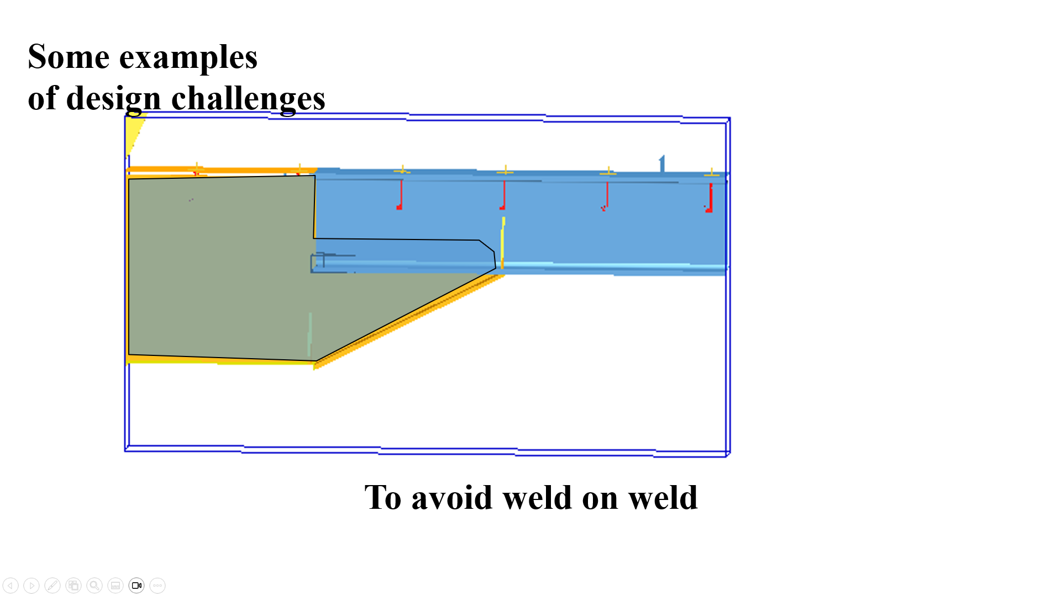
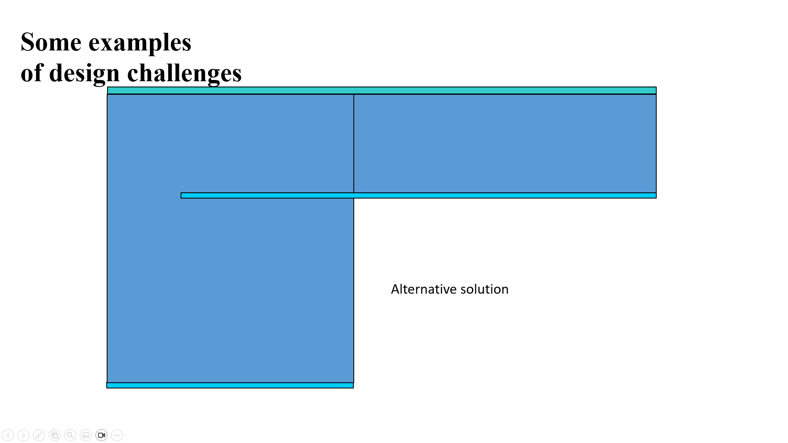
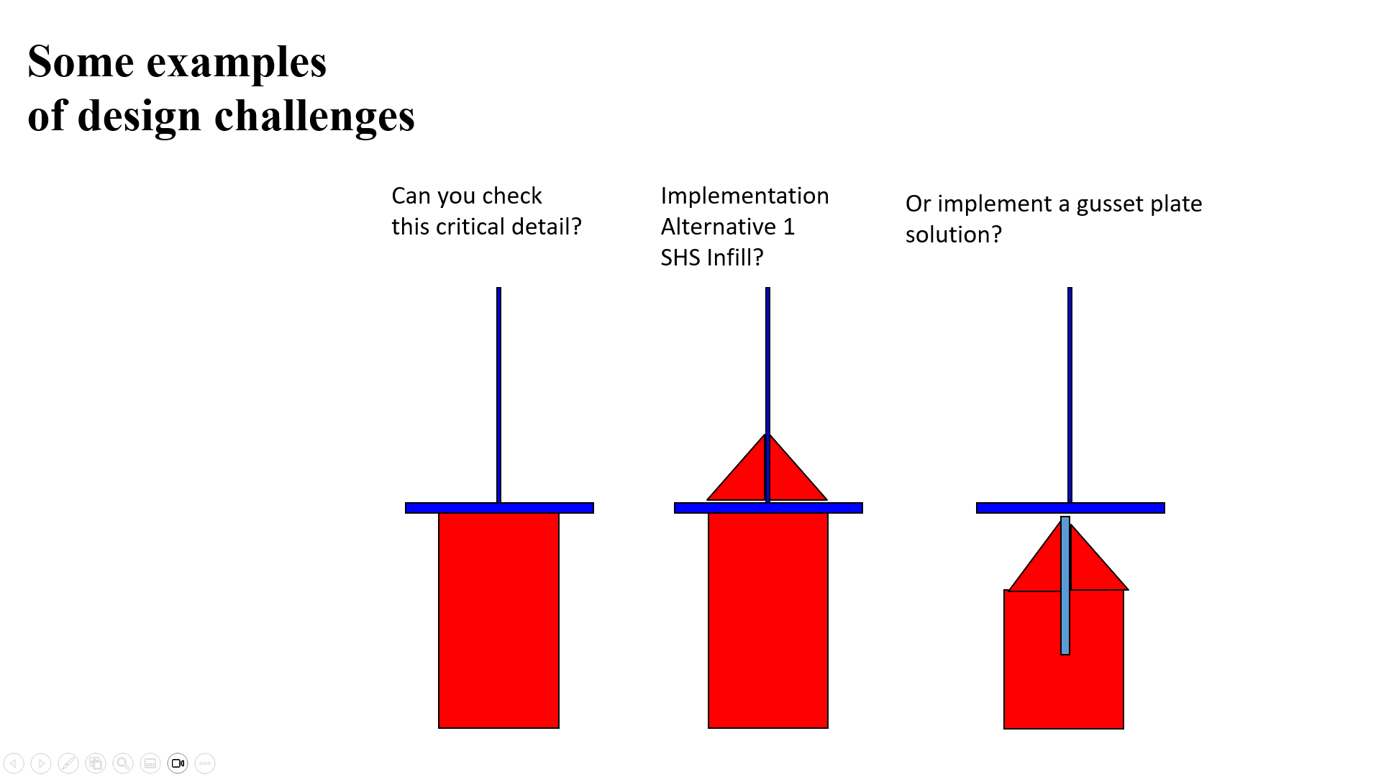
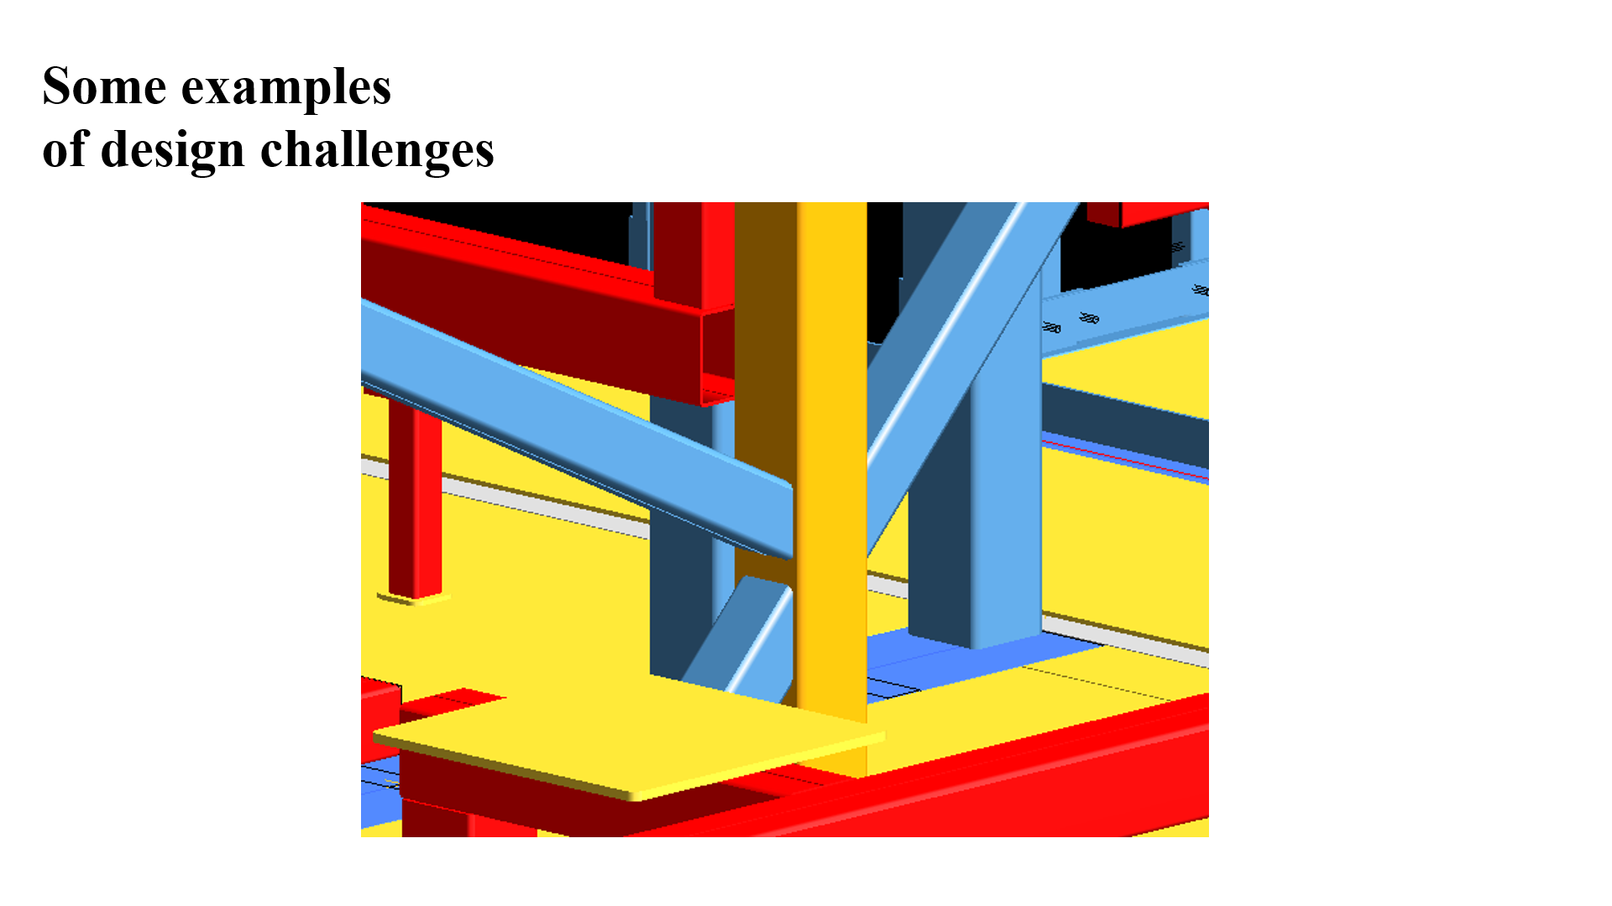
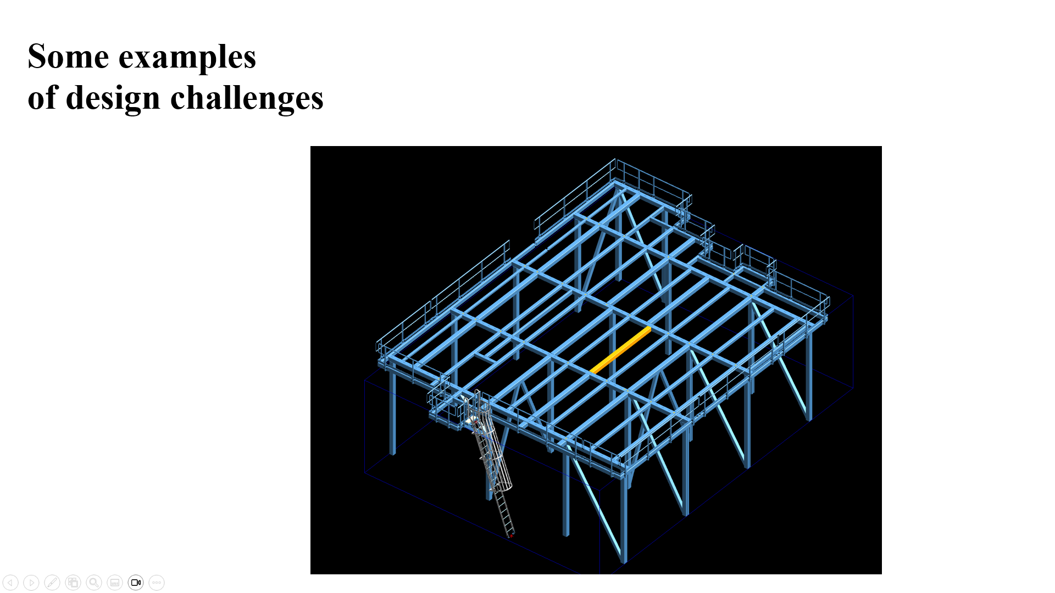
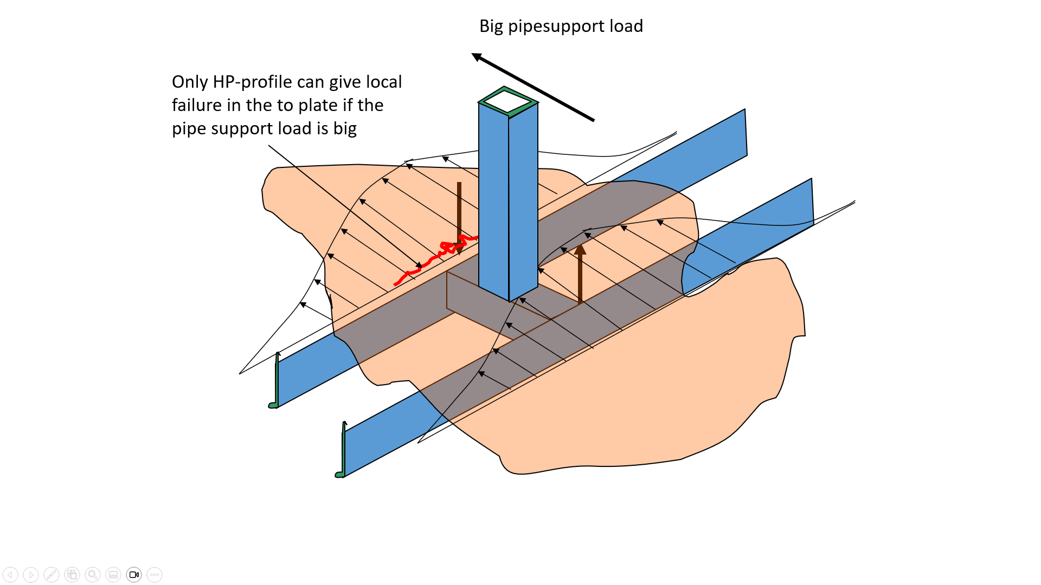
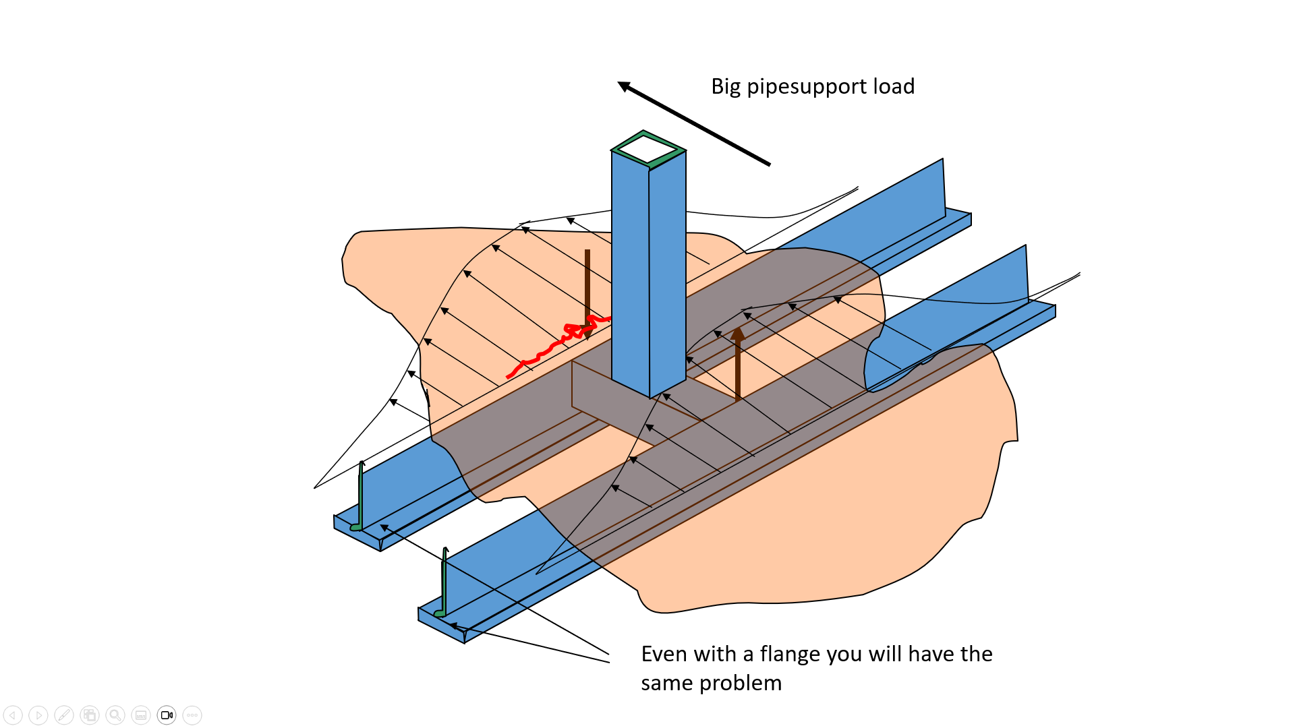
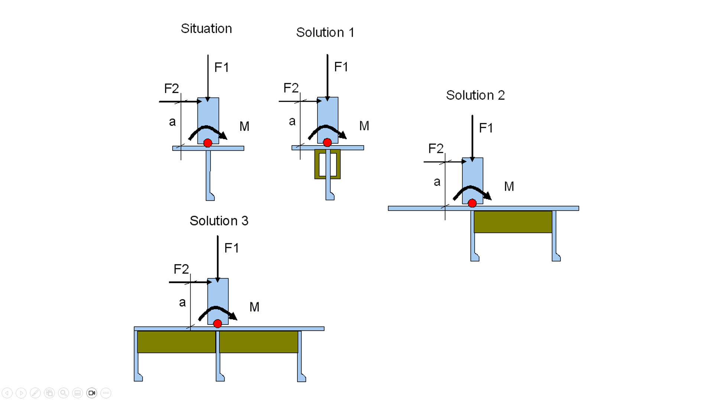
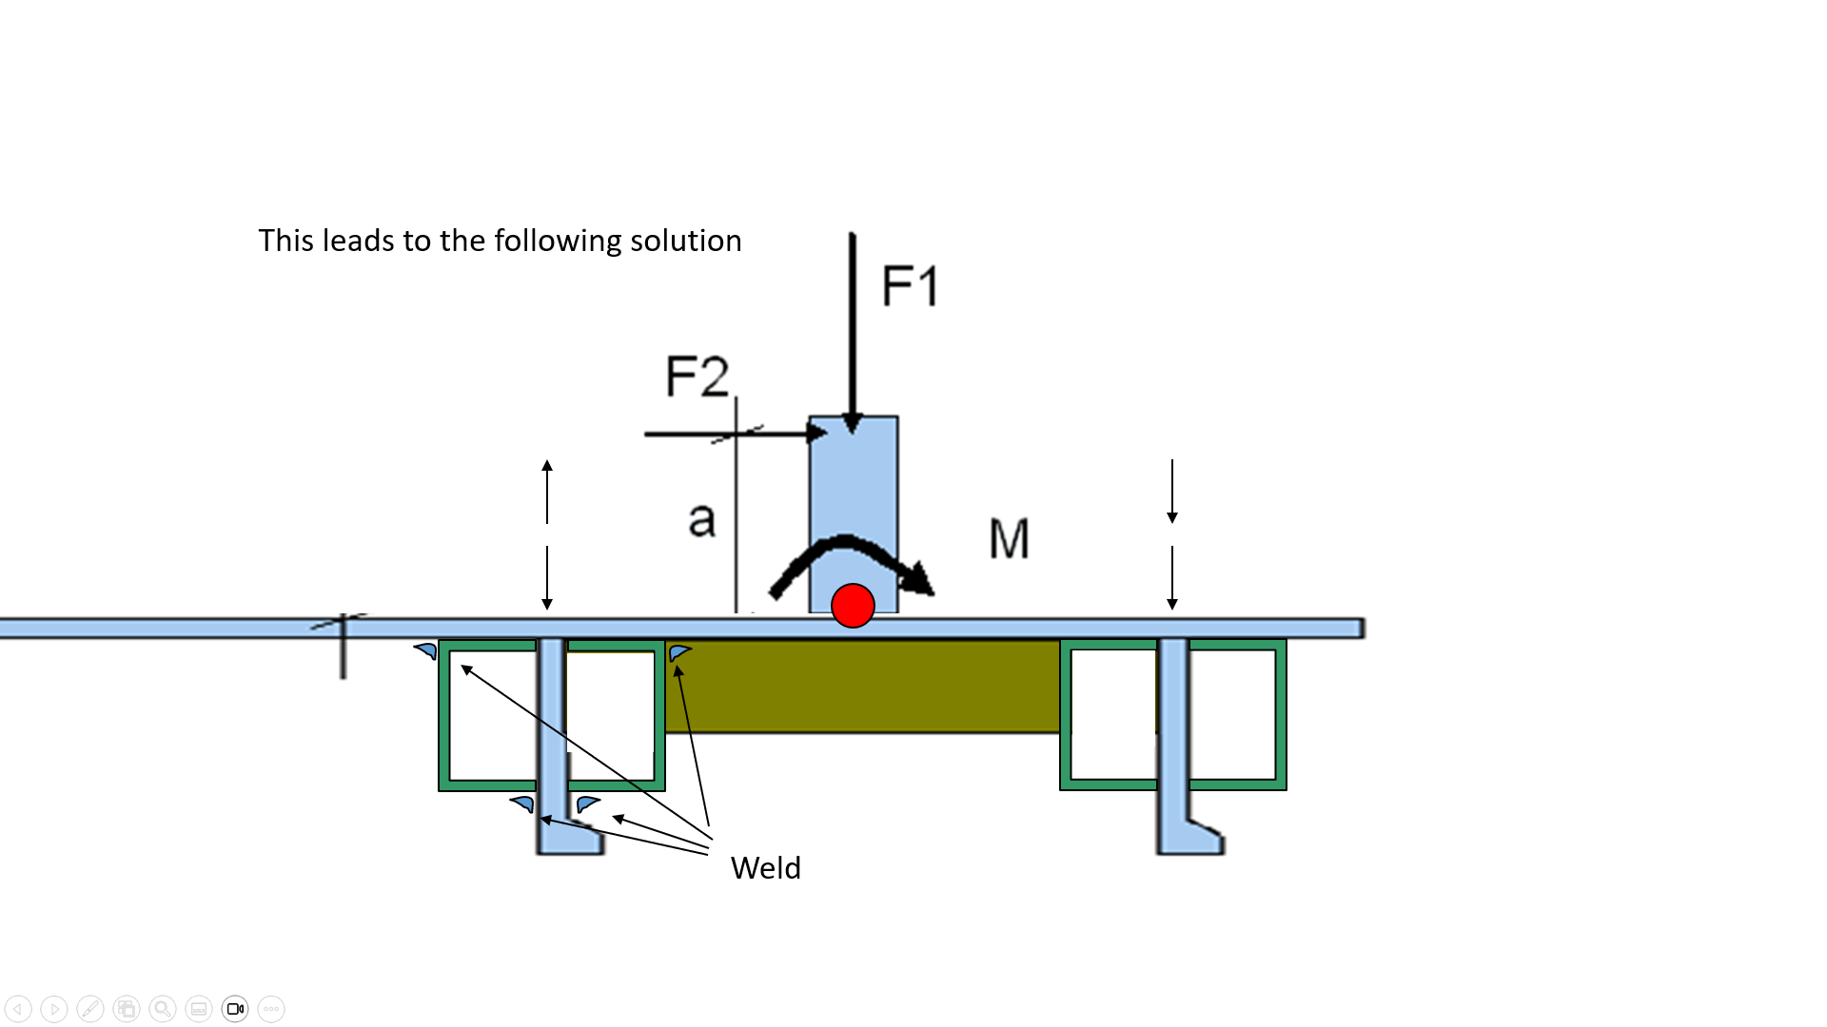
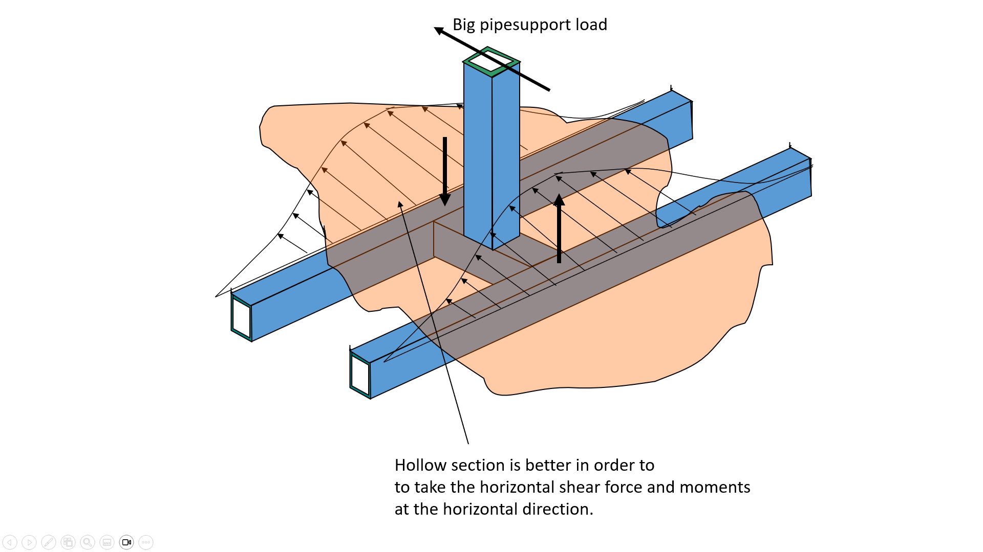
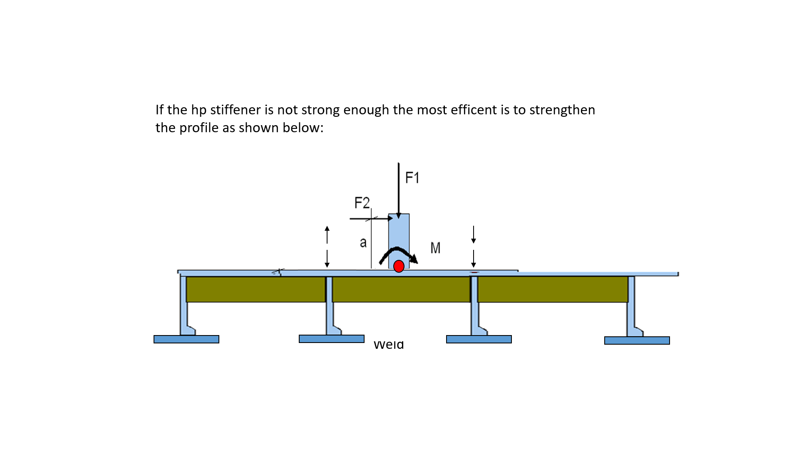
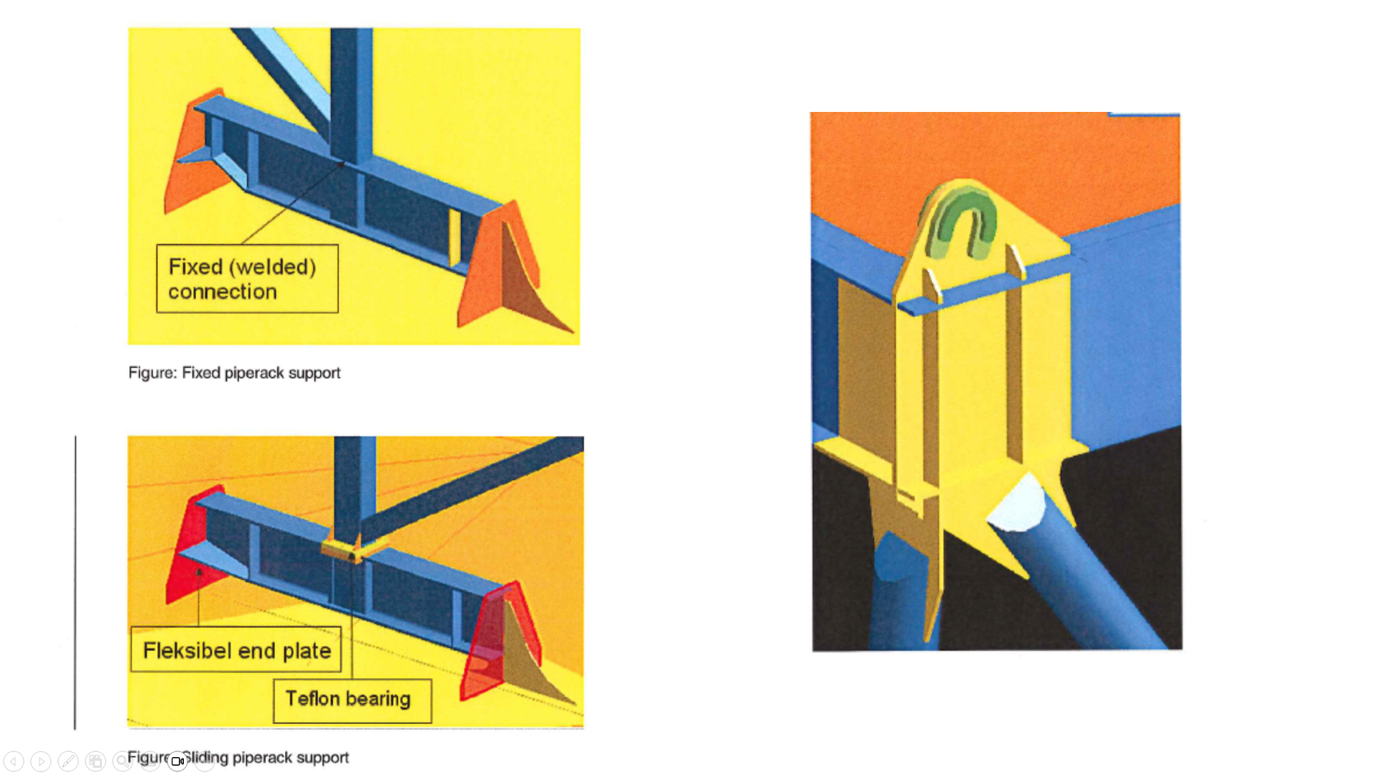

6. Cross section capasity and use of profiles
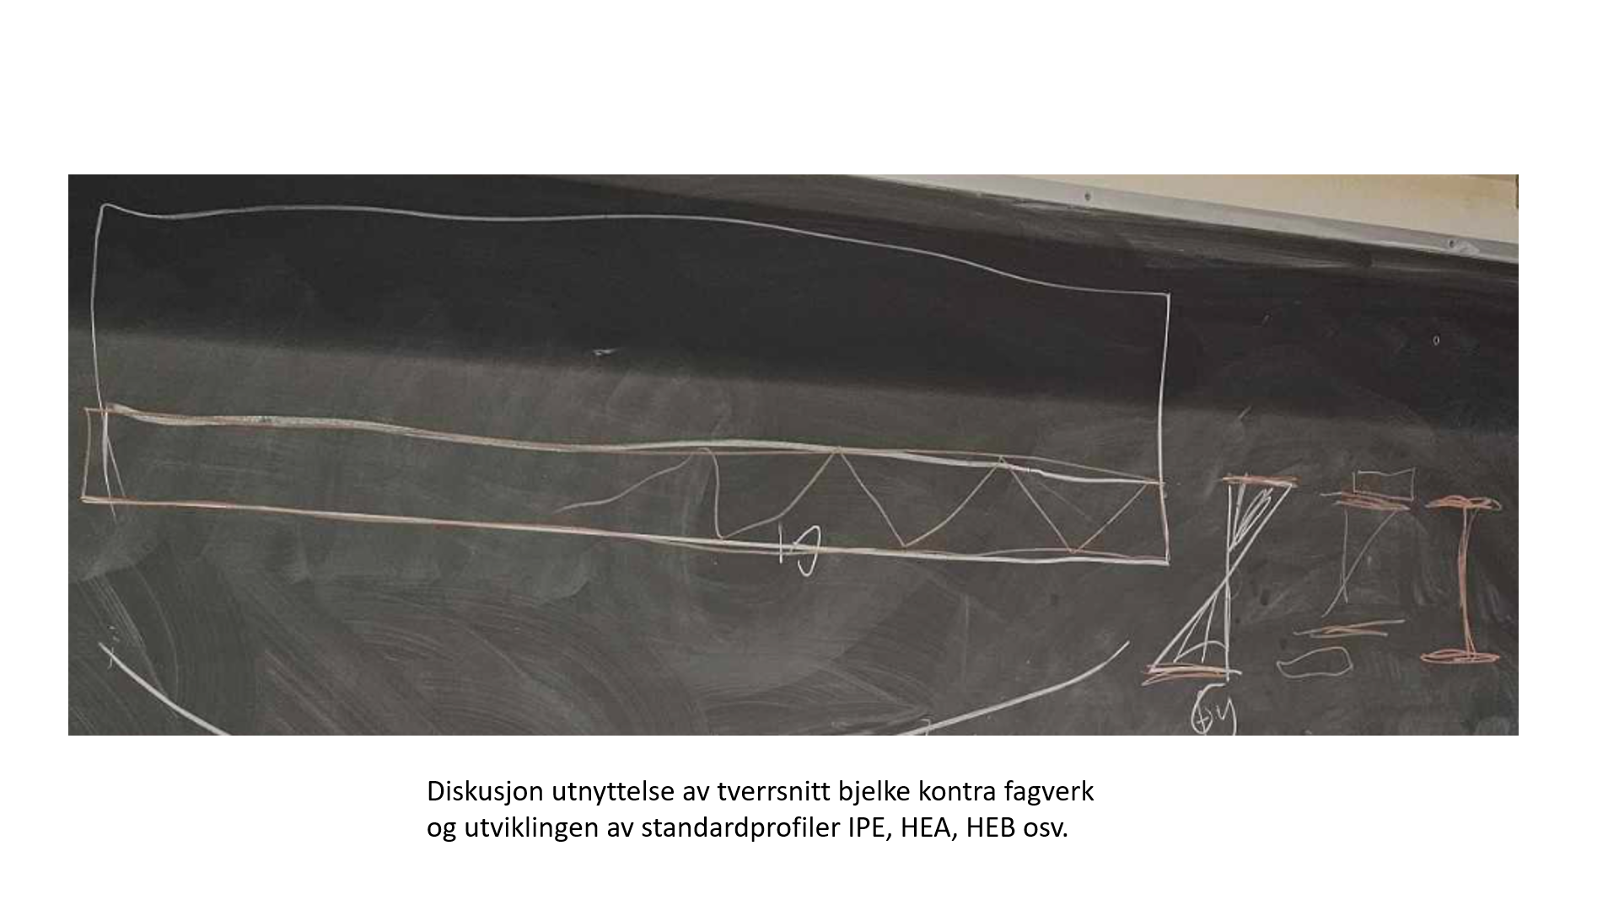

Tverrsnittsklasser (orienterende stoff, relevant for design/valg av profiler). For å si noe kort om det så benytter vi tverrsnittsklasse 1 for bjelker. Det kommer riktig noe an på spenningsfordeling over tverrsnittet. Standardprofiler tilfredstiller nesten uten unntak tverrsnittsklasse 1.
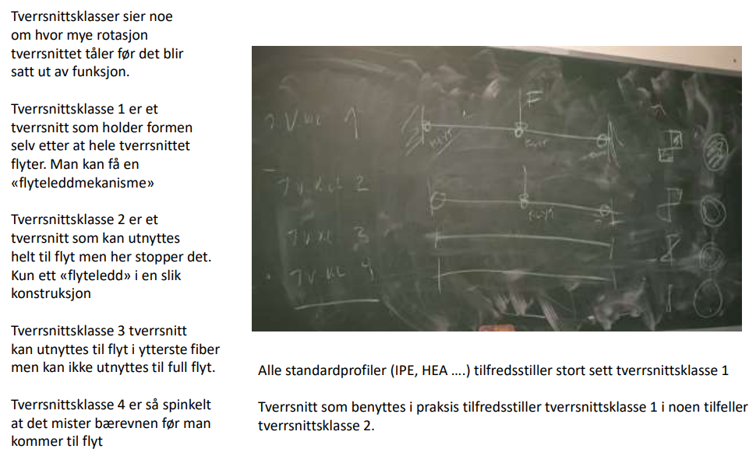
Viktig grunnlag med tanke på design, valg av profil samt for å bestemme riktige momenter/kapasitet):
For å unngå momenter pga. skjær må lasten plassers i skjærsenteret. Hvor skjærsenteret er og hvordan man finner det finnes i dette vedlegget.
I tillegg er det greit å vite at hvis man har et vinkelprofil så går det ikke an å regne spenninger på vanlig måte. Det er også beskrevet i dette vedlegget.
Lukket profil har mye større kapasitet og stivhet en et åpent profil med tanke på torsjon. Det finnes 2 typer torsjon. St.Venant og Hvelvning. Temaet er behandlet i dette vedlegget.
SkjærsenterVinkelprofilTorsjon.pdf SkjærsenterVinkelprofilTorsjon.pdf – alternative formater

For å unngå momenter pga. skjær må lasten plassers i skjærsenteret. Hvor skjærsenteret er og hvordan man finner det finnes i dette vedlegget.
I tillegg er det greit å vite at hvis man har et vinkelprofil så går det ikke an å regne spenninger på vanlig måte. Det er også beskrevet i dette vedlegget.
Lukket profil har mye større kapasitet og stivhet en et åpent profil med tanke på torsjon. Det finnes 2 typer torsjon. St.Venant og Hvelvning. Temaet er behandlet i dette vedlegget.
Skjærsenter, vinkelprofil og torsjon

7. Design and dimensioning of welds
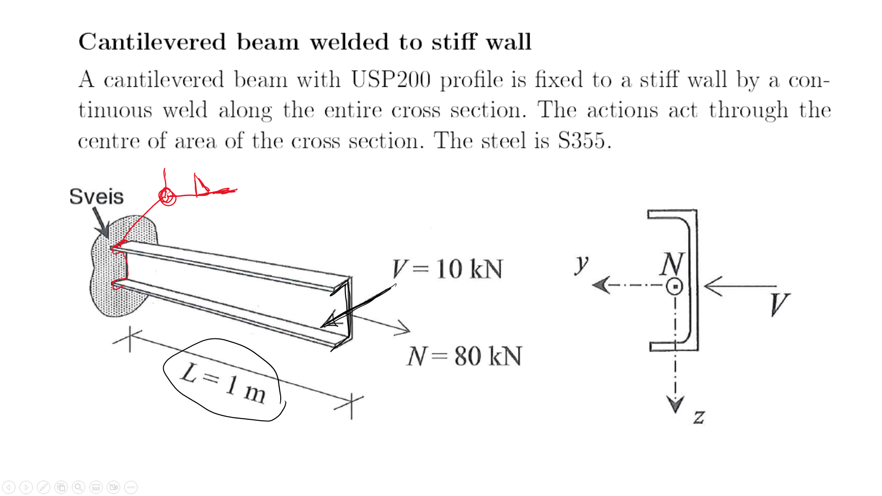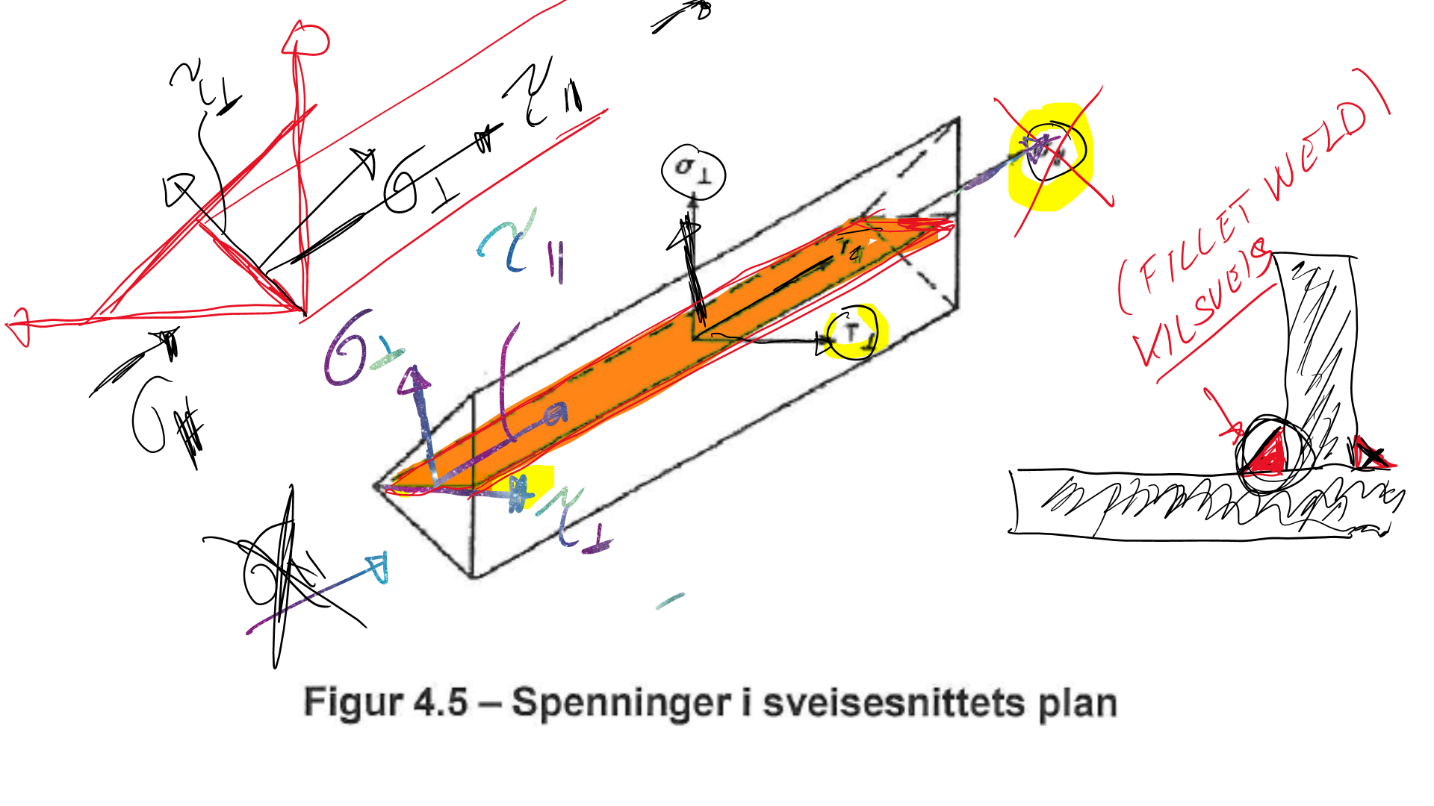
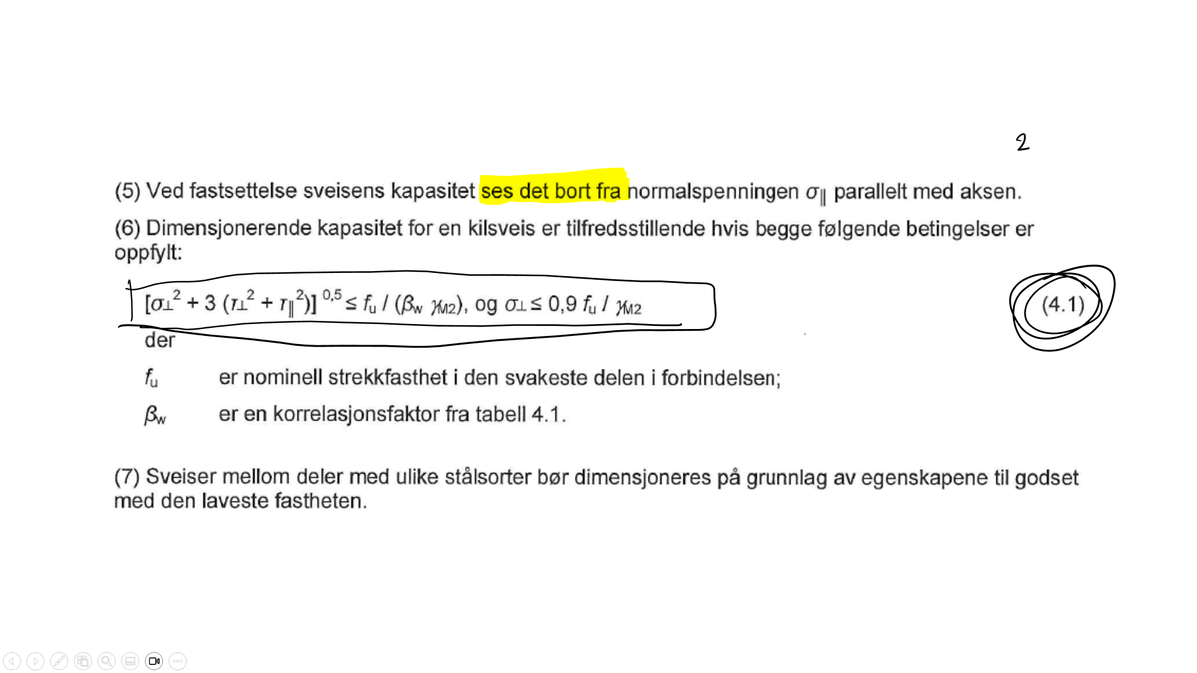
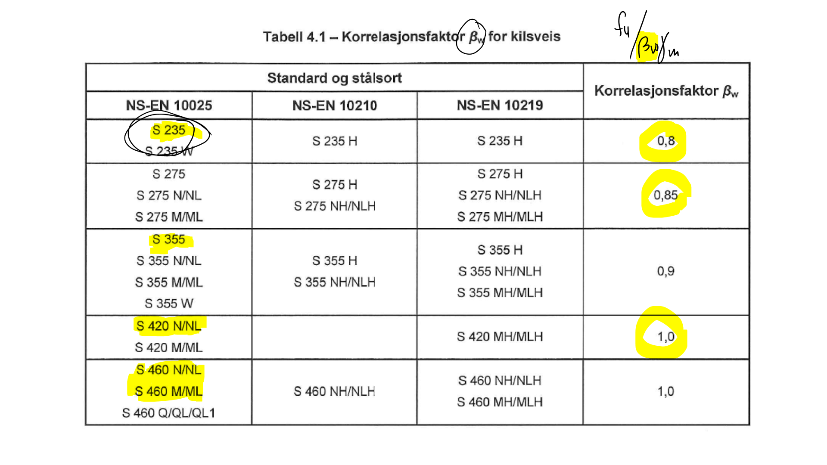
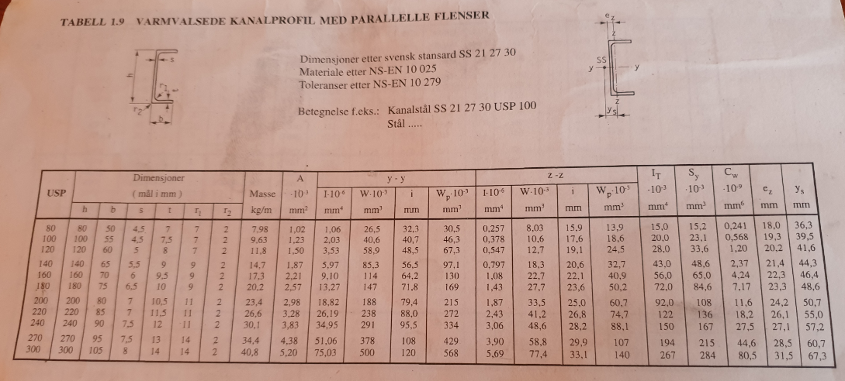
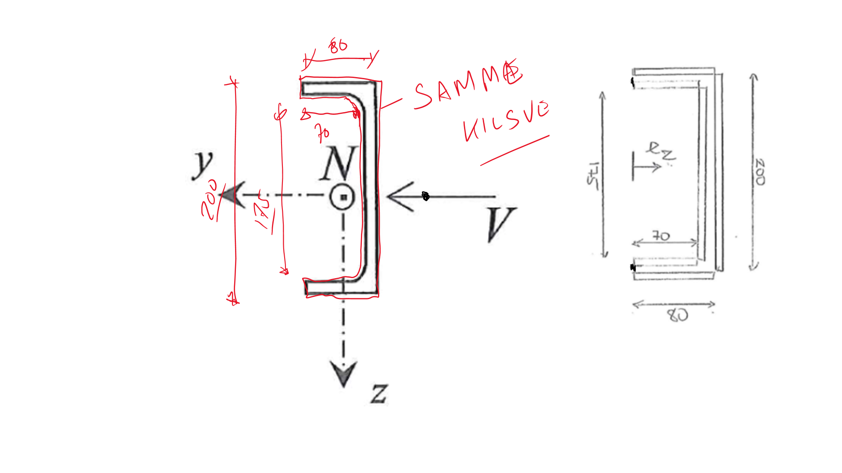

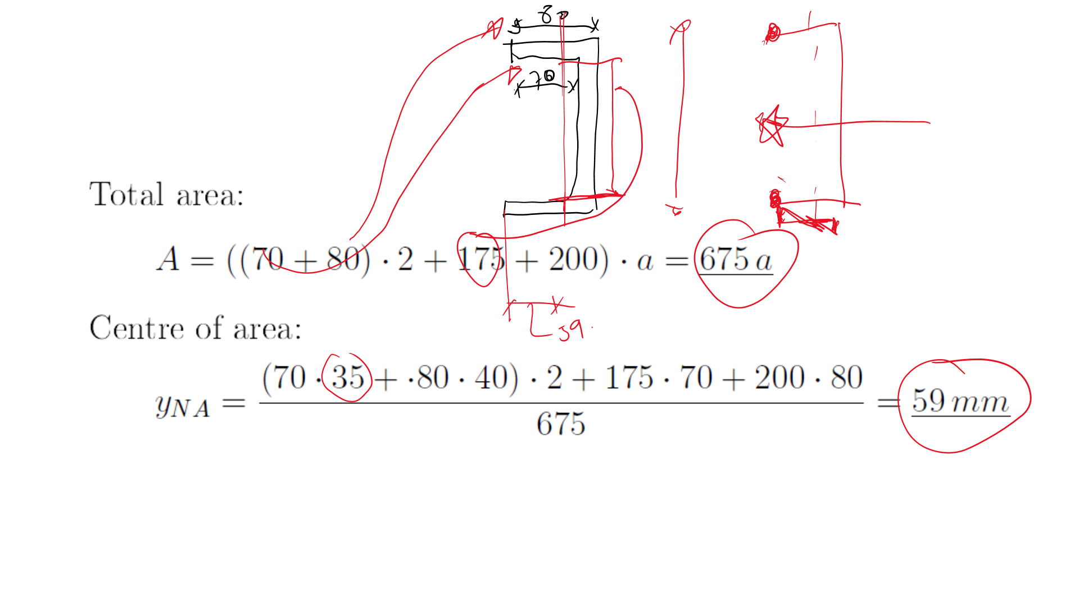
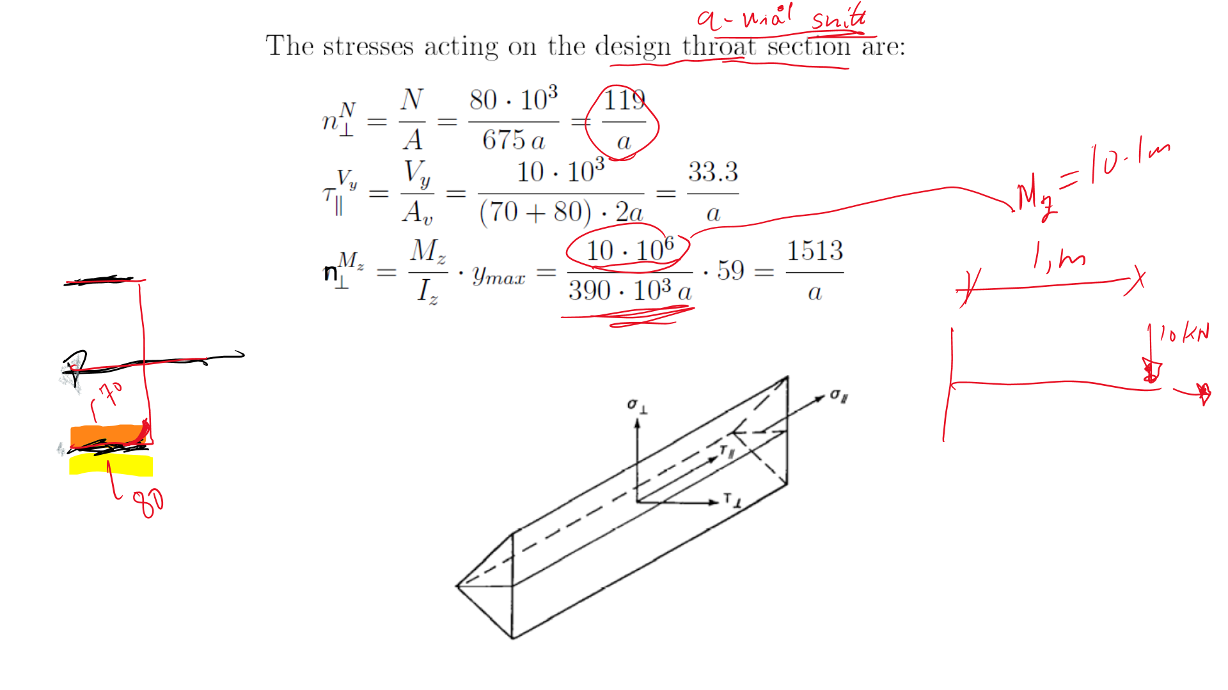
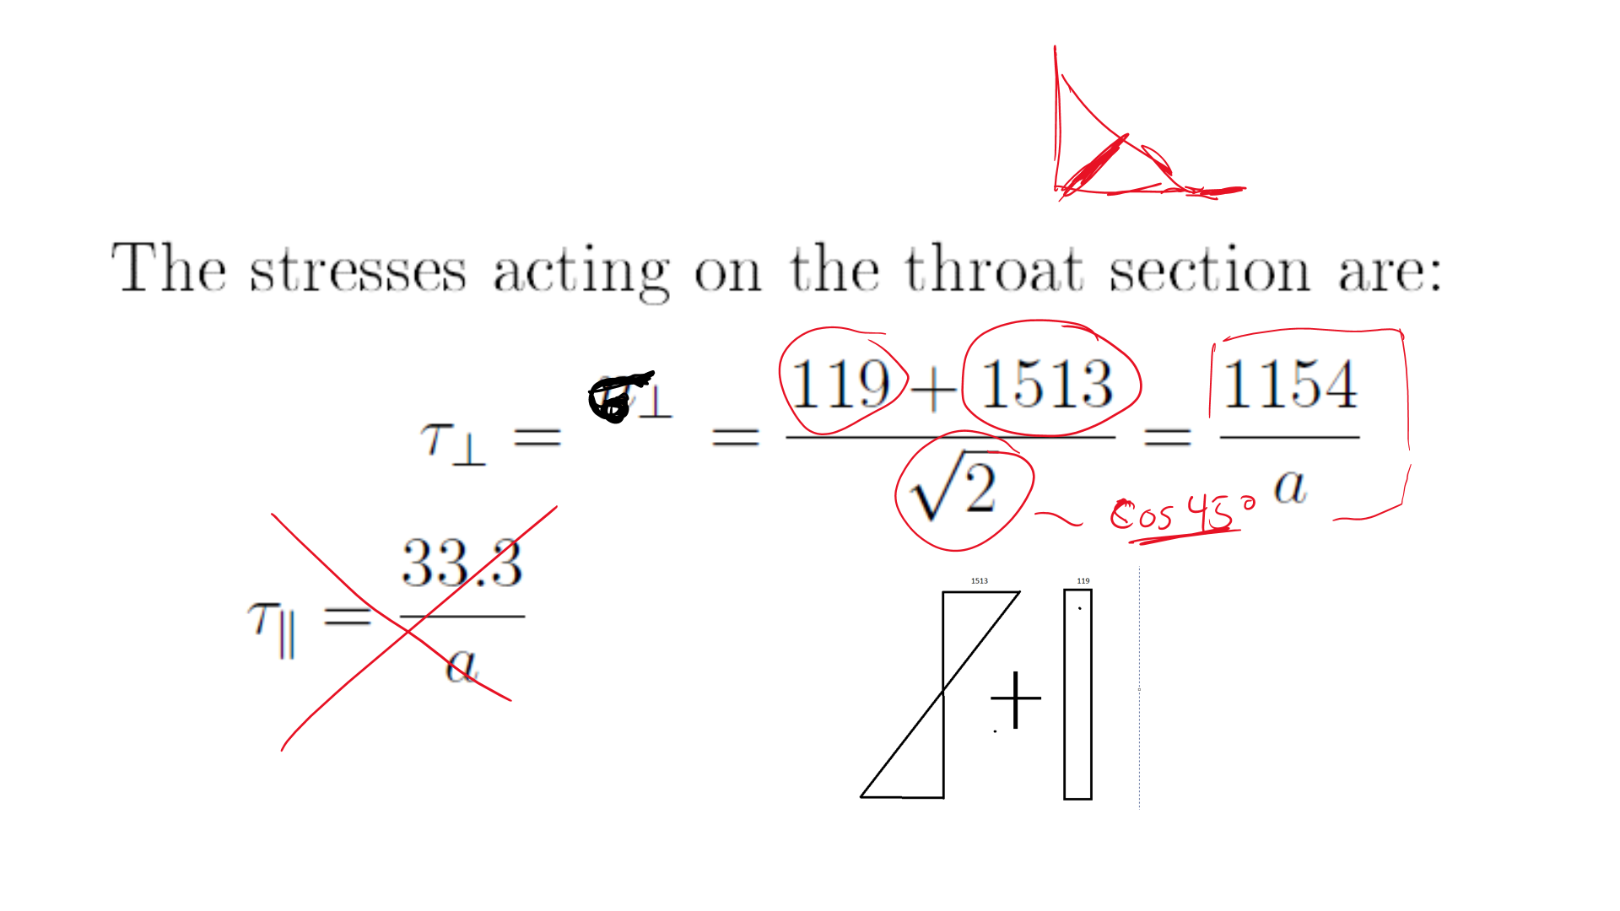
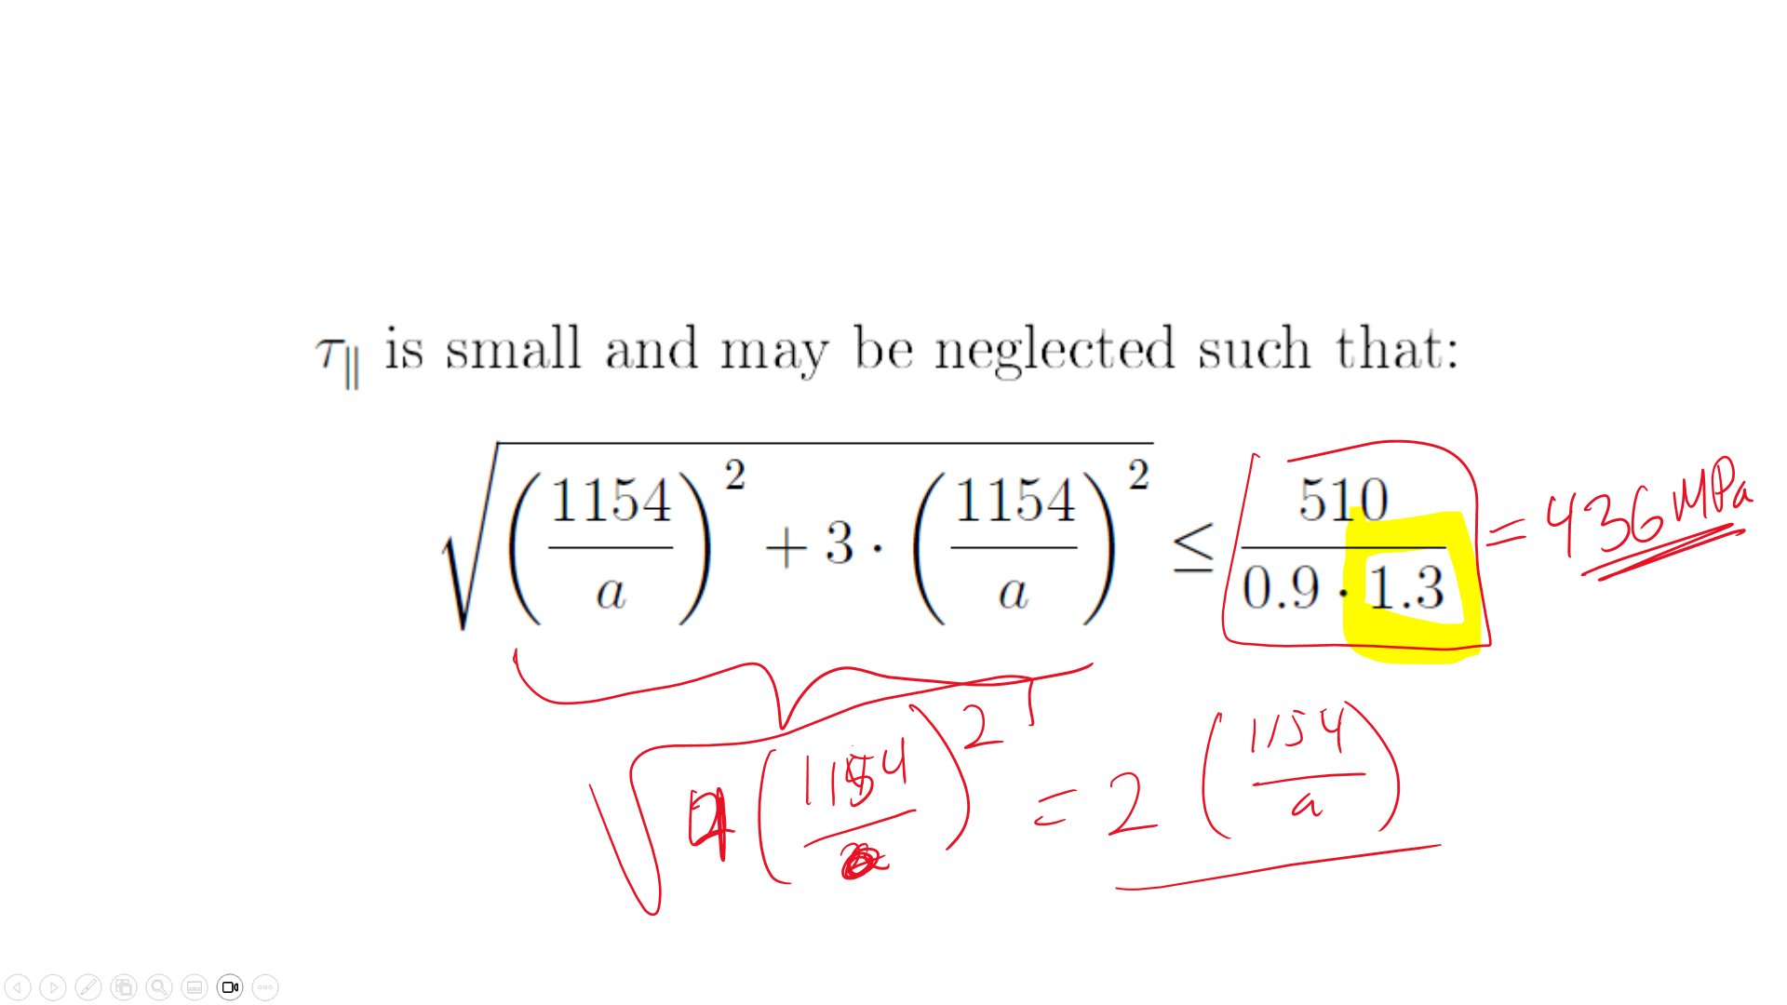
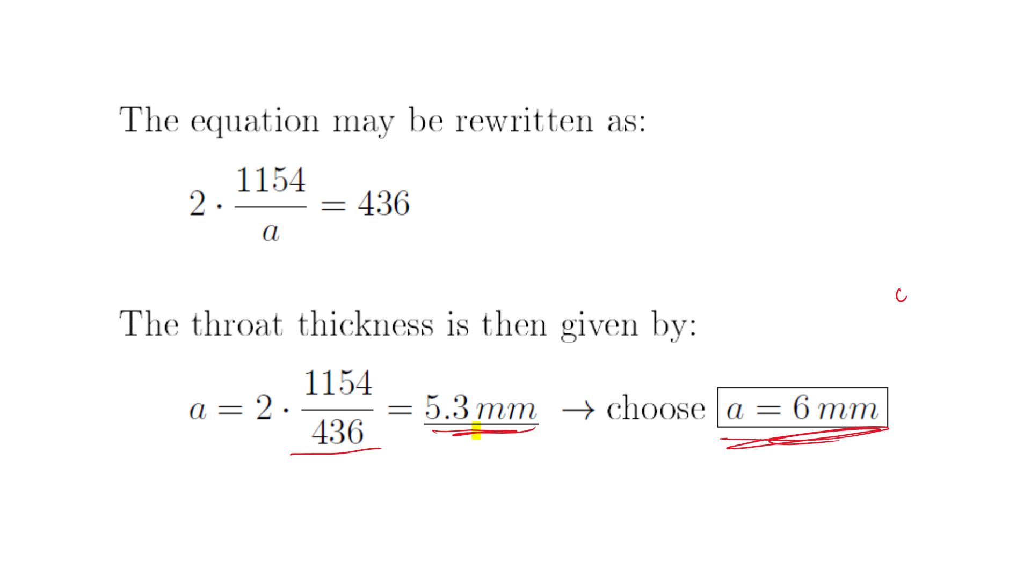

7. Bolted connections
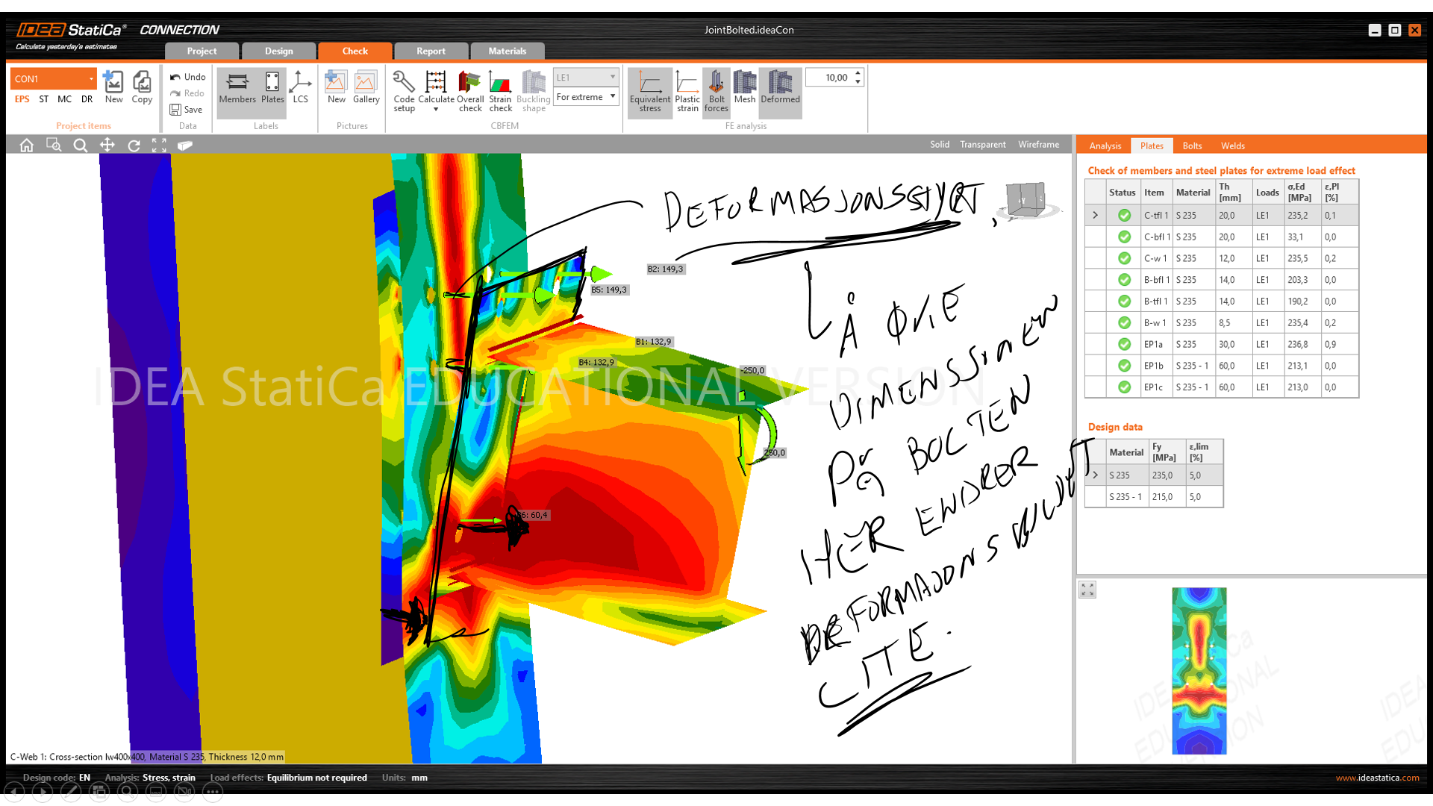
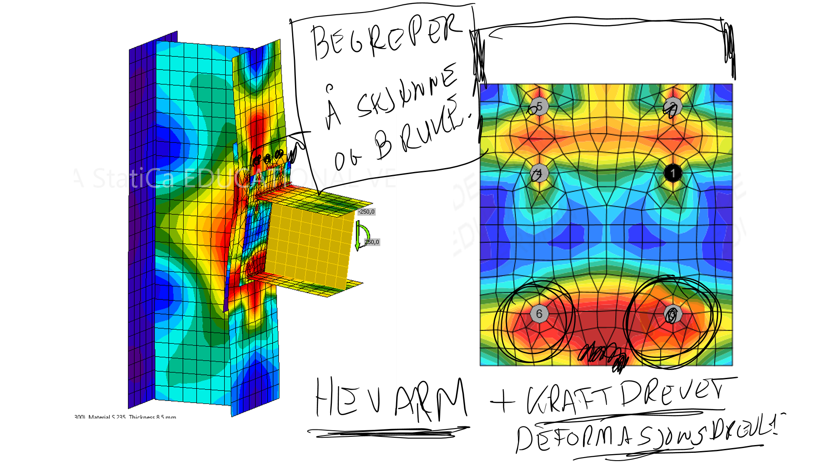
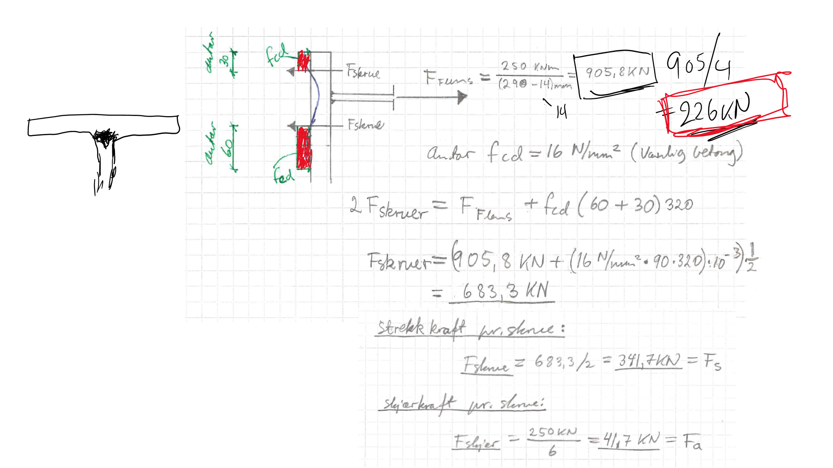
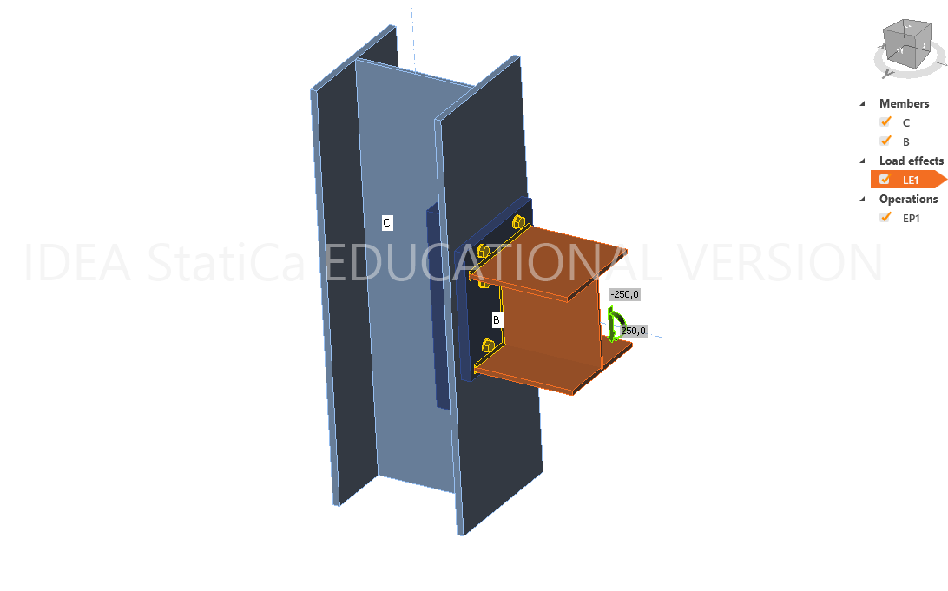
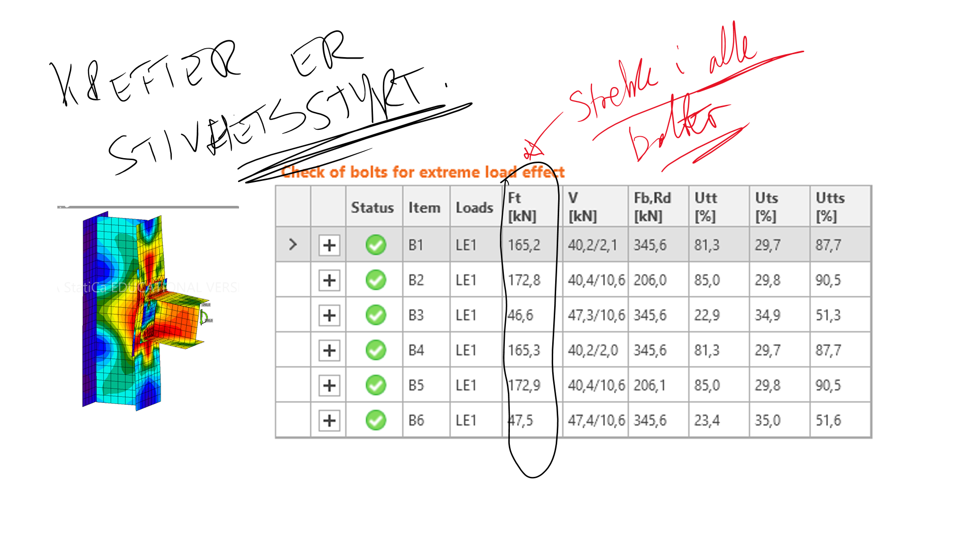
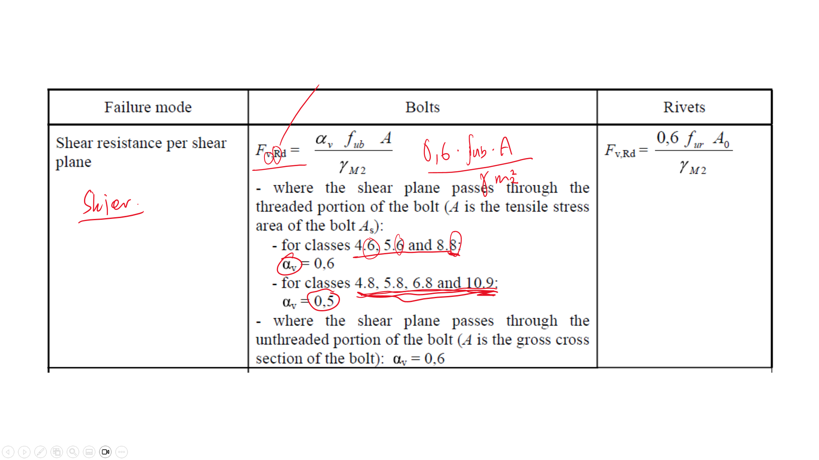
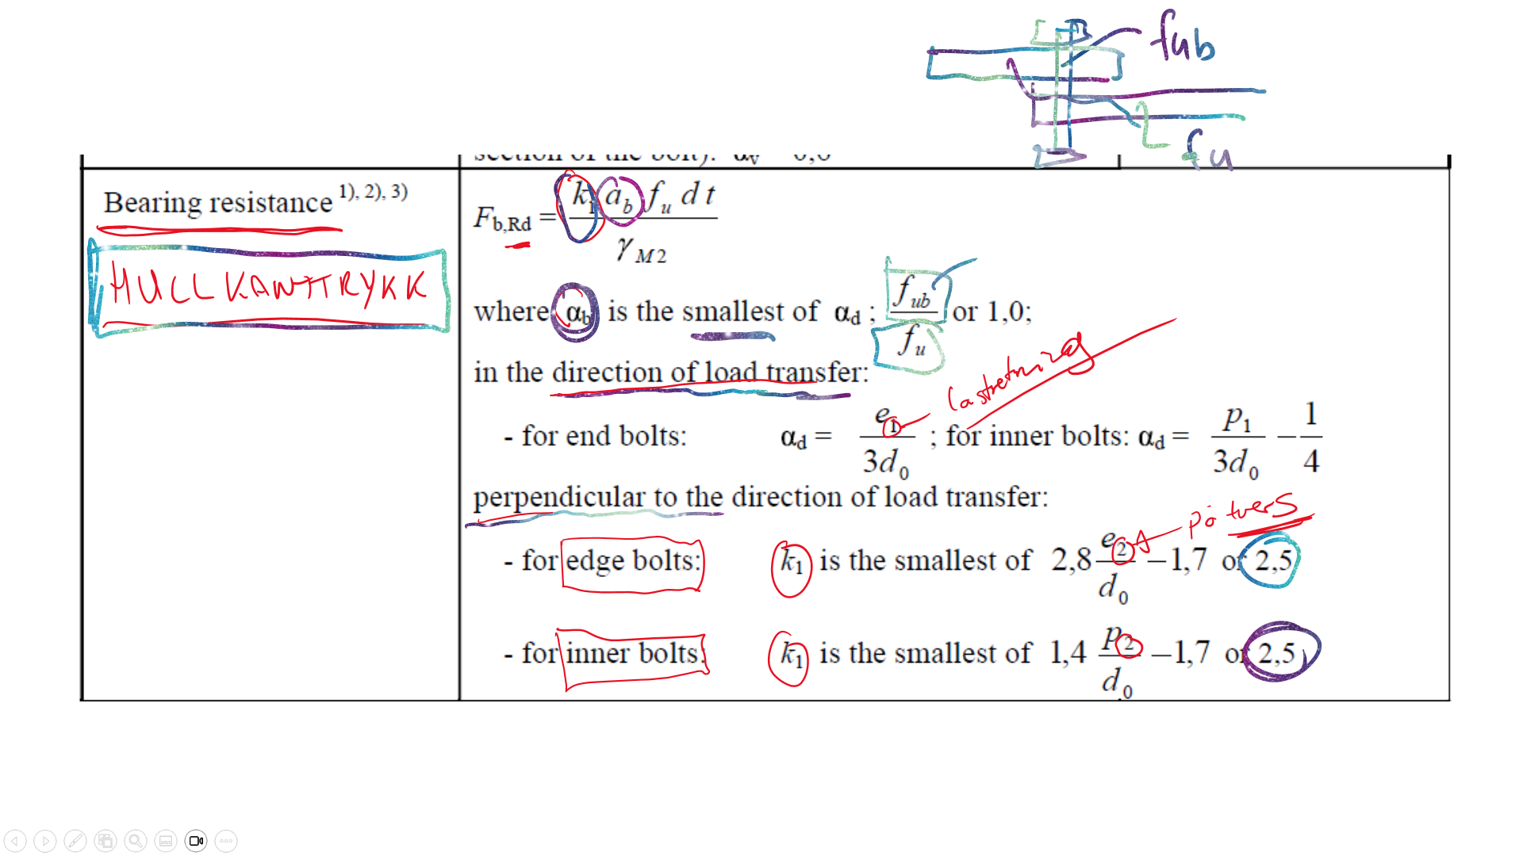
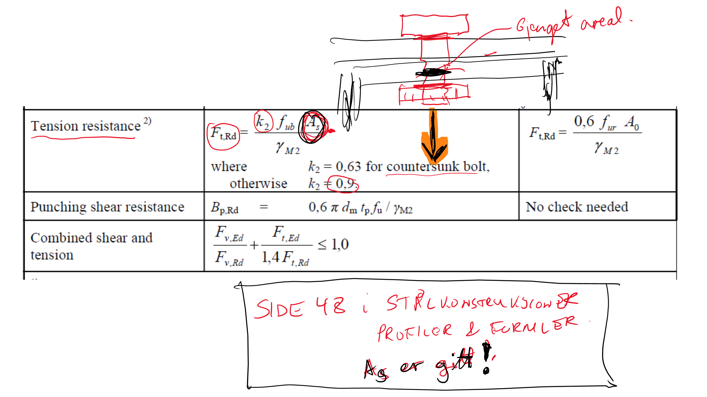

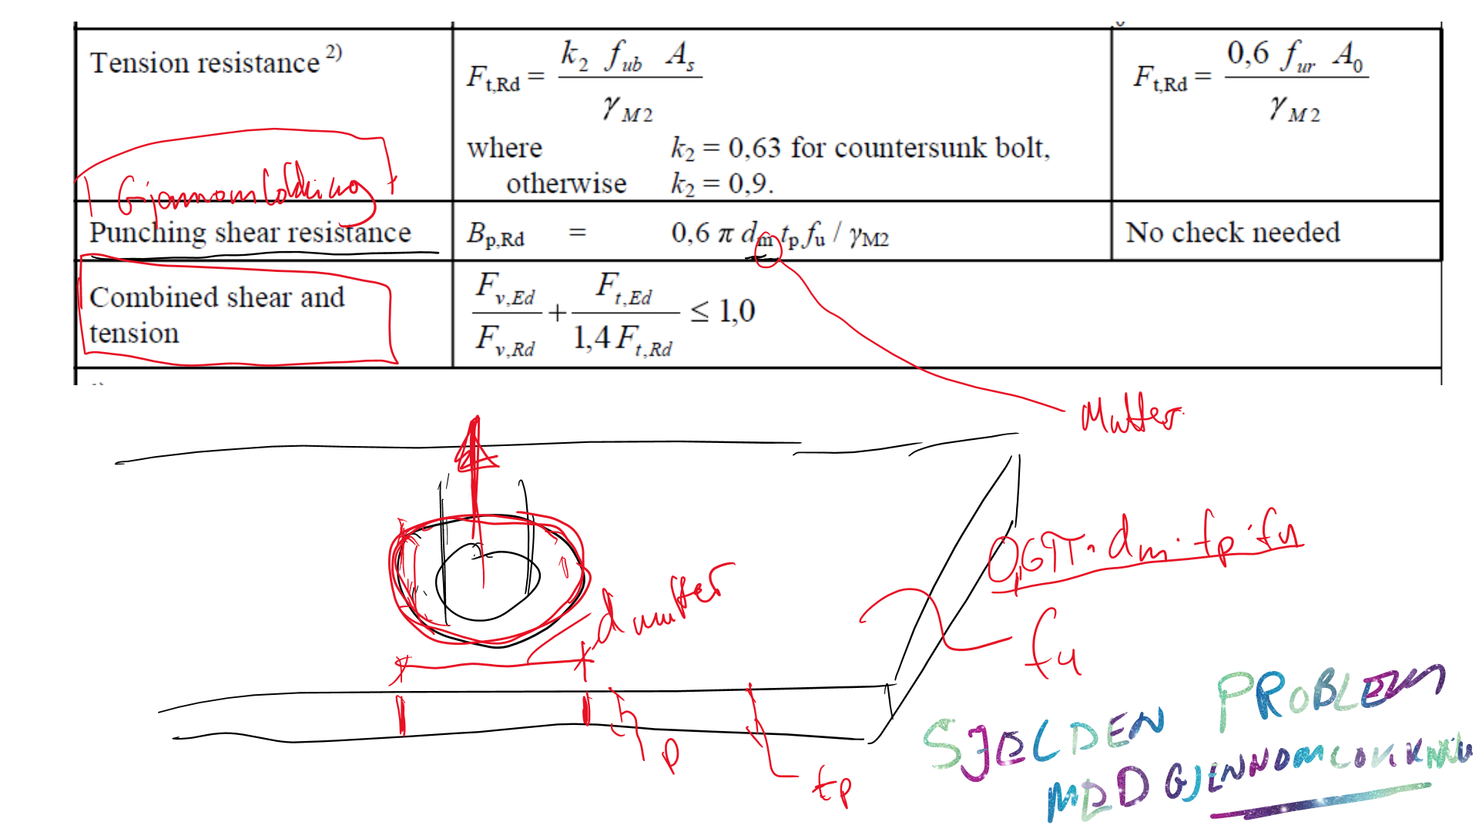
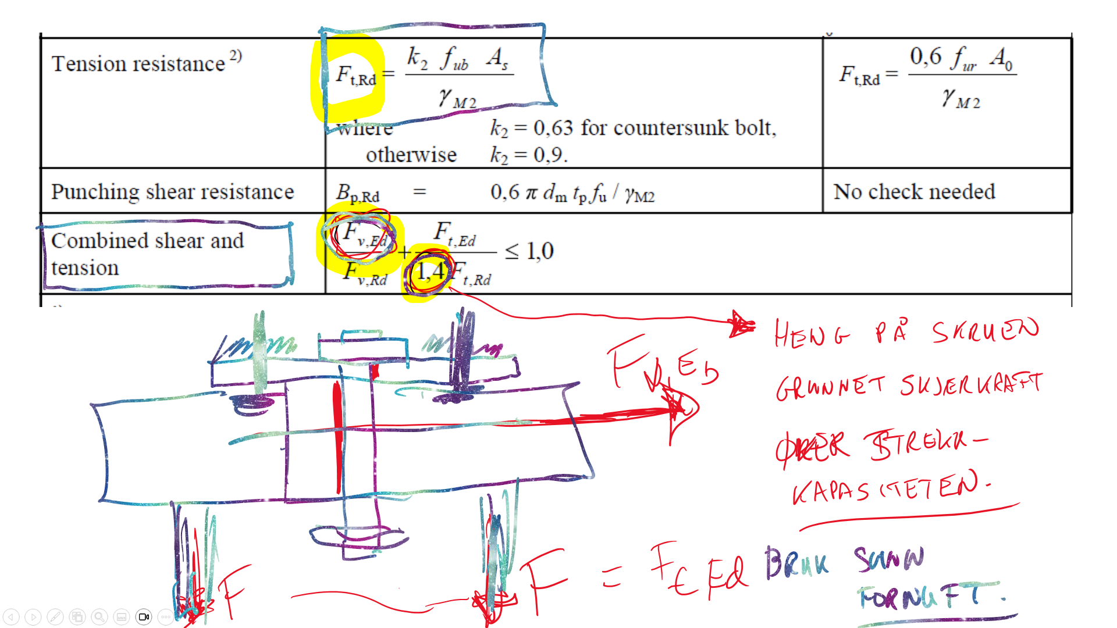
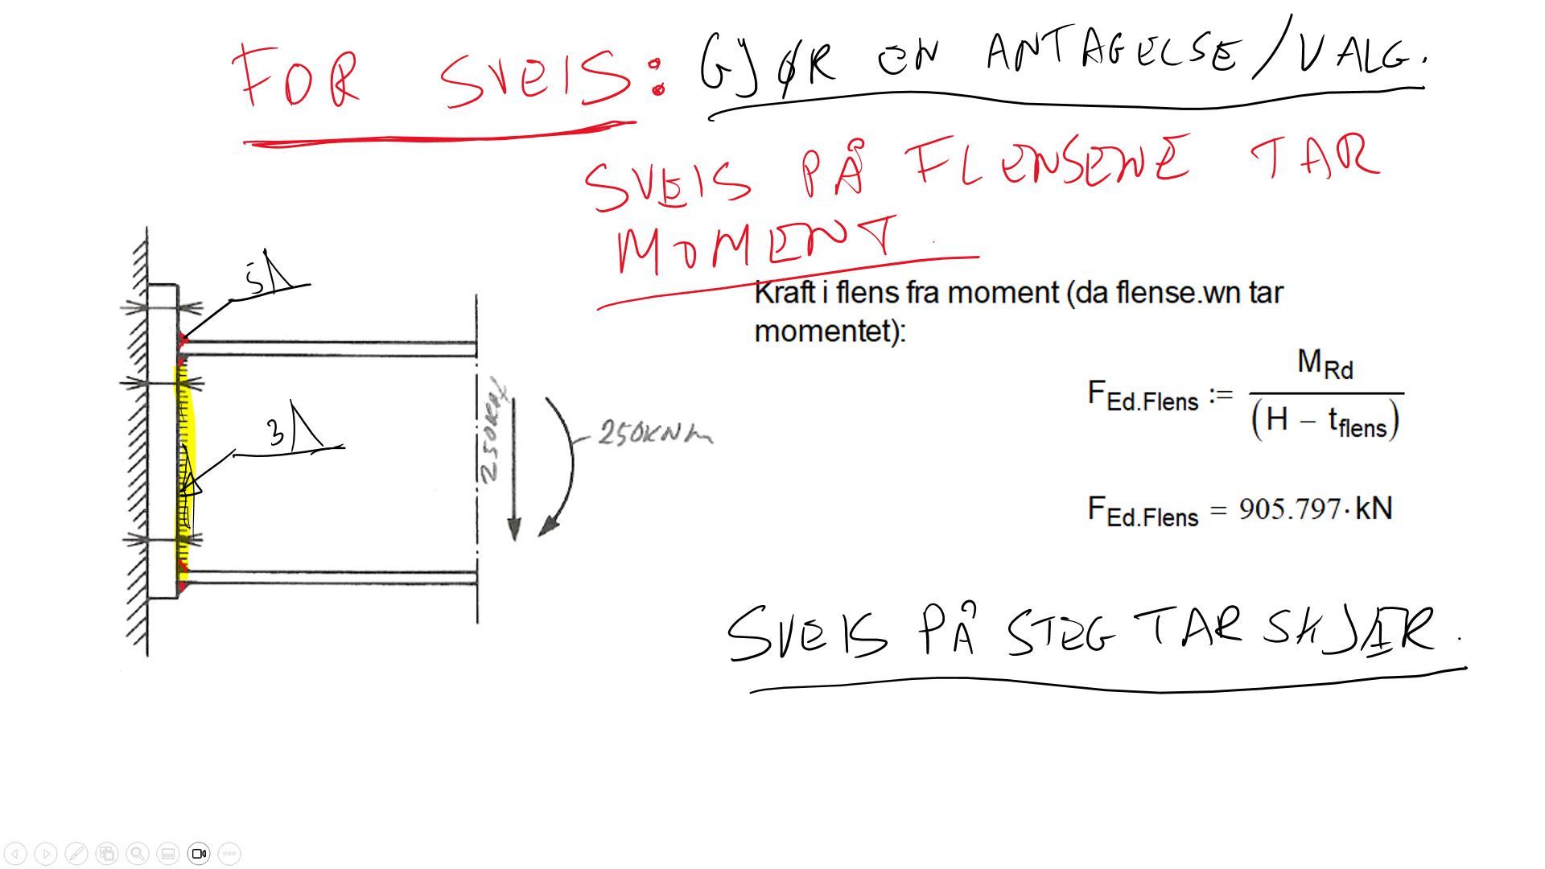
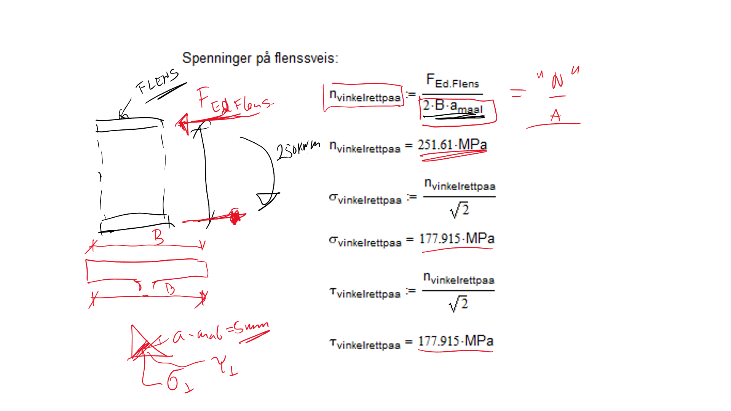

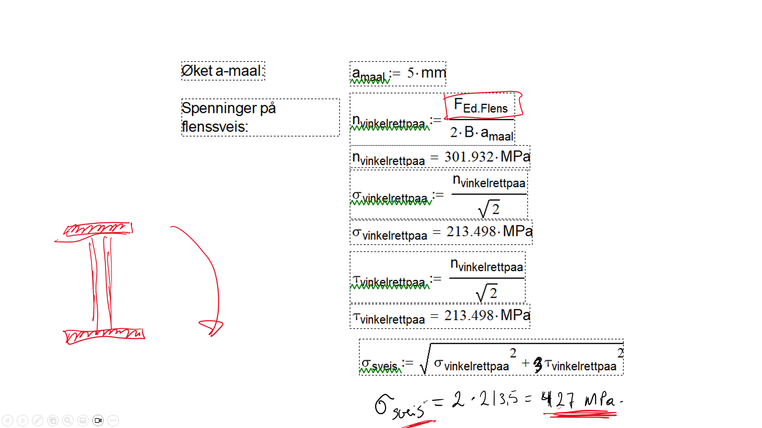

22. Local buckling

22. Interaction local and global buckling

23. Material selection and design according to NORSOK

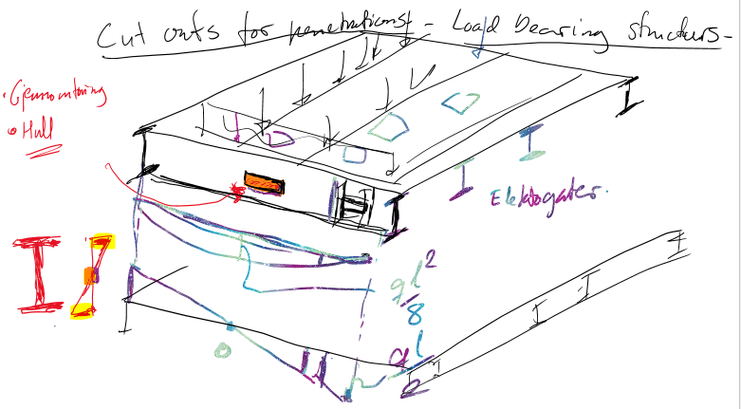
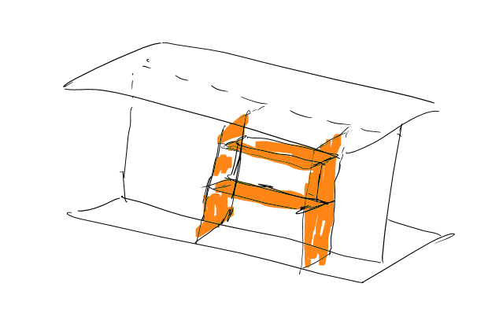
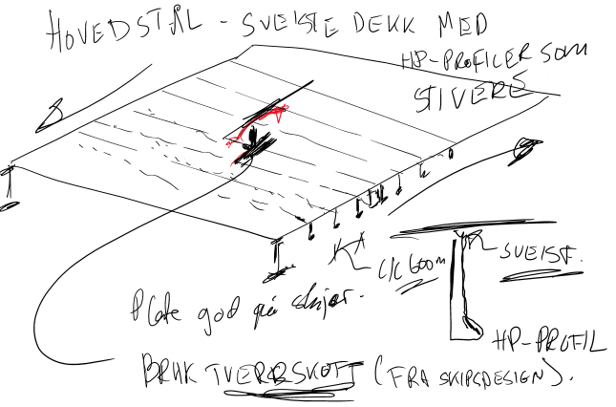
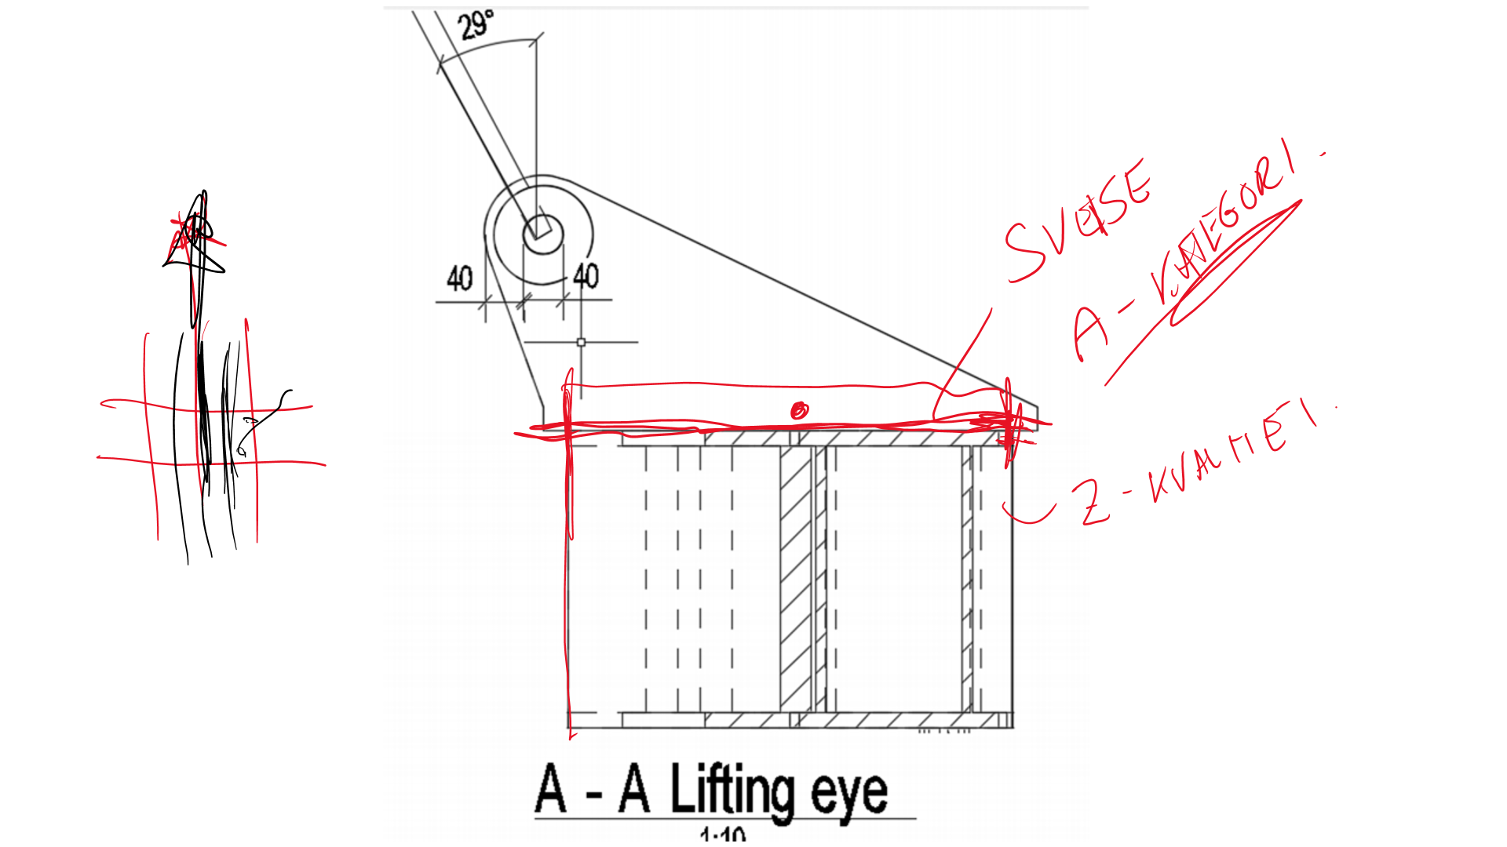
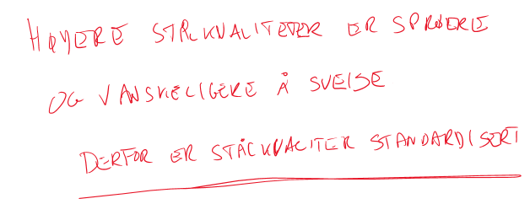
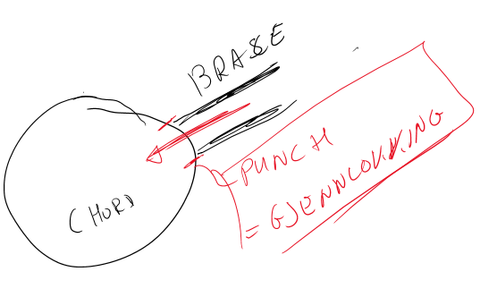
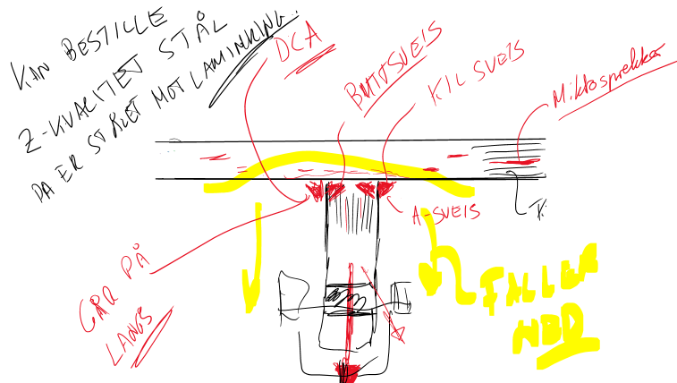
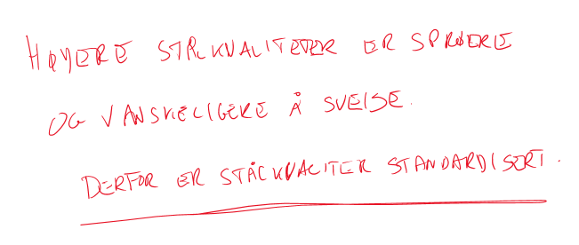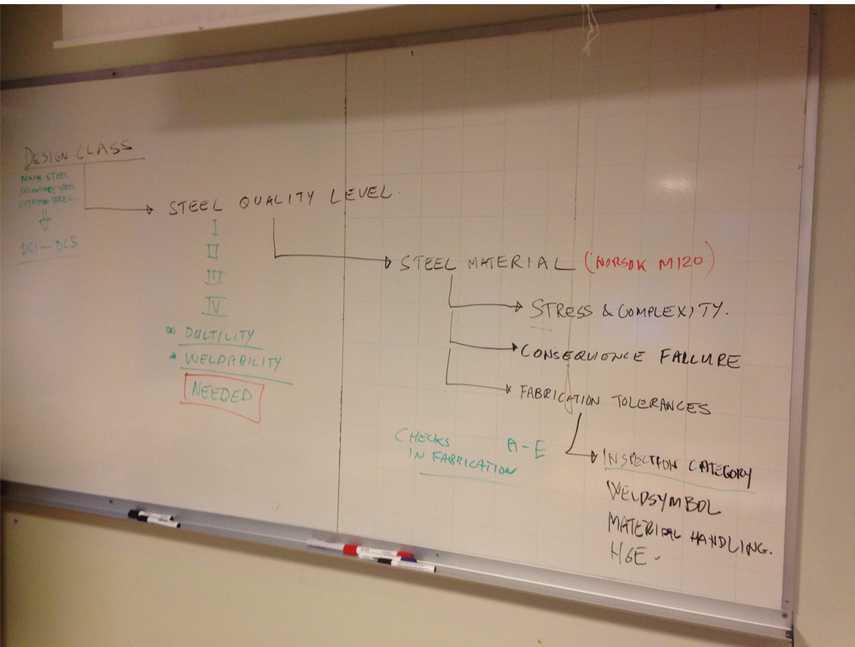

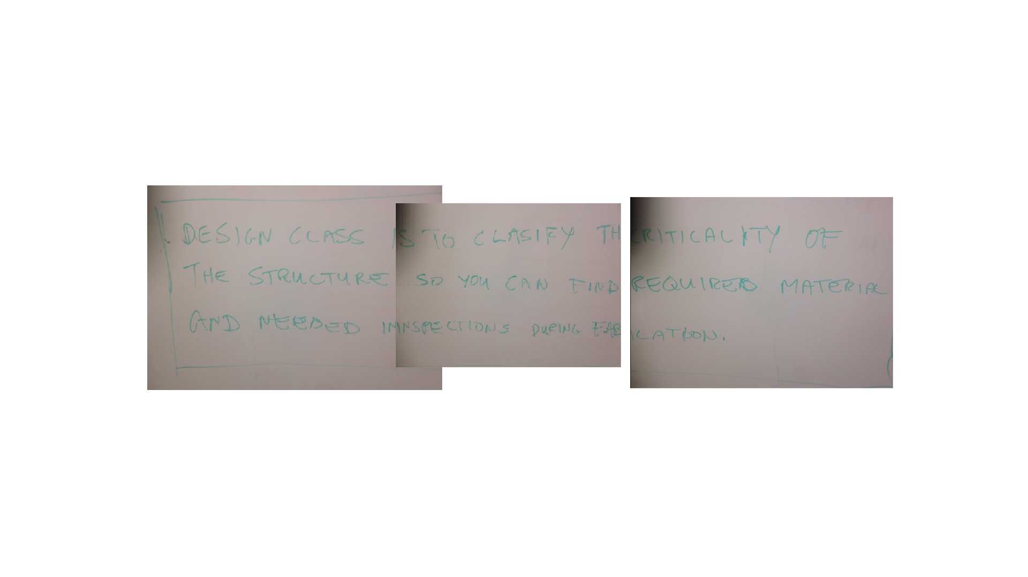
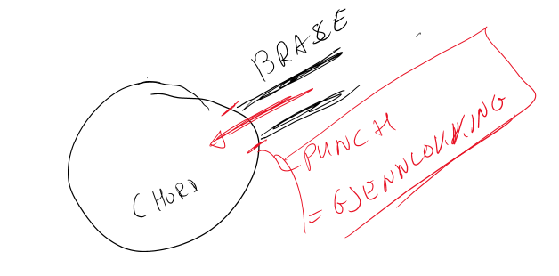
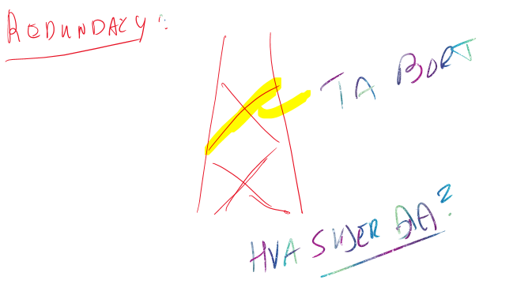
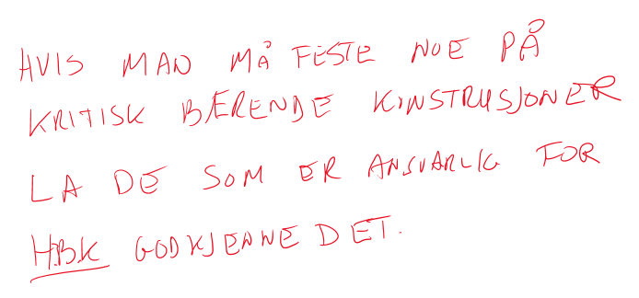

24. Fatigue and life cycle evaluations

Pga. av vind og bølger på havromskonstruksjoner så må man alltid ta hensyn til utmatning for lastbærende konstruksjoner på havet.
I faget så er det vist en god del ulike deltaljer som viser hvordan detaljene på en konstruksjon ser ut for en flyter kontra en konstruksjon på land.
Utmatting – Wikipedia
Understanding Fatigue Failure and S-N Curves - YouTube
Understanding Vibration and Resonance - YouTube
Fatigue Life: What it is and Why it Matters (sorbothane.com)
Levetidsbegrepet
SN-kurve, SCF (Stress concetration factor, spenningskonsentrasjon):
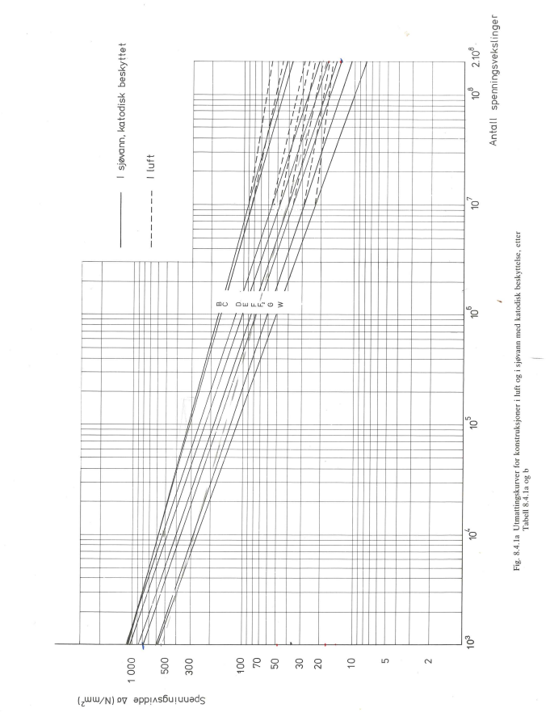
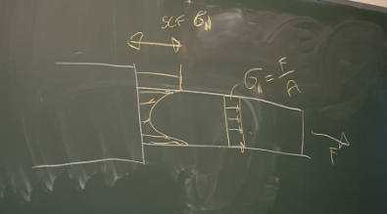
Working with Stress Concentration Factors - YouTube
Stress Concentration Factors - YouTube
SN-kurver og «giga cycles»
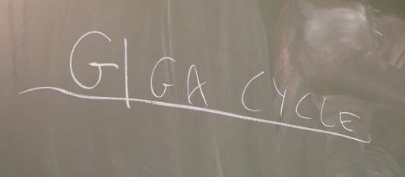
Vi har nå i øvingen sett på SN-kurver. Tradisjonelt har man sagt at under et visst
spenningsendringsnivå så får man ingen skade i stålet.
Det er en sannhet med modifikasjoner da betydningen av veldig høye frekvenser
med små amplituder kan kanskje også føre til brudd.
What is gigacycle fatigue? (moviecultists.com)
An Introduction to Fatigue Testing - YouTube

Stikkord fra tavla med DFF
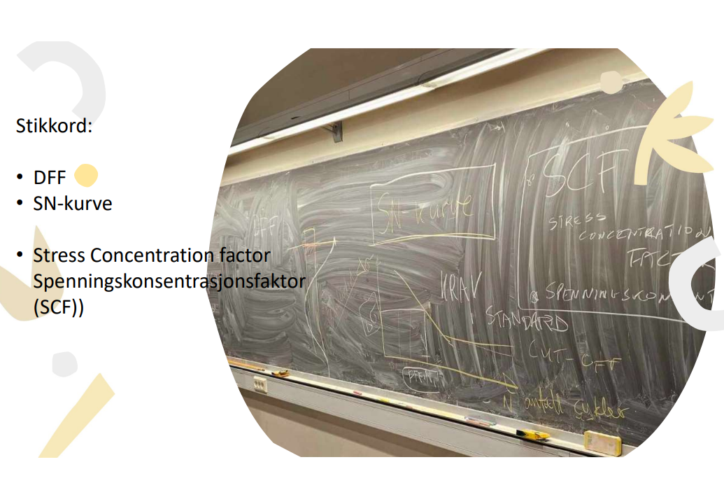
Gjennomgang øving 2.
ProblemSet2-task1-20231108.xmcd
ProblemSet2-Stabilitet20221006.xlsx
ArkimedesMetaSenter.pdf
Masteroppgaver transport barge Damping:
https://ntnuopen.ntnu.no/ntnu-xmlui/bitstream/handle/11250/2564464/18591_FULLTEXT.pdf?sequence=1
Damping jacket:
DAMPING OF JACKET STRUCTURES
https://www.researchgate.net/figure/Advantages-and-Disadvantages-of-Mass-Dampers_tbl1_357380171
Tuned mass damper:
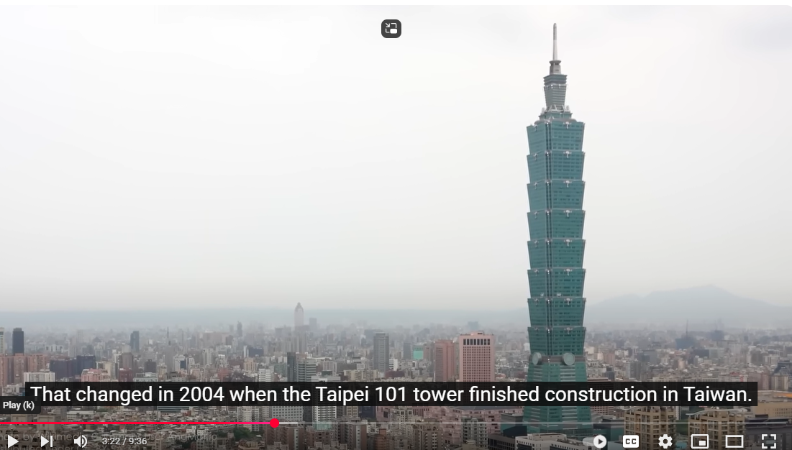https://www.youtube.com/watch?v=f1U4SAgy60c&t=2s

Vi ser på fjorårets eksamen og utmatningsoppgaven:
Eksamen20231108-Losningsforslag.pdf
Fatigue.xmcd
Veritas standard
DnV-RP-C203.pdf
Utmatingsberegninger fra gammel standard:
NS3472-Utmatning.pdf
Kapasitet av slanke konstruksjoner oppsummering:
BYGT2312-Lecture2023.11.10-Nominell-Dynamic-Fatigue.pdf
Beregningsprogram for utmatning: FATIGUE (må kjøres fra dos og navnet på programmet må endres til .exe)
Inputfil: fatigue.inp
RP-C203 RP5 - snakker litt om hva man kan gjøre
7. "Improvement of Fatigue Life by Fabrication»
LifeExtensionDnV-203-RP5.pdf

Bølgelaster i nordsjøen kan forenkelt regnes å ha logaritmisk fordeling men fordi disse bølgene har ulike perioder vil man kunne finne at noen bølger vil kunne treffe resonansfrekvenser. Forhåpenligvis er de bølgene så små at spenningene ikke bidrar til utmatningsskade. Det må man tenke på når man designer disse konstruksjonene.
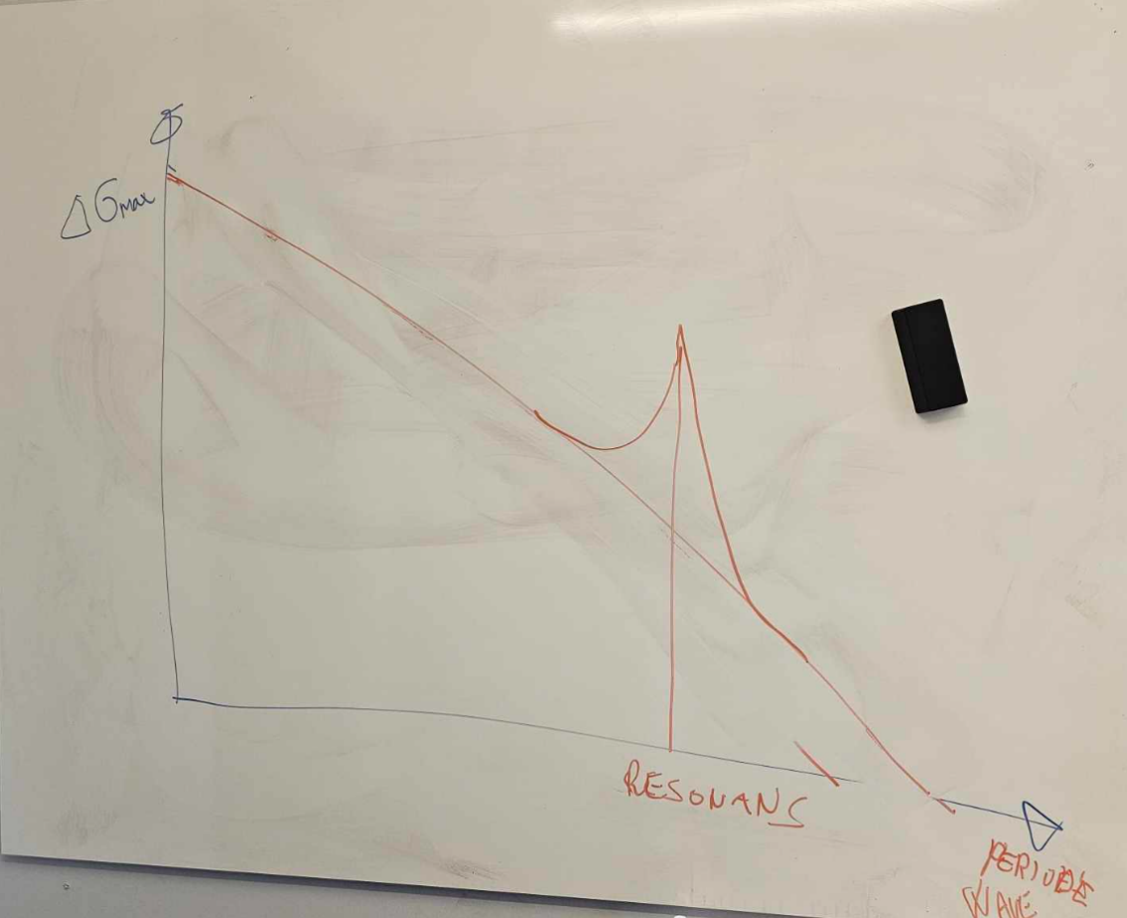

Utmatningsforelesning oversikt

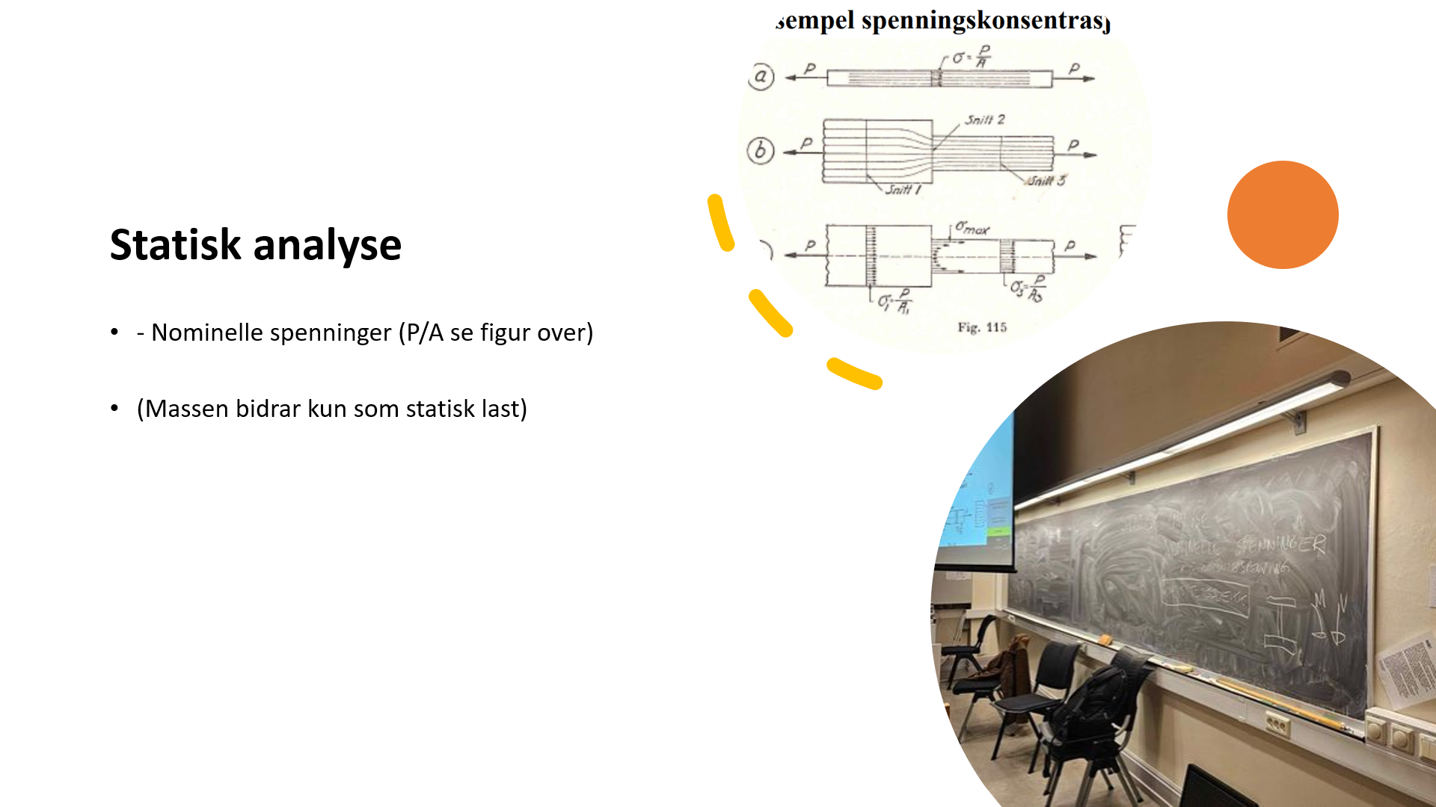
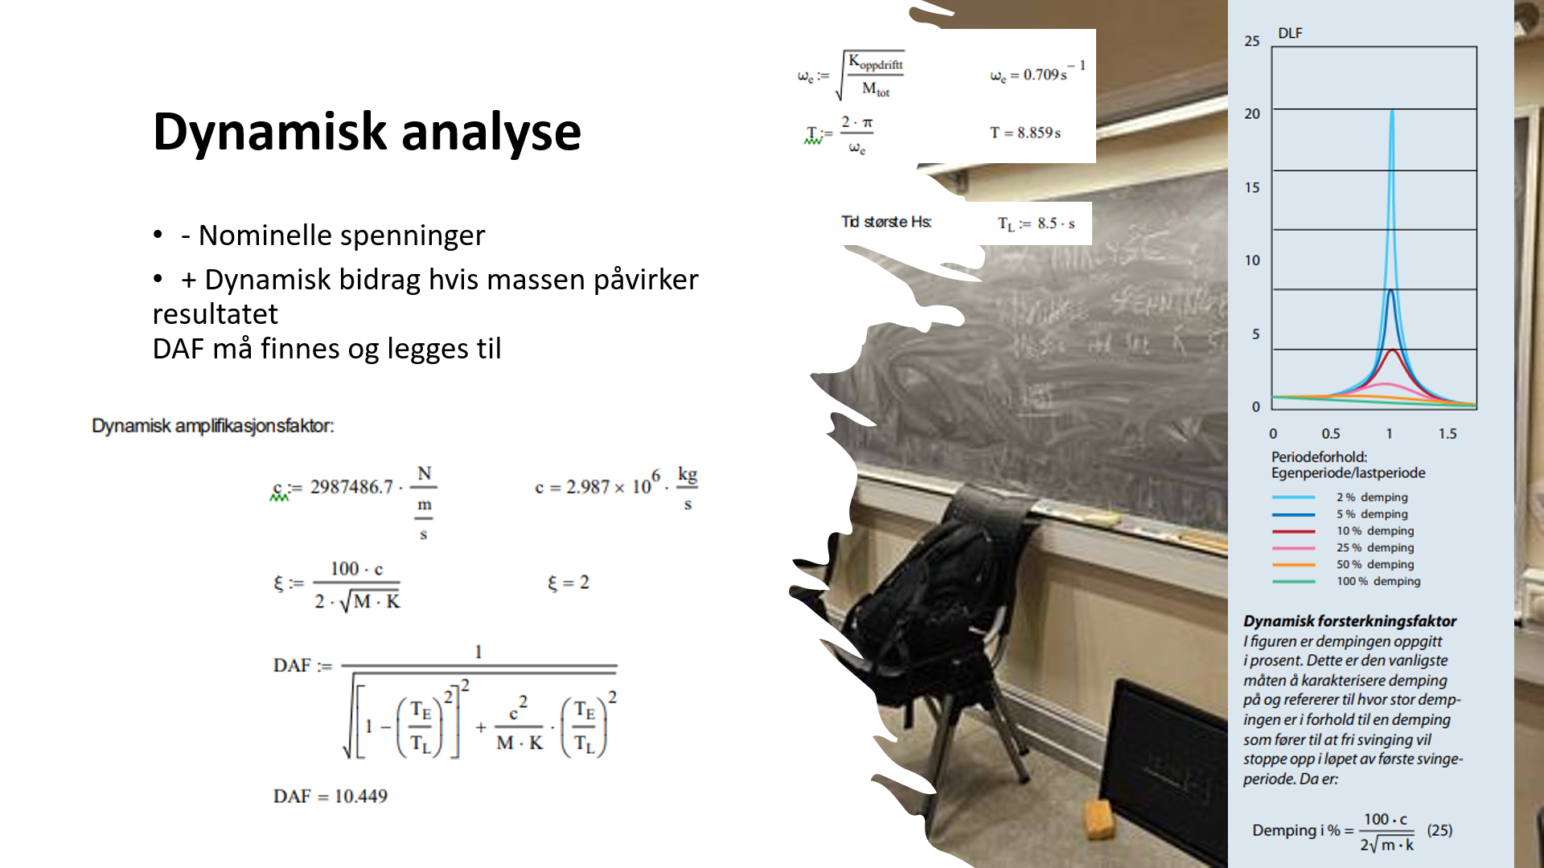
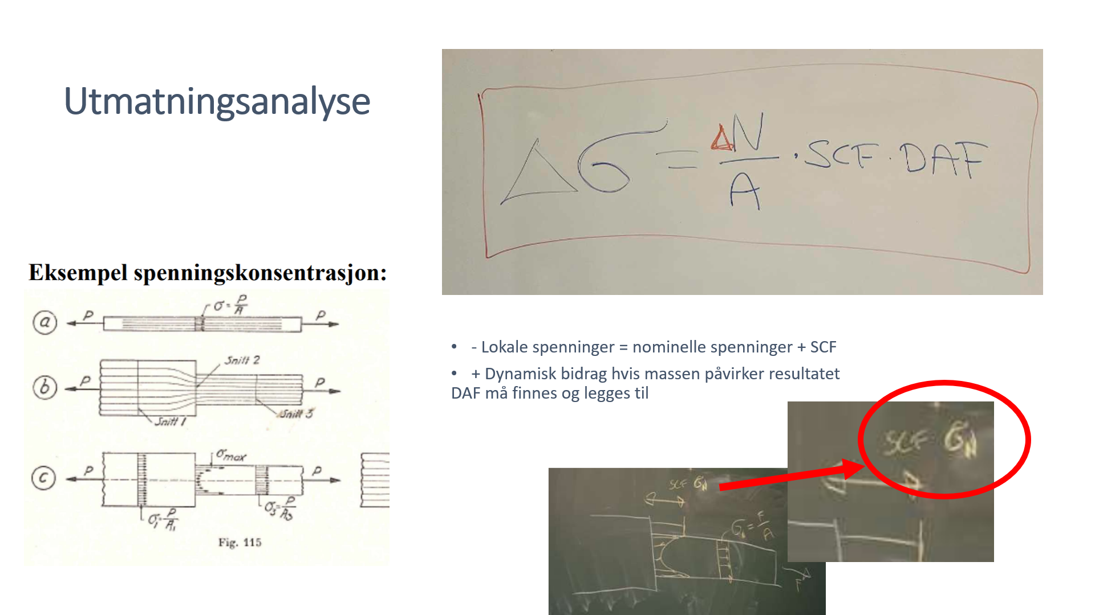
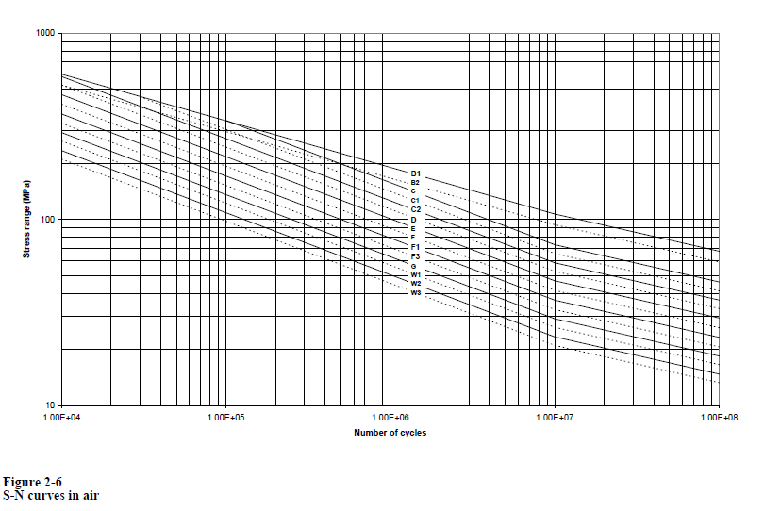
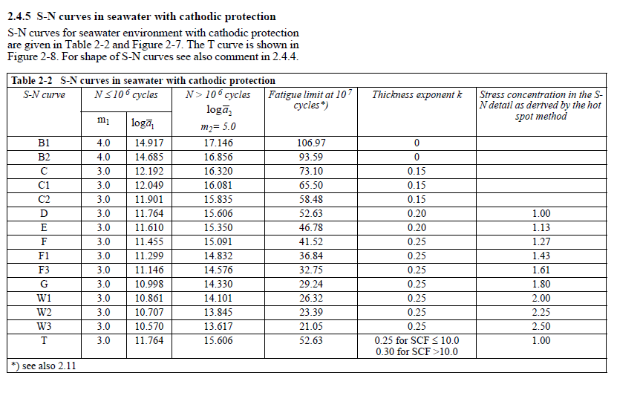
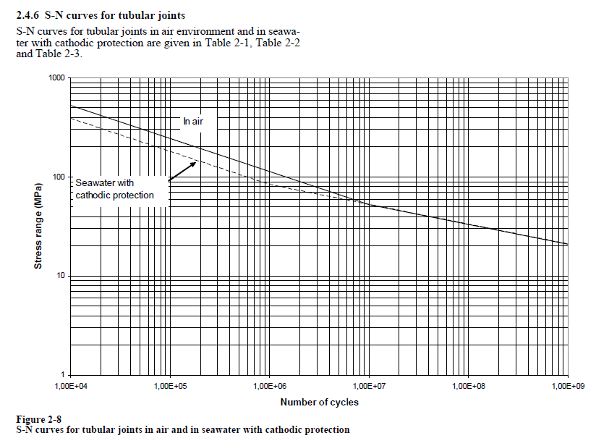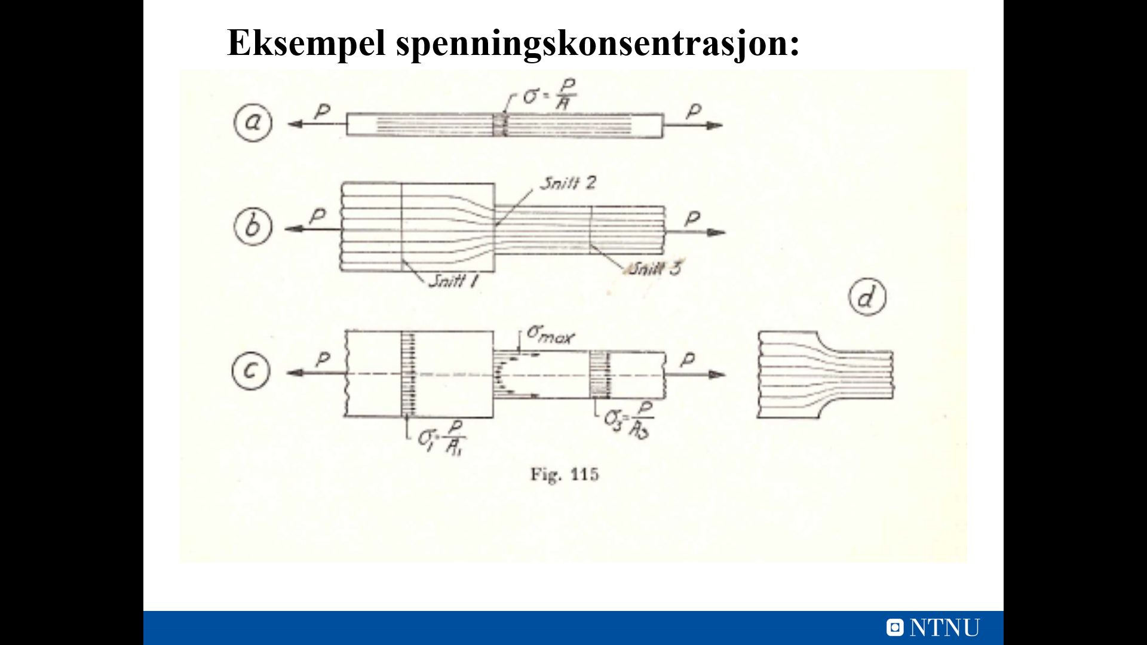
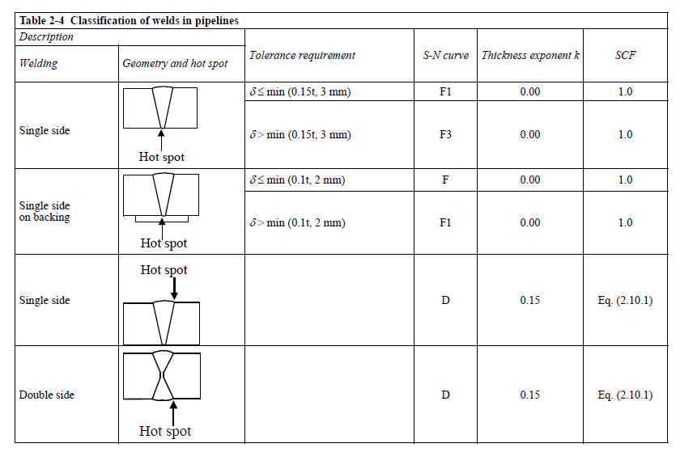
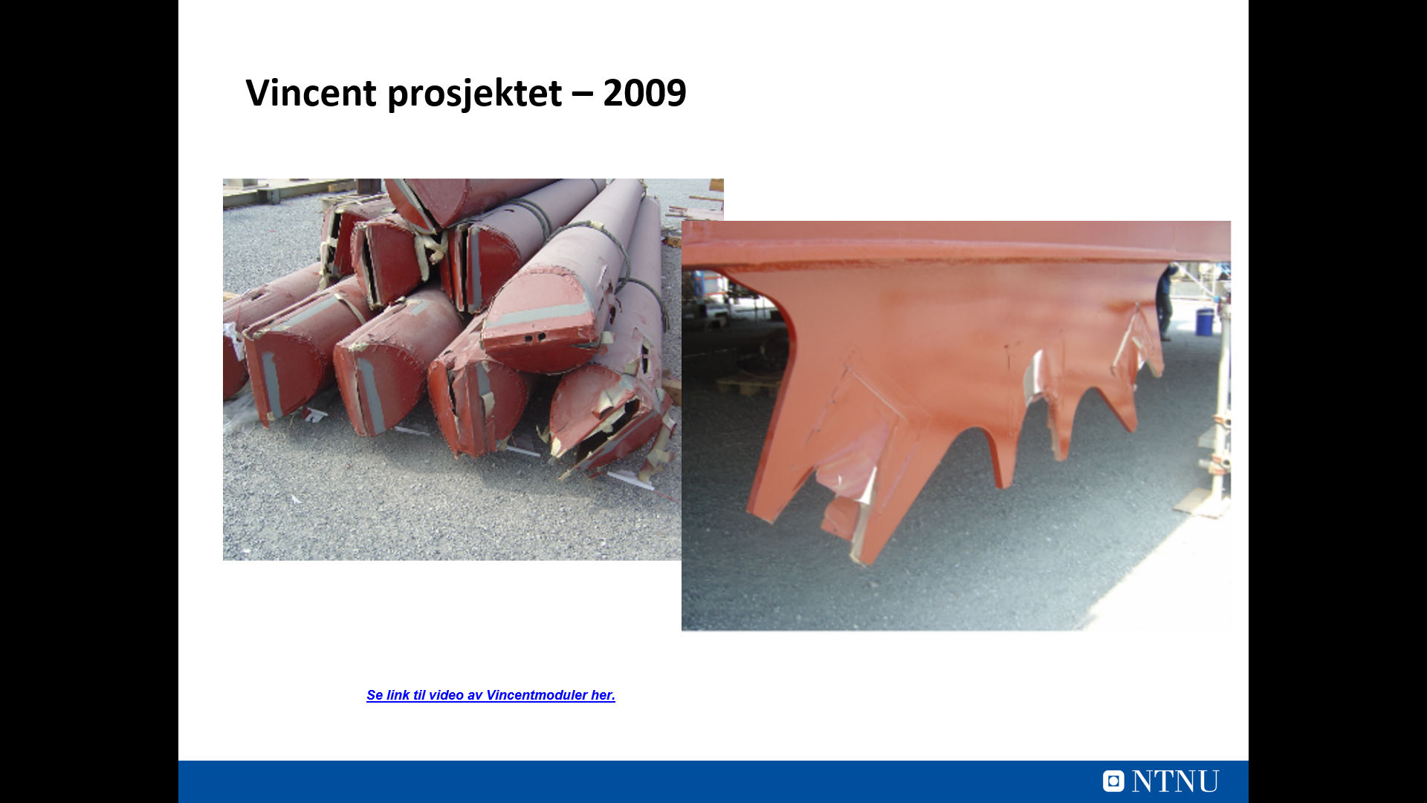
Se link til video av Vincentmoduler her
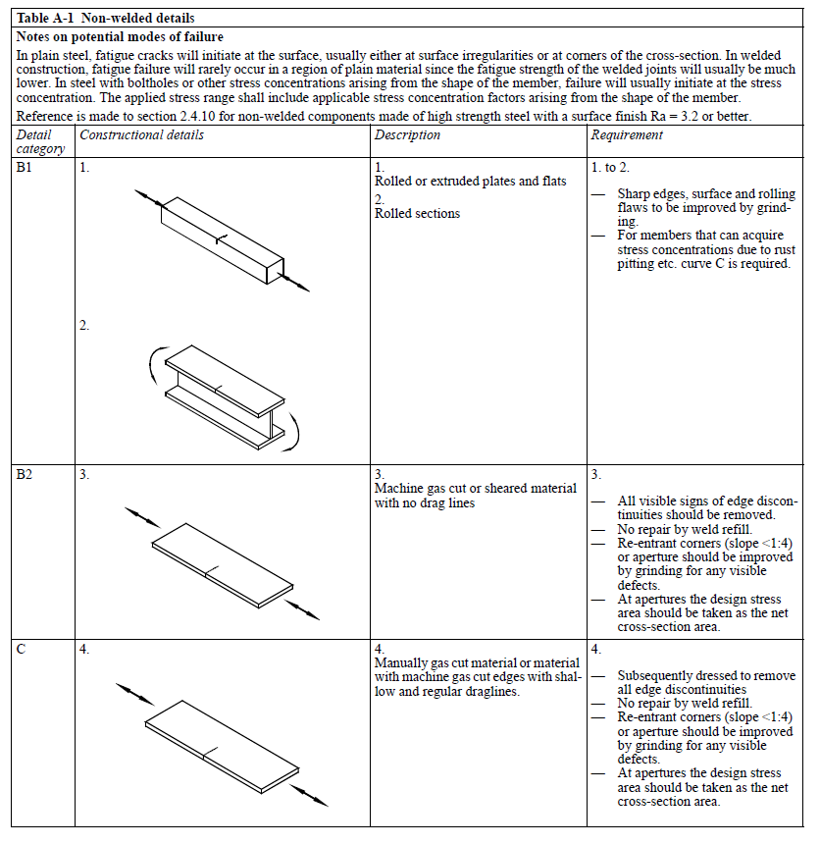
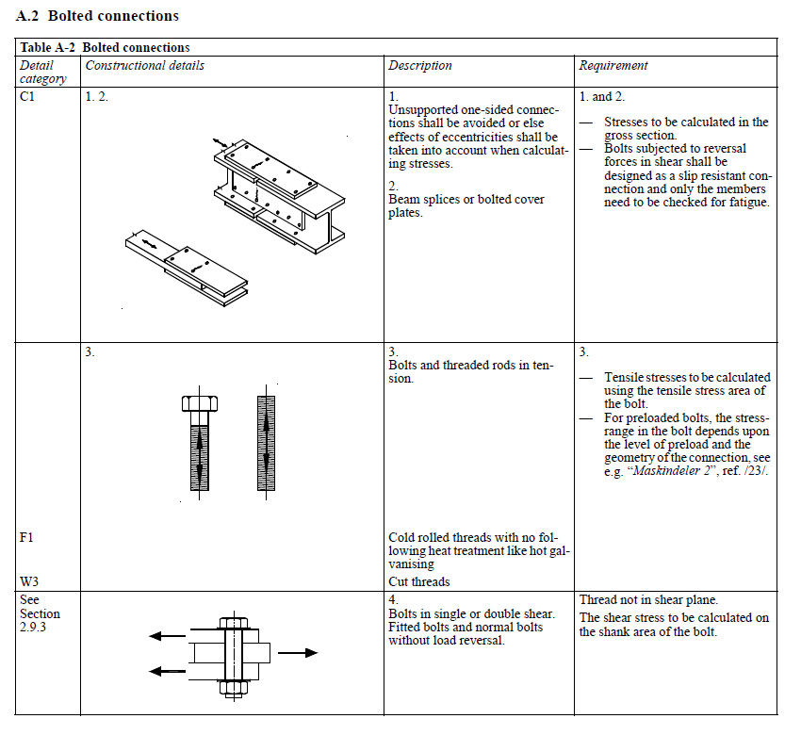
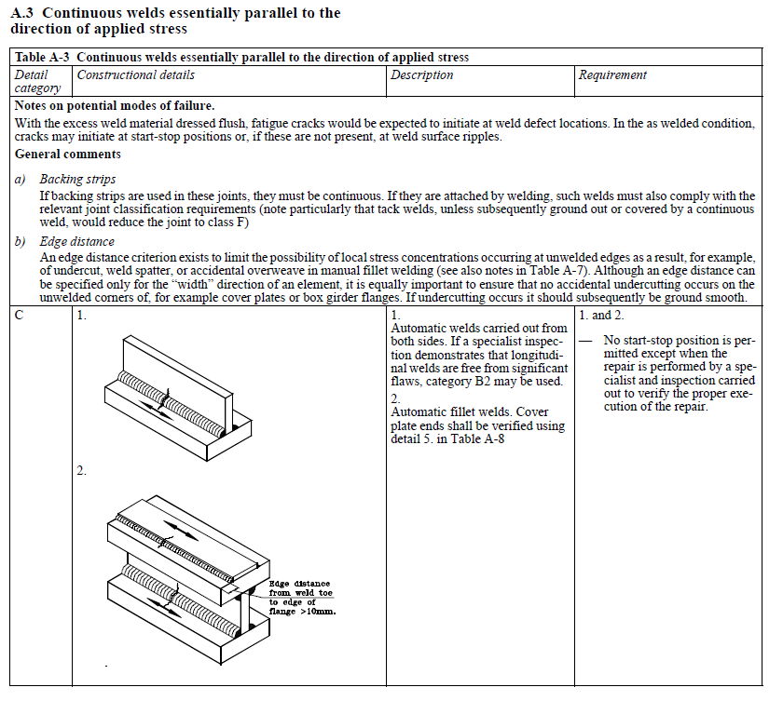
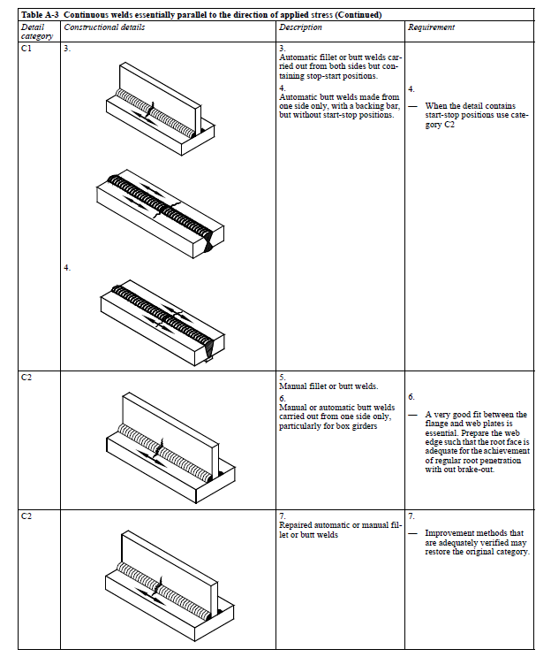
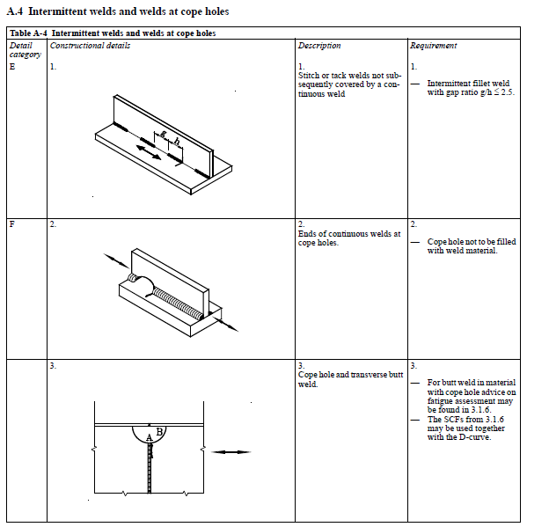
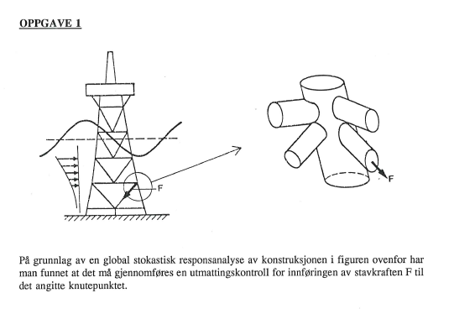
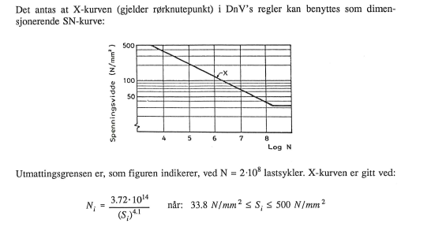
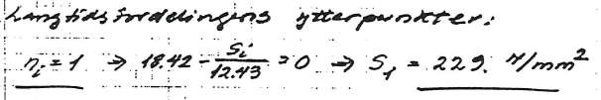
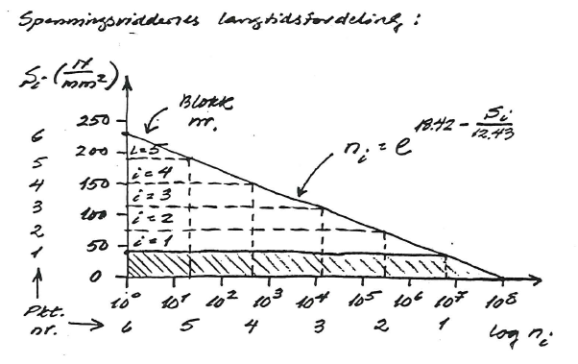
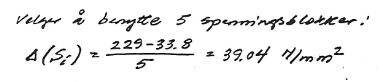
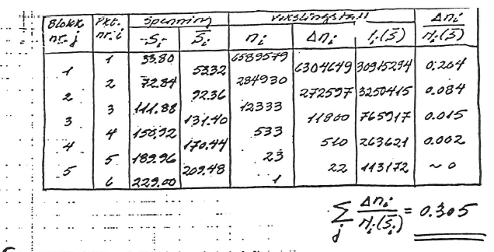

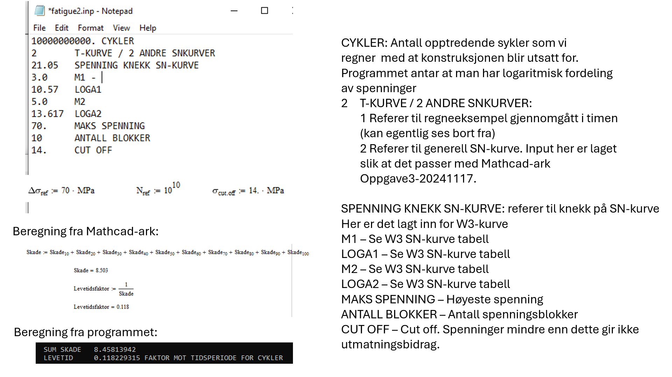

Stress concentration factors

Working with Stress Concentration Factors - YouTube
Stress Concentration Factors - YouTube
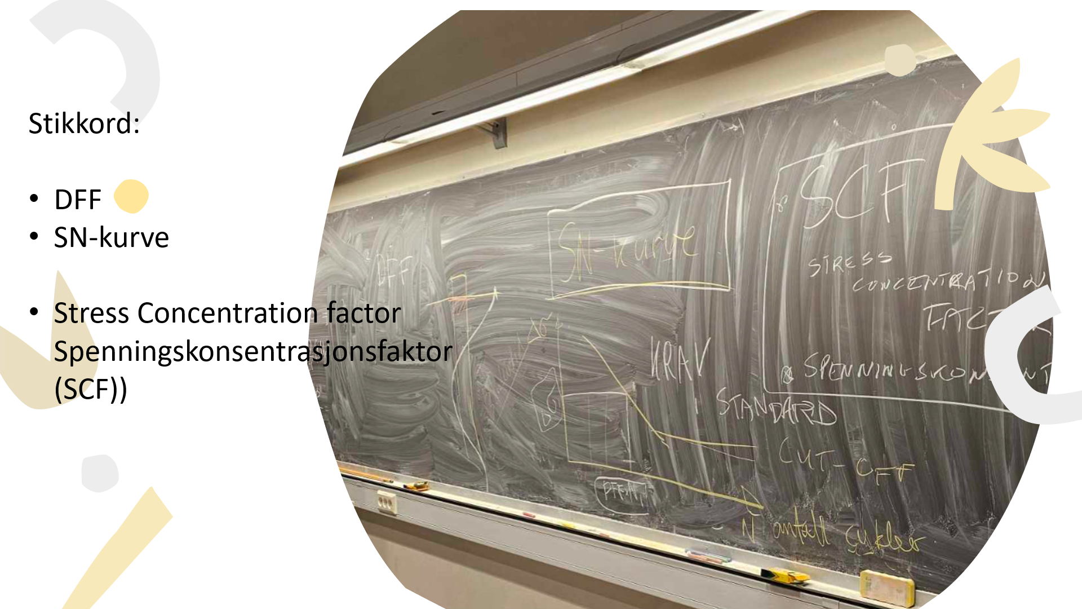
SN-kurver og «giga cycles»
Vi har nå i øvingen sett på SN-kurver. Tradisjonelt har man sagt at under et visst
spenningsendringsnivå så får man ingen skade i stålet.
Det er en sannhet med modifikasjoner da betydningen av veldig høye frekvenser
med små amplituder kan kanskje også føre til brudd.
For dimensjonering av forbindelser så er Per. Kr. Larsens "Dimensjonering av stålkonstruksjoner" og kapitlene "10 Forbindelser og forbindelsesmidler", "11 Konstruksjonsdetaljer" og "12 Utmatning".
Kapittel 12 Utmatning er spesielt aktuelt for havromskonstruksjoner naturligvis.
Fra "Dimensjonering mot utmatning, Per Kristian Larsen" er det SN-kurve og detaljklassifisering som er det viktige.
SN-kurve på sidene 492-493.
Detaljklassifisering på sidene, 494 og utover.
Begrepet SCF (Stress Consentration Factor) sier hvor mye større den lokale spenningen er opp mot den nominelle spenningen.
For kapasitetsberegning der man ikke har problemer med utmatning (gjentagende variasjon av last over tid) kan man regne enklere på kapasiteten enn der man har utmatning. Det holder at man sjekker kapasiteten opp mot nominelle spenninger. For utmatningspåkjente konstruksjoner må lokale spenningsendringer spesielt regnes på. En mer detaljert beregning som gjøres enn for en konstruksjon som ikke har disse variasjonene i lastene for å sjekke at man er innenfor kravene med tanke på utmatning, da lokale spenningsendringer kan bli starten på en sprekk som leder til en større skade og redusert kapasitet.
Per Kristian Larsen kategorisering av knutepunkter
Per Kristian Larsen beregning av utmatningsskade
Introduction to Fatigue Per Jahn Haagensen
Notater fra maskin og faget Maskindeler 2 angående utmating:
Losningsforslag_Øving 9 Maskindeler2_Utmatting.pdf
Løsningsforslag_Øving 10 Maskindeler2_Utmatting.pdf
Løsningsforslag_Øving 11 Maskindeler2_Utmatting.pdf
Løsningsforslag_Øving 11 Maskindeler2_Utmatting.pdf
Losningsforslag_Øving 12 Maskindeler2_Utmatting.pdf
Løsningsforslag_Øving 13 Maskindeler2_Utmatting.pdf
Improvement of fatigue Life by Fabrication DnV
What is gigacycle fatigue? (moviecultists.com)
Mer generelt program utmatning
FATIGUE2 kjører i batch .exe må legges til programmet. Må lastes ned en for å kjøres i DOS.
Input til progammet: fatigue2.inp
Kjøres slik:
FATIGUE2.EXE < fatigue2.inp > fatigue2.out
Resutatfilen med beregningsresultat ligger da i .out fila.
Den skal se slik ut:
fatigue2.out
Tilleggsforklaring gitt her:
EksempelFatigueBruAvProgram.pdf
Dere finner igjen tallene i dette regnearket.
Beregning i Mathcad

25. Vortex induced vibrations (VIV) in wind and wave current

Vortex Induced Vibrations (VIV) refer to oscillations that occur in structures due to the shedding of vortices in the fluid flow around them. This phenomenon is particularly relevant in the context of offshore engineering, where structures such as risers, pipelines, and floating platforms are subjected to the combined effects of wind, waves, and currents.
Key Concepts of Vortex Induced Vibrations (VIV)
- Mechanism of VIV:
  - As fluid flows past a cylindrical structure, vortices are shed alternately from either side of the structure. This shedding creates alternating pressure forces that can lead to oscillations in the structure.
  - The frequency of vortex shedding is influenced by the flow velocity and the diameter of the structure, and it can resonate with the natural frequency of the structure, leading to significant vibrations.
- Factors Influencing VIV:
  - Flow Velocity: Higher flow velocities can increase the frequency of vortex shedding, which may lead to stronger vibrations.
  - Structural Properties: The mass, stiffness, and damping characteristics of the structure affect its response to vortex shedding.
  - Fluid Properties: The density and viscosity of the fluid, as well as the presence of turbulence, can influence the behavior of vortices and the resulting vibrations.
- VIV in Wind and Wave Currents:
  - Wind: In offshore environments, wind can create additional forces on structures, contributing to VIV. The interaction between wind-induced forces and vortex shedding can amplify vibrations.
  - Waves: Wave action can alter the flow patterns around structures, affecting vortex shedding. The periodic nature of waves can lead to varying flow velocities, which can influence the frequency and amplitude of VIV.
  - Currents: Ocean currents can significantly impact VIV, especially in deep-water applications. The interaction between currents and the structure can lead to complex flow patterns and increased vortex shedding.
Implications of VIV
- Structural Integrity: VIV can lead to fatigue damage in structures over time, particularly in risers and pipelines. Engineers must consider VIV in the design process to ensure the long-term integrity of these structures.
- Design Considerations:
  - Damping: Incorporating damping mechanisms can help mitigate the effects of VIV. This can include using materials that absorb vibrations or designing structures with specific geometries that reduce vortex shedding.
  - Shape Optimization: Modifying the shape of structures can alter the flow patterns and reduce the intensity of vortex shedding, thereby minimizing VIV.
  - Monitoring: Continuous monitoring of structures for VIV can help in assessing their condition and implementing maintenance strategies.
- Modeling and Simulation: Computational fluid dynamics (CFD) and other modeling techniques are often used to predict VIV behavior in various environmental conditions, allowing for better design and risk assessment.
Conclusion
Vortex Induced Vibrations are a critical consideration in the design and operation of offshore structures subjected to wind, waves, and currents. Understanding the mechanisms behind VIV and its implications is essential for ensuring the safety and longevity of these structures in challenging marine environments. Engineers must employ a combination of design strategies, monitoring, and modeling to effectively manage the risks associated with VIV.

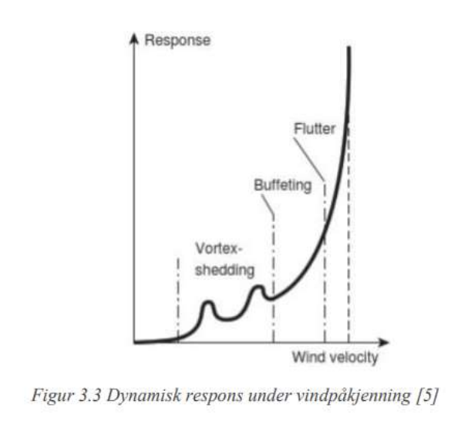
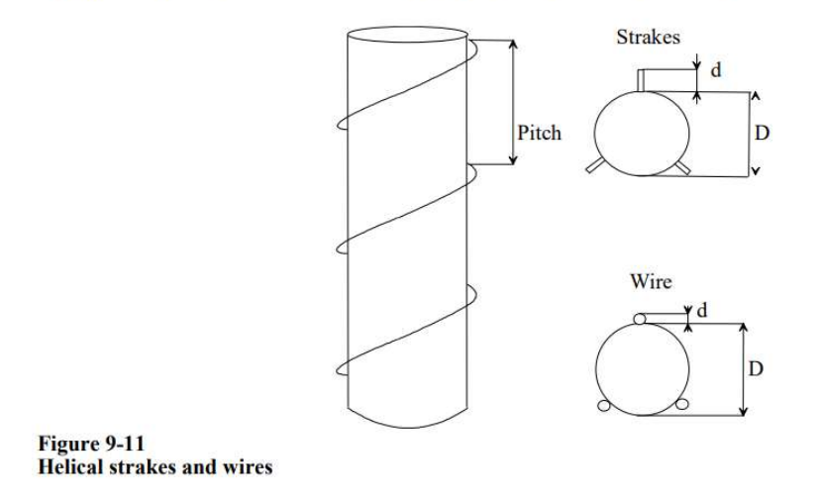
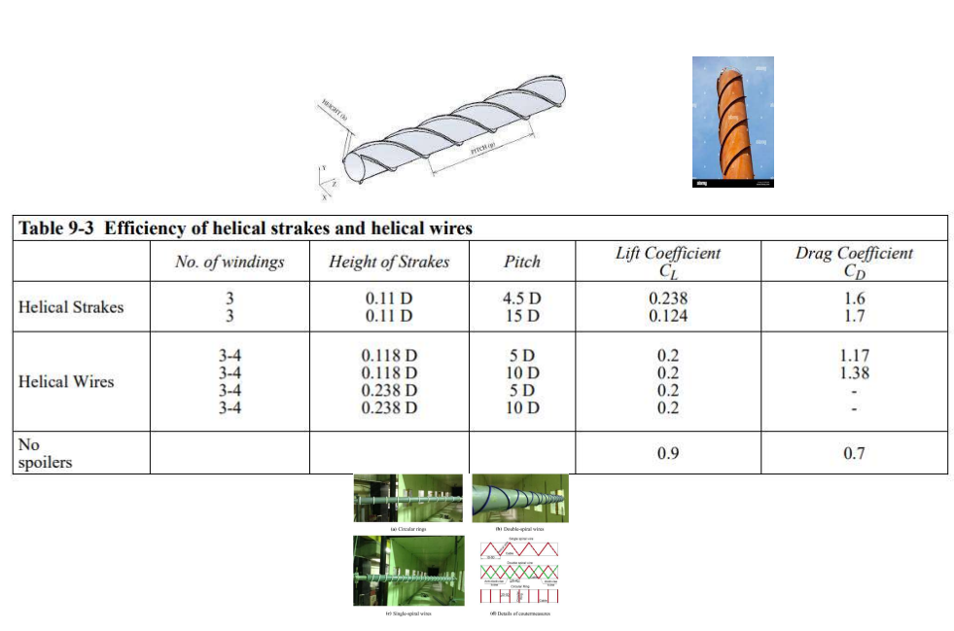

26. Vibrations and noise
Vibration & noise is a multidisciplinary problem both technically and organizationally. It applies in the design phase and the operation phase. There are many compromises that are made in the design phase and choices that are made so that things do not become too expensive.
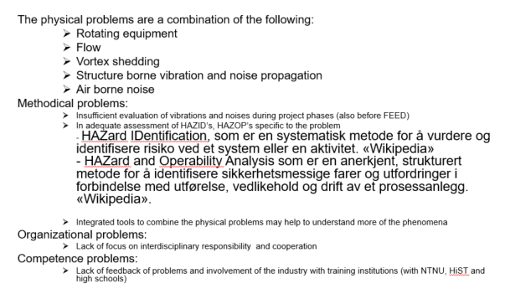
Figure 27 Vibration and the noise problem. This overview shows an overview of what the problem consists of which was created as a summary of the conference.
Lecture Vibration Oil & Gas.

27. Condition monitoring
An Introduction to Fatigue Testing - YouTube

28. Problem sets and examples

Repetisjon fra mekanikk 1
Skjærspenning 1
Skjærspenning 2
Skjærspenning 3
==================================================
Problem set 1 task 1 - 4
Problem set 1 Solution proposal
IdeaStatica Task 1
IdeaStatica Task 1 ver 2
SapMovie5 - YouTube (turn off the sound)
sap2000 Spenningskomponenter
IdeaStatica Task 2 ver 1
IdeaStatica Task 2 ver 2
IdeaStatica Task 2 ver 3
Problem set 3
IdeaStatica Task 3
IdeaStatica Task 4
IdeaStatica Task 4 ver 2

Dette er regningsovingsoppgaver og ikke nødvendigvis eksempel på gode
designløsninger.
Problem set 2 Buckling
Problem set 2 Buckling solution proposal
IdeaStatica Problem set 2 Task 1
IdeaStatica Problem set 2 Task 2
IdeaStatica Problem set 2 Task 2 ver2
IdeaStatica Problem set 2 Task 2 ver3
IdeaStatica Problem set 2 Task 2 ver6
IdeaStatica Problem set 2 Task 3
IdeaStatica Problem set 2 Task 3 ver 3
IdeaStatica Problem set 2 Task 4
IdeaStatica Problem set 2 Task 5
IdeaStatica Problem set 2 Task 5 ver 5
IdeaStatica Problem set 2 Task 6
IdeaStatica Problem set 2 Task 7
IdeaStatica Problem set 2 Task 7 ver 2
IdeaStatica Problem set 2 Task 8
IdeaStatica Problem set 2 Task 9
MathCad Problem set 2 Task 10
MathCad pdf Problem set 2 Task 10
IdeaStatica Problem set 2 Task 10
================================================
Problem set 3 Weld and Bolt Connection
Problem set 3 Weld and Bolt Connection Solutions Proposal
================================================
Exam 2014
Exam 2014 Solution proposal
IdeaStatica model
Exam 2015
Exam 2015 Solution proposal
Exam 2016
Exam 2016 Solution proposal
Exam 2017
Exam 2017 Solution proposal
Exam 2018
Exam 2018 Solution proposal
Exam 2019
Exam 2019 Solution Proposal
Exam 2020
Exam 2020 Solution proposal
Exam 2021
Exam 2021Solution proposal
IdeaStatica Stopper Plate
Exam 2022
Exam 2022 Solution proposal
IdeaStatica knutepunkt
Exam 2023
Exam 2023 Solution proposal
Exam 2024
Exam 2024 Solution proposal
============================================================
Øvingsoppgave : Case Design Challenge
=============
Vindstandard
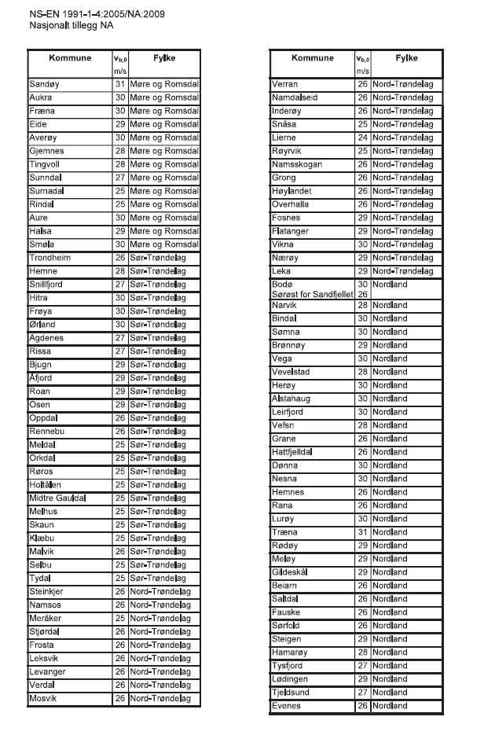
Problem set 1 – Wind
SAP2000 model vindlast Treteknisk senter.
Problem set 2 – Waves and Dynamic
Problem set 3 – Design
Problem set 4 – Fatigue

27. References

- Overview over standards and syllabus.
https://www.konstruksjon.com/undervisning/design-of-offshore-structures-2/

